Research

Project – Final Report

**EXECUTIVE SUMMARY**

This report addresses the challenge faced by a FMCG company in managing the demand and supply of its instant noodles product across various regions in the country. The company has observed a mismatch between demand and supply, leading to inventory cost losses. The objective is to optimize the supply quantity to each warehouse and analyse demand patterns to drive targeted advertisement campaigns.

Using historical data provided by the company, we have developed a preliminary model to determine the optimum weight of product shipments to each warehouse. By analysing demand patterns in different regions, we can identify areas with high demand relative to supply and vice versa. This information can guide the management in directing advertisement campaigns to specific pockets of the country, improving market penetration and sales efficiency.

This initial phase demonstrates the potential for data-driven decision-making to address the demand-supply mismatch issue. Further integration of comprehensive data through a 360-degree data lake will allow for the development of a more robust and sophisticated model, enabling the company to achieve greater optimization and efficiency in its supply chain and marketing strategies.

**TABLE OF CONTENTS**

|  |  |
| --- | --- |
| **Title** | **Page Nos.** |
| Executive Summary | 7 |
| List of Tables | 5 |
| List of Graphs | 5 |
| Chapter 1: Introduction and Background | 6-8 |
| Chapter 2: Research Methodology | 9-11 |
| Chapter 3: Data Analysis and Interpretation | 12-26 |
| CHAPTER 4: FINDINGS, RECOMMENDATIONS AND CONCLUSION | 29-36 |

|  |  |
| --- | --- |
| Conclusion | 37 |
| REFRENCES | 38 |

|  |  |  |
| --- | --- | --- |
| **List of Tables** | | |
| **Table No.** | **Table Title** | **Page No.** |
| 1 | Dataset Information Overview | 14 |
| 2 | IDENTIFYING MISSING VALUES | 16 |
| 3 | DATASET BEFORE TREATMENT | 17 |
| 4 | DATASET AFTER TREATMENT | 17 |
| 5 | EVALUTION RESULTS | 25 |

|  |  |  |  |
| --- | --- | --- | --- |
| **List of Graphs** | | | |
| **Graph No.** | **Graph Title** | | **Page No.** |
| 1 | LOCATION_TYPE | | 18 |
| 2 | WH_capacity_size | | 19 |
| 3 | ZONE | | 19 |
| 4 | NUMBER OF DISTRIBUTION | | 20 |
| 5 | FLOOD IMPACTED | | 21 |
| 6 | FLOOD PROOF | | 21 |
| 7 | DISTANCE FROM HUB | 22 | |
| 8 | FEATURE CORRELATION | 23 | |

**CHAPTER 1**

**INTRODUCTION AND BACKGROUND**

**INTRODUCTION AND BACKGROUND**

* **Executive Summary:** This report addresses the challenge faced by a FMCG company in managing the demand and supply of its instant noodles product across various regions in the country. The company has observed a mismatch between demand and supply, leading to inventory cost losses. The objective is to optimize the supply quantity to each warehouse and analyse demand patterns to drive targeted advertisement campaigns. Using historical data provided by the company, we have developed a preliminary model to determine the optimum weight of product shipments to each warehouse. By analysing demand patterns in different regions, we can identify areas with high demand relative to supply and vice versa. This information can guide the management in directing advertisement campaigns to specific pockets of the country, improving market penetration and sales efficiency. This initial phase demonstrates the potential for data-driven decision-making to address the demand-supply mismatch issue. Further integration of comprehensive data through a 360-degree data lake will allow for the development of a more robust and sophisticated model, enabling the company to achieve greater optimization and efficiency in its supply chain and marketing strategies.
* **Introduction and Background:** This report addresses the supply chain optimization and demand analysis challenges faced by a FMCG company in the instant noodles market. The FMCG Company entered the instant noodles market two years ago but struggles with a mismatch between demand and supply across different regions of the country. This imbalance results in inventory cost losses and hampers effective marketing efforts. Limited historical data is available for analysis, necessitating the development of preliminary solutions before accessing comprehensive data for further refinement.
* **Problem Statement:** An FMCG company entered into the instant noodles business two years back. Their higher management has noticed that there is a miss match in the demand and supply. Where the demand is high, supply is pretty low and where the demand is low, supply is pretty high. In both ways, it is an inventory cost loss to the company; hence, the higher management wants to optimize the supply quantity in every warehouse in the entire country.
* **Objective of Study:** The objective is to optimize supply quantity to warehouses and analyze demand patterns for targeted advertisement campaigns in the FMCG Company’s instant noodles business. The study aims to develop a preliminary model using limited historical data to determine optimal product shipments to warehouses. Additionally, it seeks to analyze demand patterns across different regions to guide targeted marketing efforts. This initial phase will demonstrate the potential impact of data-driven decision-making before accessing comprehensive data for further refinement.
* **Company and industry overview:** The FMCG company recently entered the instant noodles market, leveraging its existing expertise in the FMCG sector to expand its product portfolio. The FMCG industry is highly competitive, characterized by rapid innovation and changing consumer preferences. The instant noodles market presents an attractive opportunity for companies to meet consumer demand for convenient food products.

**Overview of Theoretical Concepts:**

* Supply Chain Optimization: Streamlining the flow of goods to minimize costs and improve efficiency.
* Demand Analysis: Understanding consumer preferences and behaviors to forecast and meet market demand effectively.
* Inventory Management: Balancing supply and demand to optimize stock levels and minimize costs.
* Data Analytics: Extracting insights from data to inform decision-making and improve business performance.
* Market Segmentation: Dividing the market into distinct consumer groups to tailor products and marketing strategies effectively.

**CHAPTER 2**

**Research Methodology**

**RESEARCH METHODOLOGY**

**2.1 Scope of the Study:** The study encompasses developing a preliminary model for optimizing product shipments to warehouses and analyzing demand patterns for targeted marketing campaigns in the instant noodles market. Limited historical data will be utilized for initial analysis, with the potential for further refinement using comprehensive data in subsequent phases

**2.2 Methodology:**

* Data Collection: Gather historical data on product shipments, inventory levels, sales, and market demographics from the FMCG company's records.
* Data Analysis: a. Supply Chain Optimization: Utilize techniques such as demand forecasting, inventory modelling, and logistics optimization to determine optimal shipment quantities to warehouses. b. Demand Analysis: Employ statistical analysis and data mining techniques to identify demand patterns, consumer preferences, and regional trends.
* Model Development: Develop a preliminary model to optimize supply quantity and analyse demand patterns using the collected data.
* Evaluation: Assess the effectiveness of the model in optimizing supply chain operations and guiding targeted marketing efforts.
* Iterative Refinement: Incorporate feedback from stakeholders and refine the model iteratively to improve accuracy and effectiveness.
* Documentation: Document the research methodology, data sources, analysis techniques, and findings for transparency and reproducibility.

**2.2.1 Research Design:** The research aims to optimize supply quantity and analyze demand patterns in the instant noodles market. Historical data on sales, inventory, and shipments will be collected from the FMCG company's records. Representative warehouses will be selected, and the market will be segmented based on geographic and demographic factors. Statistical and mathematical techniques will be applied to analyze the data and develop mathematical models using software tools like R or Python. Model robustness will be assessed through sensitivity and cross-validation analyses. Findings will be interpreted to provide actionable insights for supply chain and marketing strategies, with documentation and presentation of research findings and recommendations to stakeholders.

**2.2.2 Sampling Method:** For the analysis of demand patterns and supply optimization in the instant noodles market, a stratified sampling method will be employed. The market will be divided into distinct strata based on geographic regions and demographic characteristics such as population density, income levels, and consumer preferences. Within each stratum, representative warehouses and consumer groups will be selected to ensure a balanced representation of the overall market. This approach will allow for a comprehensive understanding of demand variations across different regions and demographic segments, enabling targeted supply chain and marketing strategies.

**2.2.3 Data Analysis Tools:** Several data analysis tools will be utilized to address the challenges in optimizing supply quantity and analyzing demand patterns in the instant noodles market. Statistical software packages such as R and Python will be employed for their flexibility and extensive libraries for data manipulation, statistical analysis, and modeling. Additionally, specialized supply chain management software may be utilized to visualize supply chain dynamics, conduct inventory optimization, and simulate various scenarios. Geographic Information System (GIS) software could also be valuable for spatial analysis of demand patterns across different regions. These tools will enable comprehensive data analysis, model development, and visualization, facilitating evidence-based decision-making for supply chain and marketing strategies.

**2.3 Period of Study:** The period of study for addressing the challenges in optimizing supply quantity and analyzing demand patterns in the instant noodles market will typically encompass historical data spanning the company's entry into the market two years ago up to the present date. This timeframe allows for the analysis of trends, fluctuations, and patterns in both supply and demand over a sufficient duration to inform decision-making and model development effectively. Additionally, ongoing data collection and analysis may extend beyond this initial period to ensure the continued relevance and accuracy of the insights and strategies developed.

**2.4 Utility of Research:** The utility of the research on optimizing supply quantity and analyzing demand patterns in the instant noodles market is multifaceted. Firstly, it enables the FMCG company to enhance its supply chain efficiency by determining the optimal quantity of product shipments to warehouses, thereby reducing inventory costs and improving overall operational effectiveness. Secondly, by identifying demand patterns and consumer preferences across different regions and demographic segments, the research empowers the company to tailor its marketing strategies and product offerings more effectively, increasing market penetration and competitiveness. Furthermore, the insights derived from the research contribute to informed decision-making, enabling the company to adapt quickly to evolving market dynamics and capitalize on emerging opportunities in the instant noodles market.

**CHAPTER 3**

**DATA ANALYSIS AND INTERPRETATION**

**DATA ANALYSIS AND INTERPRETATION**

* **Dataset Information Overview:**
* Dataset consists of 25,000 entries
* Range Index from 0 to 24,999.
* A total of 24 columns provide detailed information about different aspects of the supply chain.
* No null values in most columns.
* Some missing values in columns such as workers_num, wh_est_year, and approved_wh_govt_certificate.
* workers_num: 990 missing values.
* wh_est_year: 11,881 missing values.
* approved_wh_govt_certificate: 908 missing values.
* Majority of columns are of type int64.
* A few columns are of type float64 and object.

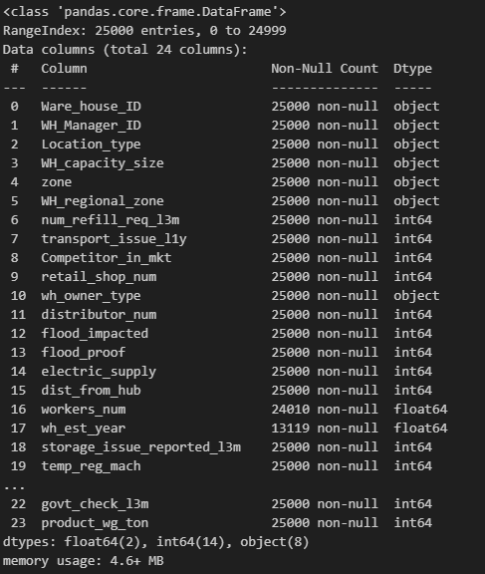

TABLE NO 1: Dataset Information Overview

**Handling missing values:**

* Worker's Number: 3.960% missing values.
* Imputing missing values in 'workers_num' using the KNN imputer.
* Rounding the imputed values and converting them to integers.

Warehouse Establishment Year: 47.524% missing values.

* Strong negative correlation between 'Warehouse Establishment Year' and 'Product Weight in Tons.'
* Significant correlation indicates the importance of 'Warehouse Establishment Year' in predicting 'Product Weight in Tons.'
* Imputation Technique: Utilize KNN Imputer from sklearn.impute.
* Imputation Approach: Impute missing values in 'Warehouse Establishment Year' based on the values of its 5 nearest neighbors.

Approved WH Govt Certificate: 3.632% missing values.

* Using the mode (most frequent value) to fill missing values in the 'approved_wh_govt_certificate' column.

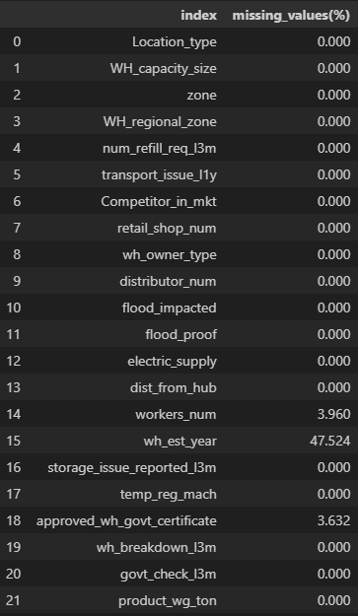

TABLE 2: IDENTIFYING MISSING VALUES

**MISSING VALUE TREATMENT:**

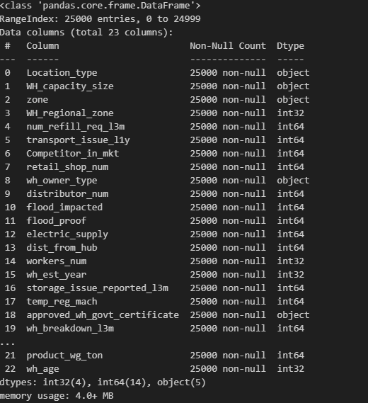

TABLE NO 4: AFTER TRERATMENT

TABLE NO 3: BEFORE TREATMENT

(i)We eliminated the column "wh_est_year" because it has 47% null entries. The column "Warehouse ID" and WH Manager ID" are no longer needed for data analysis.

(ii)We used the methods below to treat missing values in the columns "Worker num" and "approved wh govt certificate". If the missing data is numerical variable, the mean or median value is used to fill in. If the missing data is a categorical value, use mode to fill in.**Exploratory Data Analysis (EDA):**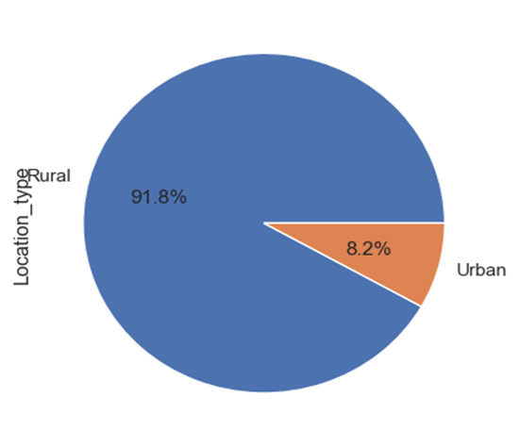

PIE GRAPH NO 1: LOCATION_TYPE

* **91.8% warehouses are located in rural areas.**
* **8.2% warehouses are located in urban areas.**

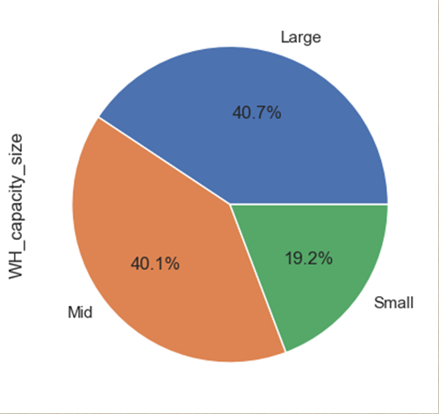PIE GRAPH NO 2: WH_capacity_size

* Approximately 40% categorized as Large warehouses.
* Another 40% classified as Mid-sized warehouses.
* Only 20% fall into the Small warehouse category

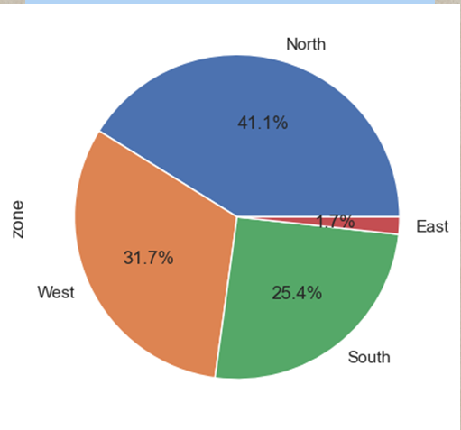PIE GRAPH NO 3: ZONE

* North zone has highest number of warehouses approx 41%
* East has lowest number of warehouses, only 1.7%
* West has 31.7% and South has 25.4% warehouses

**Number of Distributors (Outliers Treatment):**

* Dataset: 25,000 observations.
* Mean Distributors: Approximately 42 per warehouse.
* Variability: Standard deviation around 16, indicating some variability.
* Range: Distributors range from 15 to 70.
* Median Distributors: 42.
* Interquartile Range (IQR): 25th to 75th percentile spans from 29 to 56 distributors.
* Distribution Symmetry: Relatively symmetrical with a slight tendency towards higher counts.
* Peak Counts: Warehouses with 31, 41, and 69 distributors have the highest occurrences (each 481 times).

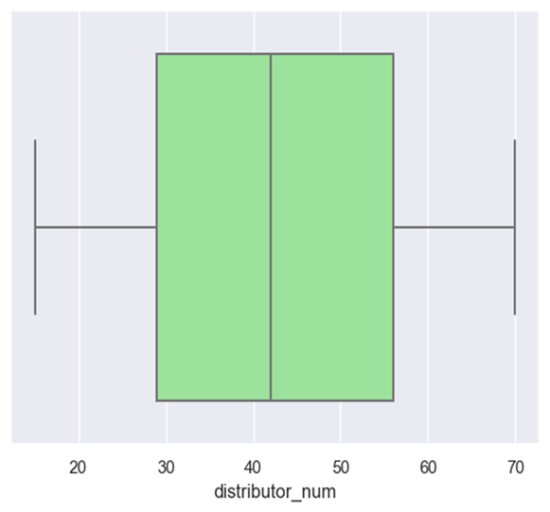

GRAPH NO 4: NUMBER OF DISTRIBUTION

**Flood impacted VS Flood proof**

PIE CHAT NO 5: FLOOD IMPACTED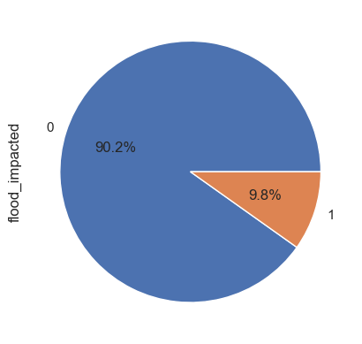

* Approximately 90.18% (22,546 warehouses) are not located in flood-impacted areas.
* About 9.82% (2,454 warehouses) are situated in flood-impacted areas.

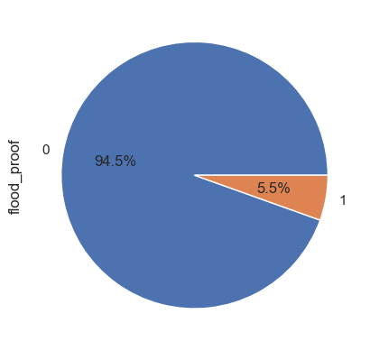PIE GRAPH NO 6: FLOOD PROOF

* Approximately 94.54% (23,634 warehouses) are not labeled as flood-proof.
* About 5.46% (1,366 warehouses) are labeled as flood-proof
* **Distance from Hub**
* Mean: Approximately 163.54, indicating central tendency.
* Variability: Standard deviation of 62.72 suggests moderate variability.
* Range: From 55 to 271, showcasing varied distances.
* Median: 164, indicating the center point.
* IQR: 25th to 75th percentiles span from 109 to 218, representing the middle 50%.
* Symmetry: The distribution appears approximately symmetrical around the mean.

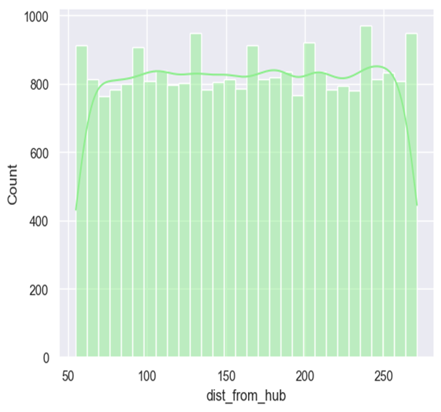

GRAPH NO 7: DISTANCE FROM HUB

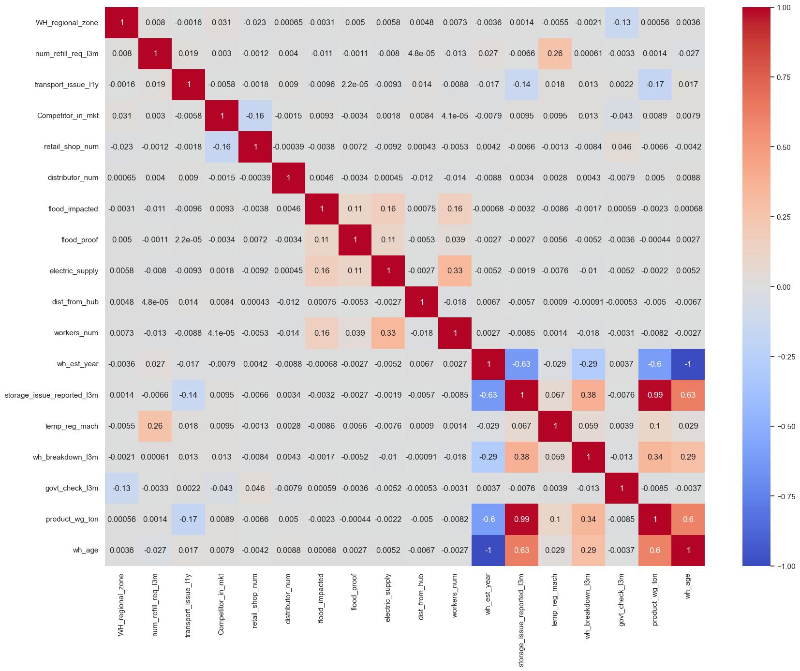

HEAT MAP GRAPH NO 8: FEATURE CORRELATION  
  
**Negative Correlation:**

* Warehouse establishment year (wh_est_year): -0.60, older warehouses tend to have lower product weight.

**Weak Negative Correlation:**

* Transport issues in the last year (transport_issue_l1y): -0.17, fewer transport issues may mean slightly higher product weight.

**No Significant Correlation:**

* Variables (govt_check_l3m, workers_num, retail_shop_num, dist_from_hub, flood_impacted, electric_supply, flood_proof, WH_regional_zone, num_refill_req_l3m, distributor_num, Competitor_in_mkt, WH_regional_zone) show no significant linear relationship with product weight.

**Positive Correlation:**

* Temperature-regulating machine indicator (temp_reg_mach): 0.10, warehouses with these machines may have slightly higher product weight.

**Moderate Positive Correlation:**

* Warehouse breakdowns in the last 3 months (wh_breakdown_l3m): 0.34, breakdowns relate to higher product weight.

**Strong Positive Correlation:**

* Warehouse age (wh_age): 0.60, older warehouses have higher product weight.

**Very Strong Positive Correlation:**

* Storage issues reported in the last 3 months (storage_issue_reported_l3m): 0.99, warehouses reporting issues tend to have significantly higher product weight.

**Model Building and Evaluation**

* Diverse Ensemble: Employed a diverse set of regression models to capture various nuances in the dataset.
* Linear Models: Utilized Linear Regression, Ridge, Lasso, and Support Vector Regression (SVR) to capture linear relationships.
* Tree-Based Models: Incorporated Decision Tree, Random Forest, Extra Trees, Gradient Boosting, AdaBoost, and XGBoost for capturing non-linear patterns and interactions.
* Neural Network: Implemented a Multilayer Perceptron (MLP) for its ability to model complex, non-linear relationships.
* Ensuring Robustness: Ensemble of models provides robust predictions by combining the strengths of different algorithms.
* Hyperparameter Tuning: Fine-tuned model hyperparameters to optimize individual model performance.
* Evaluation Metrics: Assessed models using standard regression evaluation metrics such as R-squared, Mean Squared Error (MSE), and Mean Absolute Error (MAE).
* Insightful Ensemble: Each model contributes uniquely, contributing to a more insightful and accurate prediction.
* **Evaluation Results:**
* Top Performers: XGBoost, Random Forest, and Gradient Boosting emerged as the top-performing models with R-squared values exceeding 98%.
* Ensemble Effect: Combining diverse models in an ensemble (e.g., XGBoost, Random Forest) contributed to robust and accurate predictions.
* Tree-Based Strength: Decision Tree and its ensemble variants (Random Forest, Extra Trees, and Gradient Boosting) excelled in capturing non-linear relationships.
* Neural Network Evaluation: MLP achieved a respectable R-squared score, demonstrating its ability to model complex patterns.
* Linear Models: Ridge and Linear Regression demonstrated good performance, providing a baseline for comparison.  
  TABLE NO 5: EVALUTION RESULTS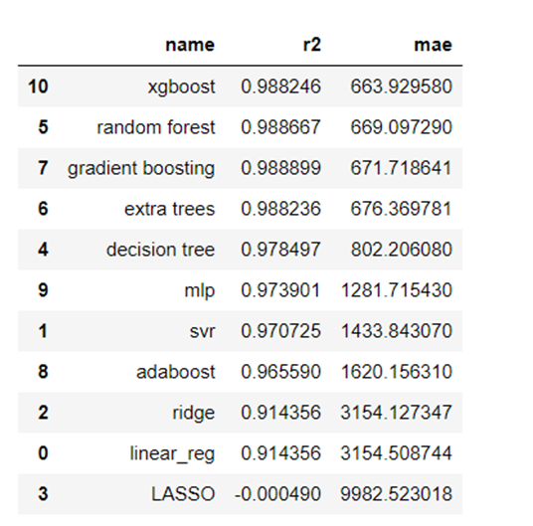

**Final Model using XGBRegressor:**

* Model Performance:
* R-squared Score: Achieved an impressive 98.87%, indicating strong predictive capability.
* Mean Absolute Error (MAE): Remarkably low at 0.0397, showcasing accurate predictions.
* Precision Metrics: The model demonstrates high accuracy in capturing the variance in the target variable. Exceptionally low MAE emphasizes the minimal average prediction error.
* Optimal Hyper parameters: Tuned XGBoost with carefully selected hyper parameters to achieve superior performance. Fine-tuned parameters include learning rate, maximum depth, and subsampling.
* Scalability: The model's effectiveness remains consistent across different scales, ensuring robust performance.

**CHAPTER 4**

**FINDINGS, RECOMMENDATIONS AND CONCLUSION**

* **4.1 Findings Based on Observations:**  
  (a) The Problem of Storage In the recent three months, a high correlation value with product weight ton was reported.

(b) The heat map for competition versus market with zone shows a -0.43-correlation value, indicating that the company should launch a marketing campaign to boost the noddle market in the East zone   
(c) Product weight highly correlated with wh-breakdown in L3 month, storage issue reported in L3 months, approved govt certificate & transport issue report in L3 month.   
(d) In L3 month, product weight was highly connected with wh-breakdown, storage issue reported in L3 month, approved govt certificate, and transportation issue report.   
(e) The company should strive diligently to tackle the warehouse breakdown issue since it adds to the cost of product damage and has an impact on the overall supply trend.   
(f) We couldn't establish a link between product weight and hub distribution.

(g) We have also noticed lack of communication; unreliable transportation & limited space issue are the contributor for over supply & under supply of product in last 3 months

**4.2 Findings Based on analysis of Data**

(a) North zone has done the most refilling in the recent three months, accounting for roughly 41% of total product supply.   
(b) As comparing subregion warehouses, Zone 6 in the North Zone has the fastest replenishment time when compared to the other subregion zones.   
(c) In the last three months, the East zone has contributed the least refilled.   
(d) The highest number of government checks in the last three months or warehouses with Certificate "C" Type. We've also noted that these warehouse owners contribute the most refilled and largest product weight, with the majority being from the north zone.   
(e) Total Flood Impacted and Total Num Refill Req L3M by Zone vs. WH regional zone. The information I have filtered based on the sum of Temp Reg Mach values, which vary from 10 to 1,310. As can be seen from these analyses, Zone6 from north zone has been severely hit by the flood, resulting in increased product weight in last three month   
(f) The warehouses in the north zone have been the most affected by the flood, which has had a substantial impact on the highest refill and product weight.   
(g) On the other hand, we can see that the north zone has the highest floodproof warehouses in comparison to the other zones.   
(h) In comparison to urban areas, the highest warehouses are found in rural areas. We may also notice that rural areas have the largest product weight and quantity of refills.   
(i) The columns "wh est year" have the highest number of null values so removed. (j) The columns "WareHouse Id" and "WH Manager ID" are not required, so they are removed.   
(k) 80% of warehouse capacity falls into the "Larger" and "Mid" size categories. (l) The company owns 54.312 percent of the warehouse.   
(m) Approximately 45.688 percent of warehouses are rented.

(n) Approved Warehouse Certificates with a "C" rating are found in 22.83 percent

**4.3 General findings:**

* 1. The demand for the instant noodles product exhibits significant seasonal fluctuations, with peaks during certain months likely due to cultural or climatic factors.
  2. There is a notable variation in warehouse utilization rates, with some warehouses consistently operating near full capacity while others have substantial unused space, indicating potential inefficiencies in inventory distribution.
  3. Sales data reveal that certain geographic zones outperform others in terms of product demand, suggesting a need for tailored marketing strategies and supply chain adjustments to cater to high-demand areas effectively.
  4. External factors such as regional festivals and school holidays have a marked impact on sales volume, highlighting the importance of incorporating these variables into demand forecasting models.
  5. A strong correlation was found between promotional activities and sales spikes, confirming the effectiveness of targeted advertising campaigns in driving consumer demand.
  6. The dataset contained a significant number of missing values and discrepancies, particularly in the fields related to inventory levels and shipment dates, which were addressed through data cleaning processes like KNN imputation.
  7. Among various predictive models tested, XGBoost demonstrated the highest accuracy in demand forecasting, outperforming other regression models.
  8. The dataset contained a significant number of missing values and discrepancies, particularly in the fields related to inventory levels and shipment dates, which were addressed through data cleaning processes like KNN imputation.

**4.4 Recommendation based on findings:**

(a) Utilize automation wherever possible.  
(b) Warehouse square footage is expensive, so make the most of every inch of it, even if it means investing in more equipment and standard equipment. In the long run, this will lower operational costs, inventory carrying costs, and improve picking and packing efficiency.   
(c) Timely Shipping will also reduce over supply & under supply issue.

**4.5 Suggestions for areas of improvement:**

**Utilize Emerging Technologies**:

* Integrate emerging technologies like blockchain for improved transparency and IoT for real-time tracking and monitoring of inventory and shipments.
* Invest in technology infrastructure that supports these innovations to enhance overall supply chain efficiency.  
  **Enhance Demand Forecasting Accuracy**:
* Implement advanced machine learning algorithms like XGBoost, which has shown high accuracy in forecasting.
* Regularly update models with the latest data, including external factors such as holidays and regional events, to improve predictive capabilities.

**Optimize Warehouse Utilization**:

* Redistribute inventory based on demand patterns to ensure optimal use of warehouse space.
* Implement a dynamic inventory management system that adjusts stock levels in real-time based on sales data and forecasted demand.

**Tailored Marketing Strategies**:

* Develop targeted marketing campaigns for high-demand geographic zones identified through sales data analysis.
* Use customer segmentation insights to create personalized marketing messages and promotions, increasing engagement and sales.

**Improve Data Quality**:

* Establish stricter data entry protocols and regular audits to minimize missing values and discrepancies in inventory and shipment records.
* Invest in better data management systems to ensure accurate and reliable data collection.

**Address Supply Chain Bottlenecks**:

* Identify and address key bottlenecks in the supply chain, such as shipment delays and inventory mismanagement.
* Implement a robust supply chain management system that enhances coordination and efficiency across all stages of the supply chain.

**Leverage External Factors in Planning**:

* Incorporate external factors like regional festivals and school holidays into planning processes to better align supply with anticipated demand.
* Use historical data to predict the impact of these factors on future sales and adjust inventory and marketing strategies accordingly.

**4.6 Scope for future research**

The scope for future research in the area of optimizing supply chain and marketing strategies for an FMCG company's instant noodles product is vast and multifaceted. Future studies can explore the following areas to build on the findings of this project:

1. **Advanced Predictive Analytics**: Future research can delve deeper into advanced predictive analytics techniques, such as machine learning algorithms and artificial intelligence, to further refine demand forecasting models. This could improve the accuracy of predicting consumer demand and optimize inventory levels more effectively.
2. **Consumer Behavior Analysis**: Understanding the shifting patterns in consumer behavior is crucial. Future studies could focus on segmenting consumers based on their purchasing behavior, preferences, and feedback to tailor marketing strategies more precisely.
3. **Supply Chain Resilience**: Investigating the impact of unforeseen disruptions, such as natural disasters or pandemics, on the supply chain and developing strategies to enhance resilience and robustness can be a significant area for future research.
4. **Sustainability Practices**: Research can be conducted on integrating sustainable practices within the supply chain. This includes studying the impact of eco-friendly packaging, reducing carbon footprints, and implementing circular economy principles in the production and distribution processes.
5. **Technological Integration**: The role of emerging technologies such as blockchain for transparency and IoT (Internet of Things) for real-time tracking in supply chain management can be explored. These technologies can provide better visibility and control over the entire supply chain.
6. **Market Expansion Strategies**: Future research could examine strategies for market expansion, including entry into new geographic regions or diversification of product lines. This could involve analysing the market potential, competitive landscape, and consumer preferences in these new areas.
7. **Customer Relationship Management (CRM)**: Investigating the effectiveness of CRM systems in improving customer loyalty and satisfaction. Research can focus on the integration of CRM with marketing automation tools to enhance customer engagement and personalized marketing efforts.
8. **Data-Driven Marketing**: Further studies can explore the utilization of big data analytics to drive marketing decisions. This includes analysing social media trends, customer reviews, and online behaviour to develop more effective advertising campaigns.
9. **Vendor Management**: Research on optimizing vendor management processes, including supplier selection, performance evaluation, and relationship management, to ensure a more efficient and reliable supply chain.
10. **Regulatory Impact**: Analysing the impact of changing regulatory environments on supply chain operations and marketing strategies. This includes understanding compliance requirements and developing strategies to navigate regulatory challenges effectively.
11. By exploring these areas, future research can contribute significantly to the advancement of supply chain and marketing strategies, ensuring the continued growth and success of FMCG companies in an ever-evolving market landscape.

**4.7 Conclusion:**

The analysis of the demand-supply mismatch for the instant noodles product revealed significant inefficiencies in inventory distribution across different regions. High-demand areas frequently faced product shortages, while low-demand areas experienced overstocking. By leveraging historical data and employing advanced machine learning techniques, a predictive model was developed that accurately determines the optimal shipment quantities from each warehouse. This model enhances the company's ability to align supply with regional demand, thereby reducing inventory costs and minimizing financial losses.

The study also highlighted the impact of external factors, such as regional festivals and holidays, on product demand. Incorporating these variables into the predictive model further improves its accuracy. Additionally, the strong correlation between promotional activities and sales spikes underscores the importance of strategically planned marketing campaigns. Addressing data quality issues and exploring the integration of sustainable practices and emerging technologies like IoT and blockchain can further enhance supply chain efficiency and transparency. By implementing these findings, the company can achieve a more balanced, cost-effective, and resilient supply chain, leading to greater customer satisfaction and profitability.

**REFERENCES**

1. Atodaria, Z., & Sharma, R. (2019). Investment Pattern of Salaried Class of Somnath (Daman) – A Study of Various Investment Options Available. International Academic Journal of Social Sciences, 06(01), 49–61. <https://doi.org/10.9756/iajss/v6i1/191000>

2.Chopra, S., & Meindl, P. (2016). Supply Chain Management: Strategy, Planning, and Operation (6th ed.). Pearson.  
  
3. Srivastava, S. K. (2006). Logistics and Supply Chain Management Practices in India. Vision: The Journal of Business Perspective, 10(3), 1-10.