**TABLE OF CONTENTS**

|  |  |
| --- | --- |
| **Title** | **Page Nos.** |
| Executive Summary | 3 |
| List of Tables | 5 |
| List of Graphs | 5 |
| Chapter 1: Introduction and Background | 6-7 |
| Chapter 2: Research Methodology | 8-9 |
| Chapter 3: Data Analysis and Interpretation | 10-15 |
| References |  |

4

|  |  |  |
| --- | --- | --- |
| **List of Tables** | | |
| **Table No.** | **Table Title** | **Page No.** |
|  |  |  |
|  |  |  |
|  |  |  |
|  |  |  |
|  |  |  |
|  |  |  |

|  |  |  |
| --- | --- | --- |
| **List of Graphs** | | |
| **Graph No.** | **Graph Title** | **Page No.** |
|  | Exploratory Data analysis | 12-14 |
|  |  |  |
|  |  |  |
|  |  |  |
|  |  |  |
|  |  |  |

**5**

**CHAPTER 1**

**INTRODUCTION AND BACKGROUND**

The FMCG company in question has been operating in the instant noodles business for the past two years and has identified a mismatch between demand and supply, leading to inventory cost losses. A company that sells fast-moving consumer goods (FMCG) started making instant noodles two years ago. They noticed that there is a mismatch between the demand and supply of their noodles. In places where demand is high, supply is low, and where demand is low, supply is high. This situation leads to inventory cost losses for the company.

To solve this problem, the company can use various techniques. For example, they can predict future demand using demand forecasting. This technique uses analytics and machine learning algorithms to predict how much demand there will be for their noodles. By doing this, the company can make sure that they have enough noodles in high-demand areas and reduce excess inventory in low-demand areas.

The company can also use real-time inventory management to track their inventory levels and sales in real-time. This way, they can quickly adjust supply quantities as needed and identify any discrepancies between supply and demand.

Another technique the company can use is just-in-time (JIT) inventory management. This means that the company only orders and receives inventory as it is needed, rather than keeping large inventories in warehouses. This approach can help the company reduce inventory costs and improve efficiency

.Finally, the company can use data visualization tools to identify trends and patterns in demand and supply data. These tools can help the company identify areas where demand is high and supply is low, so they can make data-driven decisions about where to allocate resources.

Overall, by using these techniques, the company can optimize the supply quantity in each warehouse, reduce inventory costs, and improve efficiency. This can lead to better inventory management, increased sales, and higher revenue.

Executive Summary:  
The instant noodles industry is growing globally, with various flavors and types available. Major players include Uni-President, Masan Group Corporation, Marchand, and Indofood

Introduction and Background   
A company recently entered the instant noodles market but faces challenges with demand and supply mismatch, leading to inventory losses. They produce different noodle flavors using ingredients like flour, spices, and packaging materials.

Problem Statement:  
The company struggles with high demand and low supply in some areas, causing inventory losses. This imbalance affects operational efficiency and profitability, prompting the need for supply chain optimization.

**Objective of Study:**  
The goal is to optimize supply in each warehouse to match demand, reducing costs, improving efficiency, and enhancing customer satisfaction.

**Company and Industry Overview:**  
Operating in the FMCG sector, the company focuses on instant noodles, aiming to improve supply chain operations to meet market needs effectively.

**Overview of Theoretical Concepts:**  
The study uses concepts like demand forecasting, real-time inventory management, and JIT systems to optimize supply. By using data analytics and strategic inventory practices, the company aims to enhance efficiency and profitability in the competitive instant

7

**7**

**CHAPTER 2**

**Research Methodology**

In conducting research to optimize supply quantity in a FMCG company's instant noodles business, a mix of qualitative and quantitative methods will be used. The study will focus on a real-life case of a company facing a mismatch between demand and supply, leading to inventory cost losses.

To gather information, surveys, interviews, and document reviews will be conducted with the company's management, employees, and customers. This primary data will be complemented by secondary data from company records and reports. Statistical analysis like regression and correlation, along with qualitative methods such as content analysis, will be employed to interpret the data.

The research will be guided by theories in supply chain management, inventory control, and demand forecasting. Models like the Bullwhip Effect and EOQ will be used to analyze data and propose solutions. A triangulation approach will be taken to ensure data accuracy and reliability by cross-verifying information from various sources and methods.

The study will involve collaboration with the company's stakeholders to develop practical recommendations. By combining different research methods and involving key players, the research aims to provide valuable insights and actionable strategies to optimize supply and reduce inventory costs effectively.

**8**

The research methodology for this study includes

:**Scope of the Study:**  
The research will focus on the FMCG company's instant noodles business, specifically on optimizing the supply quantity in each warehouse to address the mismatch between demand and supply

.**Methodology:**

* **Research Design:** The study will use a combination of quantitative and qualitative research methods.
* **Data Collection:** Data will be collected through surveys, interviews, and document analysis.
* **Sampling Method:** A random sampling method may be used to select a representative sample of warehouses across the country.
* **Data Analysis Tools:** Statistical analysis tools like regression analysis, correlation analysis, and hypothesis testing will be used to analyse the data.

**Period of Study:**  
The research will cover the past two years of the company's operations in the instant noodles business.

**Utility of Research:**  
The research aims to provide practical recommendations for the company to optimize their supply quantity, reduce inventory costs, and improve operational efficiency. The findings will be useful for the company's management to make informed decisions and improve the company's performance in the instant noodles business.

Share

Rewrite

**9**

**Data :**

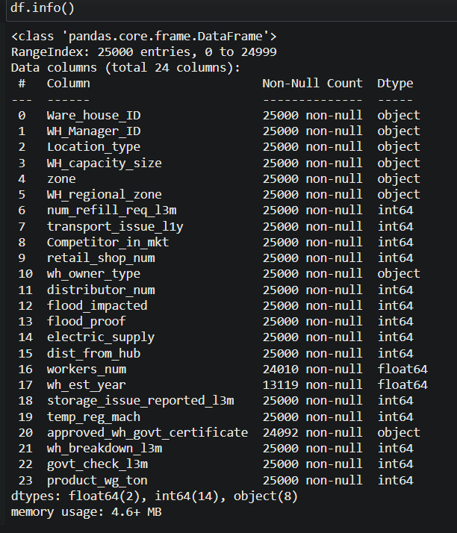

TABLE NO1: VISUALISATION OF DATA

10

**DATA TREATMENT**

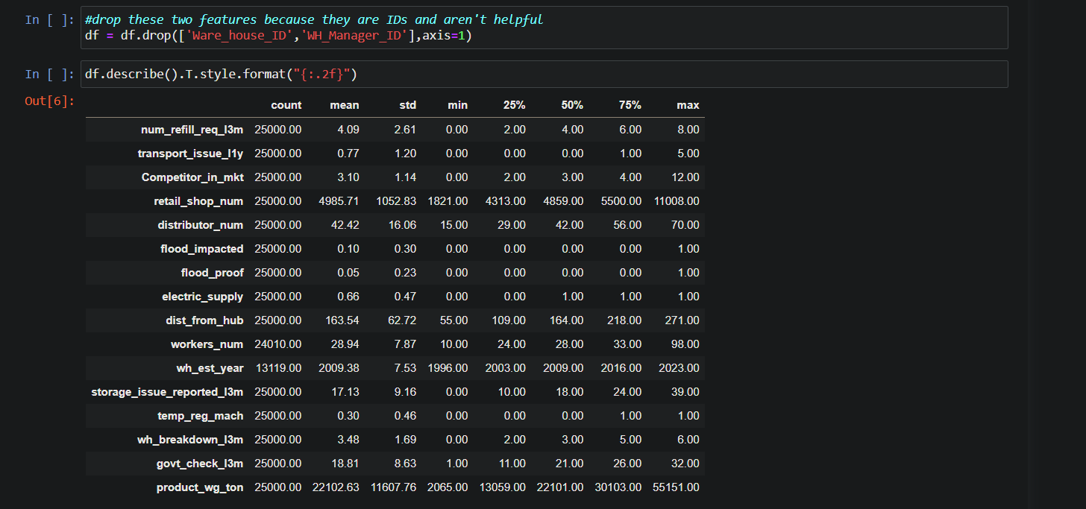**NULL VALUE TREATMENT**: We have also found null values in the different variables of data. Some variables are also having special characters in the data, which are treated like Tenure is having these different unique values in data.

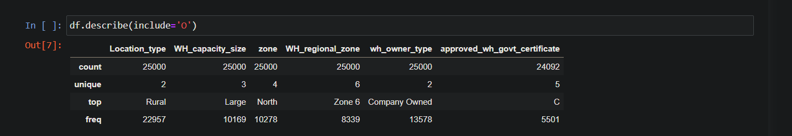

11

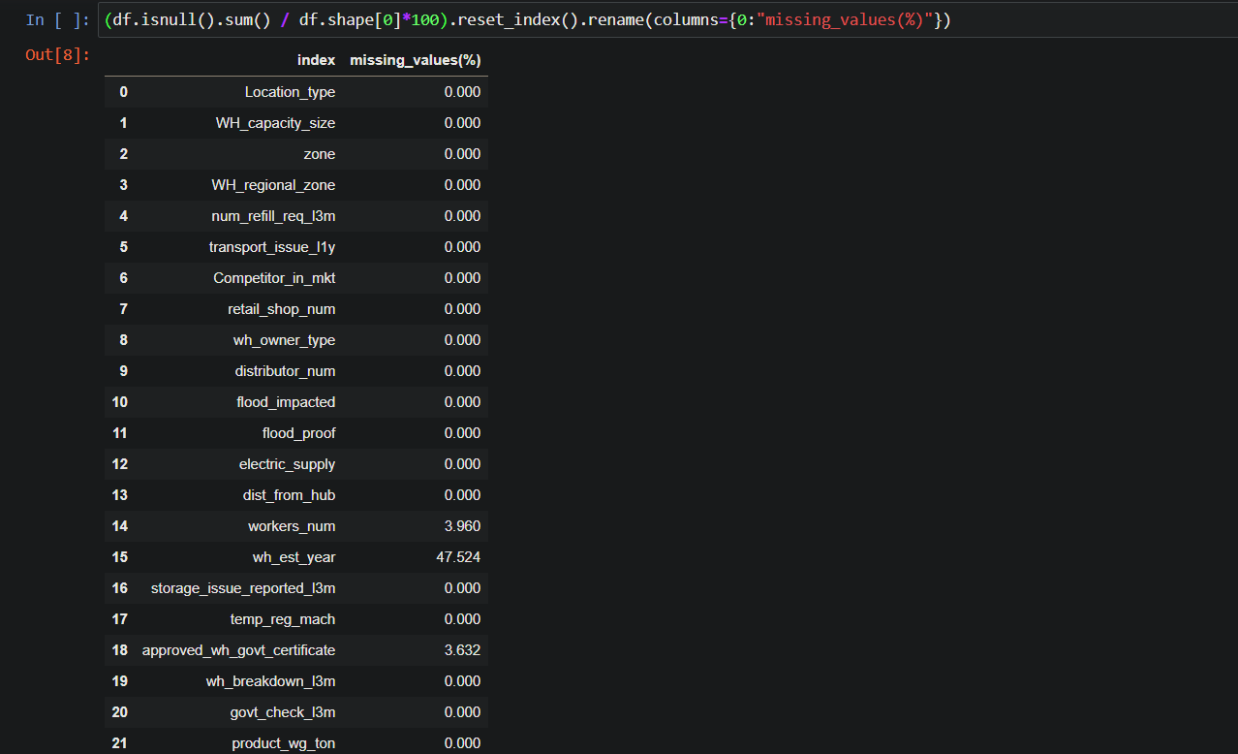

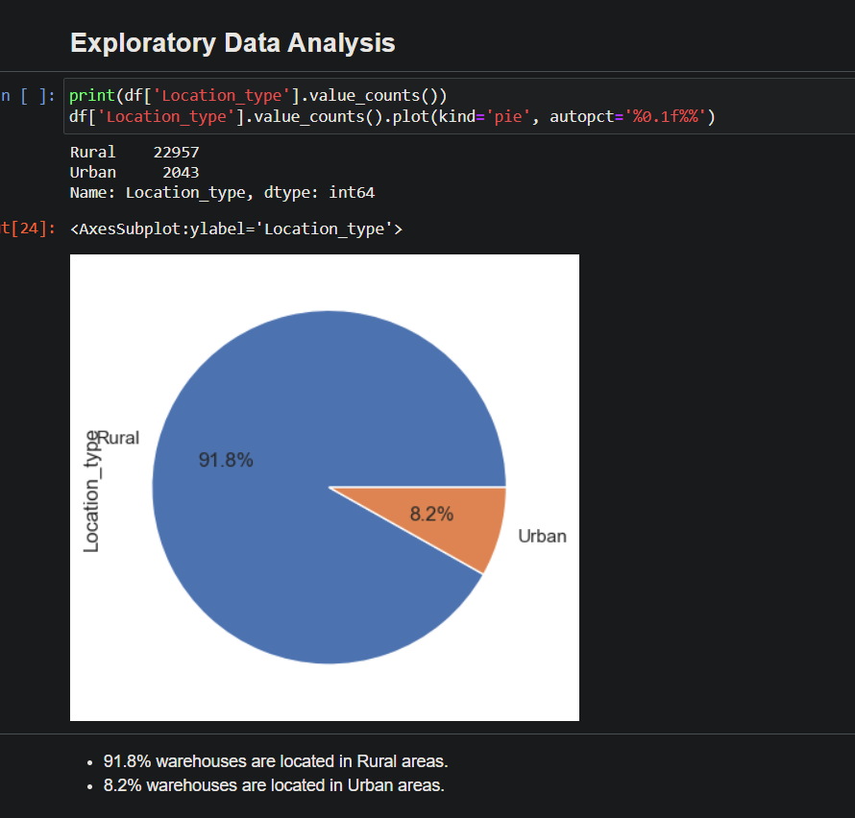 **12**

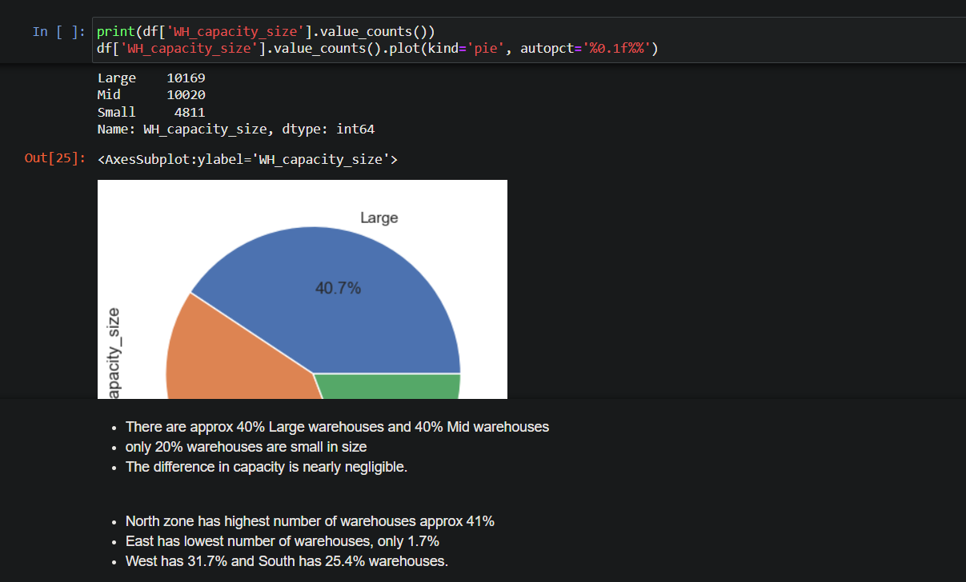

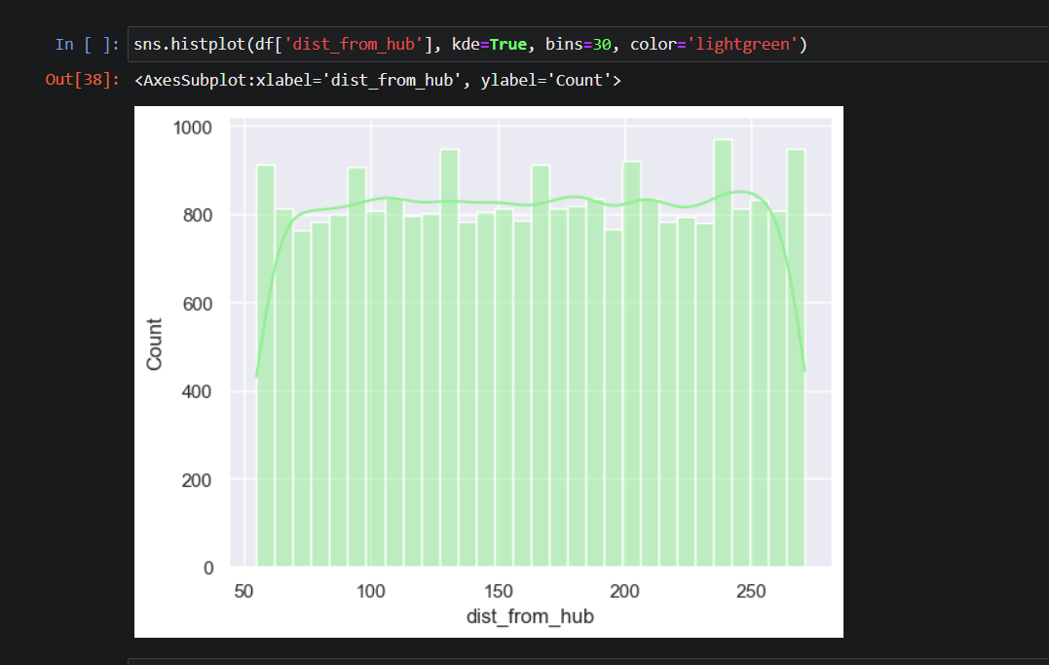

**13**

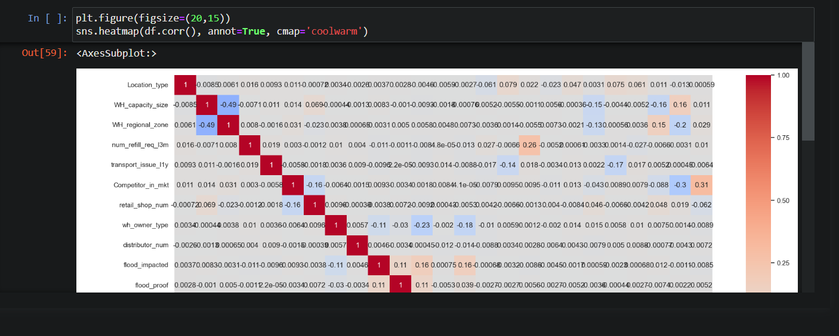

**14**