DOCKER VERSION

LIST ALL DOCKER IMAGES

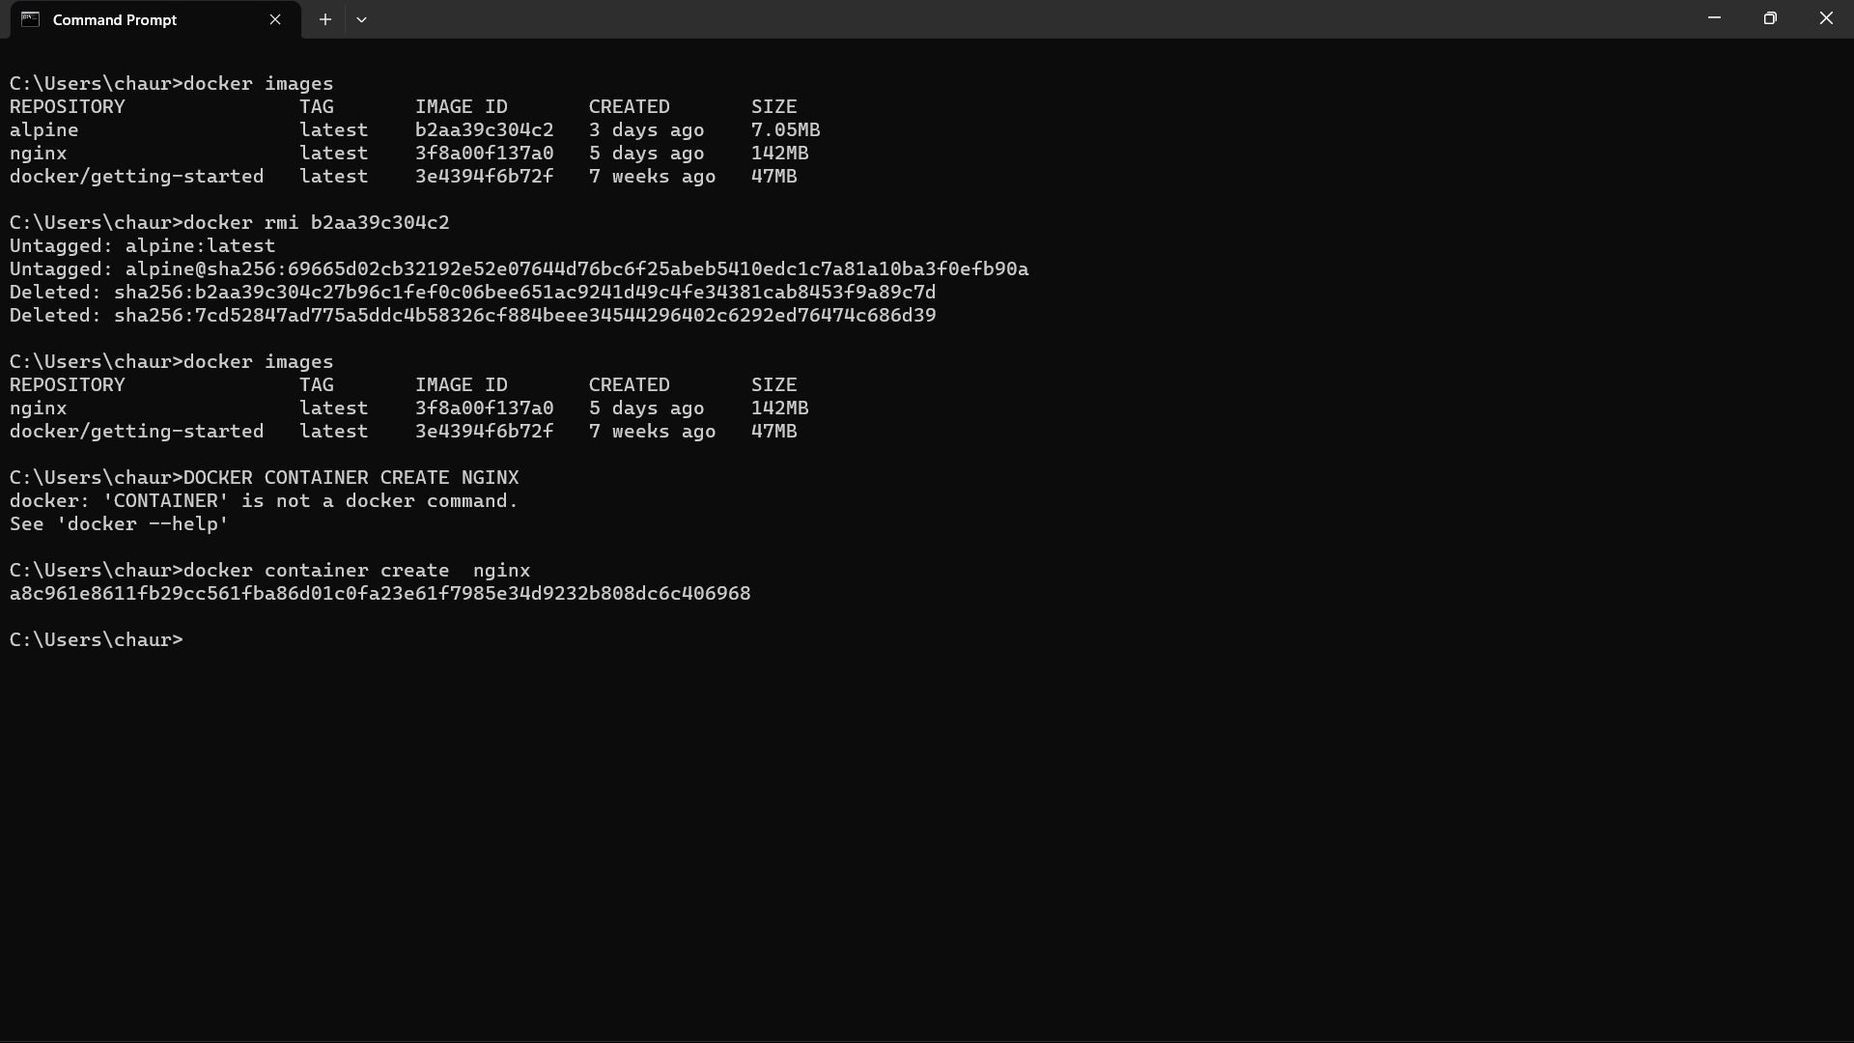

DOCKER CREATE CONTAINER

LIST ALL STOPPED CONTAINERS

REMOVE AN IMAGE FROM SYSTEM

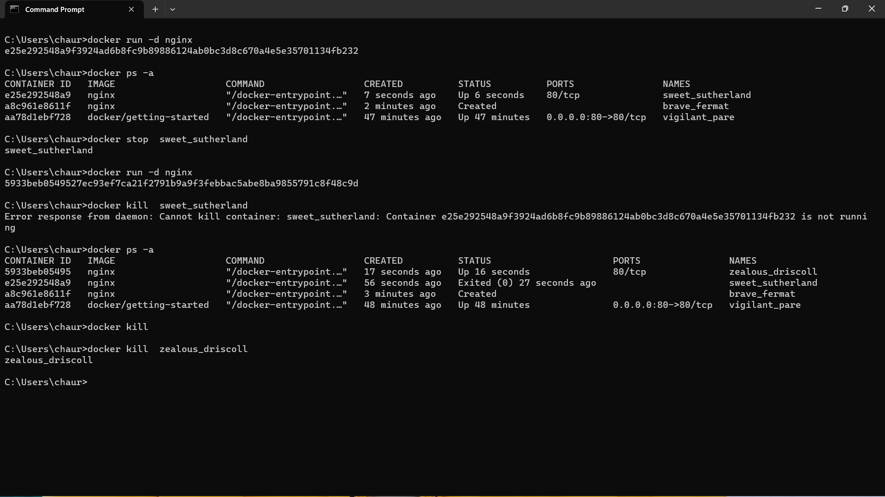

KILL AND STOP

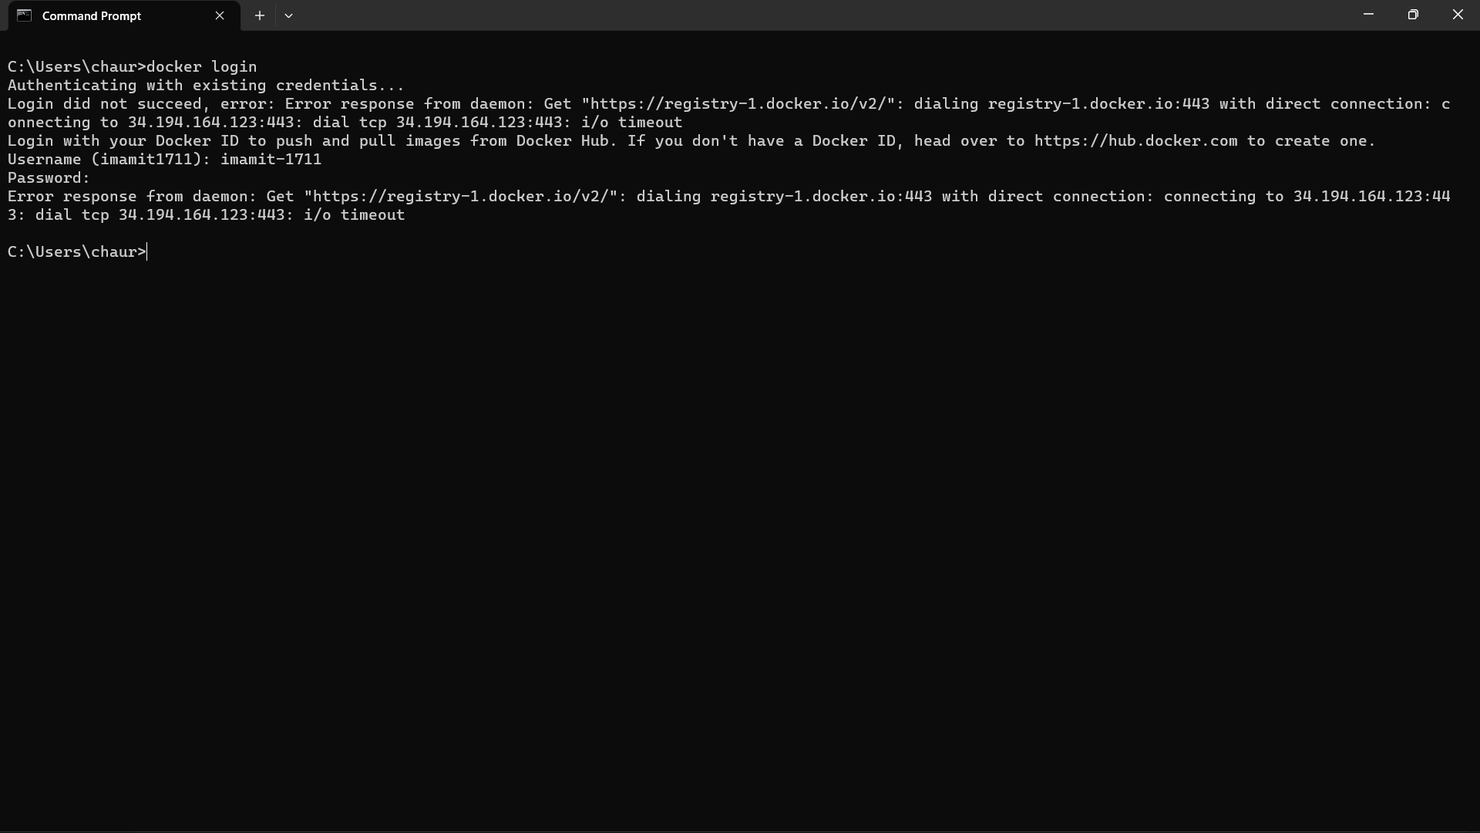

LOGIN

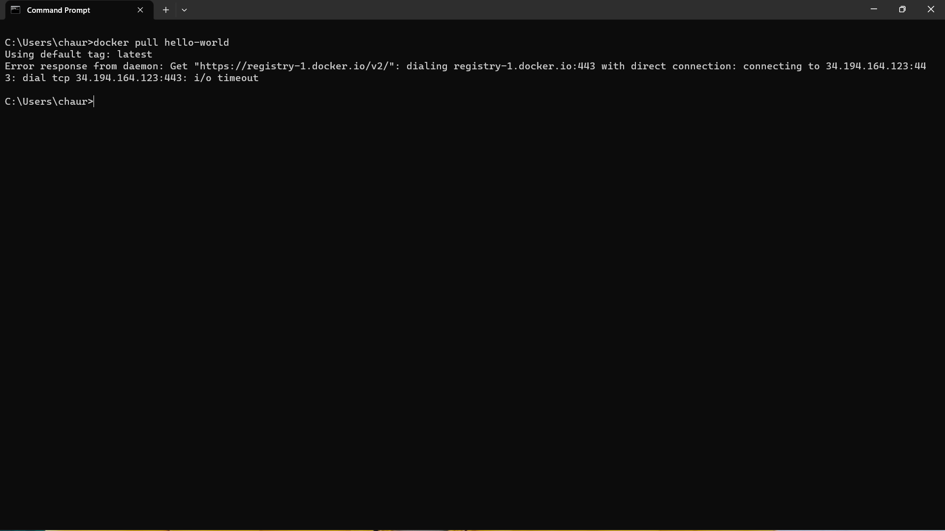

PULL IMAGE