

**DAYANANDA SAGAR COLLEGE OF ENGINEERING**

*(An Autonomous Institute Affiliated to VTU, Belagavi)*

ShavigeMalleshwara Hills, Kumaraswamy Layout, Bengaluru-560078

**Introduction to Python Programming**

**CS45**

**AAT-2**

(Mini Project)

“Question Paper Generator”

Submitted in partial fulfillment of the requirement for the award of the degree of

**Bachelor of Engineering**

in

**Computer Science & Engineering**

Submitted by

|  |  |  |
| --- | --- | --- |
| **Name** | **USN** | **Class** |
| Amit Kumar Gupta | **1DS16CS704** | IV D |

Submitted to

**Mr. ANIL SAGAR**

**Asst. Professor, CSE, DSCE**

**Contents**

Introduction 3

Pre Requisites and Resources used 4

Implementation(Code) 5

Application Software 15

Applications 18

Conclusion 19

Bibliography 20

# **Introduction**

In this project we are making a ’Question Paper Generator’ which will take various parameters as inputs like Question paper code, course code, maximum marks, exam name, date and duration etc. and based on the inputs it will generate a question paper in PDF format.

We are generating two file formats which we have named as QPP and QPD, respectively.QPP stores all the Question paper attributes like question name, exam date, duration, time, and QPD stores all the actual data of the Question paper like Question and allotted marks. QPD actually works like a Question bank from which we can select question paper according to our choice.

# 

# **Pre Requisites and Resources used**

Py Charm for programming.

PyQt for GUI design.

JSON for the question paper format.

Libraries used: PyQt5

Reportlab to generate PDF

Created object oriented GUI classes

Used qt designer to design GUI

Used pyuic5 to generate ui code

**Reason for using libraries:**

We have used PyQt5 which is a python implementation of the Qt library for C++. We have used this library for it's vast arsenal of GUI tools and widgets which is not provided by tkinter. The Qt library also has a lot of online support, which was invaluable to create this project.

|  |  |
| --- | --- |
| ]\ |  |

**Application** **Software**

asdf asdfasdf

asdfasdfas

df

Welcome Page: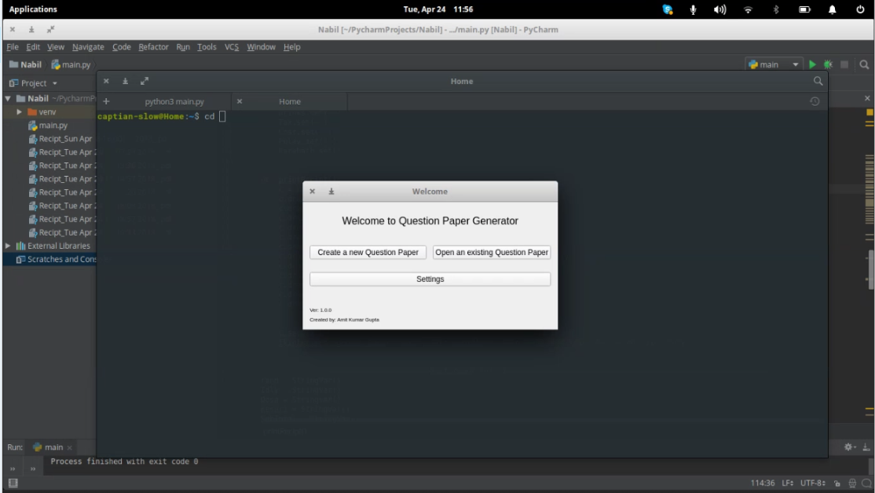

Create New Page: 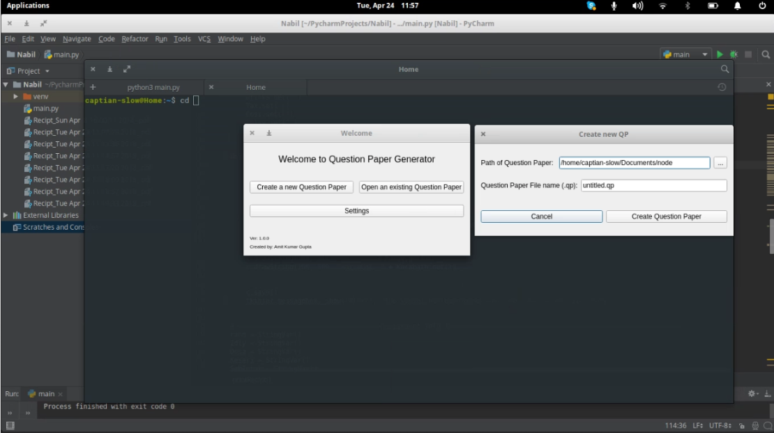

Open Page: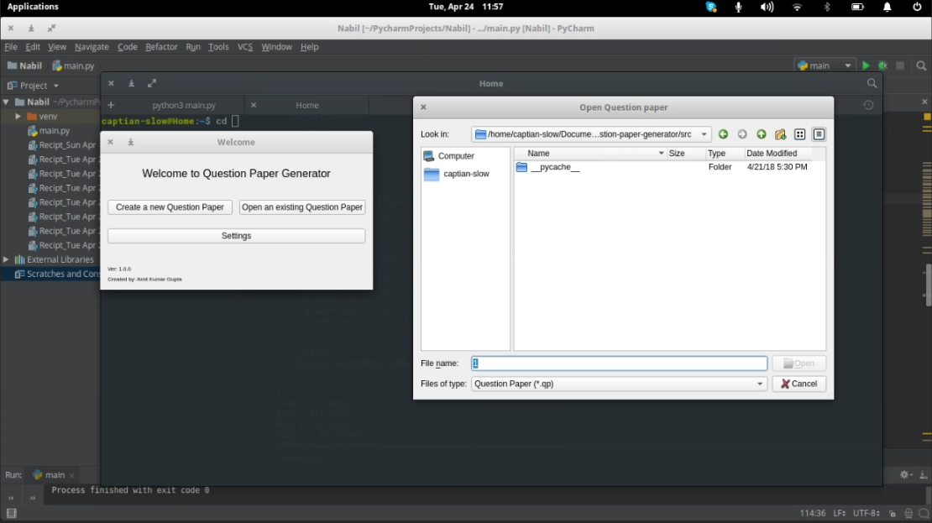

Creating a Paper: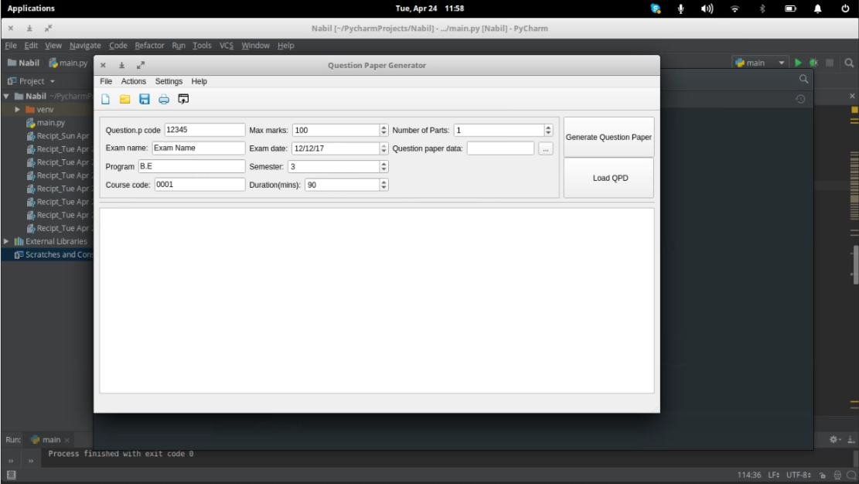

Importing from .qb file: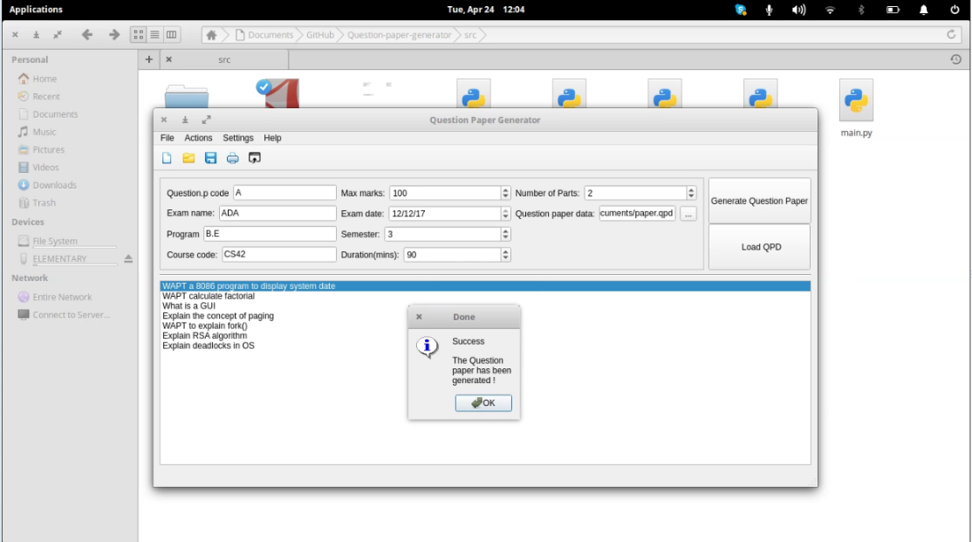

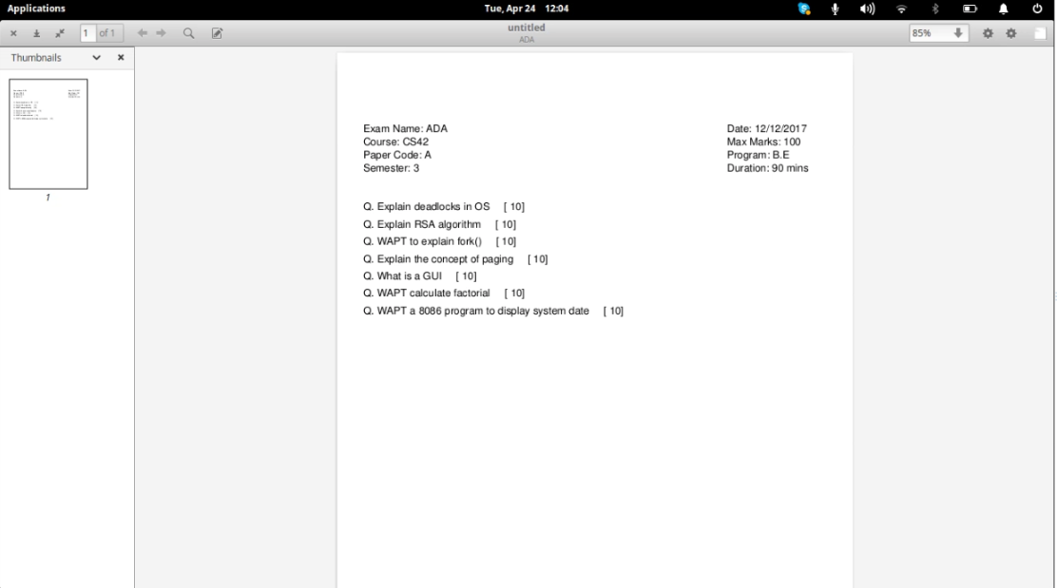Question paper final(.pdf):

# **Applications**

This can be used to generate Question paper for school, colleges, and other educational institution.

The question paper generated is in the PDF format so it is very convenient for transfer across different platforms.

# **Conclusion**

Therefore, we have completed out project of the question paper generator, and we hope to continue to add features to it.

# **Bibliography**

qt.io

wikipedia.com

python.org