CONTAINERIZATION & ORCHESTRATION PROJECT
Task 3 — Containerization and Orchestration Report
Student | Amit Mohanty
Roll No. | 2301730325
Task | Task 3 — Containerization and Orchestration Report (10 marks)
Environment | Docker Desktop Kubernetes (kind provisioner, single node), MINGW64 / Git Bash terminal in VS Code
Application | Sample Flask application, containerized as flask-app:1.0 / flask-app:2.0
1. Objective
This report describes the architecture used to containerize and orchestrate the sample Flask application, the deployment strategy followed to run it on Kubernetes, the results of scaling and updating that deployment, and observations drawn from the exercise. It consolidates the containerization work (Docker) with its orchestration on Docker Desktop's built-in Kubernetes cluster.
2. Architecture
The application moves from a single Dockerfile to a running, orchestrated deployment in four stages: local image build, image transfer into the cluster node, scheduling by Kubernetes, and external access through a Service. Because Docker Desktop's Kubernetes node (kind provisioner) keeps its own containerd image store separate from the local Docker image cache, a locally built image is not automatically visible to the cluster — it must be explicitly exported and imported into the node before Kubernetes can run it with imagePullPolicy: Never.
Developer machine (Docker Desktop, Windows)
|
| docker build -t flask-app:1.0 .
v
Local Docker image store --------------------------+
| |
| docker save -o flask-app.tar flask-app:1.0 |
| docker cp flask-app.tar desktop-control-plane:/ |
| docker exec ... ctr images import |
v |
kind node containerd store (namespace k8s.io) <---+
|
| kubectl apply -f deployment.yaml
v
Kubernetes control-plane (desktop-control-plane, single node)
|-- Deployment: flask-app-deployment (3 replicas)
| |-- Pod: flask-app:1.0 (x3, imagePullPolicy: Never)
|
|-- Service: flask-app-service (type: LoadBalancer, port 5000)
|
v
Docker Desktop cloud-provider-kind
(auto-publishes LoadBalancer Services on localhost)
|
v
Client -- curl / browser --> http://localhost:5000
This architecture was chosen over a NodePort Service because Docker Desktop's kind-based cluster only auto-publishes the API server port to localhost by default; its cloud-provider-kind component, however, automatically publishes any LoadBalancer-type Service on localhost, making it the simpler choice for local access on this environment.
3. Deployment Strategy
The application was deployed as a Kubernetes Deployment (3 replicas) exposed via a LoadBalancer Service, both defined in a single manifest:
apiVersion: apps/v1
kind: Deployment
metadata:
name: flask-app-deployment
spec:
replicas: 3
selector:
matchLabels:
app: flask-app
template:
metadata:
labels:
app: flask-app
spec:
containers:
- name: flask-app
image: flask-app:1.0
imagePullPolicy: Never
ports:
- containerPort: 5000
---
apiVersion: v1
kind: Service
metadata:
name: flask-app-service
spec:
selector:
app: flask-app
type: LoadBalancer
ports:
- port: 5000
targetPort: 5000
Before applying the manifest, the cluster's single node was confirmed ready, and the image was exported from the local Docker cache and imported directly into the node's containerd store:
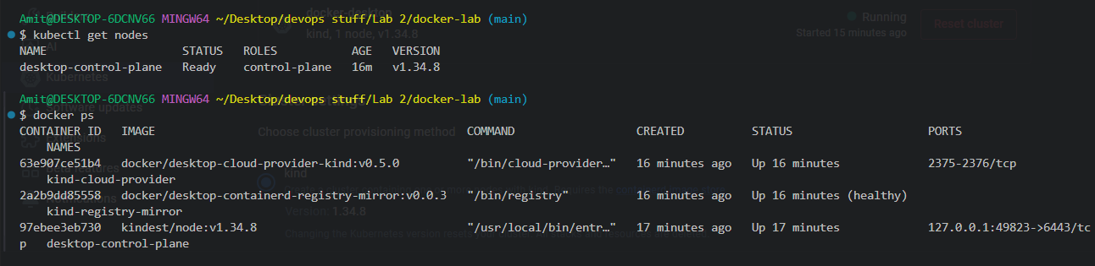
Evidence 1: The desktop-control-plane node Ready, running Kubernetes v1.34.8, confirmed before deploying.
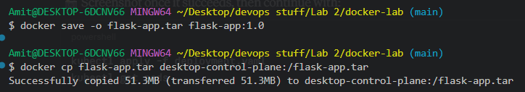
Evidence 2: flask-app:1.0 saved to a tar archive and copied into the desktop-control-plane node container.
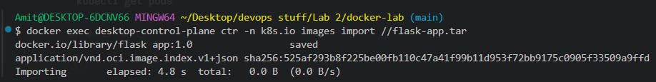
Evidence 3: The image imported directly into the node's containerd store under the k8s.io namespace, making it available to the kubelet.
With the image available on the node, the manifest was applied and the Pods came up successfully:
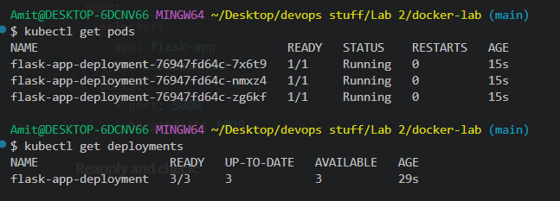
Evidence 4: All 3 replicas of flask-app-deployment reached Running status, with the Deployment showing 3/3 ready.
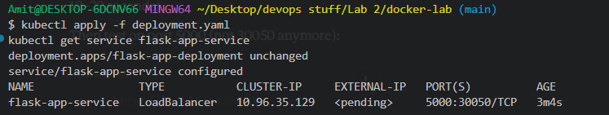
Evidence 5: flask-app-service configured as type LoadBalancer on port 5000.
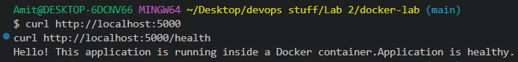
Evidence 6: Both application routes (/ and /health) responded correctly through the LoadBalancer Service, confirming the deployment was fully reachable.
4. Scaling Results
The deployment was scaled from 3 to 5 replicas using an imperative kubectl command, without changing the manifest:
kubectl scale deployment flask-app-deployment --replicas=5
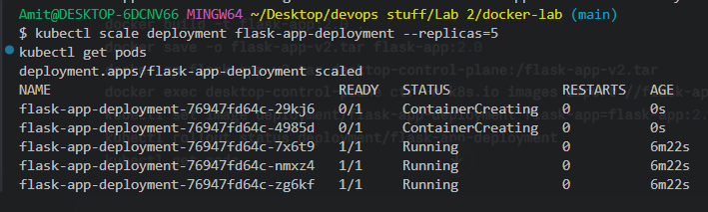
Evidence 7: kubectl scale reported the deployment scaled; kubectl get pods showed 5 Pods total — the original 3 already Running, and 2 new ones in ContainerCreating — confirming Kubernetes added replicas on demand.
5. Rolling Update and Rollback
A new image tag, flask-app:2.0, was built and imported into the node the same way as the base image, and the Deployment's container image was updated with kubectl set image:
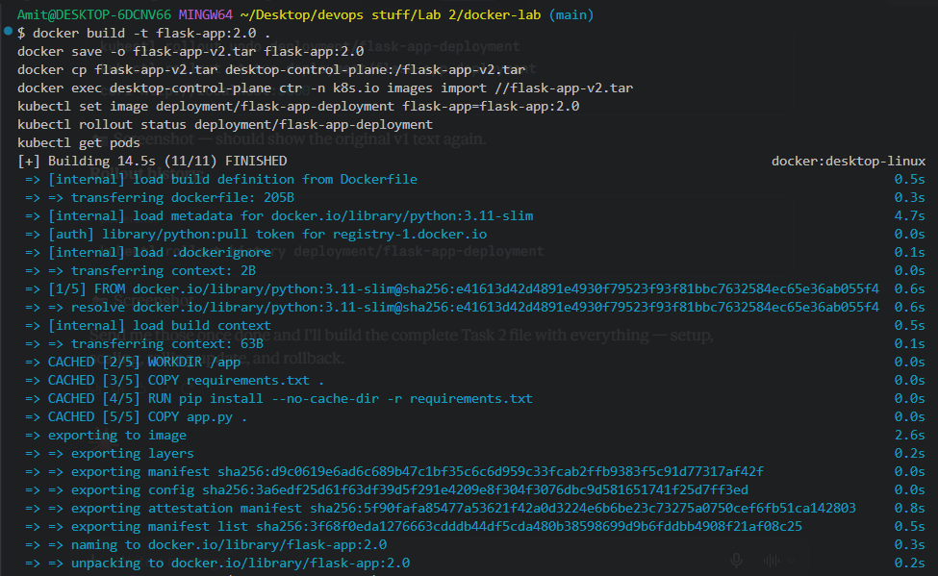
Evidence 8: flask-app:2.0 built successfully from the same Dockerfile and application code.
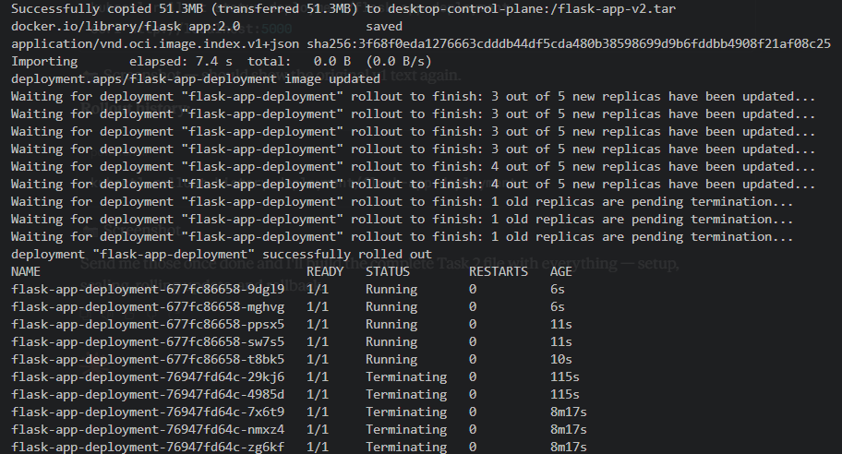
Evidence 9: kubectl rollout status shows Pods replaced incrementally (old ReplicaSet Pods Terminating as new ReplicaSet Pods come up Running) rather than all at once, and reports the deployment successfully rolled out.
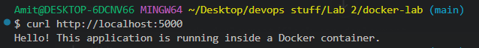
Evidence 10: The service continued responding without interruption throughout the update, confirming zero-downtime rollout.
The deployment was then rolled back to its previous revision:
kubectl rollout undo deployment/flask-app-deployment
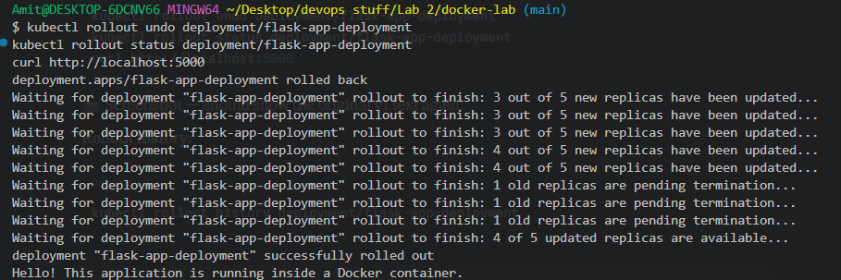
Evidence 11: kubectl rollout undo triggered a new rollout back to the prior pod template, again replacing Pods incrementally until reported successfully rolled out, with the app continuing to respond correctly afterward.
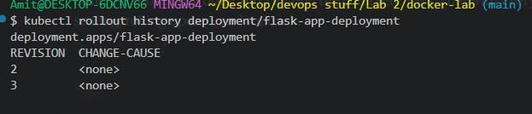
Evidence 12: kubectl rollout history lists revisions 2 (the flask-app:2.0 update) and 3 (the rollback) as distinct, tracked, reversible revisions.
6. Observations
- Docker Desktop's kind-based Kubernetes node keeps its own containerd image store, so locally built images had to be explicitly exported and imported into the node before they could be used with imagePullPolicy: Never.
- A LoadBalancer-type Service, not NodePort, was required to get a localhost-reachable endpoint on this cluster, since Docker Desktop's cloud-provider-kind component only auto-publishes LoadBalancer services.
- kubectl scale deployment --replicas=5 added new Pods on demand, growing the deployment from 3/3 to 5/5 ready without redefining the Deployment itself.
- kubectl set image triggered a rolling update: Pods were replaced incrementally (a few new Pods created while a few old ones terminated at a time) rather than all being replaced simultaneously, keeping the service available throughout.
- kubectl rollout undo reverted the deployment to its previous pod template using the same incremental, zero-downtime rollout mechanism, and kubectl rollout history confirmed both the update and the rollback were recorded as separate, distinct revisions.
- Because the Deployment and Service were defined in one manifest, a single kubectl apply -f deployment.yaml call created or updated both resources together.
7. Conclusion
Task 3 was completed successfully. The containerization and orchestration architecture — from a locally built Docker image, through its transfer into the Kubernetes node, to a running Deployment exposed via a LoadBalancer Service — was documented end-to-end. The deployment strategy, scaling to 5 replicas, a zero-downtime rolling update to flask-app:2.0, and a rollback to the previous revision were all demonstrated and verified with kubectl output and direct application checks, confirming Kubernetes managed each change as an incremental, trackable, and reversible operation.

