CONTAINERIZATION & ORCHESTRATION PROJECT
Task 8 — Configure Continuous Deployment
Student | Amit Mohanty
Roll No. | 2301730325
Task | Task 8 — Configure Continuous Deployment
Environment | Jenkins (Windows), driving kubectl against Docker Desktop Kubernetes (kind provisioner, single node); PowerShell terminal
Application | Sample Flask application, containerized as flask-app:1.0, deployed as a Deployment (3 replicas) + LoadBalancer Service
1. Objective
This task configures continuous deployment using Jenkins and Kubernetes, automating what had previously been manual kubectl and docker commands (Tasks 2 and 4) into a single repeatable pipeline. A Jenkins Pipeline job named kubernetes-continuous-deployment was built to build the Flask application image, apply the Kubernetes Deployment manifest, and verify the resulting rollout, Pods, and Service — all triggered by a single "Build Now" click.
2. Jenkins Pipeline Configuration
A new Pipeline job, kubernetes-continuous-deployment, was created in Jenkins with its Definition set to "Pipeline script". The script defines six sequential stages: verifying the cluster is reachable, building the application image, applying the Kubernetes manifest, verifying the rollout, verifying the Pods, and verifying the Service.
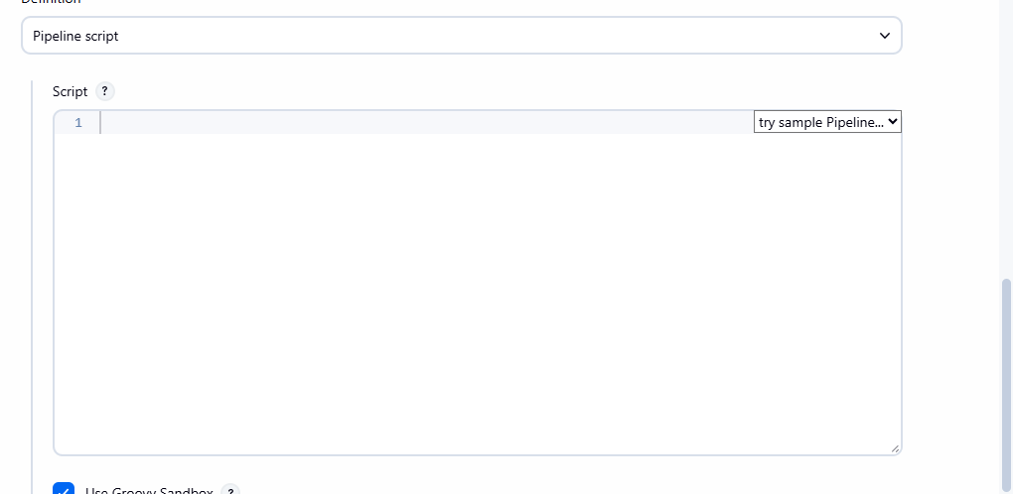
Evidence 1: The Pipeline job's Definition set to "Pipeline script", with the script editor ready for the stages below.
The pipeline script used:
pipeline {
agent any
environment {
KUBECONFIG = 'C:\\Users\\Amit\\.kube\\config'
}
stages {
stage('Verify Kubernetes') {
steps {
bat '"C:/Program Files/Docker/Docker/resources/bin/kubectl.exe" get nodes'
}
}
stage('Build Image') {
steps {
dir('C:/Users/Amit/Desktop/devops stuff/Lab 2/docker-lab/app') {
bat 'docker build -t flask-app:1.0 .'
}
}
}
stage('Deploy Application') {
steps {
dir('C:/Users/Amit/Desktop/devops stuff/Lab 2/docker-lab/k8s') {
bat '"C:/Program Files/Docker/Docker/resources/bin/kubectl.exe" apply -f deployment.yaml'
}
}
}
stage('Verify Deployment') {
steps {
bat '"C:/Program Files/Docker/Docker/resources/bin/kubectl.exe" rollout status deployment/flask-app-deployment'
}
}
stage('Verify Pods') {
steps {
bat '"C:/Program Files/Docker/Docker/resources/bin/kubectl.exe" get pods -o wide'
}
}
stage('Verify Service') {
steps {
bat '"C:/Program Files/Docker/Docker/resources/bin/kubectl.exe" get service flask-app-service'
}
}
}
}
3. Initial Build Failure — Missing Kubeconfig
The first build (#1) failed at the very first stage. The error returned by kubectl was not a Kubernetes error at all, but Jenkins' own login page HTML ("Authentication required", hudson.model.Hudson.Read). This happened because kubectl had no kubeconfig context available to the Jenkins service account, so it fell back to its legacy default address, https://localhost:8080 — which is the exact port Jenkins itself listens on. kubectl was therefore accidentally talking to Jenkins instead of the Kubernetes API server.
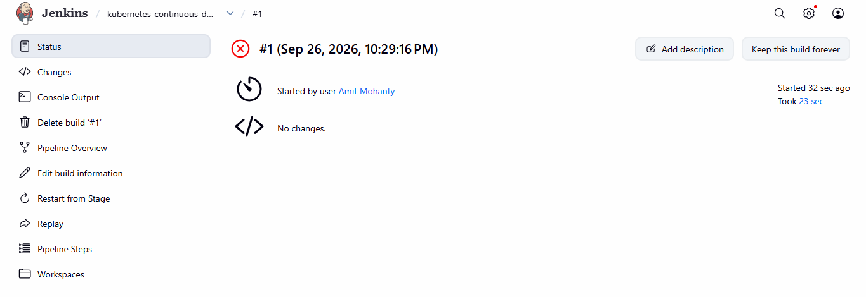
Evidence 2: Build #1 failed after 23 seconds. The Console Output traced the failure to kubectl silently defaulting to Jenkins' own port instead of the Kubernetes API server.
The fix was to explicitly point kubectl at the correct kubeconfig file for every stage, by adding an environment block to the top of the pipeline (KUBECONFIG = 'C:\Users\Amit\.kube\config'), as shown in the script in Section 2. This ensures every bat step in the pipeline uses the intended cluster configuration, regardless of which account Jenkins runs as.
4. Successful Build
With the KUBECONFIG fix applied, Build #2 completed successfully. All six stages executed in order: the node was verified Ready, the flask-app:1.0 image was rebuilt, the Kubernetes manifest was applied, the rollout was confirmed successful, the Pods were verified Running, and the Service was confirmed as type LoadBalancer.
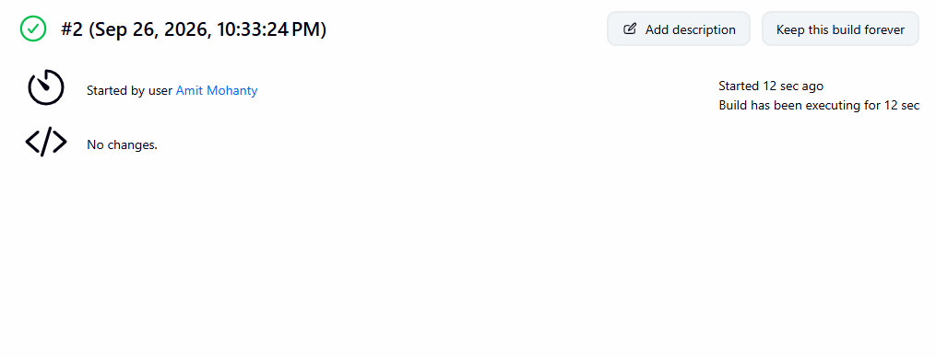
Evidence 3: Build #2 completed successfully, started by user Amit Mohanty, with no source changes since Build #1 — confirming the KUBECONFIG fix alone resolved the failure.
Console Output (Build #2) — key excerpts from each stage:
[Verify Kubernetes]
NAME STATUS ROLES AGE VERSION
desktop-control-plane Ready control-plane 3h4m v1.34.8
[Build Image]
... flask-app:1.0 built successfully (cached layers reused)
naming to docker.io/library/flask-app:1.0
[Deploy Application]
deployment.apps/flask-app-deployment configured
service/flask-app-service unchanged
[Verify Deployment]
deployment "flask-app-deployment" successfully rolled out
[Verify Pods]
NAME READY STATUS RESTARTS AGE
flask-app-deployment-76947fd64c-69x8p 1/1 Running 0 150m
flask-app-deployment-76947fd64c-ptgmm 1/1 Running 0 150m
flask-app-deployment-76947fd64c-xh9rt 1/1 Running 0 150m
[Verify Service]
NAME TYPE CLUSTER-IP EXTERNAL-IP PORT(S) AGE
flask-app-service LoadBalancer 10.96.35.129 172.20.0.5 5000:30050/TCP 160m
Finished: SUCCESS
5. Deployment Verification
The job's dashboard reflects the completed pipeline: a green status indicator, the Permalinks list (Last build, Last stable build, Last successful build), and the build history showing Build #1's failure alongside Build #2's success — evidence that the pipeline is now reliably repeatable.
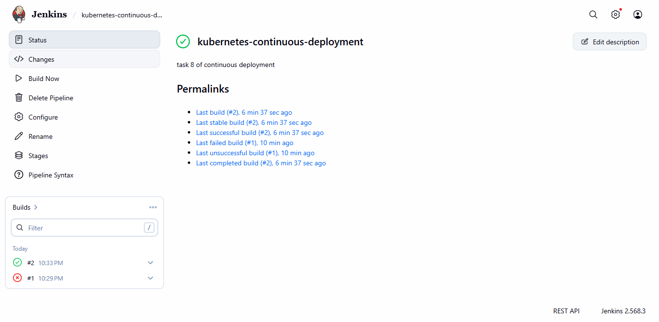
Evidence 4: The kubernetes-continuous-deployment job dashboard, showing Build #2 successful and Build #1 failed, with full Permalinks history.
Finally, the deployed application was confirmed reachable through the Service that Jenkins had just applied, by curling both of its routes directly:
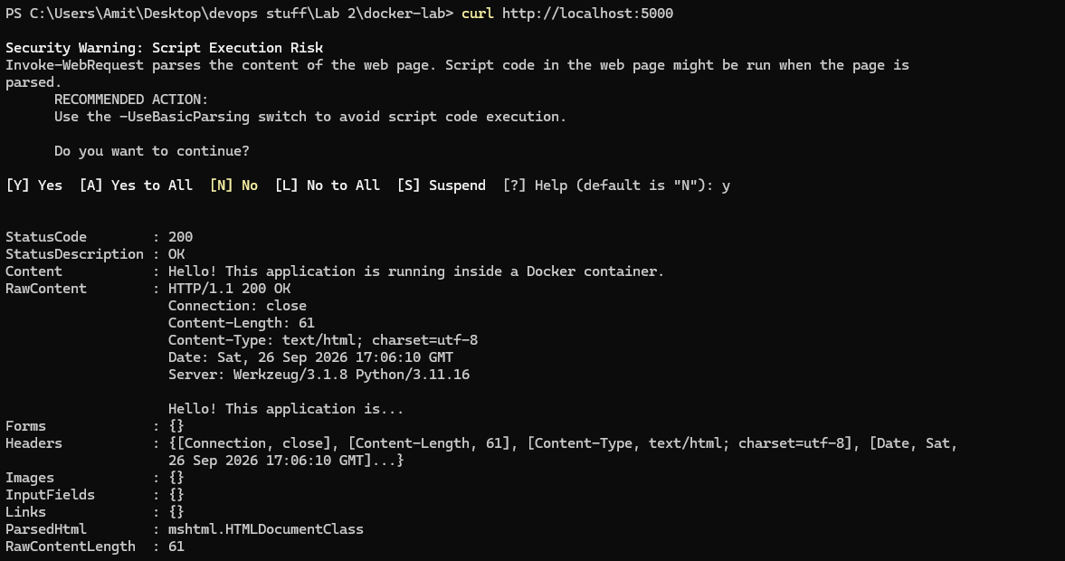
Evidence 5: curl http://localhost:5000 returned HTTP 200 with the expected greeting, confirming the pipeline-deployed Pods are serving live traffic.
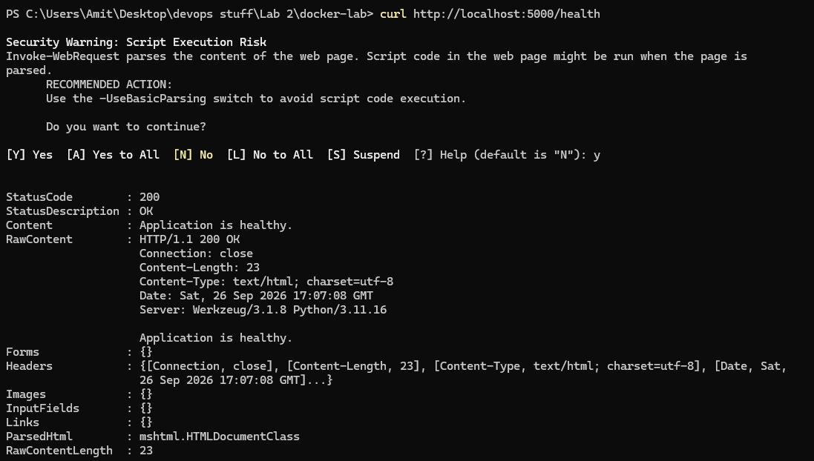
Evidence 6: curl http://localhost:5000/health returned HTTP 200 with "Application is healthy.", confirming the second route is also reachable through the Service.
6. Observations
- Jenkins runs under its own service account, separate from the interactive user's shell — a plain kubectl call without an explicit KUBECONFIG can silently fall back to a default address rather than failing loudly, which is what caused Build #1 to appear to hit an "authentication" error rather than a clear "cluster unreachable" one.
- Setting KUBECONFIG in the pipeline's environment block was sufficient to fix every kubectl-based stage at once, without needing to change each bat command individually.
- Because the Deployment already had a Service defined in the same manifest, one kubectl apply -f deployment.yaml call updated both resources in a single stage.
- Structuring the pipeline into distinct, named stages (Verify Kubernetes, Build Image, Deploy Application, Verify Deployment, Verify Pods, Verify Service) meant the Console Output pinpointed the failing stage immediately, rather than requiring the whole log to be read line by line.
- Verifying the deployment with a live curl request, not just kubectl get, confirmed the pipeline resulted in an actually reachable application, not just resources that reported as "created".
7. Conclusion
Task 8 was completed successfully. A Jenkins Pipeline was configured to automatically build the Flask application image, apply its Kubernetes Deployment and Service manifest, and verify the resulting rollout, Pods, and Service, all from a single "Build Now" trigger. An initial configuration issue — kubectl defaulting to the wrong endpoint under Jenkins' service account — was diagnosed from the Console Output and resolved by explicitly setting KUBECONFIG in the pipeline. The subsequent successful build, verified both through kubectl output and direct curl requests to the running application, confirms that continuous deployment is functioning end-to-end.

