Task 9 — Record All Tools & Documents
Student: Amit Mohanty | Roll No.: 2301730325
Practical Record
This document consolidates the tools, configuration files, commands, screenshots, and observations from the completed Docker and Kubernetes practical work.
Area | Tools / Documents Recorded
Docker | Docker Desktop, Docker CLI, Dockerfile, Docker Compose, Docker images, containers, volumes, networks
Application | Python, Flask, requirements.txt, application containers (flask-docker-app:1.0, flask-app:1.0 / 2.0)
Kubernetes | Docker Desktop Kubernetes (kind provisioner), kubectl, Deployment YAML, Service YAML, Flask app
CI/CD | Jenkins Pipeline, kubectl, Kubernetes Deployment and Service manifests
Environment | Windows PowerShell / Git Bash in VS Code, local Docker Desktop Kubernetes cluster
Recorded Practical Areas
Docker containerization and lifecycle management; Docker image tagging, Docker Hub push and Docker Compose; Docker storage (volumes and bind mounts); Docker networking; Kubernetes deployment, scaling, rolling update and rollback; and Jenkins-based continuous deployment.
Docker Task 1 — Containerize a Sample Application
A Flask application (app.py, requirements.txt) was containerized using a Dockerfile based on python:3.11-slim, exposing port 5000. The image was built, run as a container, and verified via the browser and container logs.
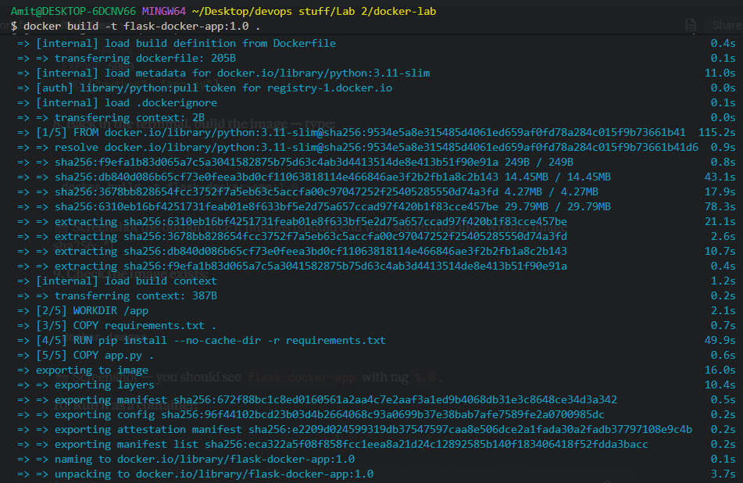
Evidence 1: docker build -t flask-docker-app:1.0 . — each Dockerfile instruction processed and the final image exported successfully.
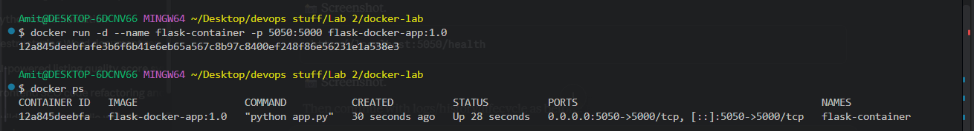
Evidence 2: docker ps confirming flask-container running, with port mapping 0.0.0.0:5050->5000/tcp.
The same Dockerfile and application were later rebuilt as flask-app:1.0 — the image subsequently deployed to Kubernetes — and re-verified through both of its routes:
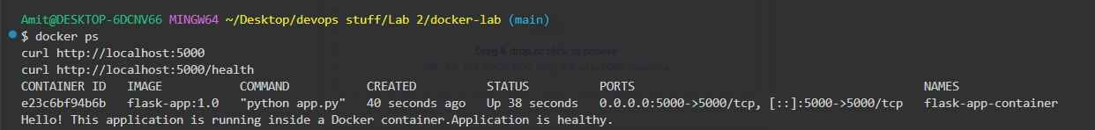
Evidence 3: docker ps and curl to both / and /health confirmed flask-app:1.0 serving correctly before its Kubernetes deployment.
Docker Task 2 — Containers, Images & Compose
This task covered container/image listing, tagging and pushing an image to Docker Hub, and using Docker Compose to run a multi-container setup (a Flask web service alongside a Redis service).
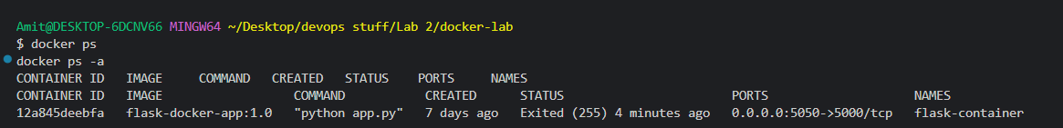
Evidence 1: docker ps and docker ps -a listing running and stopped containers.
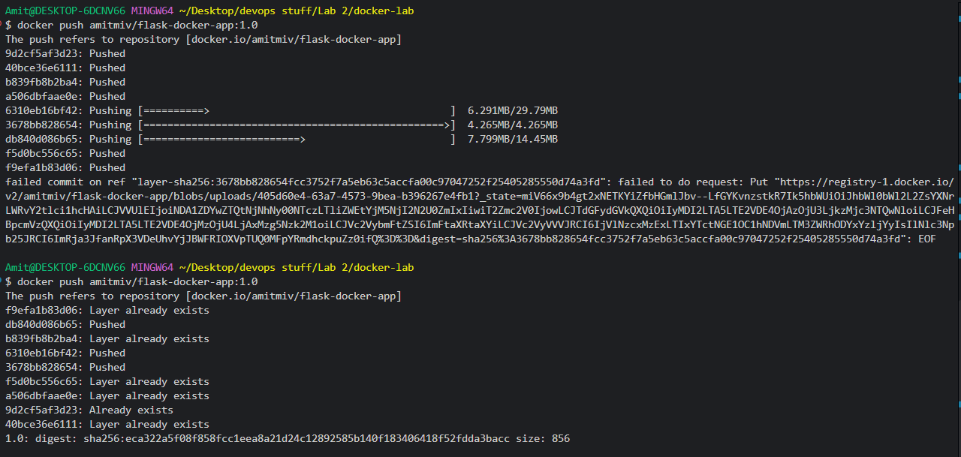
Evidence 2: docker push amitmiv/flask-docker-app:1.0 completing successfully to Docker Hub, with a digest confirmation.
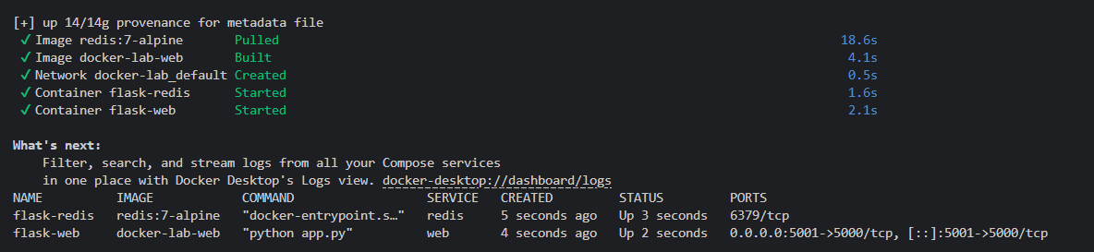
Evidence 3: docker compose up -d — redis:7-alpine pulled, docker-lab-web built, and both flask-redis and flask-web confirmed running via docker compose ps.
Docker Task 3 — Docker Storage: Volumes and Bind Mounts
This task demonstrated that a container's writable layer does not survive removal, and that named volumes and bind mounts both persist data independently of any single container's lifecycle.
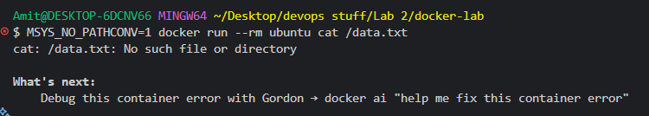
Evidence 1: After the storage-test container was removed, a fresh container reported the file missing — confirming the container's writable layer is ephemeral.
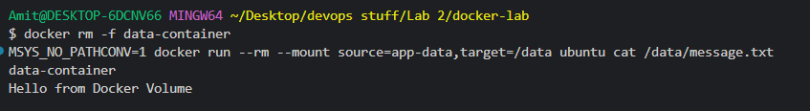
Evidence 2: A fresh container mounting the app-data named volume successfully read back data written by a previous, now-removed container.
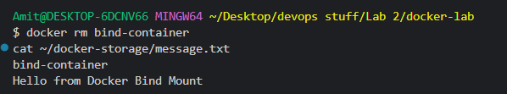
Evidence 3: Data written via a bind mount remained readable directly from the host filesystem (~/docker-storage), independent of Docker.
Docker Task 4 — Docker Network
A user-defined bridge network (task4-network) was created, and two containers attached to it were shown to communicate both by container name (via Docker's built-in DNS) and by raw IP address.
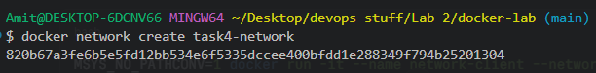
Evidence 1: docker network create task4-network completed successfully, returning its network ID.
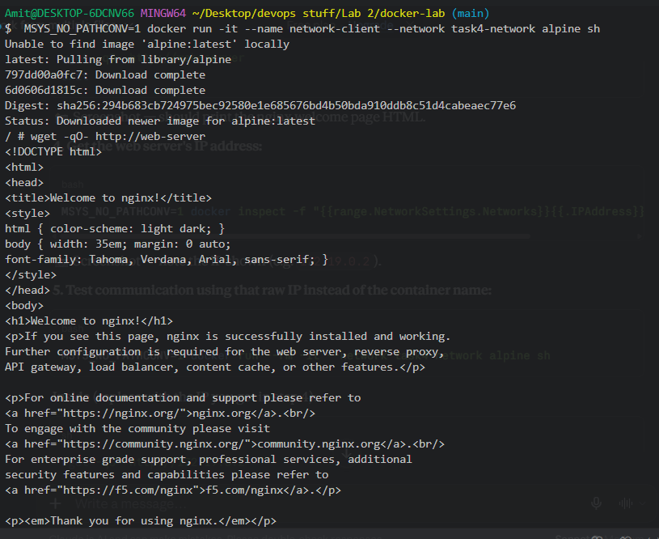
Evidence 2: wget -qO- http://web-server from a second container returned the nginx welcome page, confirming name-based resolution.
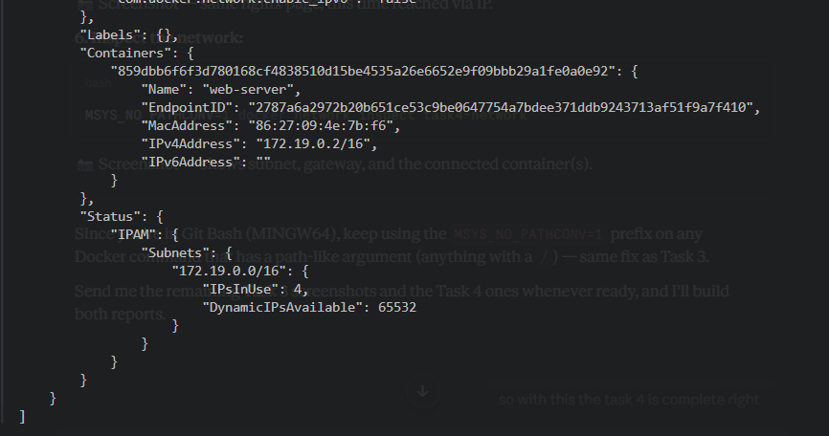
Evidence 3: docker network inspect task4-network showing the bridge driver, subnet 172.19.0.0/16, gateway, and the connected web-server container.
Kubernetes — Deployment, Scaling, Rolling Update & Rollback
The containerized Flask application (flask-app:1.0) was deployed to Docker Desktop's built-in Kubernetes cluster (kind provisioner) using a Deployment (3 replicas) and a LoadBalancer Service. Scaling, a rolling update to flask-app:2.0, and a rollback to the previous revision were then demonstrated.
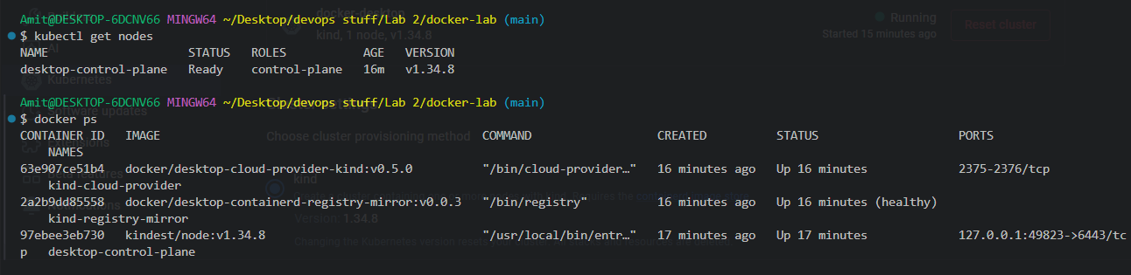
Evidence 1: The desktop-control-plane node Ready, running Kubernetes v1.34.8, confirmed before deploying.
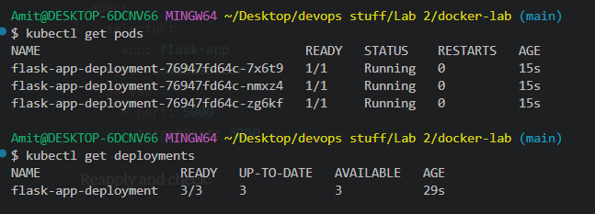
Evidence 2: All 3 replicas of flask-app-deployment reached Running status, with the Deployment showing 3/3 ready.
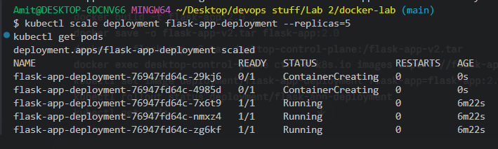
Evidence 3: kubectl scale deployment flask-app-deployment --replicas=5 — Kubernetes added 2 new Pods on demand, growing the deployment to 5 replicas.
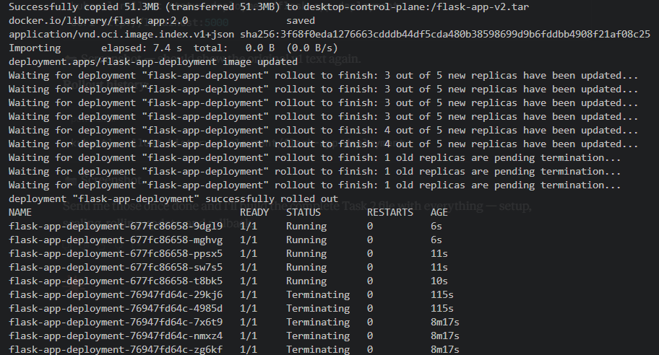
Evidence 4: kubectl rollout status showing Pods replaced incrementally during the update to flask-app:2.0, reporting the deployment successfully rolled out.
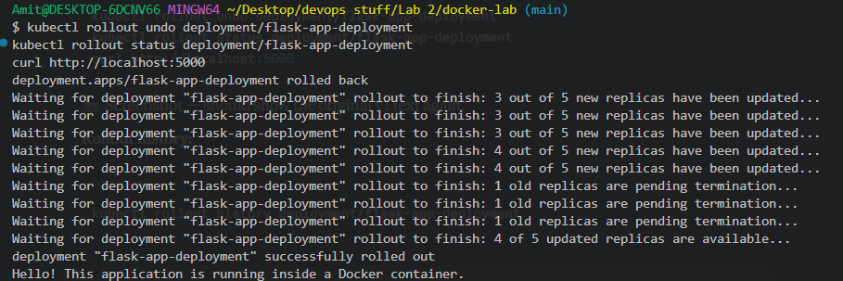
Evidence 5: kubectl rollout undo triggering a new rollout back to the prior pod template, again completed successfully with the app continuing to respond.
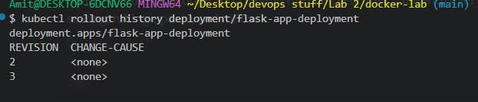
Evidence 6: kubectl rollout history listing revisions 2 (the flask-app:2.0 update) and 3 (the rollback) as distinct, tracked revisions.
Task 8 — Continuous Deployment (Jenkins)
A Jenkins Pipeline named kubernetes-continuous-deployment was configured to build the Flask image, apply the Kubernetes Deployment/Service manifest, and verify the resulting rollout, Pods and Service — all triggered from a single "Build Now" click.
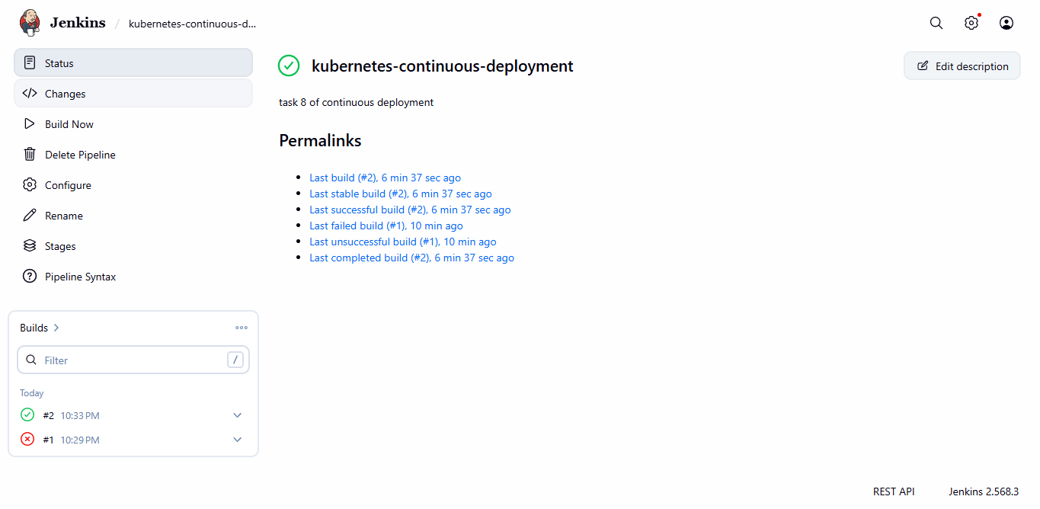
Evidence 1: The kubernetes-continuous-deployment job dashboard, showing Build #2 successful and full Permalinks history.
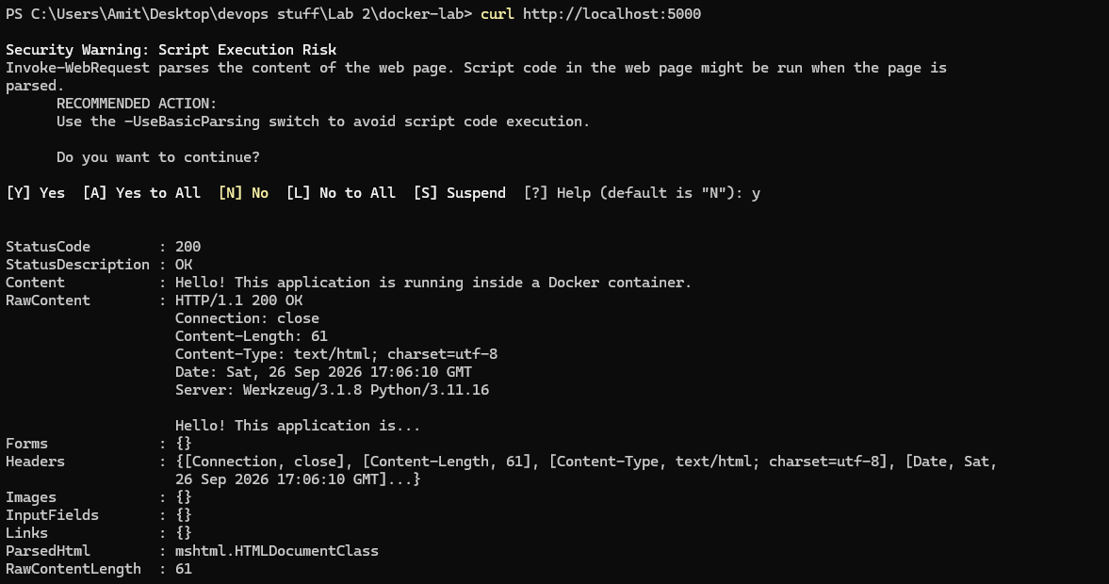
Evidence 2: curl http://localhost:5000 returned HTTP 200, confirming the pipeline-deployed Pods were reachable through the Service.
Commands & Configuration Record
Important commands recorded across the practical work:
Docker
docker build -t flask-docker-app:1.0 .
docker build -t flask-app:1.0 .
docker run -d --name flask-container -p 5050:5000 flask-docker-app:1.0
docker ps / docker ps -a
docker stop flask-container / docker start flask-container
docker logs flask-container
docker history flask-docker-app:1.0
docker tag flask-docker-app:1.0 amitmiv/flask-docker-app:1.0
docker push amitmiv/flask-docker-app:1.0
docker compose config / docker compose up -d / docker compose ps
docker volume create app-data
docker run --mount source=app-data,target=/data ...
docker run --mount type=bind,source="$HOME/docker-storage",target=/data ...
docker network create task4-network
docker network inspect task4-network
Kubernetes
kubectl get nodes
kubectl apply -f deployment.yaml
kubectl get pods / kubectl get deployments
kubectl get service flask-app-service
kubectl scale deployment flask-app-deployment --replicas=5
kubectl set image deployment/flask-app-deployment flask-app=flask-app:2.0
kubectl rollout status deployment/flask-app-deployment
kubectl rollout undo deployment/flask-app-deployment
kubectl rollout history deployment/flask-app-deployment
Jenkins
bat 'kubectl get nodes'
bat 'docker build -t flask-app:1.0 .'
bat 'kubectl apply -f deployment.yaml'
bat 'kubectl rollout status deployment/flask-app-deployment'
bat 'kubectl get pods -o wide'
bat 'kubectl get service flask-app-service'
Final Record
The practical record contains the Docker and Kubernetes configuration documents, command history, deployment evidence, storage and networking experiments, scaling/rolling-update/rollback results, and the successful Jenkins continuous-deployment execution — together demonstrating a complete containerization-to-orchestration workflow, from a single Dockerfile through to an automated Kubernetes deployment pipeline.

