CONTAINERIZATION & ORCHESTRATION PROJECT
Task 2 — Implement Kubernetes Deployment
Student | Amit Mohanty
Roll No. | 2301730325
Task | Task 2 — Implement Kubernetes Deployment (5 marks)
Environment | Docker Desktop Kubernetes (kind provisioner, single node), MINGW64 / Git Bash terminal in VS Code
Application | Sample Flask application, containerized as flask-app:1.0 / flask-app:2.0

1. Objective
This task deploys the containerized Flask application to Kubernetes, using Docker Desktop's built-in single-node cluster (kind provisioner). It demonstrates three core Kubernetes deployment strategies: scaling the number of running replicas, performing a rolling update to a new image version with zero downtime, and rolling back a deployment to its previous, known-good revision.
2. Deployment and Service Definition
The application was deployed using a Deployment (3 replicas) and exposed via a Service. Since Docker Desktop's kind-based Kubernetes only auto-publishes the API server port to localhost, a LoadBalancer-type Service was used instead of NodePort, as Docker Desktop's cloud-provider-kind component automatically publishes LoadBalancer services on localhost:
apiVersion: apps/v1
kind: Deployment
metadata:
name: flask-app-deployment
spec:
replicas: 3
selector:
matchLabels:
app: flask-app
template:
metadata:
labels:
app: flask-app
spec:
containers:
- name: flask-app
image: flask-app:1.0
imagePullPolicy: Never
ports:
- containerPort: 5000
---
apiVersion: v1
kind: Service
metadata:
name: flask-app-service
spec:
selector:
app: flask-app
type: LoadBalancer
ports:
- port: 5000
targetPort: 5000
3. Cluster Setup and Image Availability
The single-node cluster was confirmed ready before deploying:
kubectl get nodes
docker ps
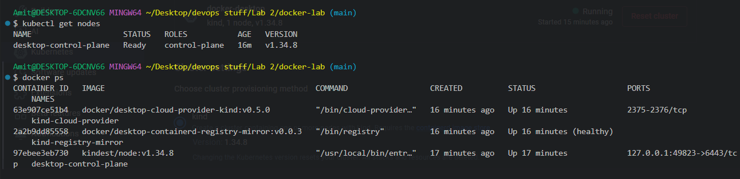
Evidence 1: The desktop-control-plane node is Ready, running Kubernetes v1.34.8. docker ps shows the kind node container alongside the cloud-provider-kind and containerd-registry-mirror helper containers Docker Desktop uses for this cluster.
Because the kind node runs its own containerd image store separate from the local Docker image cache, the flask-app:1.0 image had to be exported and imported directly into the node before the Deployment could start (imagePullPolicy: Never otherwise fails with ErrImageNeverPull):
docker save -o flask-app.tar flask-app:1.0
docker cp flask-app.tar desktop-control-plane:/flask-app.tar
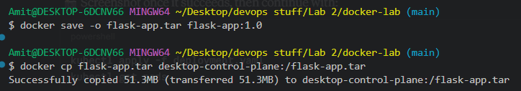
Evidence 2: The flask-app:1.0 image was saved to a tar archive and copied into the desktop-control-plane node container.
docker exec desktop-control-plane ctr -n k8s.io images import //flask-app.tar
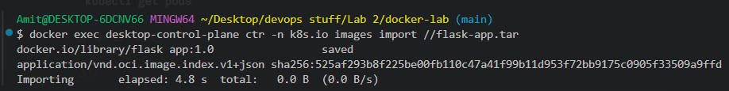
Evidence 3: The image was imported directly into the node's containerd store under the k8s.io namespace, making it available to the kubelet.
4. Applying the Deployment
With the image available on the node, the Deployment and Service were applied and the pods came up successfully:
kubectl get pods
kubectl get deployments
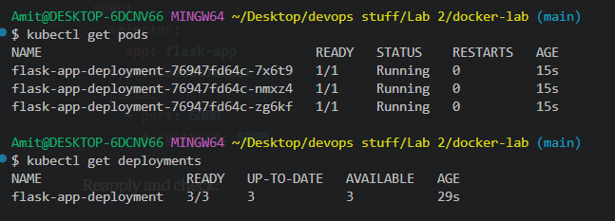
Evidence 4: All 3 replicas of flask-app-deployment reached Running status, and the Deployment shows 3/3 ready.
The Service was configured as LoadBalancer to get a localhost-reachable endpoint:
kubectl apply -f deployment.yaml
kubectl get service flask-app-service
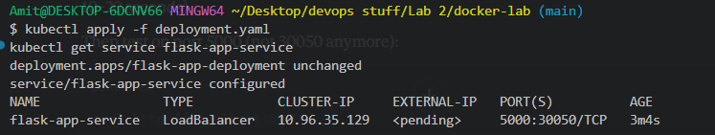
Evidence 5: flask-app-service is of type LoadBalancer on port 5000, with its EXTERNAL-IP shown as pending immediately after being configured.
Once the external IP resolved, the app was confirmed reachable:
curl http://localhost:5000
curl http://localhost:5000/health
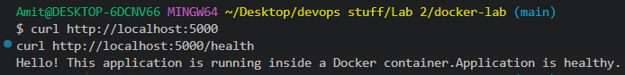
Evidence 6: Both routes responded correctly through the LoadBalancer service, confirming the base deployment was fully working.
5. Scaling the Deployment
The deployment was scaled up from 3 to 5 replicas:
kubectl scale deployment flask-app-deployment --replicas=5
kubectl get pods
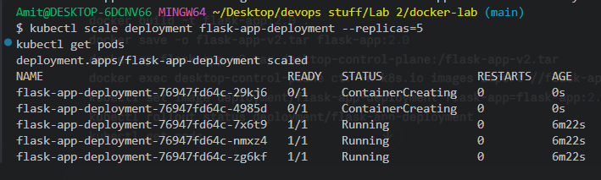
Evidence 7: kubectl scale reported the deployment scaled; kubectl get pods shows 5 pods total — the original 3 already Running, and 2 new ones in ContainerCreating — confirming Kubernetes added replicas on demand.
6. Rolling Update
A new image tag, flask-app:2.0, was built and imported into the node the same way as the base image, and the deployment's container image was updated:
docker build -t flask-app:2.0 .
docker save -o flask-app-v2.tar flask-app:2.0
docker cp flask-app-v2.tar desktop-control-plane:/flask-app-v2.tar
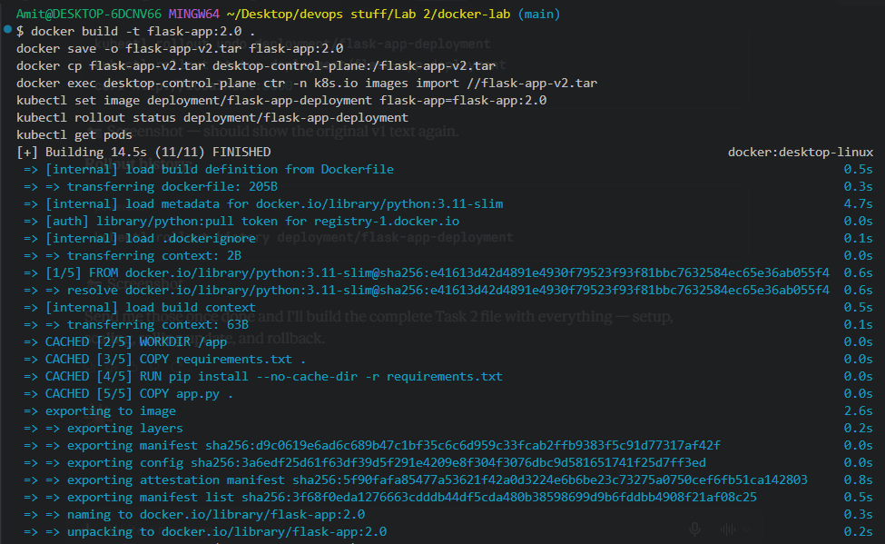
Evidence 8: The flask-app:2.0 image was built successfully from the same Dockerfile and application code.
docker exec desktop-control-plane ctr -n k8s.io images import //flask-app-v2.tar
kubectl set image deployment/flask-app-deployment flask-app=flask-app:2.0
kubectl rollout status deployment/flask-app-deployment
kubectl get pods
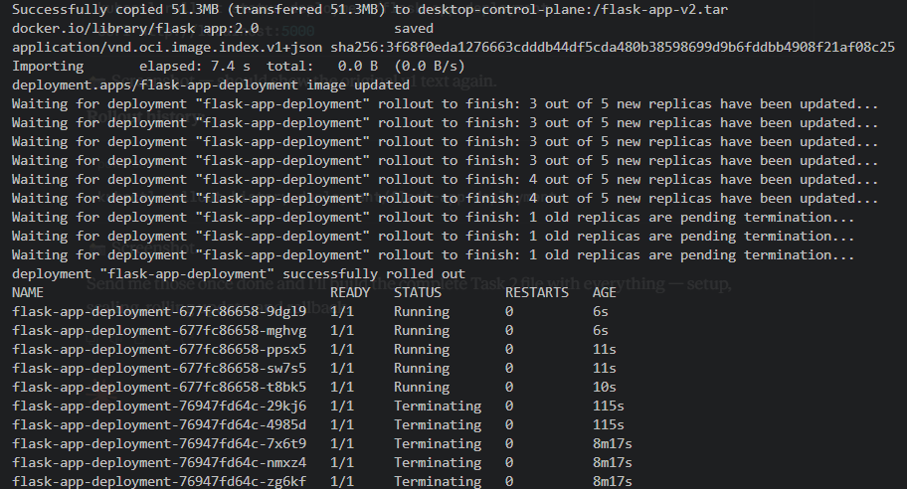
Evidence 9: kubectl rollout status shows Kubernetes replacing pods incrementally (3 of 5, then 4 of 5 new replicas, with old replicas pending termination) rather than all at once, and reports the deployment successfully rolled out. The old ReplicaSet's pods (76947fd64c-*) are shown Terminating while the new ReplicaSet's pods (677fc86658-*) come up Running — the rolling update mechanism in action.
The app was re-checked after the rollout completed:
curl http://localhost:5000
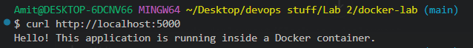
Evidence 10: The service continued responding without interruption throughout the update. The response text is unchanged from v1, since app.py's content was not modified before building the flask-app:2.0 tag — the update was verified instead through the new image tag, the new ReplicaSet hash, and the rollout status output above.
7. Rollback
The deployment was rolled back to its previous revision:
kubectl rollout undo deployment/flask-app-deployment
kubectl rollout status deployment/flask-app-deployment
curl http://localhost:5000
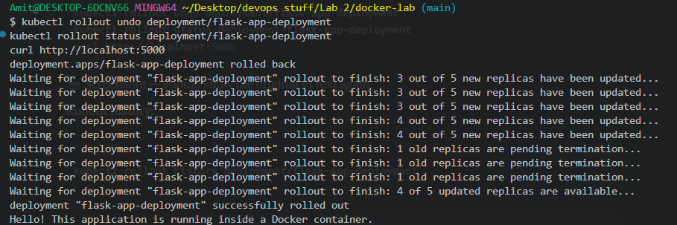
Evidence 11: kubectl rollout undo triggered a new rollout back to the prior pod template, again replacing pods incrementally (3 of 5, then 4 of 5 updated) until the deployment was reported successfully rolled out, and the app continued responding correctly afterward.
The revision history was reviewed to confirm both the update and the rollback were tracked as separate rollouts:
kubectl rollout history deployment/flask-app-deployment
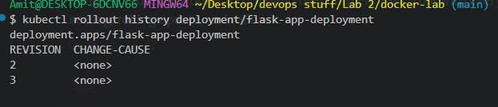
Evidence 12: kubectl rollout history lists revisions 2 and 3 for the deployment — revision 2 corresponding to the flask-app:2.0 image update, and revision 3 to the rollback — confirming Kubernetes tracked each change as a distinct, reversible revision.
8. Observations
- Docker Desktop's kind-based Kubernetes node keeps its own containerd image store, so locally built images had to be explicitly exported and imported into the node before they could be used with imagePullPolicy: Never.
- A LoadBalancer-type Service, not NodePort, was required to get a localhost-reachable endpoint on this cluster, since Docker Desktop's cloud-provider-kind component only auto-publishes LoadBalancer services.
- kubectl scale deployment --replicas=5 added new pods on demand, growing the deployment from 3/3 to 5/5 ready without redefining the Deployment.
- kubectl set image triggered a rolling update: pods were replaced incrementally (a few new pods created while a few old ones terminated at a time) rather than all being replaced simultaneously, keeping the service available throughout.
- kubectl rollout undo reverted the deployment to its previous pod template using the same incremental, zero-downtime rollout mechanism, and kubectl rollout history confirmed both the update and the rollback were recorded as separate, distinct revisions.
9. Conclusion
Task 2 was completed successfully. The Flask application was deployed to Docker Desktop's Kubernetes cluster with a working Deployment and Service, and all three required strategies were demonstrated: scaling replicas on demand, performing a rolling update to a new image version with continuous availability, and rolling back to a previous revision. The rollout status output and revision history together confirm Kubernetes managed each change as an incremental, trackable, and reversible operation.

