LAB 2: CONTAINERIZATION & KUBERNETES ORCHESTRATION
Task 3 — Docker Storage: Volumes and Bind Mounts
Student | Amit Mohanty
Roll No. | 2301730325
Topic | Docker Storage: Volumes and Bind Mounts
Environment | Docker Desktop (Windows), MINGW64 / Git Bash terminal in VS Code
Tools Used | Windows PowerShell / Git Bash, Docker Desktop, VS Code, Docker CLI

1. Objective
This task demonstrates Docker's data persistence mechanisms. It shows that data written to a container's writable layer is lost once the container is removed, and then demonstrates two ways to persist data beyond a container's lifecycle: named volumes managed by Docker, and bind mounts that map a host directory directly into a container.
2. Container-Layer Data Loss
A plain container was started and a file was written to its writable layer (not to any volume):
docker run -it --name storage-test ubuntu bash
echo "This data will be lost" > /data.txt
cat /data.txt
exit
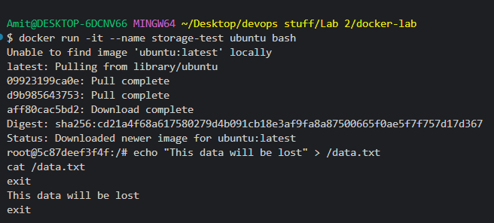
Evidence 1: The ubuntu image was pulled, the storage-test container started, and "This data will be lost" was written to and read back from /data.txt inside the container's writable layer.
The container was then removed, and a fresh container from the same image was started to check whether the file still existed:
docker rm -f storage-test
docker run --rm ubuntu cat /data.txt
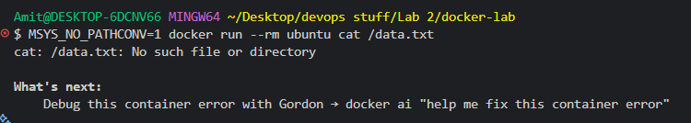
Evidence 2: After storage-test was removed, a new container from the ubuntu image reported "cat: /data.txt: No such file or directory" — confirming the data did not survive container removal since it lived only in that container's writable layer.
3. Creating a Named Volume
A Docker-managed named volume was created and listed:
docker volume create app-data
docker volume ls
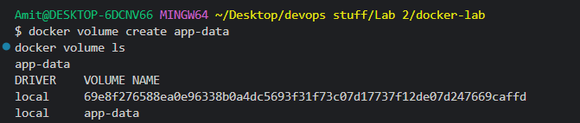
Evidence 3: docker volume create app-data succeeded, and docker volume ls confirms the app-data volume alongside an existing anonymous volume.
4. Using the Volume in a Container
A new container was started with the app-data volume mounted at /data, and a file was written inside it:
docker run -it --name data-container --mount source=app-data,target=/data ubuntu bash
echo "Hello from Docker Volume" > /data/message.txt
cat /data/message.txt
exit
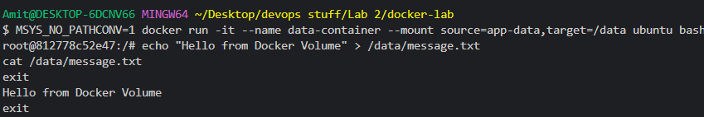
Evidence 4: Inside data-container, "Hello from Docker Volume" was written to /data/message.txt (backed by the app-data volume) and read back successfully.
5. Verifying Volume Persistence
The container was removed, and a new, unrelated container was started with the same volume mounted, to check whether the data survived:
docker rm -f data-container
docker run --rm --mount source=app-data,target=/data ubuntu cat /data/message.txt
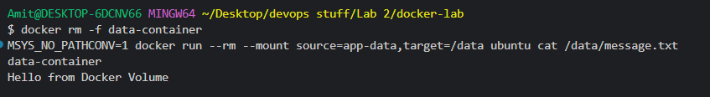
Evidence 5: After data-container was removed, a fresh container mounting the app-data volume printed "Hello from Docker Volume" — confirming the data persisted in the named volume independently of any container.
6. Bind Mount Setup and Use
A host directory was created, and a container was started with that directory bind-mounted to /data. A file was then written from inside the container:
mkdir -p ~/docker-storage
docker run -it --name bind-container --mount type=bind,source="$HOME/docker-storage",target=/data ubuntu bash
echo "Hello from Docker Bind Mount" > /data/message.txt
cat /data/message.txt
exit
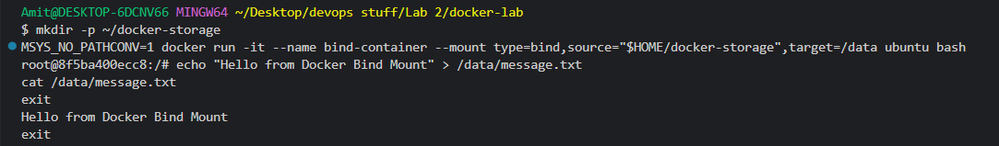
Evidence 6: The ~/docker-storage host folder was created, bind-container was started with it mounted at /data, and "Hello from Docker Bind Mount" was written to and read back from /data/message.txt.
7. Verifying Bind Mount Persistence on the Host
The container was removed, and the file was then read directly from the host filesystem, without using any container:
docker rm bind-container
cat ~/docker-storage/message.txt
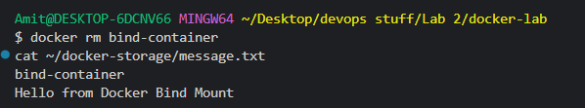
Evidence 7: After bind-container was removed, "Hello from Docker Bind Mount" was still readable directly from ~/docker-storage/message.txt on the host — confirming the bind mount wrote straight to the real filesystem, independent of Docker.
8. Observations
- Data written to a plain container's writable layer (storage-test) did not survive removal of that container, confirming the container layer is ephemeral.
- A named volume (app-data) was created with docker volume create and confirmed via docker volume ls.
- Data written inside data-container to the app-data volume mount persisted after the container was deleted, and was readable from a completely new container mounting the same volume.
- A bind mount was set up against a real host folder (~/docker-storage); data written from inside bind-container was visible directly on the host filesystem via a plain cat command, with no container involved.
- Both named volumes and bind mounts decouple data from the container lifecycle, but a bind mount ties the data to a specific host path, whereas a named volume is managed and located by Docker itself.
9. Conclusion
Task 3 was completed successfully. The exercise demonstrated that a container's writable layer is not a durable place to store data, and that Docker provides two persistence options — named volumes and bind mounts — that keep data intact across container creation and removal. Named volume persistence was verified by reading data from a completely different container, and bind mount persistence was verified by reading the file directly from the host filesystem.

