LAB 2: CONTAINERIZATION & KUBERNETES ORCHESTRATION
Task 1 — Containerize a Sample Application Using Docker
Student | Amit Mohanty
Roll No. | 2301730325
Application | Flask (app.py)
Image Name | flask-docker-app:1.0
Container Name | flask-container
Host Port Mapping | 5050 -> 5000
Tools Used | Windows PowerShell, Docker Desktop, VSCode, Python, Flask, Docker CLI

1. Aim of the Task
The aim of this task was to understand the basic Docker workflow: create a Dockerfile, build a Docker image, run a Flask application inside a container, and document the image layers and container lifecycle behaviour.
Workflow: Application -> Dockerfile -> Docker Image -> Docker Container -> Running Flask Application

2. Project Setup
A project folder (docker-lab) was created containing the Flask application (app.py), its dependency file (requirements.txt), and the Dockerfile.
app.py
requirements.txt
Dockerfile
Flask was listed in requirements.txt so that Docker installs it inside the image rather than relying on any Flask installation on the host machine.

3. Dockerfile Used
The following Dockerfile was used:
FROM python:3.11-slim
WORKDIR /app
COPY requirements.txt .
RUN pip install --no-cache-dir -r requirements.txt
COPY app.py .
EXPOSE 5000
CMD ["python", "app.py"]
Instruction | Purpose
FROM | Uses Python 3.11-slim as the base image.
WORKDIR | Sets /app as the working directory inside the container.
COPY requirements.txt | Copies the dependency file into the image.
RUN pip install | Installs Flask and other dependencies.
COPY app.py | Copies the Flask application into the image.
EXPOSE 5000 | Documents the port used by the Flask application.
CMD | Starts app.py when the container runs.

4. Building the Docker Image
From the docker-lab folder, the image was built using:
docker build -t flask-docker-app:1.0 .
Docker processed the Dockerfile step by step: it pulled the Python 3.11-slim base image, copied requirements.txt, installed Flask, copied app.py, and produced the final image flask-docker-app:1.0.
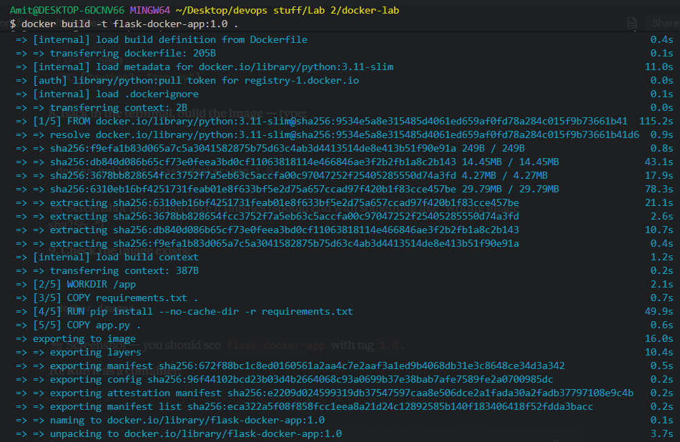
Evidence 1: Docker build output showing each layer being created and the image being exported successfully.

5. Checking the Docker Image
The image was verified using:
docker images
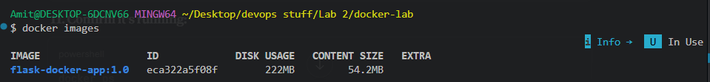
Evidence 2: docker images output confirming flask-docker-app:1.0 was created (222MB disk usage, 54.2MB content size).

6. Running the Flask Application
The image was run as a container, mapping host port 5050 to container port 5000 (port 5000 on the host was already in use, so 5050 was used instead):
docker run -d --name flask-container -p 5050:5000 flask-docker-app:1.0
The running container was then confirmed with docker ps:
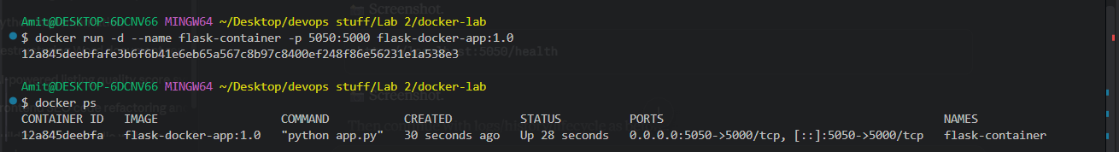
Evidence 3: Container started and confirmed running via docker ps, with port mapping 0.0.0.0:5050->5000/tcp.

7. Verifying the Application in the Browser
After starting the container, the application was opened in the browser at http://localhost:5050. The message below confirmed the Flask application was running inside the Docker container.
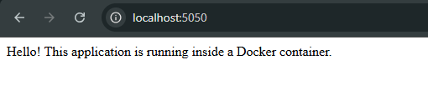
Evidence 4: Flask application successfully running inside the Docker container.

8. Checking Application Health
The application's health endpoint was checked at http://localhost:5050/health, confirming the application was responding correctly.

Evidence 5: Application health check confirming the application is healthy.

9. Checking Container Logs
The following command was used to inspect what the Flask application was doing inside the container:
docker logs flask-container
The logs confirmed Flask was serving the application on all addresses (0.0.0.0:5000), and showed incoming GET requests for /, /favicon.ico and /health.
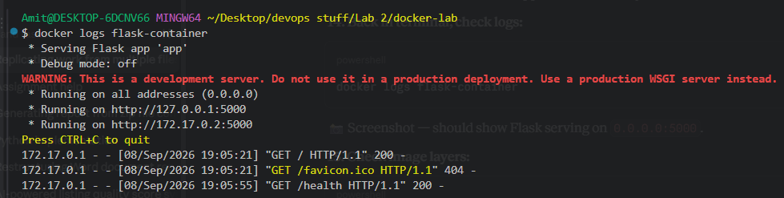
Evidence 6: Flask container logs showing the application running and serving requests.

10. Checking Image Layers
To inspect the image layers, the following command was used:
docker history flask-docker-app:1.0
The output showed each instruction from the Dockerfile (CMD, EXPOSE, COPY app.py, RUN pip install, COPY requirements.txt, WORKDIR) as well as the layers inherited from the Python base image.
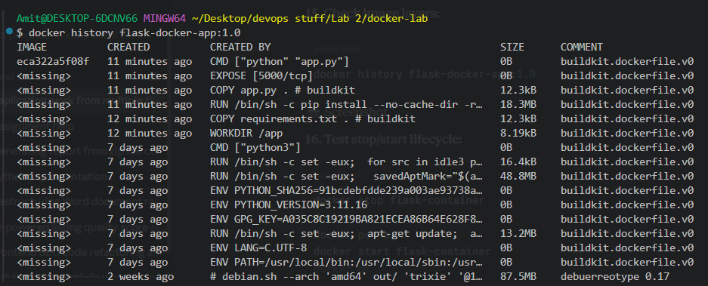
Evidence 7: docker history output showing the image layers built from the Dockerfile.

11. Container Lifecycle / Behaviour
The container stop/start lifecycle was tested using the following sequence:
docker stop flask-container
docker ps
docker ps -a
docker start flask-container
docker ps
After stopping the container, docker ps showed no running containers (since it only lists running containers). docker ps -a revealed the container in an 'Exited' state. Starting it again with docker start brought it back to a running state, confirming the container could be restarted without rebuilding the image.
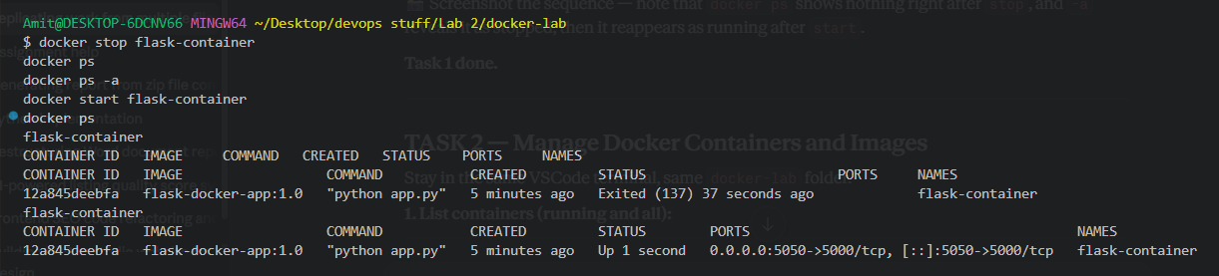
Evidence 8: Container lifecycle — stopped, confirmed exited via docker ps -a, then restarted and confirmed running again.

12. Final Result
Instruction | Purpose
Write a Dockerfile | Completed
Build the Docker image | Completed — flask-docker-app:1.0
Run the container | Completed — flask-container
Document image layers | Completed using docker history
Document container behaviour | Completed using ps, logs, stop and start
Show application working | Completed — browser output verified
Show application health | Completed — health check verified

Task 1 was completed successfully. A Flask application was containerized using Docker, the image was built and verified, the container was run and tested via the browser, and the image layers and container lifecycle were documented using docker history, docker logs, docker ps, docker stop and docker start.

