LAB 2: CONTAINERIZATION & KUBERNETES ORCHESTRATION
Task 2 — Manage Docker Containers and Images
Student | Amit Mohanty
Roll No. | 2301730325
Base Image | flask-docker-app:1.0
Docker Hub Repository | amitmiv/flask-docker-app:1.0
Compose Services | redis (flask-redis), web (flask-web)
Compose Port Mapping | 5001 -> 5000
Tools Used | Windows PowerShell, Docker Desktop, VSCode, Docker Compose, Docker Hub

1. Objective
This task covers managing Docker containers and images: listing containers, tagging and pushing an image to a registry (Docker Hub), and using Docker Compose to bring up a multi-container setup (a Flask web service alongside a Redis service).

2. Docker Container Listing
Running and all (including stopped) containers were listed using:
docker ps
docker ps -a
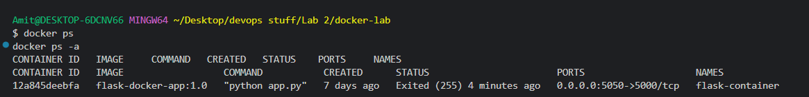
Evidence 1: docker ps and docker ps -a showing the existing flask-container from Task 1 in an Exited state.

3. Docker Image Listing
Existing images were listed using:
docker images
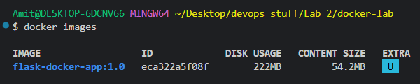
Evidence 2: docker images output confirming flask-docker-app:1.0 (222MB disk usage, 54.2MB content size).

4. Docker Image Tagging
The image was tagged for a Docker Hub repository under the username amitmiv:
docker tag flask-docker-app:1.0 amitmiv/flask-docker-app:1.0
docker images
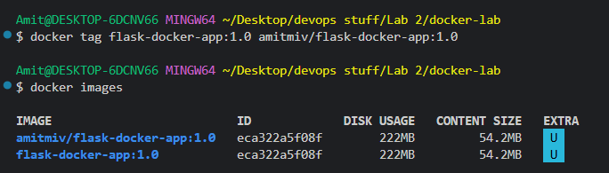
Evidence 3: Image tagged as amitmiv/flask-docker-app:1.0, shown alongside the original flask-docker-app:1.0 tag pointing to the same image ID.

5. Docker Hub Image Push
The tagged image was pushed to Docker Hub:
docker push amitmiv/flask-docker-app:1.0
The first push attempt failed partway through with a network/registry error ("failed to do request... EOF") while uploading layers. The command was re-run and completed successfully the second time, with most layers reported as already existing on the registry from the first attempt.
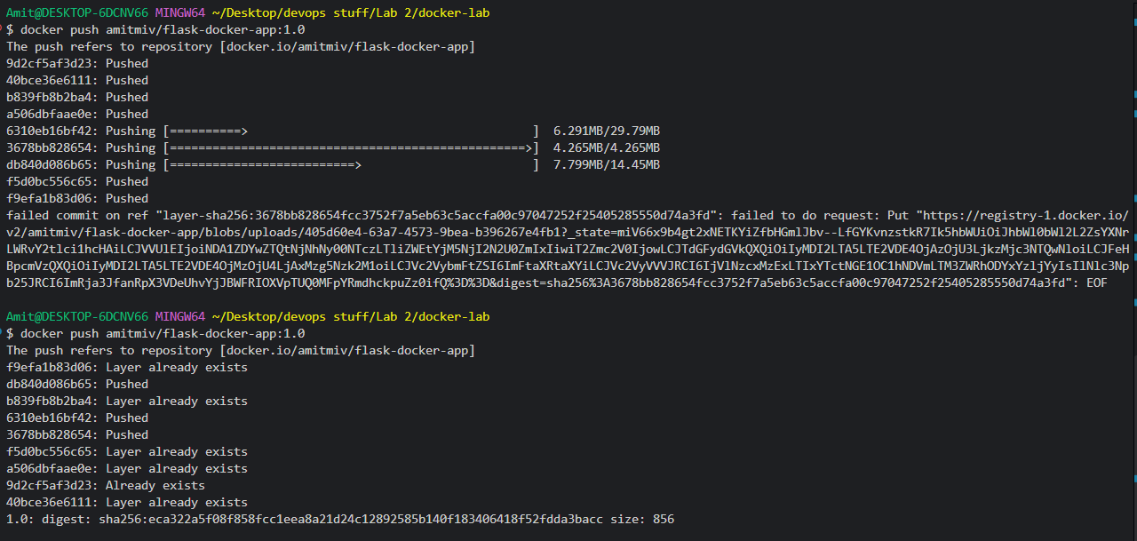
Evidence 4: Docker Hub push — initial attempt interrupted by a registry request failure, followed by a successful retry ending in a digest confirmation.

6. Docker Compose Configuration
A docker-compose.yml file was created defining two services: a Redis cache (flask-redis) and the Flask web application (flask-web), built from the existing Dockerfile and mapped to host port 5001.
services:
redis:
image: redis:7-alpine
container_name: flask-redis
web:
build: .
container_name: flask-web
depends_on:
- redis
ports:
- "5001:5000"
The configuration was validated using:
docker compose config
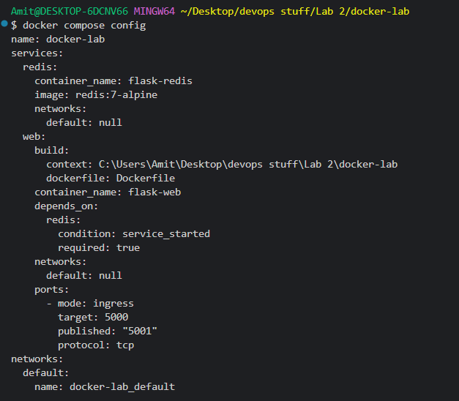
Evidence 5: docker compose config output showing the resolved services, build context, dependency on redis, and port mapping (5001 -> 5000).

7. Docker Compose Multi-Container Setup
The multi-container setup was started using:
docker compose up -d
docker compose ps
Docker Compose pulled the redis:7-alpine image, built the web image from the Dockerfile, created a dedicated network (docker-lab_default), and started both containers.
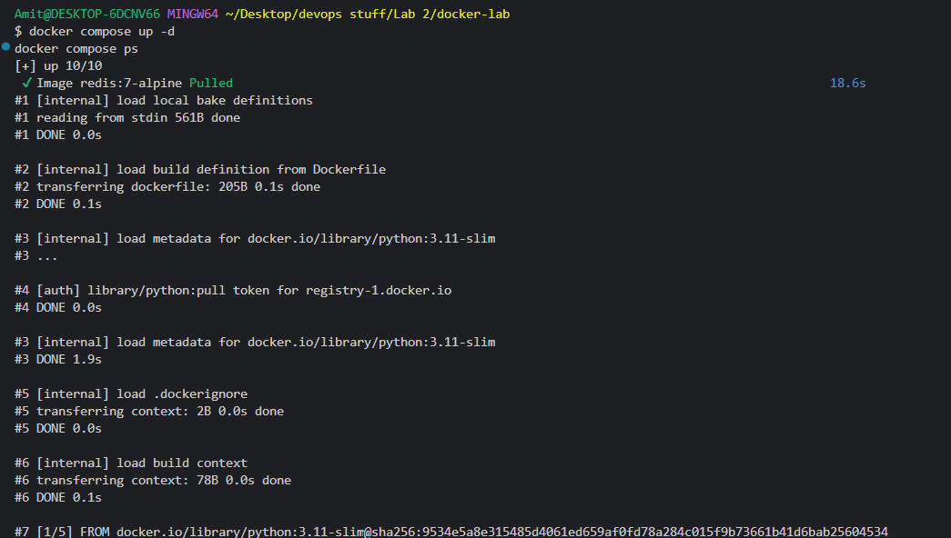
Evidence 6: docker compose up -d starting execution, resolving the Dockerfile build steps for the web service.
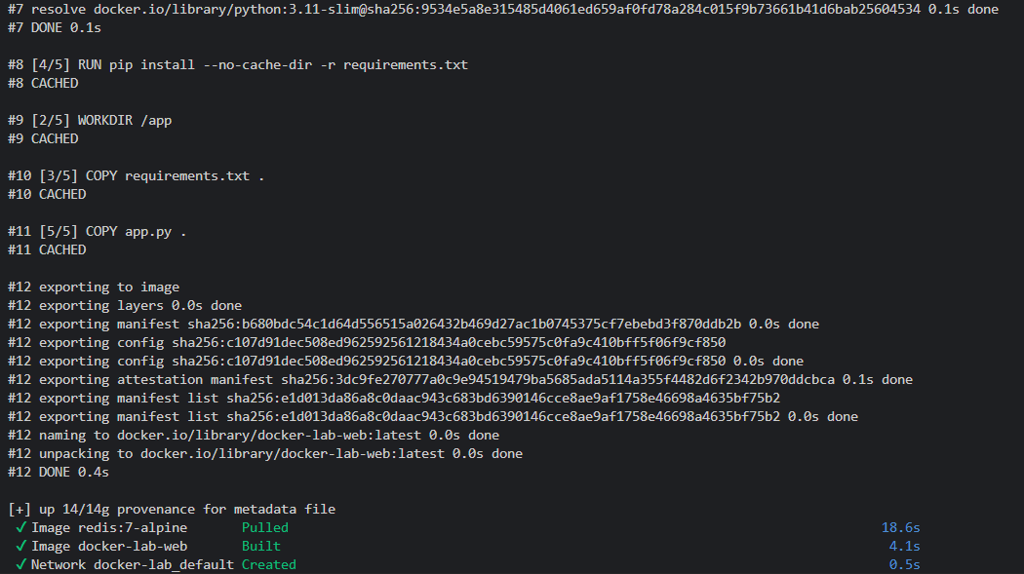
Evidence 7: Build steps continuing (cached layers reused) and the image being exported and tagged as docker-lab-web:latest.
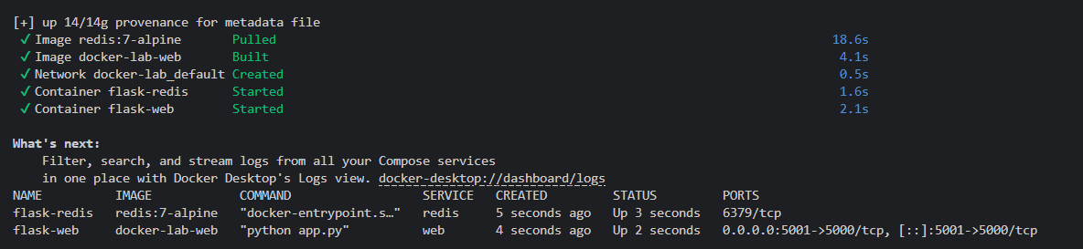
Evidence 8: Both services completed — redis:7-alpine pulled, docker-lab-web built, network created, and containers flask-redis and flask-web started and confirmed running via docker compose ps.

8. Flask Application Verification
The web service was verified in the browser at http://localhost:5001, confirming the Flask application was reachable through the Compose-managed container.
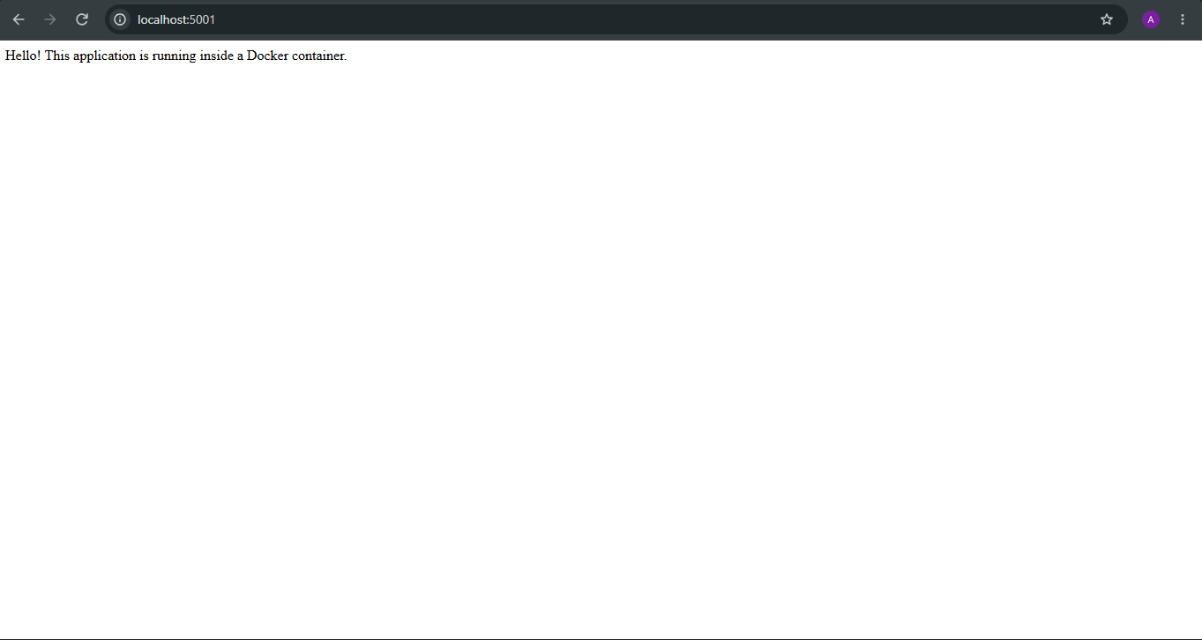
Evidence 9: Flask application running and reachable via the Docker Compose multi-container setup.

9. Observations
• docker ps and docker ps -a were used to list running and stopped containers, confirming the state of the flask-container from Task 1.
• The flask-docker-app:1.0 image was confirmed present via docker images.
• The image was tagged as amitmiv/flask-docker-app:1.0 for Docker Hub.
• The initial push attempt failed with a registry request error; retrying the push succeeded, with previously-uploaded layers reused.
• A docker-compose.yml file was created to manage a two-service setup (Redis and the Flask web app).
• docker compose up -d successfully built the web image, pulled the redis image, created a dedicated network, and started both containers.
• The Flask application was confirmed reachable in the browser at http://localhost:5001, running through the Compose-managed container.

10. Conclusion
Task 2 was completed successfully. Docker container and image management commands were demonstrated (listing, tagging, and pushing to Docker Hub), and Docker Compose was used to define and run a multi-container setup consisting of a Flask web service and a Redis service, with the application verified as reachable in the browser.

