LAB 2: CONTAINERIZATION & KUBERNETES ORCHESTRATION
Task 4 — Docker Network
Student | Amit Mohanty
Roll No. | 2301730325
Topic | Docker Networking
Environment | Docker Desktop (Windows), MINGW64 / Git Bash terminal in VS Code
Tools Used | Windows PowerShell / Git Bash, Docker Desktop, VS Code, Docker CLI

1. Objective
This task demonstrates Docker's user-defined bridge networking. A custom network was created and two containers were attached to it, showing that containers on the same user-defined network can reach each other both by container name (via Docker's built-in DNS) and by raw IP address, and that the network's configuration (subnet, gateway, and connected containers) can be inspected.
2. Creating a Custom Network
A user-defined bridge network was created:
docker network create task4-network
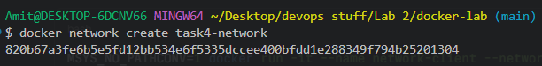
Evidence 1: task4-network was created successfully, returning its network ID.
3. Running the Web Server on the Network
An nginx container was started and attached to task4-network:
docker run -d --name web-server --network task4-network nginx:alpine
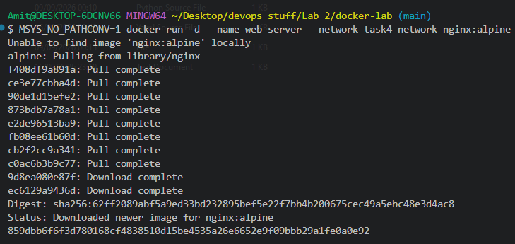
Evidence 2: The nginx:alpine image was pulled, and the web-server container was started in detached mode on task4-network.
4. Testing Communication by Container Name
A second container was started on the same network, and the web server was reached using its container name, relying on Docker's built-in DNS:
docker run -it --name network-client --network task4-network alpine sh
wget -qO- http://web-server
exit
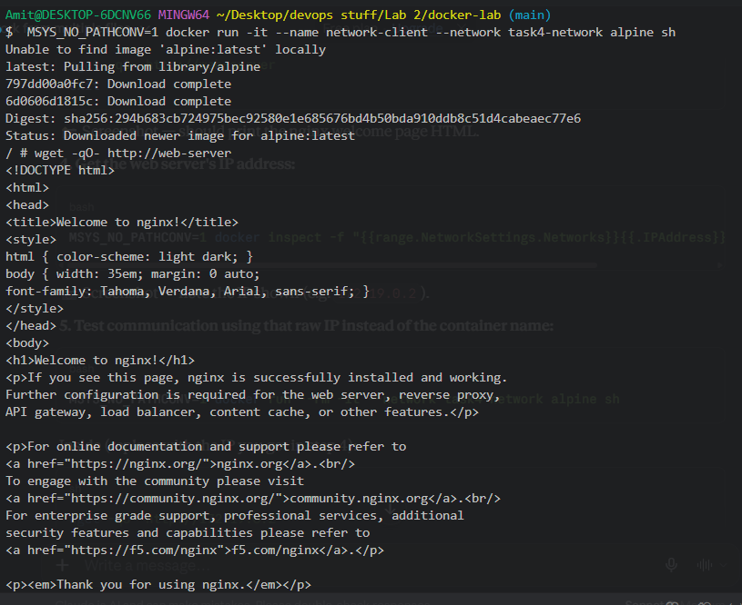
Evidence 3: From inside network-client, wget -qO- http://web-server successfully returned the nginx welcome page HTML, confirming name-based resolution between containers on task4-network.
5. Retrieving the Web Server's IP Address
The web server's IP address on the network was retrieved with docker inspect:
docker inspect -f "{{range.NetworkSettings.Networks}}{{.IPAddress}}{{end}}" web-server
Evidence 4: docker inspect reported the web-server container's IP address on task4-network as 172.19.0.2.
6. Testing Communication by IP Address
A new, unrelated container was started on task4-network, and the web server was reached using its raw IP address instead of its name:
docker run --rm -it --network task4-network alpine sh
wget -qO- http://172.19.0.2
exit
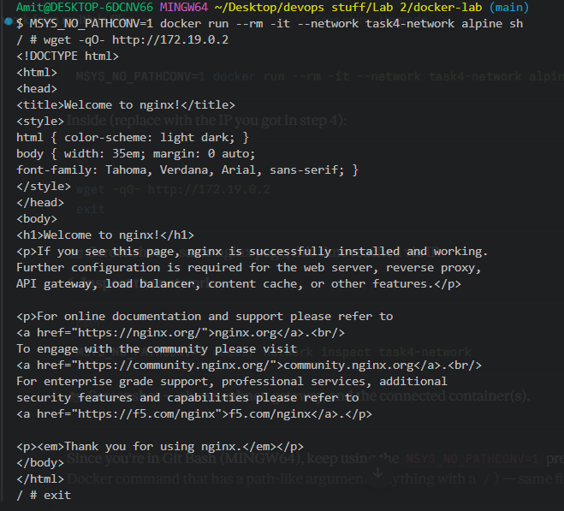
Evidence 5: wget -qO- http://172.19.0.2 returned the same nginx welcome page, confirming that IP-based communication works between containers on task4-network, in addition to name-based communication.
7. Inspecting the Network
Finally, the network itself was inspected to review its configuration and connected containers:
docker network inspect task4-network
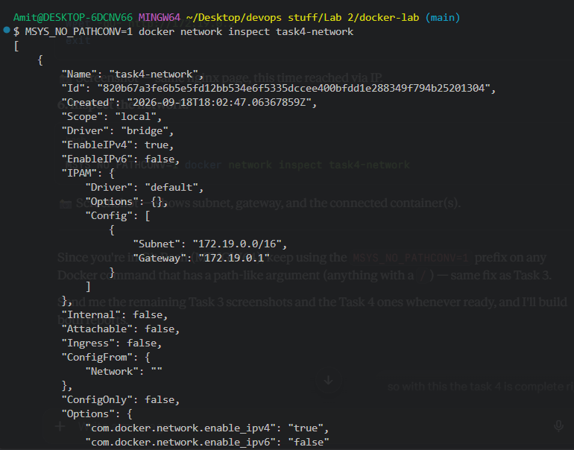
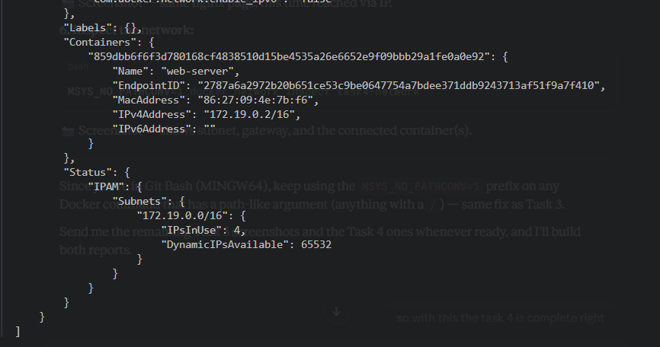
Evidence 6: docker network inspect task4-network shows the bridge driver, the subnet 172.19.0.0/16 with gateway 172.19.0.1, and web-server listed under Containers with its IPv4 address 172.19.0.2/16 — confirming the network's configuration and its connected container.
8. Observations
- A user-defined bridge network (task4-network) was created independently of any container.
- Containers attached to the same user-defined network can resolve each other by container name (web-server) through Docker's built-in DNS, without needing to know the container's IP.
- The same containers can also communicate using the container's raw IP address (172.19.0.2), confirming that both name-based and IP-based routing work on the network.
- docker network inspect confirmed the network's subnet (172.19.0.0/16), gateway (172.19.0.1), and the connected web-server container with its assigned IP.
- A default bridge network would not provide automatic DNS-based name resolution between containers; this is a key advantage of using a user-defined network like task4-network.
9. Conclusion
Task 4 was completed successfully. A custom Docker network was created, and two containers attached to it were shown to communicate with each other both by container name and by IP address, demonstrating Docker's built-in service discovery on user-defined networks. Inspecting the network confirmed its subnet, gateway, and the container connected to it.

