CONTAINERIZATION & ORCHESTRATION PROJECT
Task 4 — Containerize a Sample Application Using Docker
Student | Amit Mohanty
Roll No. | 2301730325
Task | Task 4 — Containerize a Sample Application Using Docker (5 marks)
Environment | Docker Desktop (Windows), MINGW64 / Git Bash terminal in VS Code
Application | Sample Flask application (app.py, requirements.txt) in the docker-lab repo

1. Objective
This task containerizes a sample Flask application using Docker. It covers writing a Dockerfile, building an image from it, running the application inside a container, and documenting the resulting image's layers and the container's runtime behavior (serving requests, logging, and surviving a stop/start cycle).
2. Application and Dockerfile
The sample application is a small Flask app (app.py) exposing two routes, / and /health, listening on 0.0.0.0:5000. Its dependency, flask, is declared in requirements.txt. The project files were confirmed before building:
cd docker-lab
ls
cat app.py
cat requirements.txt
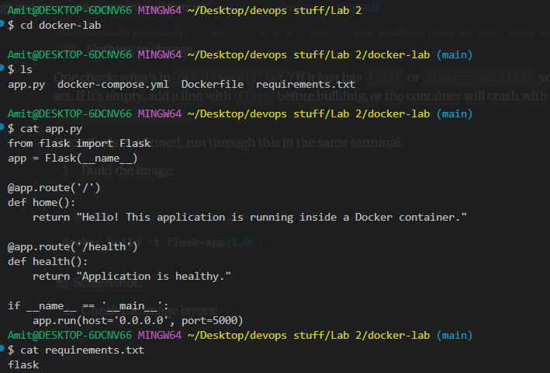
Evidence 1: The docker-lab folder contains app.py, requirements.txt, Dockerfile and docker-compose.yml. app.py defines the / and /health routes and runs on host 0.0.0.0, port 5000; requirements.txt lists flask as the only dependency.
The Dockerfile used to build the image:
FROM python:3.11-slim
WORKDIR /app
COPY requirements.txt .
RUN pip install --no-cache-dir -r requirements.txt
COPY app.py .
EXPOSE 5000
CMD ["python", "app.py"]
3. Building the Image
The image was built from the Dockerfile:
docker build -t flask-app:1.0 .
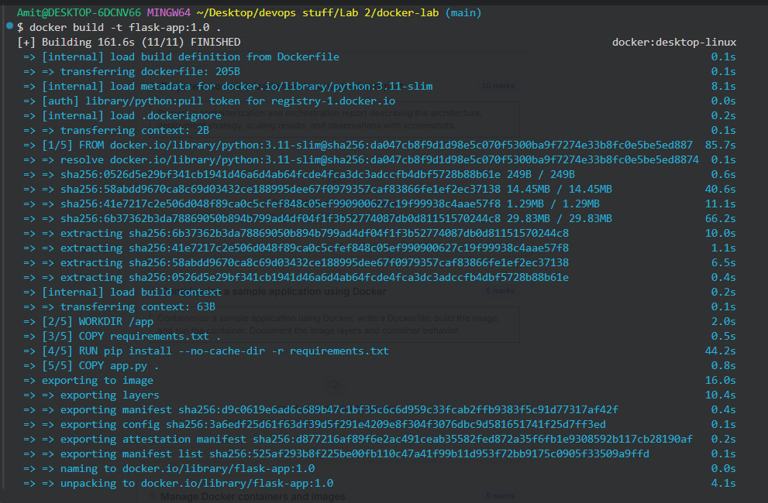
Evidence 2: BuildKit executed all 11 build steps successfully — pulling the python:3.11-slim base image, setting the working directory, installing dependencies from requirements.txt, copying app.py, and exporting the final flask-app:1.0 image.
4. Documenting the Image Layers
The image's layer history was inspected to document how it was assembled:
docker image history flask-app:1.0
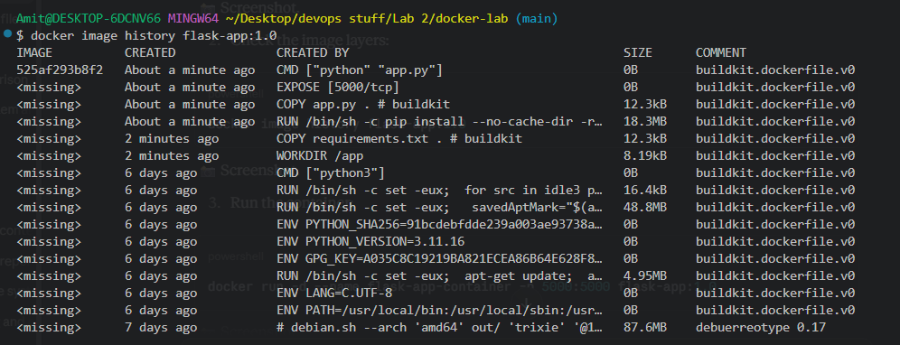
Evidence 3: docker image history shows the application layers on top of the python:3.11-slim base — WORKDIR /app, COPY requirements.txt, the pip install RUN layer (18.3 MB), COPY app.py, EXPOSE 5000, and the final CMD ["python","app.py"] layer, each added as a separate image layer.
5. Running the Container
A container was started from the built image, mapping port 5000 on the host to port 5000 in the container:
docker run -d --name flask-app-container -p 5000:5000 flask-app:1.0
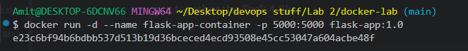
Evidence 4: flask-app-container was started in detached mode, returning its container ID.
6. Verifying Container Behavior
The running container and both application routes were verified:
docker ps
curl http://localhost:5000
curl http://localhost:5000/health
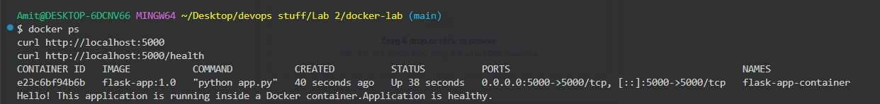
Evidence 5: docker ps shows flask-app-container up and healthy on port 5000; curl requests to / and /health returned "Hello! This application is running inside a Docker container." and "Application is healthy." respectively, confirming both routes work as expected.
Container logs were checked, and the container was stopped and restarted to confirm it retains its configuration and resumes serving requests:
docker logs flask-app-container
docker stop flask-app-container
docker start flask-app-container
docker ps
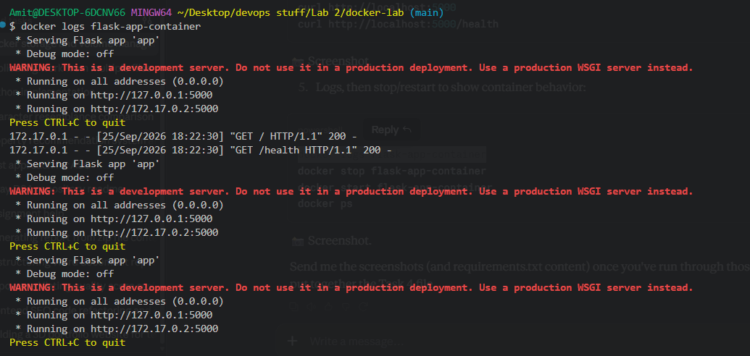
Evidence 6: docker logs shows the Flask development server starting, listening on 0.0.0.0:5000, and logging two successful requests (GET / and GET /health, both HTTP 200).
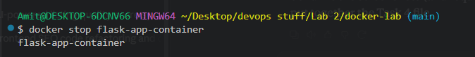
Evidence 7: docker stop flask-app-container stopped the running container.
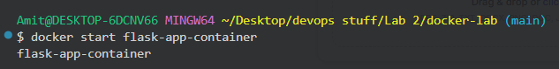
Evidence 8: docker start flask-app-container restarted the same container from its existing configuration.
Evidence 9: docker ps confirms flask-app-container is back up and running on port 5000 after the restart, with the same image (flask-app:1.0) and command (python app.py).
7. Observations
- The image was built in 11 BuildKit steps on top of python:3.11-slim, with separate layers for the working directory, dependency installation, and application code — visible in docker image history.
- Dependency installation (RUN pip install) was cached in its own layer (18.3 MB), separate from the application code layer, so future rebuilds after only editing app.py would not need to reinstall dependencies.
- Both application routes (/ and /health) responded correctly once the container was running, confirming the Dockerfile's EXPOSE 5000 and CMD correctly start and expose the Flask app.
- Container logs confirmed the requests were actually received and served by the Flask app (HTTP 200 on both routes), not just that the port was open.
- Stopping and starting the container (rather than removing and recreating it) preserved its name, image, and port mapping, and it resumed serving requests immediately.
8. Conclusion
Task 4 was completed successfully. The sample Flask application was containerized with a working Dockerfile, built into the flask-app:1.0 image, and run as a container that correctly served both of its routes. The image's layer history and the container's logs and stop/restart behavior were documented as evidence of a correctly functioning containerized application.

