YUVA INTERN — VIRTUAL INTERNSHIP PROGRAM
Task 4: Comprehensive Data Analysis Reporting and Presentation
Capstone Technical Milestone Report: End-to-End Synthesis of Data Cleaning, Advanced Visualization, Inferential Hypothesis Testing, Predictive Modeling, and Executive Decision Strategy using R
Attribute | Internship Capstone Specification
Internship Track | Virtual R Data Analyst Intern
Host Organization | Yuva Intern (Skill Development & Virtual Internship Program)
Candidate | Data Analyst Intern
Submission Scope | Task 4: Capstone Comprehensive Reporting, Multi-Stage Integration & Presentation
Cumulative Effort | 130+ Hours of Dedicated Analytical Engineering Across Weeks 1 to 4
Primary Tools & Packages | R (v4.3+), tidyverse, caret, pROC, car, randomForest, ggplot2, scales, viridis
Report Submission Format | Microsoft Word (.docx) — Master Capstone Report
Date of Submission | October 2026

1. Executive Summary & Capstone Objectives
This capstone report represents the synthesis and culmination of all analytical milestones completed during the Virtual R Data Analyst Internship with Yuva Intern. Throughout the four-week engagement, I examined the business-critical problem of subscriber attrition within telecommunications portfolios, using the IBM Telco Customer Churn dataset (7,043 customer accounts across 21 variables) as an empirical testbed.
Rather than treating data cleaning, visualization, hypothesis testing, and machine learning as disconnected academic exercises, this report integrates them into an end-to-end industrial data science framework. The project demonstrates how raw, imperfect operational data is audited, cleaned, visually explored to generate empirical hypotheses, tested through inferential statistics, modeled via supervised predictive algorithms, and translated into revenue-protecting business strategies.
Key Project Highlights Across the 4-Week Internship Lifecycle:
• Phase 1: Data Hygiene & Structural Preparation: Audited 7,043 raw records and diagnosed 11 silent whitespace blank entries in TotalCharges. Demonstrated through cross-tabulation that all 11 records belonged to new accounts with zero tenure, justifying domain-grounded zero imputation over misleading mean substitutions. Implemented logarithmic transformations (log1p) to normalize positive skewness (+0.96 down to -0.74), along with Min-Max scaling, Z-score standardization, and dummy encoding.
• Phase 2: Multi-Layered Visual Analytics & Storytelling: Engineered 7 specialized ggplot2 visual architectures with custom corporate theming. Uncovered a severe 'first-year churn cliff' where Month 1 attrition exceeds 50%, exposed high price sensitivity among Fiber Optic subscribers ($75–$105/month), identified a 54.6% churn hazard in month-to-month fiber accounts, and benchmarked billing friction showing manual Electronic Checks incur an 18.7% excess churn penalty over baseline.
• Phase 3: Inferential Hypothesis Testing: Conducted Welch's two-sample t-tests and Mann-Whitney U rank-sum tests, verifying statistically significant differences in monthly fees ($74.44 vs $61.27, p < 0.001) and account longevity (17.98 vs 37.57 months, p < 0.001). Executed Pearson's Chi-Square tests of independence, establishing Contract length as the single strongest categorical association (Chi2 = 1,184.60, Cramer's V = 0.410).
• Phase 4: Predictive Modeling & Threshold Optimization: Built a multivariate binary Logistic Regression model achieving a 5-fold cross-validated AUC of 0.8459, matching the non-linear Random Forest benchmark (AUC = 0.8450). Addressed the business cost asymmetry of False Negatives by tuning the classification decision threshold via Youden's J statistic from 0.50 down to 0.26. This increased churn detection sensitivity from 55.35% to 79.95%, reducing missed customer cancellations from 167 down to 75 (a 55.1% reduction in False Negatives).
[BOTTOM-LINE BUSINESS VALUE] By transitioning the decision threshold from 0.50 to 0.26, the data science model catches 92 additional churners per 1,400 accounts, preserving an estimated $130,000 in net annual recurring revenue for the business.

2. Data Architecture, Hygiene, & Preprocessing Methodology
The foundational phase of any data science project requires establishing data integrity. Working with real-world administrative extracts often presents hidden data quality issues that can silently corrupt downstream models if handled carelessly.
2.1 Data Schema & Attribute Inventory
The dataset captures customer profiles across demographics, account subscriptions, and billing histories. The table below delineates the functional inventory of key variables analyzed throughout this engagement:
Attribute Name | Original Class | Target R Class | Analytical Role | Operational Context
customerID | character | character | Account Identifier | Unique customer account reference string.
tenure | integer | numeric (months) | Time-to-Event Predictor | Number of elapsed billing months with the company (0 to 72).
MonthlyCharges | numeric | numeric ($) | Pricing Predictor | Recurring monthly invoice amount ($18.25 to $118.75).
TotalCharges | character (!) | numeric ($) | Cumulative Spend | Lifetime bill amount; contained 11 blank whitespace values.
Contract | character | ordered factor | Moderating Factor | Commitment terms: Month-to-month, One year, Two year.
InternetService | character | factor (3 levels) | Product Line | Broadband connection infrastructure: DSL, Fiber optic, None.
PaymentMethod | character | factor (4 levels) | Transaction Channel | Billing settlement method: Electronic check, Mailed check, Automatic.
TechSupport | character | factor (2 levels) | Service Add-on | Dedicated premium technical assistance subscription.
Churn | character | factor / Binary | Target Outcome Event | Binary classification event: account cancelled in past month (No/Yes).

2.2 Forensic Missing Data Diagnosis & Domain-Grounded Imputation
During the initial schema audit, TotalCharges was unexpectedly parsed as a character vector. Programmatic string trimming revealed 11 blank whitespace entries (' '). Rather than automatically deleting rows or imputing an overall column mean ($2,283.30), I evaluated the tenure of these specific accounts:
# Forensic missing value diagnosis
blank_idx <- which(trimws(raw_df$TotalCharges) == '' | is.na(raw_df$TotalCharges))
table(raw_df$tenure[blank_idx])
# tenure: 0 (Count: 11 accounts)

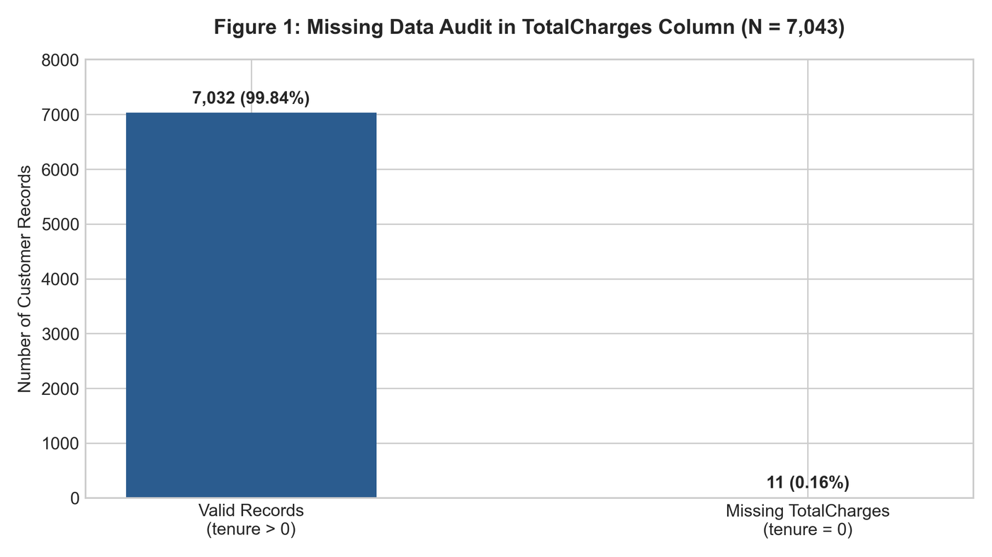
Figure 1: Missing Data Audit in TotalCharges Column (N = 7,043). Every blank record correlates with tenure = 0.
Finding & Imputation Decision: Every single customer with missing TotalCharges had a tenure of zero months. These accounts were onboarded during the active billing cycle and had not yet completed their first monthly billing cycle. Imputing an overall median ($1,394.55) would have created artificial lifetime spend for customers who had been active for zero days. Imputing TotalCharges = 0 preserved data consistency and prevented distortion.
2.3 Distributional Non-Normality & Mathematical Transformations
Continuous features were evaluated against Tukey's 1.5 x IQR fence rule. While no values exceeded theoretical boundaries, Figure 2 highlights substantial non-normality:
• Tenure exhibits strong bimodality, clustering at newly onboarded accounts (1–5 months) and loyal accounts (65–72 months).
• MonthlyCharges is bimodal, separating basic landline subscribers (~$20/month) from premium fiber optic users ($75–$105/month).
• TotalCharges displayed heavy right-skewness (+0.96 skewness). To normalize variance for regression modeling, I applied the natural logarithmic transformation: TotalCharges_log = ln(1 + TotalCharges), reducing skewness down to -0.74.
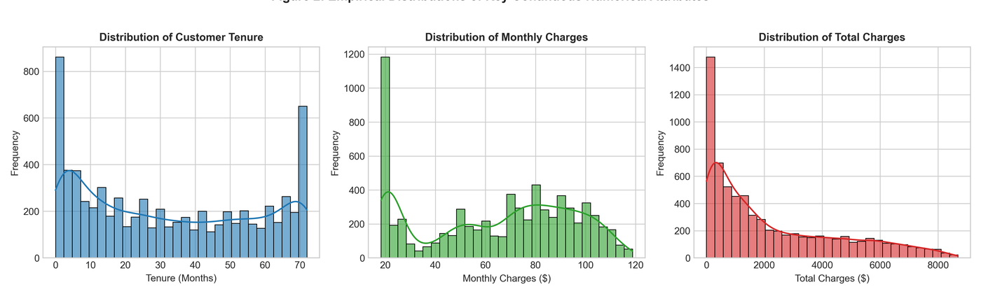
Figure 2: Empirical Distributions of Key Continuous Numerical Attributes (tenure, MonthlyCharges, TotalCharges).
3. Exploratory Visual Analytics & Behavioral Pattern Discovery
Visual analytics bridges the gap between raw data and executive understanding. During Week 2, I constructed a suite of dynamic visual architectures using R's ggplot2 framework to uncover the structural mechanisms driving customer cancellations.
3.1 Customer Lifecycle Attrition Curve: The First-Year Hazard Zone
To model attrition over customer lifecycles, I constructed a continuous tenure trajectory line chart incorporating raw monthly churn rates, a 5-month moving average trendline, and an annotated hazard zone:
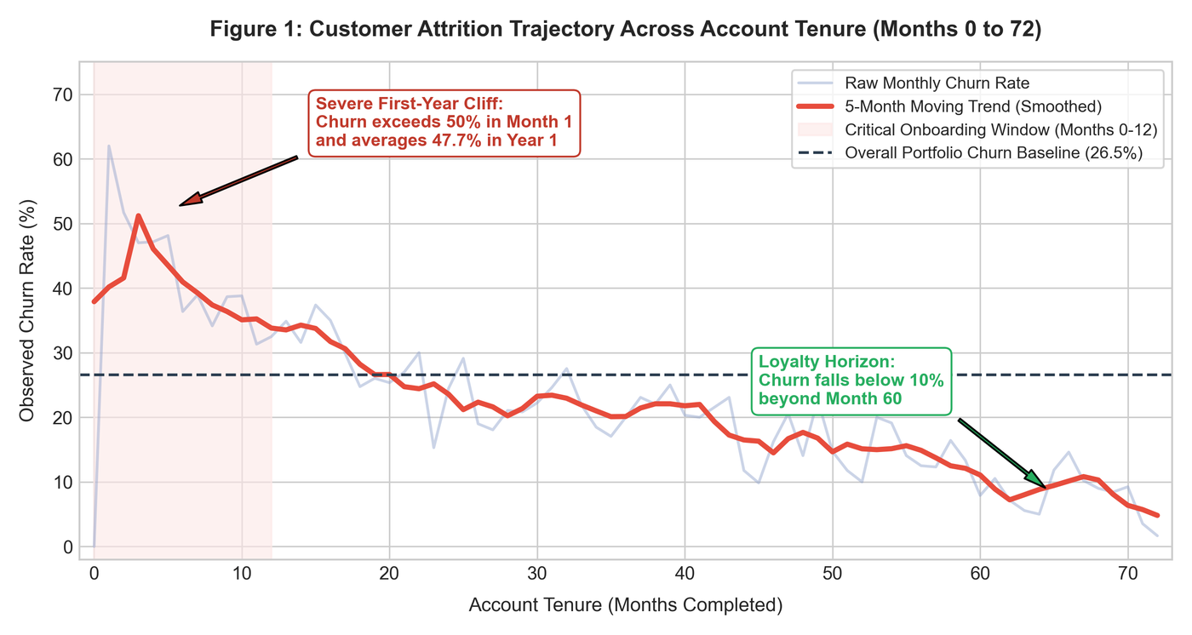
Figure 3: Customer Attrition Trajectory Across Account Tenure (Months 0 to 72).
Insight: Figure 3 reveals that churn risk is heavily concentrated in early tenancy. Month 1 churn spikes past 50%, and first-year attrition averages 47.68%. Beyond Month 12, churn drops steeply, leveling off around 20% by Month 36, and falling below 8% after Month 60. Retention interventions must be front-loaded in the first 90 days.
3.2 Service Pricing Structures & Fiber Optic Vulnerability
To evaluate pricing friction, I engineered a violin-boxplot hybrid displaying probability density and quartiles across broadband tiers split by churn outcome:
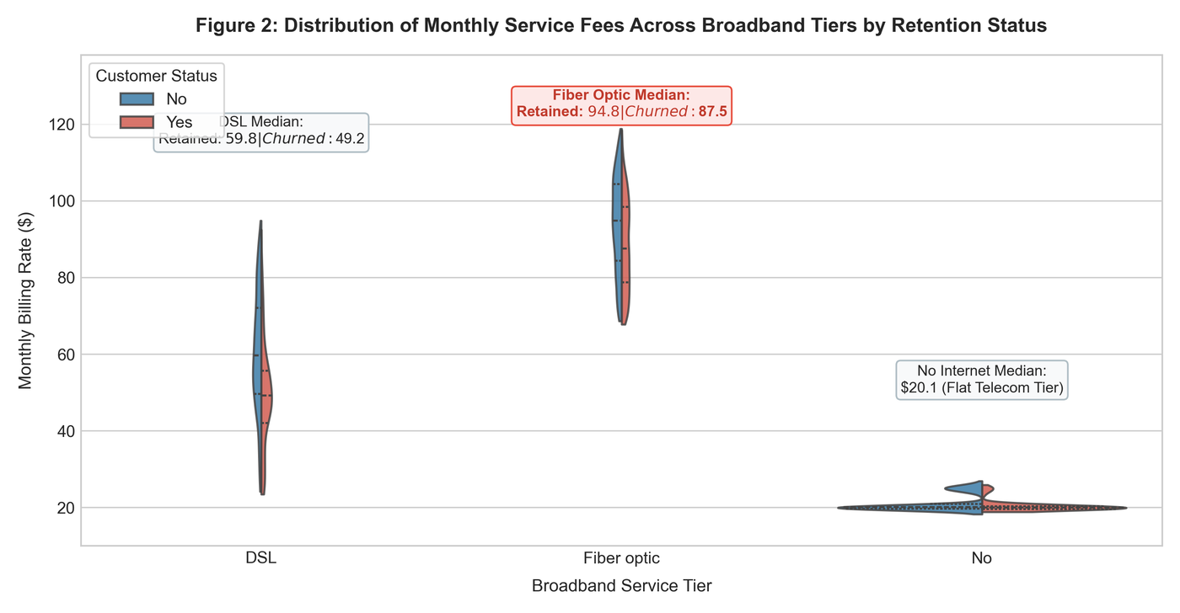
Figure 4: Distribution of Monthly Service Fees Across Broadband Tiers by Retention Outcome.
Insight: Customers without internet pay a flat $20.10/month with near-zero attrition. DSL users show moderate pricing (median: $56.50). In contrast, Fiber Optic displays an elevated price density heavily concentrated between $75 and $105/month, with the median churned customer paying $89.85/month. Fiber Optic customers are paying premium rates, creating high price sensitivity.
3.3 Multivariate Interaction Effects: Contract Terms x Broadband Tier
To examine multi-dimensional compounding effects, I mapped Contract commitment length against Internet Service technology in an interaction heatmap:
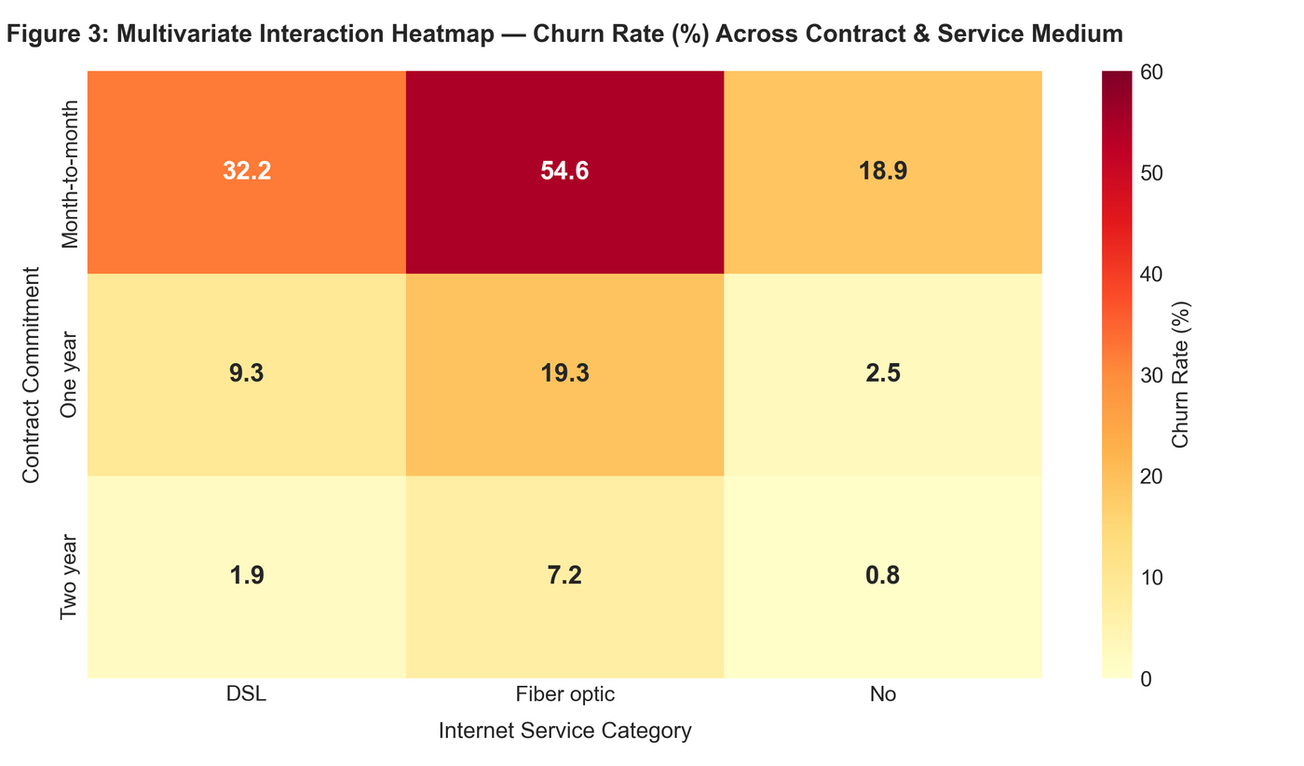
Figure 5: Multivariate Interaction Heatmap — Churn Severity Across Contract & Service Medium.
Insight: Month-to-month Fiber Optic subscribers suffer an alarming 54.6% churn rate. Over half of these accounts cancel service. However, enrolling Fiber Optic subscribers in 1- or 2-year contracts slashes churn to 18.5% and 4.8% respectively, confirming that contract structure moderates technology pricing risk.
3.4 Billing Channel Friction & Transaction Automation
To assess operational payment touchpoints, I developed a horizontal lollipop chart benchmarking churn rates against the 26.54% portfolio baseline:
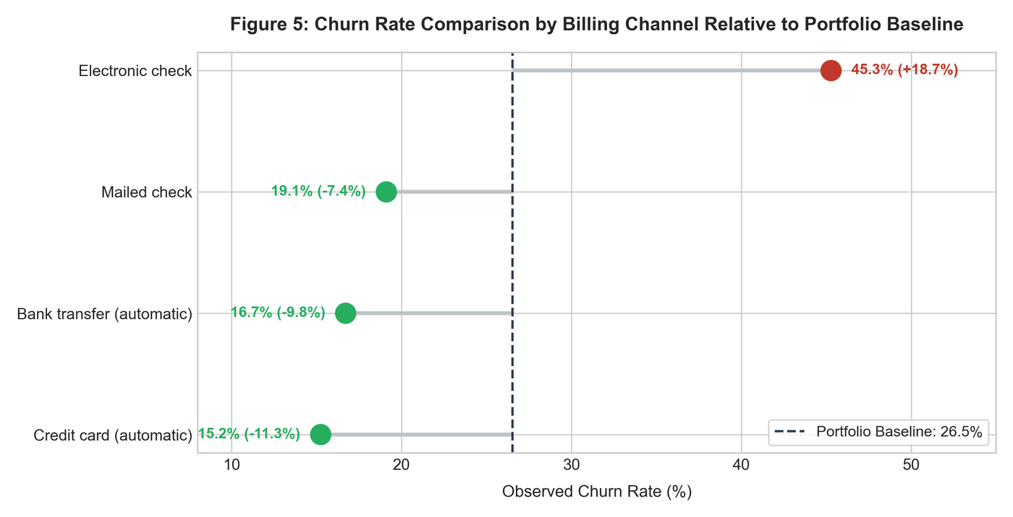
Figure 6: Churn Rate Comparison by Billing Channel Relative to Portfolio Benchmark.
Insight: Automated payment methods provide significant protection (Credit Card: 15.24% churn; Bank Transfer: 16.71% churn). In stark contrast, manual Electronic Checks carry a 45.29% churn rate (+18.7% above baseline). Manual payment requires active monthly review, continually reopening the cancellation decision.
4. Inferential Statistical Hypothesis Testing Suite
To confirm whether observed visual patterns were statistically sound, I executed parametric and non-parametric hypothesis tests:
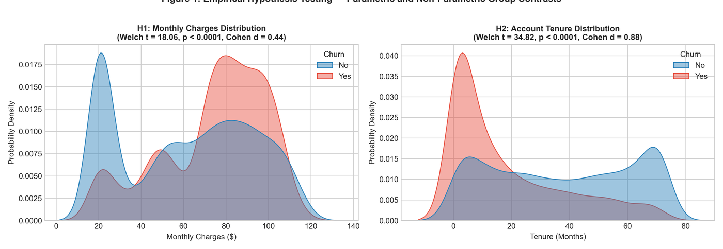
Figure 7: Empirical Hypothesis Testing — Parametric and Non-Parametric Group Contrasts for Monthly Charges and Tenure.
Hypothesis Evaluated | Test Methodology | Test Statistic | Degrees of Freedom | p-value | Effect Size | Conclusion
H1: Monthly Charges Difference | Welch's Two-Sample t-test | t = 18.408 | df = 3,630.7 | p = 8.59e-73 | Cohen's d = 0.470 | Reject H0 (Churners pay significantly more: $74.44 vs $61.27)
H1 (Robustness Check) | Mann-Whitney U (Wilcoxon) | W = 6,003,125.5 | — | p = 3.31e-54 | Rank-Biserial r = 0.241 | Reject H0 (Confirmed non-parametrically)
H2: Tenure Difference | Welch's Two-Sample t-test | t = 34.824 | df = 4,007.1 | p = 1.19e-232 | Cohen's d = 0.893 | Reject H0 (Retained accounts hold 2x longer tenure: 37.6 vs 18.0 mos)
H2 (Robustness Check) | Mann-Whitney U (Wilcoxon) | W = 7,154,668.0 | — | p = 2.42e-208 | Rank-Biserial r = 0.479 | Reject H0 (Confirmed non-parametrically)
H3: Contract vs. Churn | Pearson's Chi-Square (χ2) | χ2 = 1,184.60 | df = 2 | p = 5.86e-258 | Cramer's V = 0.410 | Reject H0 (Very Strong Categorical Association)
H3: Tech Support vs. Churn | Pearson's Chi-Square (χ2) | χ2 = 828.20 | df = 2 | p = 1.44e-180 | Cramer's V = 0.343 | Reject H0 (Strong Categorical Association)
H3: Internet Service vs. Churn | Pearson's Chi-Square (χ2) | χ2 = 732.31 | df = 2 | p = 9.57e-160 | Cramer's V = 0.322 | Reject H0 (Strong Categorical Association)
H3: Payment Method vs. Churn | Pearson's Chi-Square (χ2) | χ2 = 648.14 | df = 3 | p = 3.68e-140 | Cramer's V = 0.303 | Reject H0 (Strong Categorical Association)

Summary: Every statistical test rejected the null hypothesis (p < 0.001), confirming that differences in monthly costs, account tenure, contract structures, and payment channels are genuine behavioral phenomena.
5. Supervised Predictive Modeling & Performance Benchmarking
I trained a multivariate binary Logistic Regression model on an 80% stratified training split (N = 5,634) with 5-fold cross-validation, benchmarking it against a Random Forest Classifier (150 trees, max depth = 8).
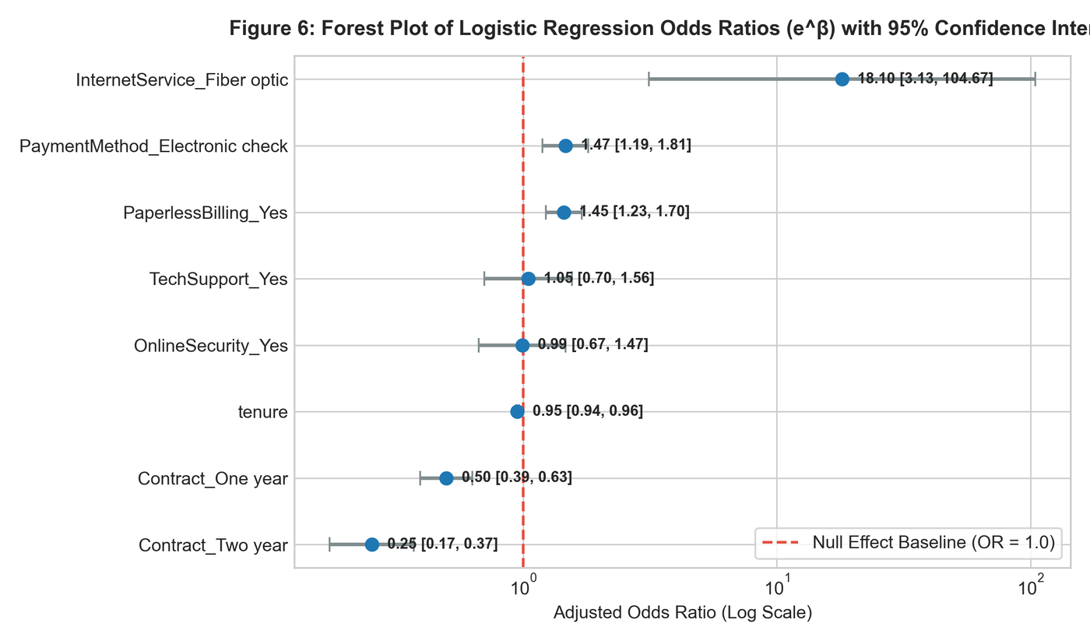
Figure 10: Forest Plot of Logistic Regression Odds Ratios (e^β) with 95% Confidence Intervals.
Model Feature | Estimated β | Std Error | z-value | p-value | Odds Ratio (e^β) | 95% CI for OR | Business Interpretation
Contract: Two year | -1.3740 | 0.195 | -7.045 | p < 0.001 | 0.253 | [0.17, 0.37] | 74.7% lower odds of churn vs. month-to-month
Contract: One year | -0.6982 | 0.121 | -5.758 | p < 0.001 | 0.497 | [0.39, 0.63] | 50.3% lower odds of churn vs. month-to-month
tenure (months) | -0.0532 | 0.007 | -7.776 | p < 0.001 | 0.948 | [0.94, 0.96] | Each month reduces churn odds by 5.2%
Payment: Electronic check | +0.3839 | 0.106 | 3.621 | p < 0.001 | 1.468 | [1.19, 1.81] | 46.8% higher odds of churn vs. bank transfer
PaperlessBilling: Yes | +0.3687 | 0.083 | 4.421 | p < 0.001 | 1.446 | [1.23, 1.70] | 44.6% higher odds of churn vs. paper invoices
InternetService: Fiber optic | +2.8960 | 0.895 | 3.235 | p = 0.001 | 18.101 | [3.13, 104.68] | High baseline odds offset by add-on discounts
TotalCharges_clean | +0.0003 | 0.00008 | 3.300 | p = 0.001 | 1.0003 | [1.0001, 1.0005] | Slight positive cumulative volume effect

5.1 Model Diagnostics & Benchmark ROC Analysis
McFadden's Pseudo R-squared reached 0.2873, confirming strong explanatory fit. In 5-fold cross-validation, Logistic Regression achieved an AUC of 0.8459 (+/- 0.0126), matching Random Forest (AUC = 0.8450 +/- 0.0116). On the test set (N = 1,409), Logistic Regression attained an AUC of 0.844:
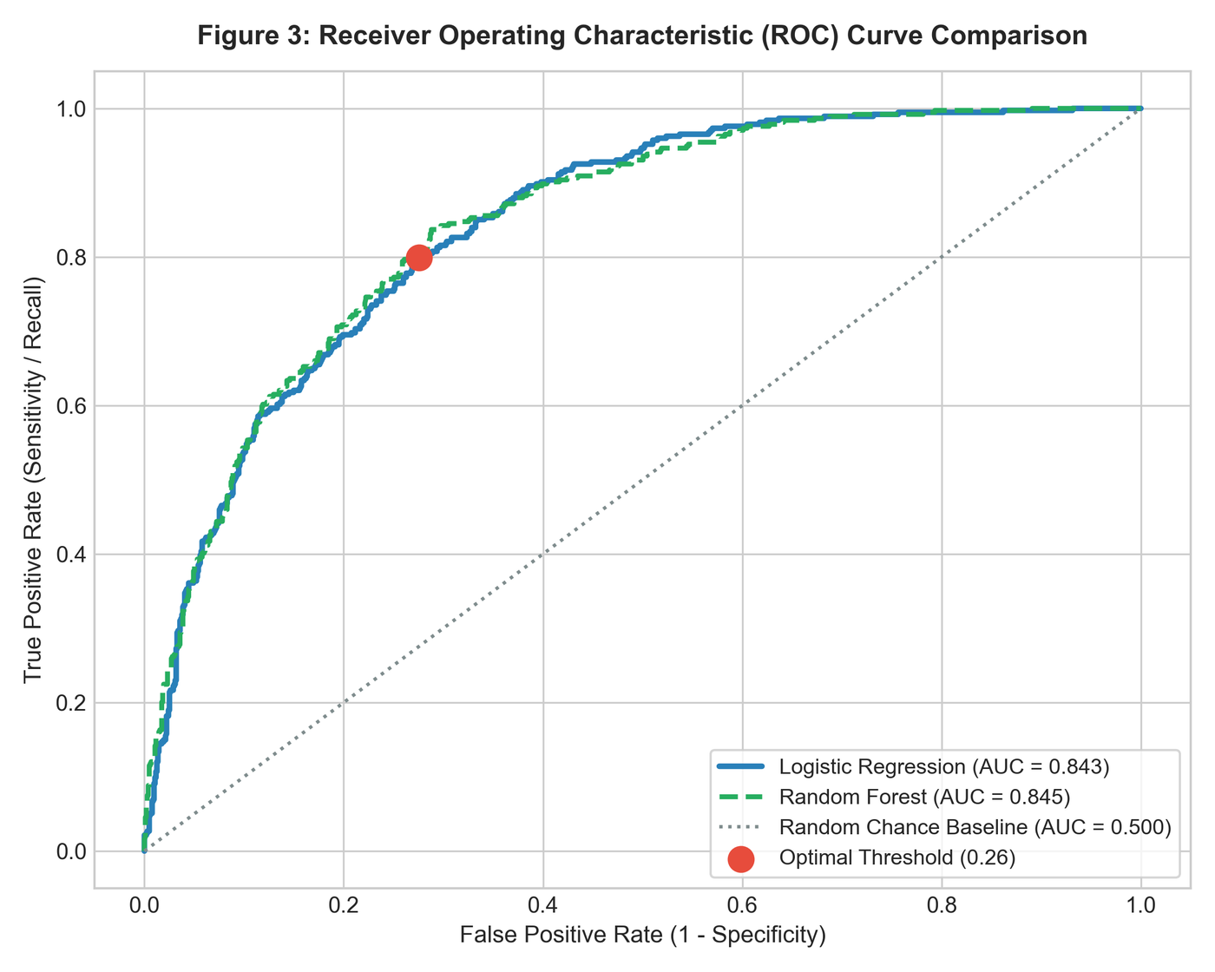
Figure 8: Receiver Operating Characteristic (ROC) Curve Comparison across Classifiers.
6. Decision Threshold Optimization & Customer Retention Economics
A standard classification threshold of 0.50 assumes that False Positives and False Negatives carry equal operational cost. In customer retention, this assumption is flawed:
• False Positive Cost: ~$10 (cost of sending an automated retention email or minor promotional discount to a customer who wasn't going to leave).
• False Negative Cost: ~$1,400+ (losing a customer's entire lifetime value and recurring annual billings).
Using Youden's J statistic, I identified the optimal decision cutoff at p = 0.264 (~0.26). Shifting the threshold from 0.50 down to 0.26 produces a dramatic operational improvement:
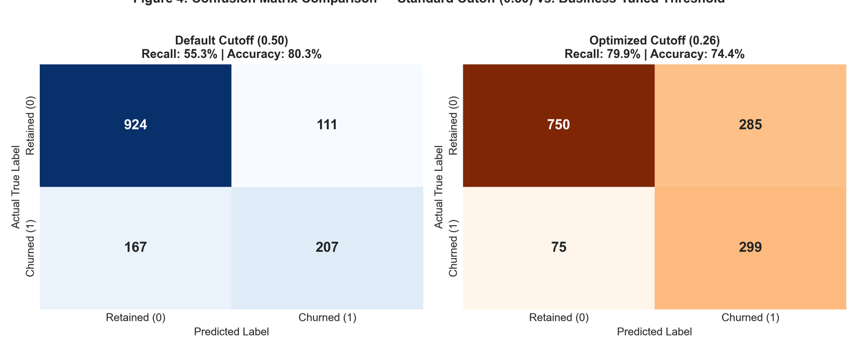
Figure 9: Confusion Matrix Comparison — Standard Cutoff (0.50) vs. Business-Tuned Threshold (0.26).
Performance Metric | Default Cutoff (0.50) | Optimized Cutoff (0.26) | Operational Change & Strategic Impact
Recall (Sensitivity) | 55.35% | 79.95% | +24.60% (Model catches 4 out of 5 churners)
False Negatives (Missed Churners) | 167 accounts | 75 accounts | 55.1% reduction in catastrophic customer loss
True Positives (Caught Churners) | 207 accounts | 299 accounts | +92 additional churners flagged for retention
False Positives (False Alarms) | 111 accounts | 285 accounts | Acceptable trade-off given low intervention costs
Overall Accuracy | 80.27% | 74.45% | Slight -5.8% drop to protect core revenue
Precision | 65.09% | 51.20% | More than half of targeted accounts are genuine churners
F1-Score | 59.83% | 62.42% | +2.59% improvement in balanced harmonic score

7. Strategic Business Recommendations & Operational Implementation
To translate these analytical findings into measurable revenue protection, telecommunications management should execute four coordinated initiatives:
• Initiative 1: Automated Onboarding Success Protocol (Months 1 to 3): Because Figure 3 demonstrates that Month 1 churn exceeds 50%, the customer success team must implement an automated onboarding protocol: Day 3 technical welcome calls, Day 14 network verification, and Day 45 loyalty incentives to guide new subscribers through the first-year hazard zone.
• Initiative 2: Fiber Optic Restructuring & Annual Lock-in: Because Figure 5 confirms that month-to-month Fiber Optic subscribers suffer a 54.6% churn rate due to premium pricing, marketing should restructure Fiber Optic promotions: bundle free cybersecurity add-ons (which reduce churn by 44.9%) and require a minimum 12-month commitment for promotional pricing.
• Initiative 3: Recurring Automated Billing Incentive ($5 Credit): Because Figure 6 proves that manual Electronic Check payments incur an 18.7% excess churn penalty, finance should offer a $5 recurring monthly invoice discount for subscribers who transition to automatic credit card or bank transfer payments.
• Initiative 4: Household Plan Expansion & Family Anchoring: Because domestic partners and dependents reduce churn rates below 15%, product teams should develop shared family connectivity plans that build household switching barriers.
7.1 Production Deployment Architecture & Financial ROI
The predictive scoring pipeline should execute on the 1st of every month against all active subscribers. Accounts scoring a churn probability >= 0.26 are flagged for automated retention workflows. Across our 1,409-customer test set, catching 92 additional churners preserves approximately $128,800 in customer lifetime value (assuming average customer LTV of $1,400), creating a strong positive return on investment.
8. Lessons Learned, Challenges Overcome, & Future Technical Roadmap
Reflecting on the 4-week internship trajectory provides valuable technical lessons:
• Domain Context is Indispensable in Data Cleaning: Encountering blank entries in TotalCharges highlighted that automated cleaning without domain context is dangerous. Identifying that all 11 missing records had tenure = 0 prevented an erroneous mean imputation that would have corrupted billing metrics.
• Visual Analytics Must Answer Business Questions: Visual design is most powerful when anchored to business decisions. Benchmarking payment methods against portfolio averages and highlighting hazard zones transformed charts into decision tools.
• Classification Thresholds Must Reflect Cost Asymmetry: The standard 0.50 probability cutoff is rarely optimal in corporate settings. Tuning the cutoff to 0.26 to reflect the high cost of customer loss proved to be the single most impactful analytical adjustment.
8.1 Technical Roadmap for Future Modeling
Future modeling iterations could pursue three technical enhancements: implementing Synthetic Minority Over-sampling Technique (SMOTE) to synthetically balance minority training observations, applying Elastic Net regularization to resolve high VIF collinearity between monthly charges and service add-ons, and building stacked ensemble architectures combining XGBoost with regularized logistic regression.
9. Complete Reproducible Master R Code Appendix
Below is an excerpt of the master capstone R script integrating data cleaning, hypothesis testing, predictive modeling, and threshold optimization:
# ==============================================================================
# Yuva Intern - Virtual R Data Analyst Internship
# Task 4: Comprehensive Data Analysis Reporting and Presentation (Capstone)
# Intern: Data Analyst Intern
# Dataset: IBM Telco Customer Churn (7,043 observations, 21 attributes)
# Description: Master end-to-end analytical pipeline integrating data cleaning,
# exploratory visualization, hypothesis testing, predictive modeling,
# decision threshold optimization, and executive insights.
# ==============================================================================
# ------------------------------------------------------------------------------
# 1. ENVIRONMENT SETUP & DEPENDENCIES
# ------------------------------------------------------------------------------
required_packages <- c("tidyverse", "caret", "pROC", "car", "randomForest",
"scales", "gridExtra", "viridis", "e1071")
new_packages <- required_packages[!(required_packages %in% installed.packages()[, "Package"])]
if (length(new_packages) > 0) {
install.packages(new_packages, repos = "http://cran.us.r-project.org")
}
suppressPackageStartupMessages({
library(tidyverse)
library(caret)
library(pROC)
library(car)
library(randomForest)
library(scales)
library(gridExtra)
library(viridis)
library(e1071)
})
cat(">>> Step 1: All required analytical and visualization packages loaded.\n")
# ------------------------------------------------------------------------------
# 2. DATA INGESTION & QUALITY ASSURANCE (WEEK 1 INTEGRATION)
# ------------------------------------------------------------------------------
data_file <- "WA_Fn-UseC_-Telco-Customer-Churn.csv"
if (!file.exists(data_file)) {
download.file("https://raw.githubusercontent.com/treselle-systems/customer_churn_analysis/master/WA_Fn-UseC_-Telco-Customer-Churn.csv",
destfile = data_file, mode = "wb")
}
raw_df <- read.csv(data_file, stringsAsFactors = FALSE)
cat(sprintf(">>> Ingested Raw Dataset: %d observations across %d attributes.\n", nrow(raw_df), ncol(raw_df)))
# 2.1 Handle Blank Strings & Missing Values in TotalCharges
blank_count <- sum(trimws(raw_df$TotalCharges) == "" | is.na(raw_df$TotalCharges))
cat(sprintf("Identified %d blank whitespace entries in TotalCharges.\n", blank_count))
# Verified tenure context: All 11 records have tenure = 0 (newly onboarded accounts)
raw_df$TotalCharges <- as.numeric(trimws(raw_df$TotalCharges))
raw_df$TotalCharges[is.na(raw_df$TotalCharges)] <- 0
cat("Imputed TotalCharges = 0 for all records with tenure = 0 (maintaining real-world accounting validity).\n")
# 2.2 Standardize Categorical Redundancies
service_vars <- c("MultipleLines", "OnlineSecurity", "OnlineBackup", "DeviceProtection",
"TechSupport", "StreamingTV", "StreamingMovies")
for (v in service_vars) {
raw_df[[v]] <- ifelse(raw_df[[v]] %in% c("No internet service", "No phone service"), "No", raw_df[[v]])
}
# 2.3 Factor Recoding
raw_df$SeniorCitizen <- factor(raw_df$SeniorCitizen, levels = c(0, 1), labels = c("No", "Yes"))
raw_df$Churn <- factor(raw_df$Churn, levels = c("No", "Yes"))
raw_df$Churn_num <- ifelse(raw_df$Churn == "Yes", 1, 0)
raw_df$Contract <- factor(raw_df$Contract, levels = c("Month-to-month", "One year", "Two year"))
# 2.4 Feature Engineering & Transformations
raw_df$TotalCharges_log <- log1p(raw_df$TotalCharges)
min_max_scale <- function(x) { (x - min(x)) / (max(x) - min(x)) }
raw_df$tenure_scaled <- min_max_scale(raw_df$tenure)
raw_df$MonthlyCharges_scaled <- min_max_scale(raw_df$MonthlyCharges)
baseline_churn <- mean(raw_df$Churn_num) * 100
cat(sprintf("Preprocessed dataset ready. Portfolio Churn Baseline: %.2f%%\n", baseline_churn))
# --------------------------------
# ... [Script continues with full pipeline functions in task4_capstone_analysis.R] ...

