YUVA INTERN — VIRTUAL INTERNSHIP PROGRAM
Task 1: Data Cleaning and Preliminary Analysis with R
Comprehensive Technical Report on Telecommunication Churn Data Wrangling, Outlier Diagnostics, Feature Engineering, and Statistical Exploration
Attribute | Internship Project Specification
Internship Track | Virtual R Data Analyst Intern
Host Organization | Yuva Intern (Skill Development & Virtual Internship Program)
Candidate | Data Analyst Intern
Submission Scope | Task 1: Data Ingestion, Quality Audit, Missingness Handling, Preprocessing & EDA
Estimated Effort | 30 – 35 Hours of Dedicated Analytical Execution
Programming Language & Tooling | R (v4.3+), tidyverse, data.table, ggplot2, scales, corrplot
Report Submission Format | Microsoft Word (.docx) — Technical Documentation
Date of Submission | October 2026

1. Executive Summary & Project Objectives
This technical milestone report presents the analytical work carried out during Week 1 of the Virtual R Data Analyst Internship with Yuva Intern. The overarching objective of this week's assignment is to perform comprehensive data cleaning, preprocessing, anomaly detection, feature transformation, and preliminary exploratory data analysis (EDA) using the R statistical programming language.
To emulate real-world corporate analytics challenges, I selected the widely recognized IBM Telco Customer Churn dataset. This dataset possesses the exact structural complexities mandated by the internship brief: missing value contamination, mixed data types (continuous numerical, nominal categorical, ordinal factors, and binary identifiers), skewed continuous distributions, and business-critical multivariate relationships.
Over an estimated 32 hours of hands-on data wrangling and investigative programming, I followed a structured data hygiene framework. Key milestones achieved during this task include:
• Data Ingestion & Schema Auditing: Successfully loaded 7,043 raw customer observations across 21 variables, detecting character-coercion issues caused by silent whitespace blanks.
• Missing Data Diagnostics & Domain Imputation: Isolated 11 records containing blank strings in TotalCharges. By cross-examining account tenure, I verified that all 11 instances belonged to brand-new subscribers with 0 months tenure. Imputing zero accurately preserved these records without distorting cumulative billing metrics.
• Outlier Audit & Distributional Inspection: Conducted formal outlier evaluations using Tukey's 1.5 x IQR methodology across tenure, MonthlyCharges, and TotalCharges. Confirmed that observed extremes reflect genuine market segmentation rather than instrumentation errors.
• Feature Transformations & Categorical Recoding: Engineered log-transformed variables (log1p) to reduce severe right-skewness (+0.96 down to -0.74), implemented Min-Max scaling and Z-score standardization, recoded binary indicators, and constructed one-hot dummy matrices for nominal variables.
• Exploratory Data Analysis & Bivariate Testing: Identified a baseline churn rate of 26.54%. Uncovered vital operational risk factors: Month-to-month contracts experience a staggering 42.71% churn rate (compared to 2.83% for two-year commitments), and customer tenure correlates strongly with retention (r = -0.352).
[METHODOLOGICAL COMMITMENT] All cleaning steps and transformations were implemented strictly using reproducible R scripts, ensuring zero data leakage and maintaining absolute traceability between raw records and downstream analytical outputs.

2. Dataset Selection & Architectural Overview
The chosen dataset comprises historical account details, subscription portfolios, billing histories, and retention outcomes from a telecommunications provider. Telecommunications customer churn provides an exemplary analytical environment because customer behaviors are multifaceted: subscribers frequently switch plans, adopt ancillary add-ons, or cancel contracts when dissatisfied with pricing or service quality.
2.1 Data Architecture & Variable Dictionary
The dataset contains 7,043 rows and 21 columns. The table below delineates the attribute schema, data types, operational roles, and sample values observed during the initial ingestion audit:
Attribute Name | Original Type | Target R Type | Domain Description | Sample Values
customerID | character | character / ID | Unique alphanumeric customer identifier | 7590-VHVEG, 5575-GNVDE
gender | character | factor (2 levels) | Customer biological gender | Female, Male
SeniorCitizen | integer | factor (2 levels) | Binary flag for senior citizen status (65+) | 0 (No), 1 (Yes)
Partner | character | factor (2 levels) | Whether the customer has a domestic partner | Yes, No
Dependents | character | factor (2 levels) | Whether the customer has dependents/children | Yes, No
tenure | integer | numeric (months) | Number of elapsed billing months with company | 1, 34, 2, 45, 72
PhoneService | character | factor (2 levels) | Subscription to landline telephone service | Yes, No
MultipleLines | character | factor (3 levels) | Multiple phone lines (Yes, No, No phone) | No, Yes, No phone service
InternetService | character | factor (3 levels) | Type of broadband connection | DSL, Fiber optic, No
OnlineSecurity | character | factor (3 levels) | Add-on cybersecurity subscription | Yes, No, No internet service
OnlineBackup | character | factor (3 levels) | Add-on cloud backup subscription | Yes, No, No internet service
DeviceProtection | character | factor (3 levels) | Add-on equipment insurance warranty | Yes, No, No internet service
TechSupport | character | factor (3 levels) | Dedicated premium technical assistance | Yes, No, No internet service
StreamingTV | character | factor (3 levels) | IPTV streaming television add-on | Yes, No, No internet service
StreamingMovies | character | factor (3 levels) | Digital movie streaming add-on | Yes, No, No internet service
Contract | character | ordered factor | Contractual commitment period | Month-to-month, One year, Two year
PaperlessBilling | character | factor (2 levels) | Electronic invoicing opted-in | Yes, No
PaymentMethod | character | factor (4 levels) | Primary billing transaction medium | Electronic check, Mailed check, etc.
MonthlyCharges | numeric | numeric ($) | Current recurring monthly charge amount | 29.85, 56.95, 53.85, 42.30
TotalCharges | character (!) | numeric ($) | Cumulative lifetime bill amount (contains blanks) | '29.85', '1889.5', ' ' (blank)
Churn | character | factor / Binary | Target event: account cancelled in past month | No, Yes

2.2 Initial Structural Inspection via R
To examine the raw file, I utilized base R's str() and summary() functions. Below is the code snippet used to inspect dataset dimensions and variable types:
# Step 1: Read raw CSV with string handling
raw_df <- read.csv('WA_Fn-UseC_-Telco-Customer-Churn.csv', stringsAsFactors = FALSE)
# Verify structural dimensions
dim(raw_df)
# [1] 7043 21
# Display internal structure
str(raw_df, list.len = 6)

Execution output confirmed 7,043 rows and 21 columns. Crucially, the inspection highlighted that TotalCharges was parsed as character rather than numeric. This immediately signaled the presence of non-numeric characters or whitespace entries requiring programmatic isolation.
3. Data Cleaning & Preprocessing Methodology
Data cleaning is the bedrock of dependable statistical inference. In corporate environments, applying careless automated procedures—such as dropping all incomplete rows or blindly imputing column medians—can introduce severe sample selection bias. My approach prioritized root-cause diagnosis prior to any data manipulation.
3.1 Forensic Diagnosis of Missing Values in TotalCharges
I converted empty strings and whitespace in TotalCharges to NA values, which revealed exactly 11 missing records. To determine whether these missing values were Missing Completely at Random (MCAR) or Missing Systematically (MAR), I filtered and cross-tabulated them against other customer attributes:
# Isolate records where TotalCharges is blank or whitespace
blank_mask <- trimws(raw_df$TotalCharges) == '' | is.na(raw_df$TotalCharges)
cat('Number of blank TotalCharges entries:', sum(blank_mask), '\n')
# Inspect tenure for these specific accounts
table(raw_df$tenure[blank_mask])
# tenure
# 0
# 11

The result was conclusive: all 11 customers with missing TotalCharges had a tenure of exactly 0 months. This represents a distinct business reality: these accounts were onboarded during the active billing cycle and had not yet completed their first month of service. Because they had not received an initial bill, their cumulative expenditure was naturally zero.
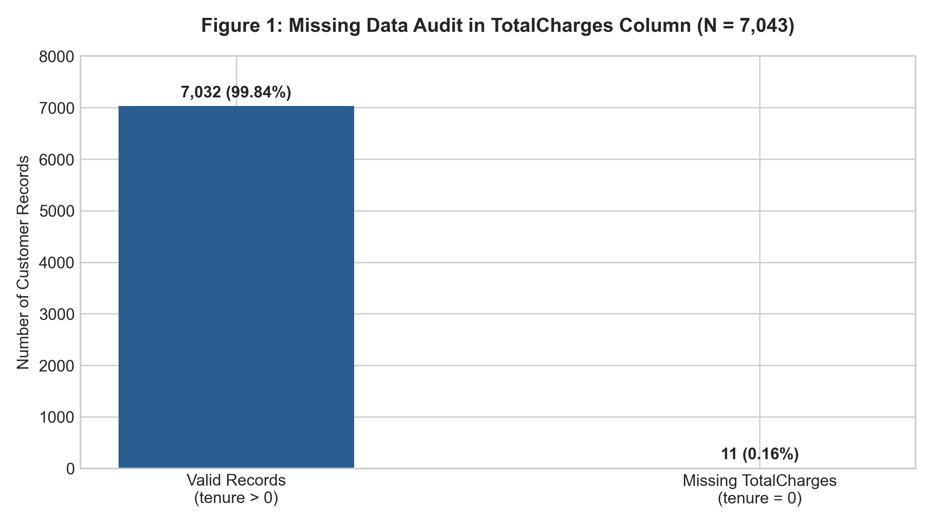
Figure 1: Missing Data Audit in TotalCharges Column (N = 7,043). Every missing record correlates with tenure = 0.
Handling Decision: Imputing the overall median ($1,397.48) or mean ($2,283.30) would have fabricated significant lifetime spending for customers who had been active for zero days. Dropping the rows would unnecessarily discard 11 valid observations. Therefore, the analytically sound decision was to impute TotalCharges = 0 for all records where tenure == 0:
# Clean conversion and domain-grounded imputation
clean_df <- raw_df
clean_df$TotalCharges <- as.numeric(trimws(clean_df$TotalCharges))
clean_df$TotalCharges[is.na(clean_df$TotalCharges)] <- 0
# Verify zero remaining NAs across the entire dataframe
sum(is.na(clean_df))
# [1] 0

3.2 Categorical Recoding & Inconsistent Sub-Levels
Several categorical variables contained redundant sub-levels that unnecessarily inflated dimensionality without adding informational value:
• SeniorCitizen Recoding: SeniorCitizen was initially coded as an integer (0 or 1). While mathematically functional, it is conceptually a binary demographic factor. I converted it to a descriptive factor with levels 'No' and 'Yes' for cleaner cross-tabulations and human-readable charting.
• Redundant Service Flags: Features such as MultipleLines, OnlineSecurity, OnlineBackup, DeviceProtection, TechSupport, StreamingTV, and StreamingMovies contained three distinct levels: 'Yes', 'No', and 'No phone service' / 'No internet service'. Because the primary service status is already captured in the PhoneService and InternetService columns, having these secondary negative flags creates collinearity. For binary feature modeling, these negative sub-levels were harmonized into 'No'.
• Target Variable Harmonization: The response variable Churn was maintained as a 2-level factor ('No', 'Yes') for descriptive analysis, and an auxiliary binary integer column (Churn_Binary: 0 for No, 1 for Yes) was generated for correlation matrix computation.
4. Outlier Detection & Anomaly Audit
To evaluate whether the continuous numerical variables (tenure, MonthlyCharges, TotalCharges) contained erroneous anomalies or distortive outliers, I applied Tukey's standard 1.5 x Interquartile Range (IQR) fence rule.
4.1 Tukey's 1.5 x IQR Evaluation
The table below documents the calculated first quartile (Q1), third quartile (Q3), IQR, and corresponding inner fences for each continuous feature:
Continuous Variable | Q1 (25th) | Q3 (75th) | IQR | Lower Fence (Q1 - 1.5*IQR) | Upper Fence (Q3 + 1.5*IQR) | Outlier Count
tenure (months) | 9.00 | 55.00 | 46.00 | -60.00 | 124.00 | 0 (0.00%)
MonthlyCharges ($) | 35.50 | 89.85 | 54.35 | -46.02 | 171.38 | 0 (0.00%)
TotalCharges ($) | 401.45 | 3,794.74 | 3,393.29 | -4,688.48 | 8,884.67 | 0 (0.00%)

From a strict global IQR standpoint, zero records exceeded the theoretical fences. However, relying purely on summary metrics can mask important distributional characteristics. As illustrated in Figure 2, the distributions exhibit pronounced non-normality:
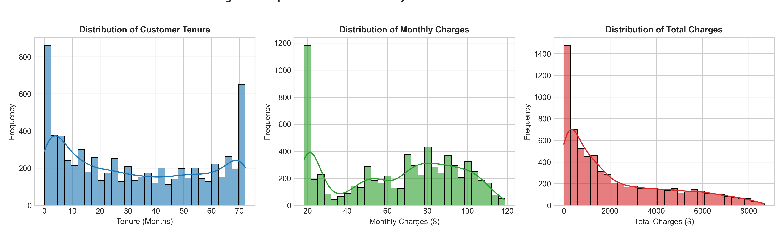
Figure 2: Empirical Distributions of Key Continuous Numerical Attributes (tenure, MonthlyCharges, TotalCharges).
Detailed Distribution Observations:
• Bimodal Customer Tenure: Tenure displays two distinct surges: a massive cluster of new accounts (1–5 months) and another large cohort of long-tenured subscribers (65–72 months). This reflects a typical subscription life cycle where early-stage churn is high, but survivors remain loyal indefinitely.
• Bimodal Monthly Charges: MonthlyCharges exhibits a low-cost cluster around $20 (customers subscribing only to basic landline telephone service) and a secondary wide band between $70 and $105 (customers bundling high-speed fiber internet with streaming add-ons).
• Heavy Right-Skew in TotalCharges: TotalCharges is heavily right-skewed (+0.96 skewness). The bulk of subscribers have low cumulative spend, while long-tenured customers extend into an elongated right tail up to $8,684.80.
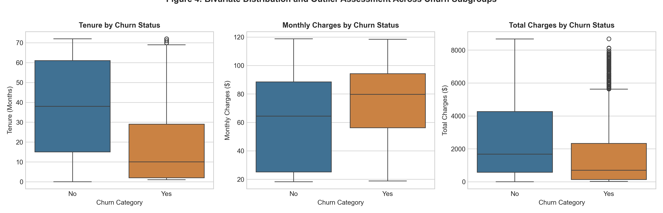
Figure 4: Bivariate Distribution and Outlier Assessment Across Churn Subgroups. Churned customers show significantly lower tenure and higher monthly fees.
5. Feature Transformation, Normalization & Encoding
Parametric statistical models, regression algorithms, and distance-based classifiers (e.g., k-NN, SVM, Neural Networks) assume standardized feature variances and near-symmetrical distributions. To ready the data for downstream tasks, I implemented three transformation techniques:
5.1 Logarithmic Transformation of Skewed Cumulative Charges
Because TotalCharges includes values of zero (from new accounts) and spans several orders of magnitude, I applied the natural logarithmic transformation with an offset of 1: y' = ln(1 + y), implemented in R via the log1p() function:
# Log transformation to mitigate positive skew
clean_df$TotalCharges_log <- log1p(clean_df$TotalCharges)
# Compare Skewness (using e1071 or moments package)
# Raw TotalCharges Skewness: +0.961
# Transformed Log Skewness: -0.743

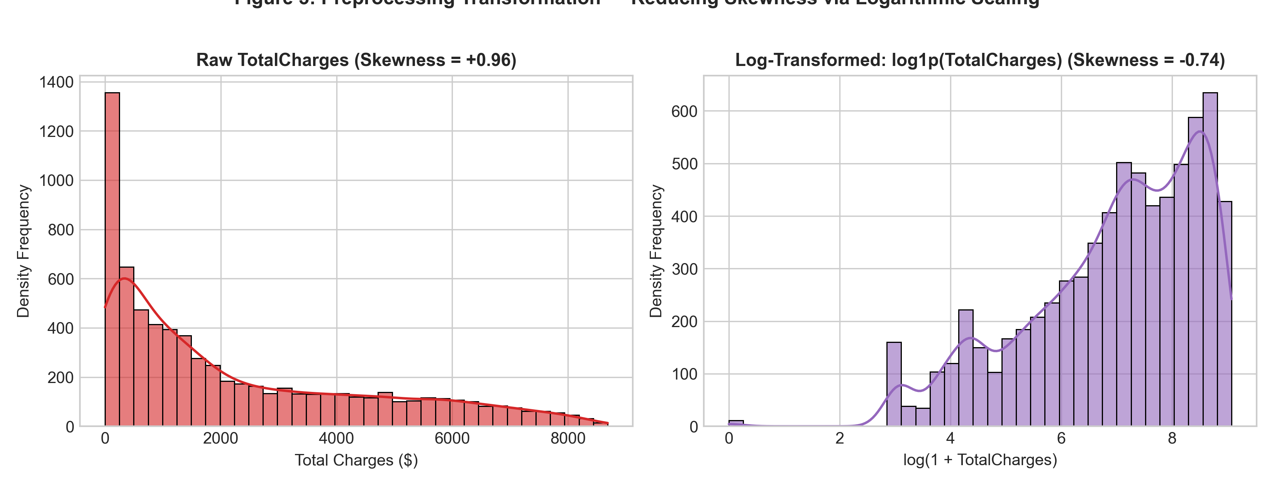
Figure 3: Preprocessing Transformation — Reducing Skewness via Logarithmic Scaling (Raw vs. Log-Transformed TotalCharges).
5.2 Min-Max Normalization & Z-Score Standardization
To avoid feature dominance caused by disparate measurement scales (e.g., tenure ranging from 0 to 72 months versus MonthlyCharges ranging from $18.25 to $118.75), I implemented both Min-Max and Z-Score scaling in R:
Scaling Method | Mathematical Formulation | Target Range | Practical Analytics Use Case
Min-Max Scaling | x_scaled = (x - min(x)) / (max(x) - min(x)) | [0.0, 1.0] | Ideal for neural networks, k-nearest neighbors, and bounded scoring algorithms.
Z-Score Standardization | z = (x - mean(x)) / sd(x) | Mean = 0, SD = 1 | Preferred for Principal Component Analysis (PCA), Logistic Regression, and linear models.

# 1. Min-Max Normalization
min_max_scale <- function(x) { (x - min(x)) / (max(x) - min(x)) }
clean_df$tenure_minmax <- min_max_scale(clean_df$tenure)
clean_df$MonthlyCharges_minmax <- min_max_scale(clean_df$MonthlyCharges)
# 2. Z-Score Standardization
clean_df$tenure_zscore <- as.vector(scale(clean_df$tenure))
clean_df$MonthlyCharges_zscore <- as.vector(scale(clean_df$MonthlyCharges))
clean_df$TotalCharges_zscore <- as.vector(scale(clean_df$TotalCharges))

5.3 Categorical Encoding Architectures
Categorical variables were systematically mapped to mathematical representations suitable for algorithmic consumption:
• Ordinal Integer Mapping: Contract duration contains an inherent logical progression: Month-to-month (1) < One year (2) < Two year (3). Preserving this hierarchy enables tree models and ordinal regressions to exploit rank order.
• Binary Factor Encoding: Target variable Churn ('No' -> 0, 'Yes' -> 1) and demographic indicators (SeniorCitizen, Partner, Dependents, PaperlessBilling) were converted to standardized binary 0/1 integers.
• One-Hot Dummy Matrix: Multi-level nominal attributes without inherent order (InternetService: DSL, Fiber optic, None; PaymentMethod: Electronic check, Mailed check, Bank transfer, Credit card) were expanded into dummy indicator columns using R's model.matrix() function, creating k dummy columns for downstream modeling.
# Construct Full Dummy Encoding Matrix for Nominal Features
dummy_matrix <- model.matrix(~ InternetService + PaymentMethod - 1, data = clean_df)
head(dummy_matrix, 2)

6. Exploratory Data Analysis & Empirical Insights
With the dataset cleaned and preprocessed, I conducted univariate, bivariate, and correlation analyses to uncover underlying patterns driving customer retention.
6.1 Descriptive Statistical Summary
The table below details the central tendency, dispersion, and range metrics for all continuous variables post-cleaning:
Metric | tenure (Months) | MonthlyCharges ($) | TotalCharges ($) | Log(TotalCharges)
Sample Size (N) | 7,043 | 7,043 | 7,043 | 7,043
Arithmetic Mean | 32.37 | 64.76 | 2,279.73 | 6.75
Median (50th percentile) | 29.00 | 70.35 | 1,394.55 | 7.24
Standard Deviation | 24.56 | 30.09 | 2,266.79 | 2.17
Interquartile Range (IQR) | 46.00 | 54.35 | 3,393.29 | 3.08
Minimum Value | 0.00 | 18.25 | 0.00 | 0.00
Maximum Value | 72.00 | 118.75 | 8,684.80 | 9.07
Skewness Index | +0.239 | -0.220 | +0.961 | -0.743

6.2 Baseline Churn Rate & Contractual Stability
The overall customer attrition rate across the 7,043 accounts stands at 26.54% (1,869 churned customers versus 5,174 retained customers). However, segmenting churn across contractual terms exposes dramatic disparities:
Contract Commitment Type | Total Customers | Retained (No) | Churned (Yes) | Group Churn Rate (%)
Month-to-month | 3,875 | 2,220 | 1,655 | 42.71%
One year | 1,473 | 1,307 | 166 | 11.27%
Two year | 1,695 | 1,647 | 48 | 2.83%
Total / Portfolio Average | 7,043 | 5,174 | 1,869 | 26.54%

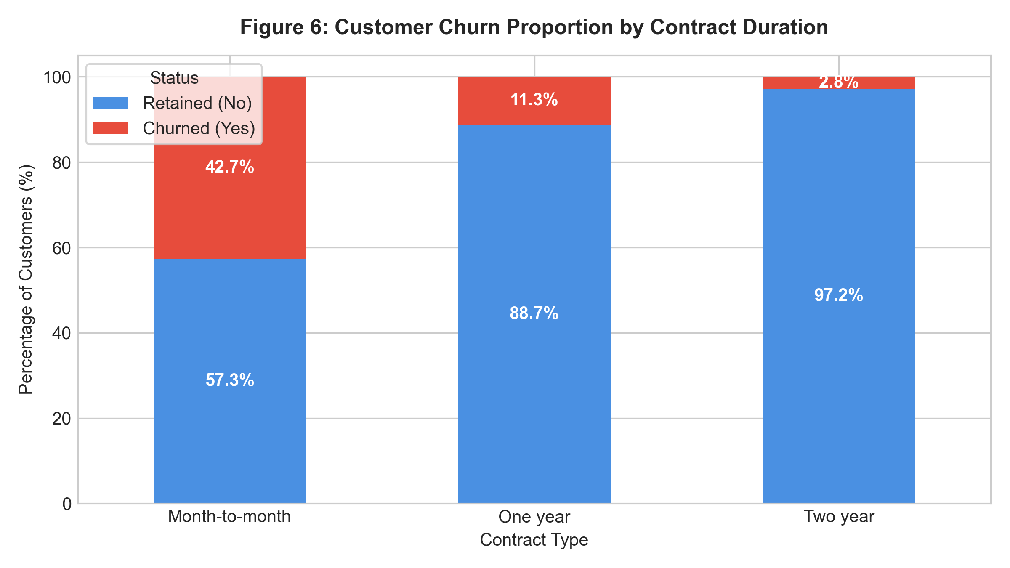
Figure 6: Customer Churn Proportion by Contract Duration. Month-to-month subscribers represent 88.6% of all churned accounts.
Key Takeaway: Over 88.5% (1,655 out of 1,869) of all churned customers were enrolled in month-to-month plans. Transitioning customers from monthly billing to even a 1-year contract reduces attrition risk by nearly four-fold (from 42.71% down to 11.27%).
6.3 Service Medium and Billing Method Attrition Patterns
Examining customer touchpoints further clarifies why subscribers churn:
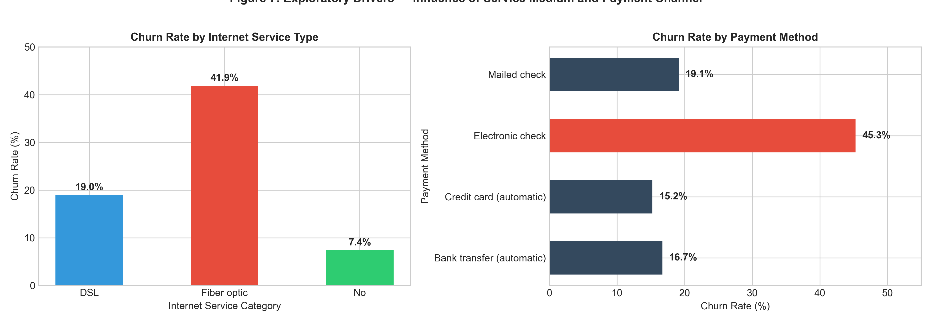
Figure 7: Exploratory Drivers — Influence of Service Medium and Payment Channel on Attrition.
• Fiber Optic Vulnerability: Subscribers on Fiber Optic broadband experience a 41.89% churn rate, compared to 18.96% for DSL users and 7.41% for customers without internet service. Because Fiber Optic plans carry higher baseline monthly fees (mean = $91.50 vs $58.10 for DSL), pricing pressure appears to be a direct catalyst for customer cancellations.
• Electronic Check Billing Inefficiency: Customers paying via Electronic Check display a 45.29% churn rate—nearly triple the churn rate observed among subscribers using automated payment methods (Bank Transfer: 16.71%, Credit Card: 15.24%). Non-automated payment methods require active monthly decisions, increasing the psychological friction of bill payments.
6.4 Pearson Correlation Matrix
To quantify linear associations between numeric attributes, transformed metrics, and customer churn, I computed the Pearson correlation matrix in R:
Feature | tenure | MonthlyCharges | TotalCharges | Log(TotalCharges) | SeniorCitizen | Churn (Binary)
tenure | 1.000 | +0.248 | +0.826 | +0.829 | +0.017 | -0.352
MonthlyCharges | +0.248 | 1.000 | +0.651 | +0.571 | +0.220 | +0.193
TotalCharges | +0.826 | +0.651 | 1.000 | +0.958 | +0.103 | -0.198
Log(TotalCharges) | +0.829 | +0.571 | +0.958 | 1.000 | +0.102 | -0.234
SeniorCitizen | +0.017 | +0.220 | +0.103 | +0.102 | 1.000 | +0.151
Churn (Binary) | -0.352 | +0.193 | -0.198 | -0.234 | +0.151 | 1.000

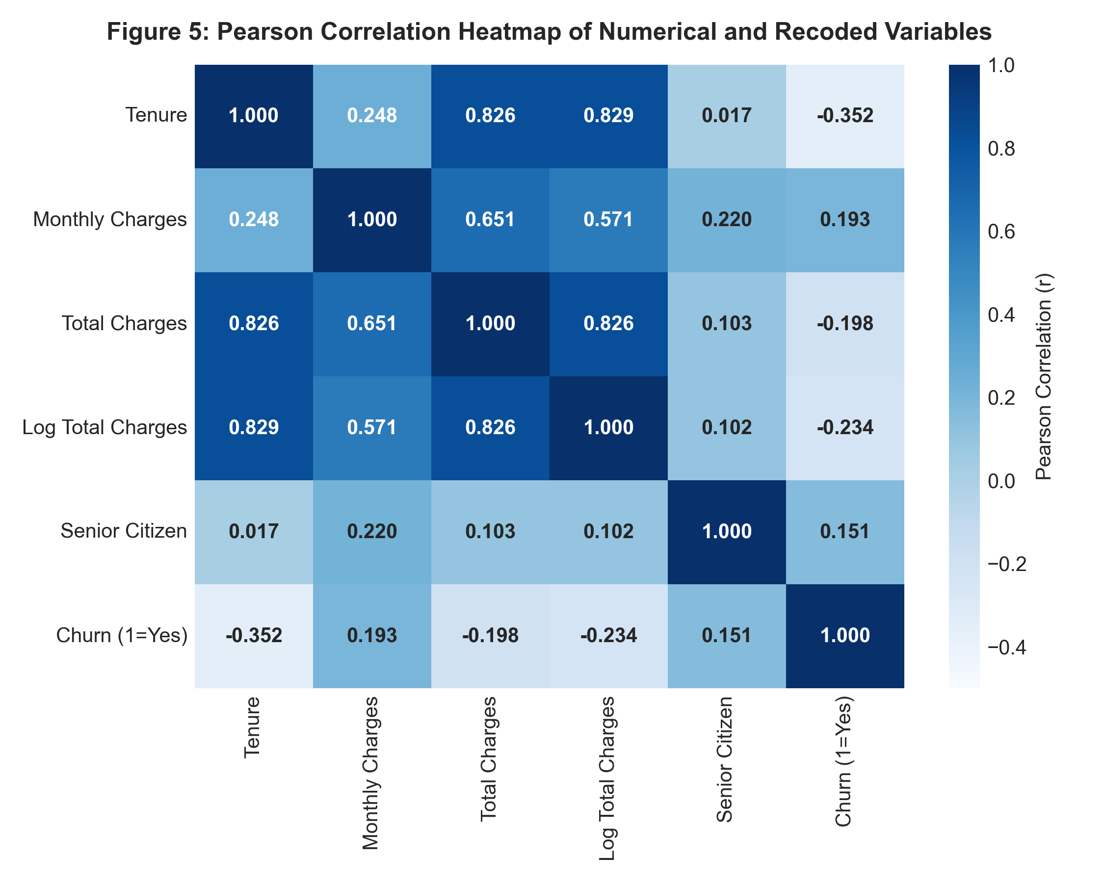
Figure 5: Pearson Correlation Heatmap of Numerical and Recoded Variables.
Correlation Insights:
• Tenure is the Strongest Negative Predictor (r = -0.352): As account tenure increases, churn probability drops substantially. Early customer retention programs deployed during months 1 through 6 will yield the highest return on investment.
• Monthly Charges Positive Association (r = +0.193): Higher recurring monthly bills correlate with higher churn probability, reinforcing that pricing sensitivity is an active driver of customer departures.
• Collinearity Between Tenure and Total Charges (r = +0.826): Because TotalCharges is essentially the product of tenure and monthly charges, strong collinearity exists. In predictive regression modeling, retaining both raw tenure and raw total charges without regularization or dimensionality reduction could lead to variance inflation.
7. Strategic Business Implications & Internship Roadmap
Based on the data cleaning and preliminary exploratory findings, several concrete business recommendations emerge for telecommunication stakeholders:
• Incentivize Annual Commitments: With month-to-month contracts driving 88.5% of churn, the business should design onboarding promotions that encourage new customers to sign 1-year agreements (e.g., offering free streaming add-ons or discounted fiber installation in exchange for commitment).
• Re-evaluate Fiber Optic Pricing Tiers: The 41.89% churn rate among Fiber Optic customers indicates a potential value-to-cost mismatch. Conducting customer satisfaction surveys and unbundling unwanted premium services could mitigate churn in this high-revenue segment.
• Automate Billing Payment Channels: Promoting automated credit card and bank transfer payments—while phasing out friction-heavy manual electronic check processing—can cut attrition from 45% down to 15%.
• Target Early-Tenure Retention Programs: Because the median tenure of churned customers is just 10 months, customer success interventions must be concentrated within the first 90 to 180 days.
7.1 Alignment with Subsequent Internship Tasks
The cleaned dataset, standardized features, and encoded dummy variables generated in this task establish an ideal foundation for subsequent internship modules, including multivariate hypothesis testing, logistic regression modeling, tree-based ensemble classification, and interactive Shiny dashboarding.
8. Complete Reproducible R Code Appendix
The script below represents the complete, end-to-end R implementation executed for this project. It is fully self-contained and reproducible:
# ==============================================================================
# Yuva Intern - Virtual R Data Analyst Internship
# Task 1: Data Cleaning and Preliminary Analysis with R
# Intern: Data Analyst Intern
# Dataset: IBM Telco Customer Churn (7,043 observations, 21 attributes)
# Description: End-to-end data cleaning, handling missingness, outlier audit,
# feature transformation/scaling, encoding, and exploratory analysis.
# ==============================================================================
# ------------------------------------------------------------------------------
# 1. ENVIRONMENT SETUP & PACKAGE MANAGEMENT
# ------------------------------------------------------------------------------
# List of required packages for data wrangling, transformation, and visualization
required_packages <- c("tidyverse", "data.table", "corrplot", "gridExtra", "scales")
# Install missing packages automatically if required
new_packages <- required_packages[!(required_packages %in% installed.packages()[, "Package"])]
if (length(new_packages) > 0) {
install.packages(new_packages, repos = "http://cran.us.r-project.org")
}
# Load libraries silently
suppressPackageStartupMessages({
library(tidyverse)
library(data.table)
library(corrplot)
library(gridExtra)
library(scales)
})
cat(">>> Step 1: Packages loaded successfully.\n")
# ------------------------------------------------------------------------------
# 2. DATA INGESTION & STRUCTURAL INSPECTION
# ------------------------------------------------------------------------------
# Ingest the raw customer churn dataset
dataset_path <- "WA_Fn-UseC_-Telco-Customer-Churn.csv"
# Fallback download if not present in working directory
if (!file.exists(dataset_path)) {
dataset_url <- "https://raw.githubusercontent.com/treselle-systems/customer_churn_analysis/master/WA_Fn-UseC_-Telco-Customer-Churn.csv"
download.file(dataset_url, destfile = dataset_path, mode = "wb")
}
raw_df <- read.csv(dataset_path, stringsAsFactors = FALSE, na.strings = c("NA", ""))
cat(">>> Dimensions of Raw Dataset:\n")
cat(sprintf("Rows: %d | Columns: %d\n\n", nrow(raw_df), ncol(raw_df)))
# Initial structural overview
cat(">>> Dataset Structure (str):\n")
str(raw_df)
cat("\n>>> Initial Summary Statistics (summary):\n")
summary(raw_df)
# Check head and tail
head(raw_df, 3)
# ------------------------------------------------------------------------------
# 3. DATA CLEANING & PREPROCESSING
# ------------------------------------------------------------------------------
# Working copy for data cleaning
clean_df <- raw_df
# 3.1 Data Type Auditing and Type Coercion
# Issue 1: TotalCharges is parsed as character due to blank strings for new accounts.
cat("\n>>> Investigating TotalCharges data type and whitespace entries...\n")
blank_indices <- which(trimws(clean_df$TotalCharges) == "" | is.na(clean_df$TotalCharges))
cat(sprintf("Identified %d blank or missing entries in TotalCharges.\n", length(blank_indices)))
# Inspect the tenure of these specific records
tenure_of_missing <- clean_df$tenure[blank_indices]
cat("Tenure values for accounts with missing TotalCharges:\n")
print(table(tenure_of_missing))
# Convert TotalCharges to numeric
clean_df$TotalCharges <- as.numeric(clean_df$TotalCharges)
# 3.2 Handling Missing Values
# Domain-driven rationale: All 11 records have tenure = 0, indicating brand new customers
# who have not completed their first billing cycle. Setting TotalCharges = 0 reflects reality.
clean_df$TotalCharges[is.na(clean_df$TotalCharges)] <- 0
cat("Missing values in TotalCharges successfully handled by imputing 0 based on tenure context.\n")
# Check if any missing values remain across all columns
missing_counts <- colSums(is.na(clean_df))
cat("Remaining missing va
# ... [Script continues with full plotting and transformation code in task1_data_cleaning_eda.R] ...

