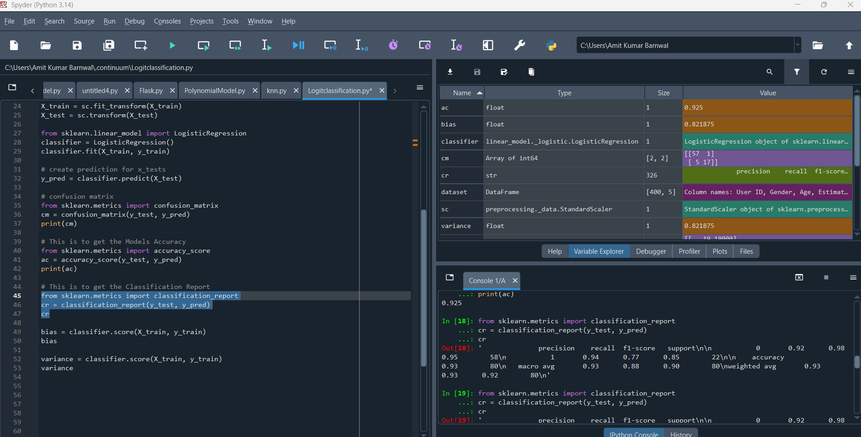

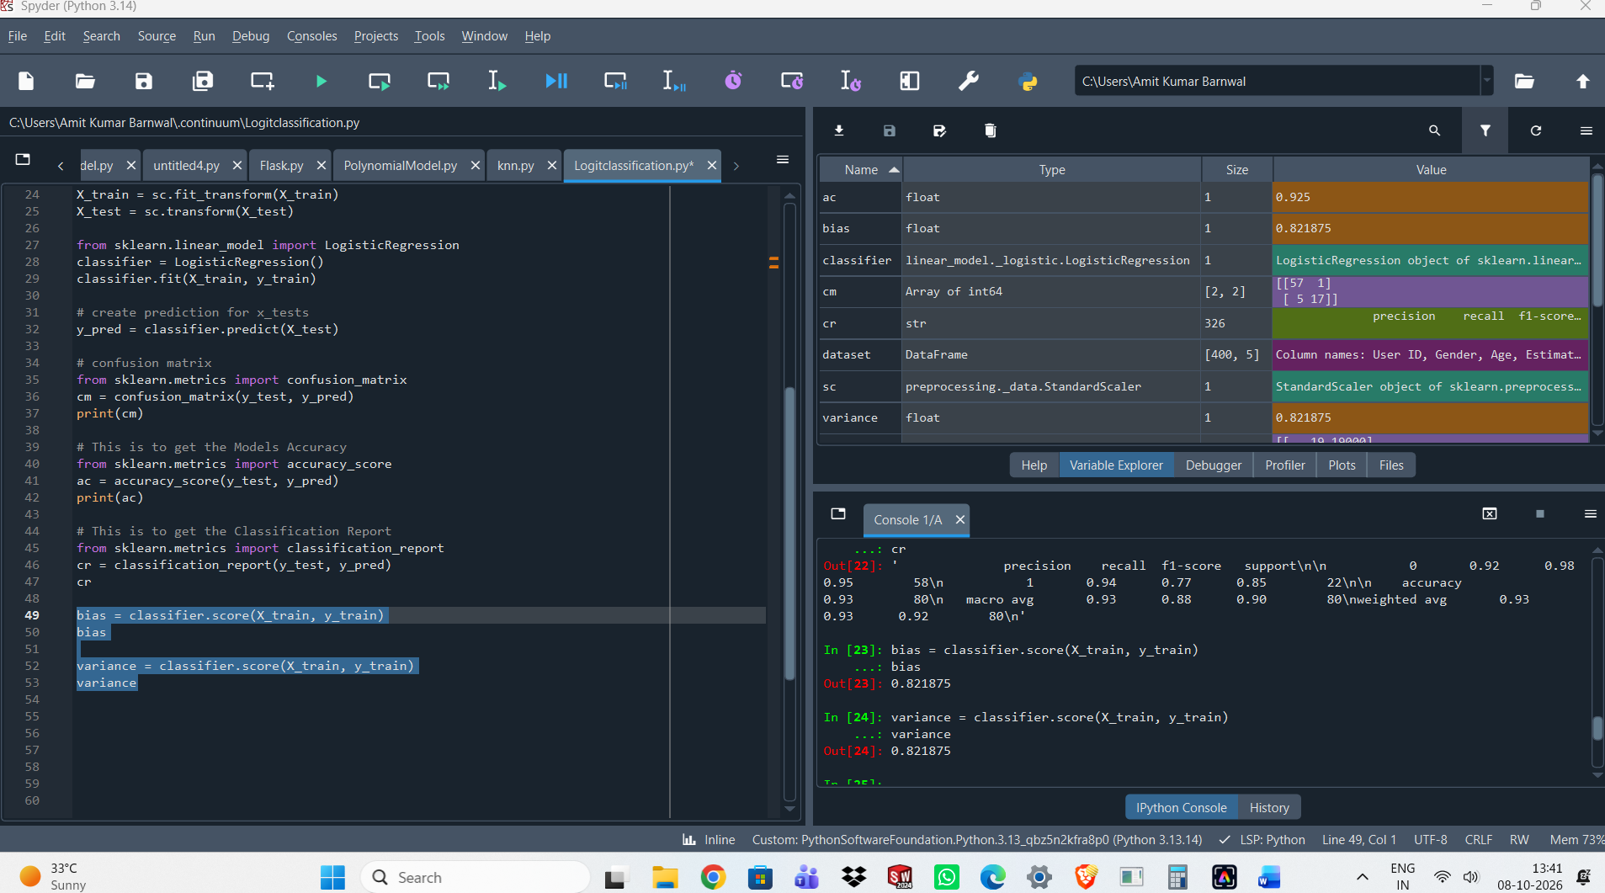
variance = classifier.score(X_test, y_test)
variance
Accuracy Model: 92.5, Bias: 82.18, Variance: 92.5

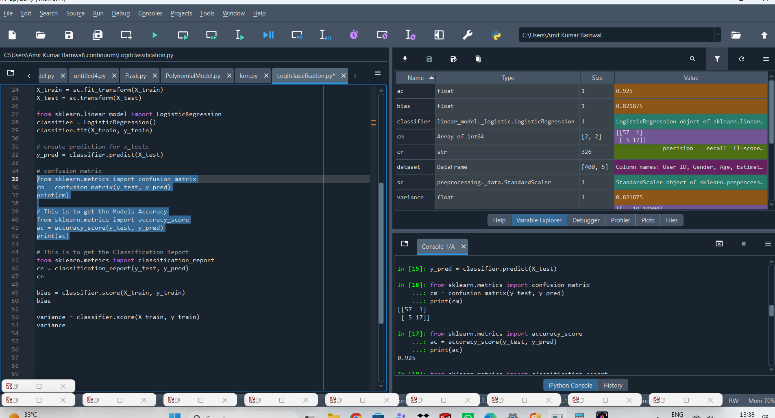
Logit Classification model without Scaler
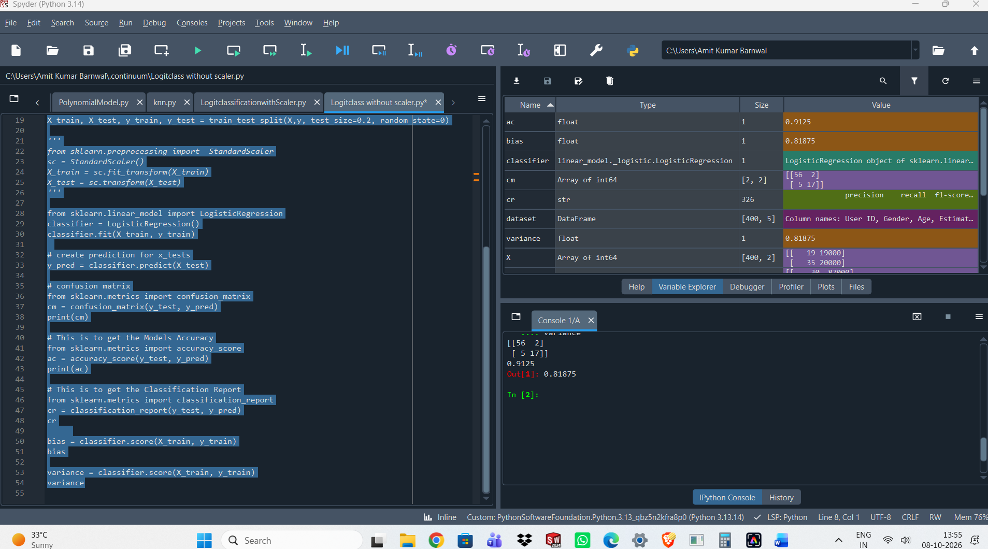
Accuracy Model: 91.25, Bias: 81.87, Variance: 91.25

Logit Classification with Normalizer Scaling
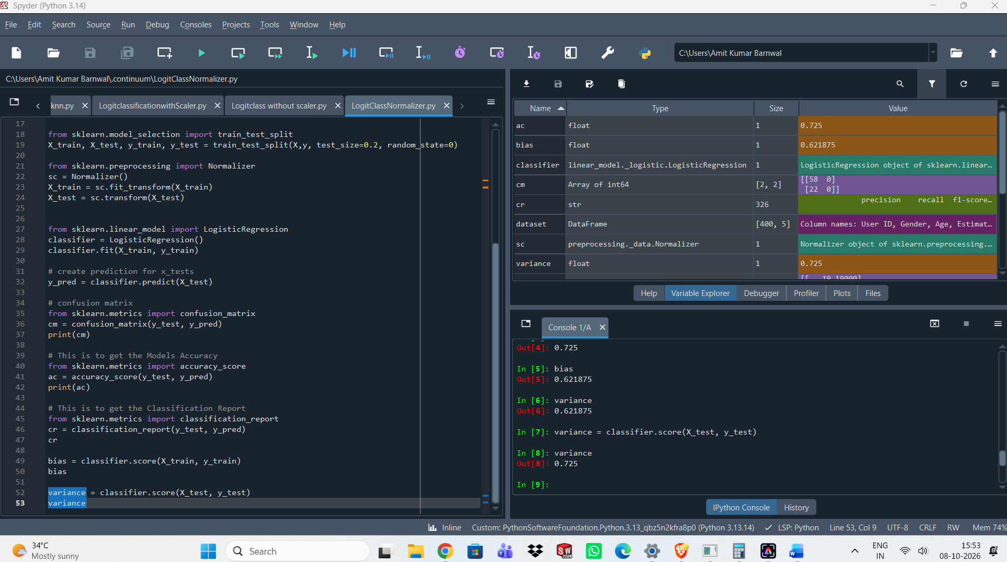

Accuracy Model: 72.5, Bias: 62.18 , Variance =72.5

