**Assignment-2 Part-D**

The Purpose of fairness in congestion control is to equally divide the bandwidth so that one flow shouldn’t hog the whole bandwidth. The purpose of the feedback control algorithm is to put all the flow to an equilibrium point such that bandwidth is utilised to the maximum and every stream/flow gets proportionate share.

To reach the point of equilibrium it is important that there is a difference in the rate of increase and decrease to observe the change in the current condition.

Here are the explanation of three different algorithm which might not be useful in controlling the fairness

1. Multiplicative Increase and Additive Decrease (MIAD):

In this approach, the flow will never reach the equilibrium. Consider the case as shown in following figure

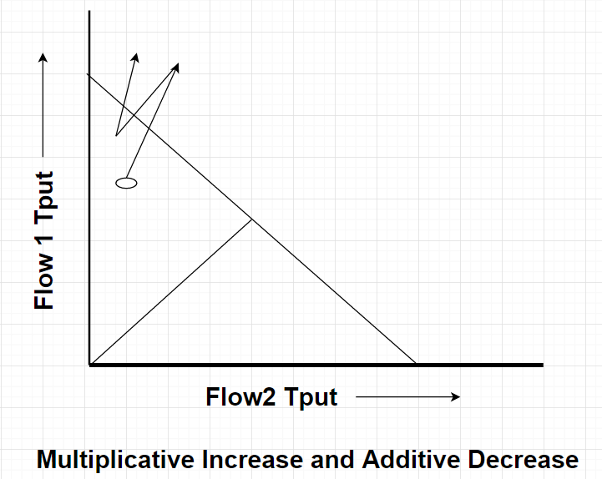

Here due to multiplicative increase flow 1’s congestion window has crossed the efficiency line and it starts decreasing the congestion window in linearly. After reaching the point where no more congestion is observed flow1 & flow 2 starts increasing their windows multiplicatively but since flow1 was already having the higher value of cwnd the bandwidth utilisation shifted towards its side. Hence MIAD can’t be consider as fair scheme.

1. Multiplicative Increase & Multiplicative Decrease (MIMD):

As stated above, a fairness algorithm should have a difference in the rate of increase and decrease which will lead all flow to equilibrium. In the current case, the flow will oscillate between two points as shown in below figure.

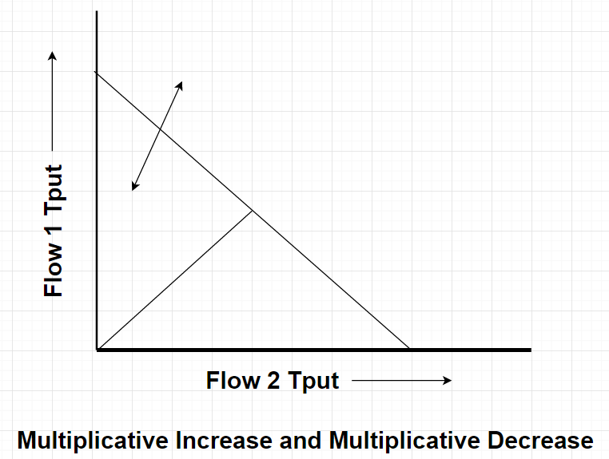

C) Additive Increase and Additive Decrease (AIAD):

In current case, since there is no change in the increment and decrement rate the flow will oscillate between two points as shown in the following figure.

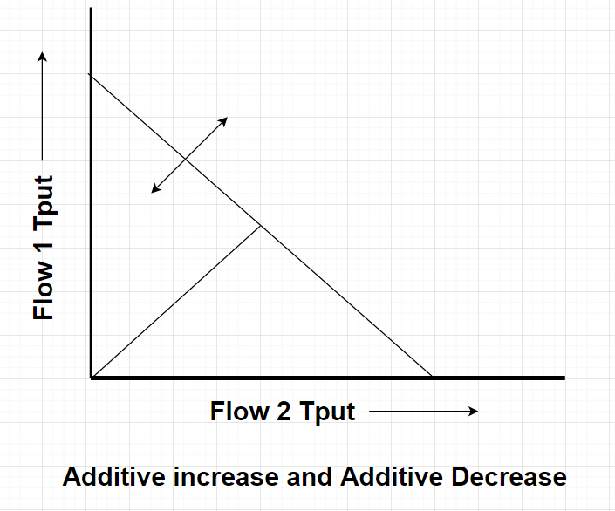

Equilibrium in above case can be reached only when flow1 is slowed down so that flow2 can increase its congestion window in between.

Hence Additive Increase multiplicative decrease is the most fairer feedback control algorithm.