Web Security Scanner
An automated Python audit of HTTP security headers, cookies and CORS configuration
Submitted by: Amit Kumar

1. Introduction
Many web attacks, such as cross-site scripting, clickjacking, session theft and cross-origin data theft, can be blocked or reduced by a handful of HTTP response headers and cookie settings. These settings are easy to forget and easy to get wrong, and checking them by hand on every site does not scale.
This project is a Python scanner that sends safe, read-only requests to a web application and audits its security headers, cookie flags, information leaks and CORS (Cross-Origin Resource Sharing) policy. Each issue gets a severity and a fix, and each site gets a score and a letter grade.

1.1 Objectives
- Check the most important security headers and report which are missing or weak.
- Detect common CORS mistakes: reflected origins, wildcard origins, the null origin and risky preflight methods.
- Check cookies for the HttpOnly, Secure and SameSite flags.
- Turn the findings into a score, a grade and fix recommendations.
- Verify the scanner against test servers whose configuration is known.

2. What the Scanner Checks
Category | Check | Why it matters
Headers | Strict-Transport-Security | Forces browsers to use HTTPS and stops downgrade attacks.
Headers | Content-Security-Policy | Limits where scripts can load from, reducing the impact of XSS.
Headers | Clickjacking protection | X-Frame-Options or frame-ancestors stops the page being framed by attackers.
Headers | X-Content-Type-Options | Stops browsers guessing content types (MIME sniffing).
Headers | Referrer-Policy | Controls how much URL information leaks to other sites.
Headers | Permissions-Policy | Disables browser features the site does not need.
Info leak | Server version, X-Powered-By | Version details help attackers pick known exploits.
Cookies | HttpOnly, SameSite, Secure | Protect session cookies from scripts, CSRF and plain-HTTP exposure.
CORS | Reflected origin | A server that echoes any Origin lets any website read its responses.
CORS | Wildcard origin | Allows every site to read the response.
CORS | Null origin | Sandboxed pages can send Origin: null, so trusting it is unsafe.
CORS | Preflight methods | Untrusted origins should not be allowed to use PUT, DELETE or PATCH.

Scoring: a site starts at 100 points. Each High finding costs 20 points, Medium 10 and Low 4. Grades are A (90 or more), B (80), C (65), D (50) and F (below 50).

3. Methodology
- The scanner is written in Python using the requests library. It only sends ordinary GET and OPTIONS requests and never attempts exploitation.
- CORS is tested by sending requests with Origin: https://evil.example and Origin: null, plus an OPTIONS preflight asking for DELETE.
- Every check is recorded as Pass, Low, Medium, High or N/A so a complete pass/fail matrix can be drawn.
- To make the results repeatable, the notebook starts 3 small local web servers with different configurations on purpose: an insecure one, a partially secured one and a hardened one. These give the scanner known answers to be tested against.
- A self-check cell asserts that the scanner reports the expected findings for each test server.
Scanning real sites is supported (section 5 of the notebook) but should only be done on sites you own or have permission to test.

4. Results
The scanner ran 15 checks against each of the 3 test servers.
Target | Score | Grade | High | Medium | Low | Passed
insecure-lab | 2 | F | 2 | 3 | 7 | 1
partial-lab | 74 | C | 0 | 1 | 4 | 8
hardened-lab | 100 | A | 0 | 0 | 0 | 13

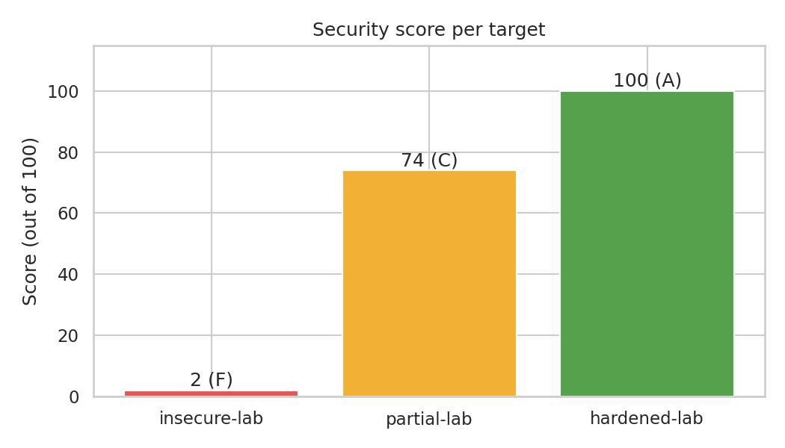
Figure 1: Security score per target
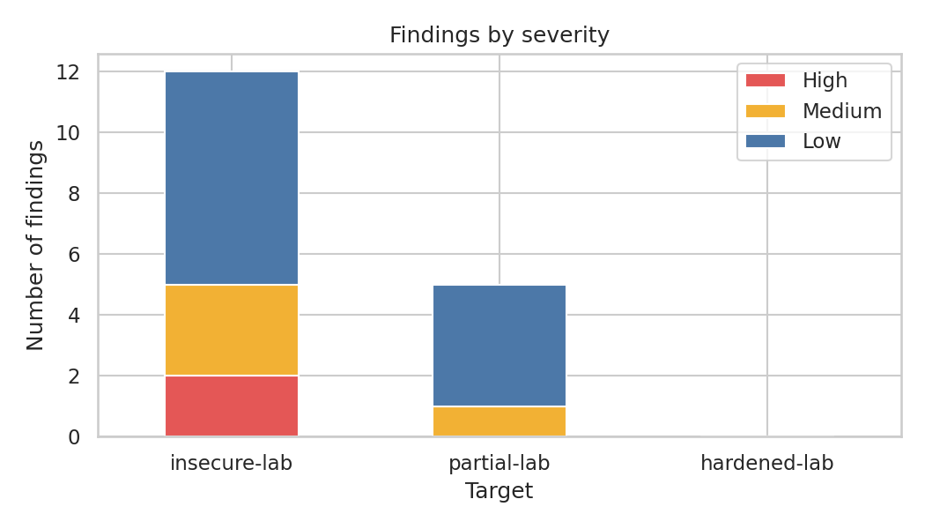
Figure 2: Findings by severity
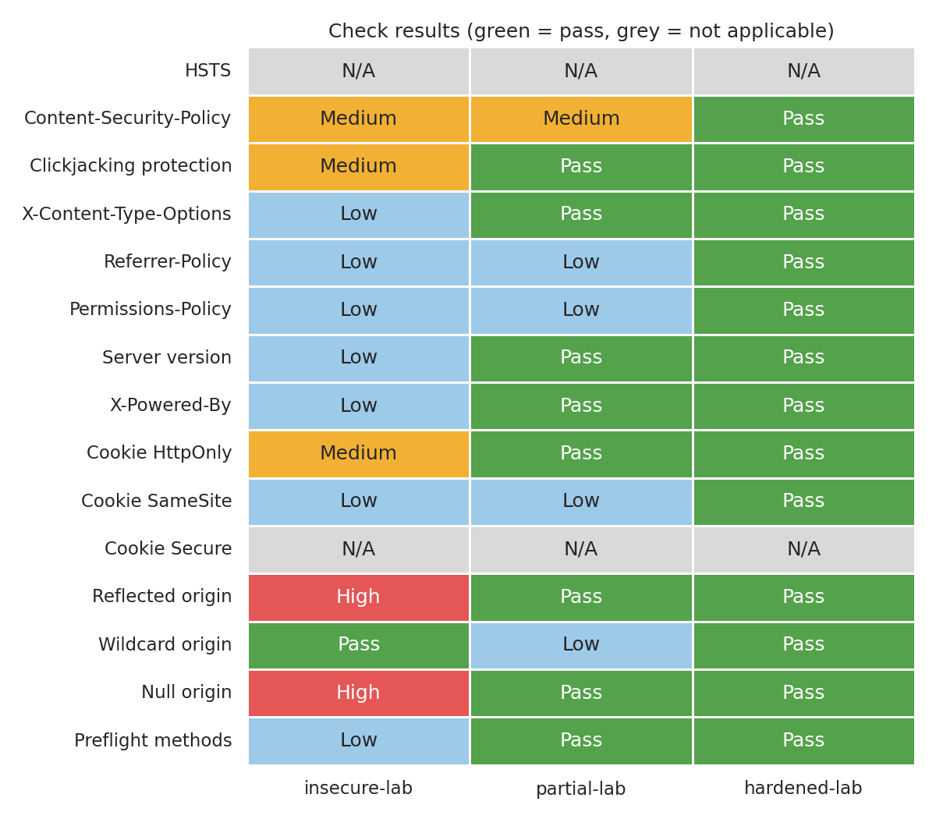
Figure 3: Result of every check on every target

4.1 Findings for each target

insecure-lab (score 2, grade F)
Severity | Check | Finding | Recommended fix
High | Reflected origin | Server echoes any Origin back and allows credentials; any website can read responses. | Allow only a fixed list of trusted origins.
High | Null origin | The 'null' origin is trusted (sandboxed iframes and local files can use it). | Never allow the null origin.
Medium | Content-Security-Policy | No CSP header; the browser will run any injected script. | Define a CSP such as default-src 'self'.
Medium | Clickjacking protection | Neither X-Frame-Options nor CSP frame-ancestors is set. | Add X-Frame-Options: DENY or CSP frame-ancestors 'none'.
Medium | Cookie HttpOnly | Cookie PHPSESSID can be read by JavaScript. | Add the HttpOnly flag.
Low | X-Content-Type-Options | X-Content-Type-Options header is missing or has an unexpected value. | Add X-Content-Type-Options: nosniff
Low | Referrer-Policy | Referrer-Policy header is missing or has an unexpected value. | Add Referrer-Policy: strict-origin-when-cross-origin
Low | Permissions-Policy | Permissions-Policy header is missing or has an unexpected value. | Add a Permissions-Policy that disables unused features.
Low | Server version | Server header reveals version: Apache/2.2.15 (CentOS) | Hide version details (for example server_tokens off).
Low | X-Powered-By | X-Powered-By reveals technology: PHP/5.3.3 | Remove the X-Powered-By header.
Low | Cookie SameSite | Cookie PHPSESSID has no SameSite attribute. | Add SameSite=Lax or Strict.
Low | Preflight methods | Untrusted origins may use risky methods: GET, POST, PUT, DELETE | Limit Access-Control-Allow-Methods to what the API needs.

partial-lab (score 74, grade C)
Severity | Check | Finding | Recommended fix
Medium | Content-Security-Policy | No CSP header; the browser will run any injected script. | Define a CSP such as default-src 'self'.
Low | Referrer-Policy | Referrer-Policy header is missing or has an unexpected value. | Add Referrer-Policy: strict-origin-when-cross-origin
Low | Permissions-Policy | Permissions-Policy header is missing or has an unexpected value. | Add a Permissions-Policy that disables unused features.
Low | Cookie SameSite | Cookie session has no SameSite attribute. | Add SameSite=Lax or Strict.
Low | Wildcard origin | Access-Control-Allow-Origin is * so every site can read this response. | Replace * with specific trusted origins unless the content is fully public.

hardened-lab (score 100, grade A)
No issues found.

5. Discussion
The scores follow the amount of hardening: insecure-lab scored 2, partial-lab scored 74, hardened-lab scored 100. This matches how each test server was set up, which shows that the checks and the scoring behave sensibly.
The most serious problems were in CORS. The insecure server echoed back any origin while also allowing credentials and trusted the null origin, so 2 High findings were raised in total. This combination would let any website read private responses on behalf of a logged-in user, which is why it is rated higher than a missing header.
The partially secured server shows a common real-world pattern: a few easy headers were added (nosniff and X-Frame-Options), but there was no Content-Security-Policy, Referrer-Policy or Permissions-Policy, the cookie had no SameSite attribute, and CORS used a wildcard. The hardened server passed every check.

5.1 Limitations
- Only passive checks are done; the scanner does not look for vulnerabilities such as SQL injection or XSS directly.
- The results here come from local test servers built for this project, so they show that the scanner detects problems correctly, not how common these problems are on the internet.
- A site can set different headers on different pages; only the URL given is checked.
- The CSP check looks for obviously weak values but does not fully parse every policy.
- Results are a snapshot in time and should be repeated after configuration changes.

6. Conclusion and Future Work
The scanner finds missing or weak security headers, cookie flags and CORS misconfigurations, explains how to fix each one, and summarises the result as a score. It correctly separated the insecure, partial and hardened test servers.
- Crawl several pages of a site and compare their headers.
- Check TLS settings and certificate expiry.
- Add HTML and PDF report output and a command-line interface.
- Run the scanner in a CI/CD pipeline to catch header regressions before release.

7. Technologies Used
Python, Jupyter Notebook, requests, pandas, matplotlib, seaborn, python-docx and the built-in http.server module. Setup steps are in README.md.

8. References
- OWASP Secure Headers Project: https://owasp.org/www-project-secure-headers/
- MDN Web Docs, Cross-Origin Resource Sharing (CORS): https://developer.mozilla.org/en-US/docs/Web/HTTP/CORS
- MDN Web Docs, HTTP security headers and Content-Security-Policy: https://developer.mozilla.org/en-US/docs/Web/HTTP/CSP
- OWASP Web Security Testing Guide: https://owasp.org/www-project-web-security-testing-guide/

