Assessment Cover Sheet
MDA691 Assignment 1
Student ID Number/s: | Student Last name/s: |  | Student First name/s:
MIT252463 | Shrestha |  | Amit
MIT251400 | Reddy |  | Teegala Pavan
MIT252219 | Shrestha |  | Subala
MIT250081 | Pandey |  | Asmita
Course: Master of Data Analytics |  |  | School: Melbourne Institute of Technology
Unit code: MDA691 | Unit title: Project Management and Research Methods
Due date: 13 September 2026 | Date submitted: 13 September 2026 |  | Campus: Melbourne Institute of Technology
Lecturer’s Name: Dr. Basharat Ali |  |  | Tutor: Dr. Basharat Ali
Student Declaration
I/We declare and certify that:
- the work contained in this assessment is my/our own work/group work, except where acknowledgement of sources is made;
- this assessment has not been submitted previously for academic credit in this or any other course;
- I/we have read MIT’s Plagiarism and Academic Misconduct Policy and Procedure, and I/we understand the consequences of engaging in plagiarism, collusion and contract cheating;
- a copy of the original assignment is retained by me/us and that I/we may be required to submit the original assignment to the Lecturer and/or Unit Co-ordinator upon request;
I/we have not plagiarised the work of others or participated in unauthorised collaboration or contract cheating when preparing this assessment.
MIT ID |  | Signature |  | Date
MIT252463 |  | Amit Shrestha |  | 13 September 2026
MIT251400 |  | Teegala Pavan Reddy |  | 13 September 2026
MIT252219 |  | Subala Shrestha |  | 13 September 2026
MIT250081 |  | Asmita Pandey |  | 13 September 2026

1. Introduction
This report converts the preliminary concept from Assignment 1b into an implementable project plan and intermediate design for eLabtronics/runlinc. The capstone delivers a laboratory prototype on client-supplied STEMSEL E32W (ESP32) hardware programmed through the runlinc IDE (MicroPython). The team collects all real-time sensor data from its own E32W lab kit — not from the client factory or plant systems.
The proposed contribution is a dual-path architecture: millisecond ISO 10816 reflex alarms on the edge, combined with slower agentic reasoning (runlinc AI Assistant) for maintenance recommendations, simulated ERP tool calls, and an auditable Thought Log dashboard. Assignment 2 focuses on planning, requirements refinement, and intermediate design; full implementation and demonstration are scheduled for MDA692.
This report is structured as follows: Section 2 defines the problem, revised research questions, and measurable objectives; Section 3 provides a critical literature synthesis; Section 4 documents refined requirements and client engagement since Assignment 1; Sections 5–6 map the project to the MDA512 data-science lifecycle and software engineering methods; Section 7 presents the intermediate design with diagrams; Section 8 covers timeline, roles, WBS, Gantt chart, and budget; Section 9 addresses risks and limitations. Appendices I–III provide client details, the annotated literature bibliography, and the Assignment 1 feedback response.

1.1 Significance and contribution
Industrial predictive maintenance increasingly combines edge sensing, machine learning, and AI agents, but few published systems integrate all three on a low-cost ESP32 platform with explicit safety-path separation. This project advances practice by demonstrating traceable edge-to-agent workflows on runlinc hardware using team-collected lab data supplemented by public RUL benchmarks (C-MAPSS, XJTU-SY).

2. Problem Domain, Research Questions and Objectives

2.1 Problem domain
Unplanned equipment failures cause downtime, cost, and safety risk. Industry 4.0 enables continuous condition monitoring via IIoT sensors, but cloud-only analytics introduce latency and connectivity dependencies. Agentic AI can automate maintenance decisions, yet must not delay safety-critical reflex alarms. The eLabtronics E32W platform provides a controlled environment to evaluate this trade-off.

2.2 Research questions (revised)
RQ1: How can real-time vibration and temperature features extracted on the E32W (ESP32) be streamed reliably for predictive maintenance analytics?
RQ2: What RUL estimation accuracy is achievable using LSTM models trained on benchmark datasets and validated against team hardware streams?
RQ3: How can an agentic AI layer (runlinc AI Assistant) use structured tool calls to support maintenance decisions with auditable traceability?
RQ4: How does a dual-path design (reflex alarm vs agentic reasoning) compare with conventional alert-only AI on latency, reliability, and traceability?

2.3 Aim
To design and evaluate an eLabtronics runlinc E32W prototype that converts real-time condition data into reliable edge alarms, predictive RUL evidence, and agent-assisted maintenance recommendations with full traceability.

2.4 Measurable objectives aligned to RQs
Obj | Objective | Success criterion | RQ | Week
1 | Real-time telemetry pipeline from E32W | ≥1 hr continuous stream; 0 dropped windows; latency <2× real-time in replay | RQ1 | 8
2 | Edge features on ESP32 | RMS/peak/crest/FFT within 1 s window; memory ≤400 KB; NumPy tolerance ±5% | RQ1 | 9
3 | LSTM RUL model | RMSE ≤ Zheng et al. [4] baseline +10% on C-MAPSS FD001 | RQ2 | 12
4 | Agentic assessment layer | ≥80% structured-output pass rate on 30-scenario suite | RQ3 | 14
5 | Simulated ERP/messaging tools | 100% schema-valid tool calls; ≥5 negative test cases handled | RQ3 | 16
6 | Thought Log dashboard | 100% sample actions traceable to feature-window ID | RQ3 | 18
7 | Dual-path benchmark | Reflex alarm <200 ms with agent API offline; agent cycle 2–10 s | RQ4 | 20

3. Critical Literature Review Summary
Assignment 1b literature was primarily descriptive. This report responds to supervisor feedback by adding critical comparison, synthesis across themes, and an explicit research gap. The full annotated bibliography (40 sources: 10 per member, 2023–2026, including peer-reviewed journal and conference papers) is submitted as Appendix II (MDA691_Assignment2_Appendix_II_Literature.docx) and must be uploaded with this report.

3.1 Critical synthesis
Prior PdM surveys (Zonta et al. [1]) establish the Industry 4.0 context but treat edge hardware, RUL modelling, and agentic orchestration as separate concerns. Edge vibration studies on ESP32 (Kolok et al. [7]) demonstrate feasible anomaly detection at low cost, yet stop at classification — they do not publish RUL estimates, agent tool contracts, or auditable maintenance workflows. Conversely, LSTM RUL work (Zheng et al. [4], Wu et al. [2]) achieves strong benchmark accuracy but assumes cloud-scale compute and omits millisecond safety reflexes.
Agentic AI frameworks (ReAct [11], industrial surveys [13]) show that tool-augmented LLMs can automate multi-step tasks, but published deployments rarely constrain tool schemas for safety-critical maintenance or separate reflex alarms from deliberative reasoning. Explainability research (Nor et al. [16], Huang et al. [15]) highlights trust and hallucination risks that matter when an agent recommends downtime or parts ordering. Our design therefore combines: (i) deterministic ISO reflex on-device, (ii) feature-vector RUL from validated models, and (iii) schema-validated agent tools with a Thought Log — a combination not found as an integrated system on the runlinc E32W platform.

3.2 Comparative analysis
Theme | Representative work | Strength | Limitation vs our project | Our advance
PdM surveys | Zonta [1], Alaoui [36] | Broad Industry 4.0 context | No runlinc/ESP32 agentic integration | Platform-specific dual-path design
ESP32 vibration | Kolok [7], TinyML ESP32 2025 | Low-cost edge anomaly ~73–92% | No RUL; no agent; lab only | RUL + agent + Thought Log on E32W
RUL deep learning | Wu [2], Zheng [4], BLTTNet 2025 | Strong C-MAPSS benchmarks | Cloud-centric; not edge+agent | Feature-vector RUL fed to agent
Agentic AI | ReAct [11], Rayfield [13] | Tool use paradigm | Generic; fails naive industrial deploy | Schema-validated maintenance tools
XAI/trust | Nor [16], Huang [15] | Explainability, hallucination risks | Not linked to reflex/agent split | Thought Log + ISO reflex isolation

Research gap: no integrated end-to-end system combines ESP32 edge reflex alarms, LSTM RUL, and schema-validated agentic maintenance tools on the runlinc E32W platform with team-collected lab telemetry. Table 1 summarises how prior work falls short and how this project advances the state of practice.

3.3 Research gap and project positioning
The gap is not merely technical — it is architectural and operational. Factory PdM systems often assume always-on cloud connectivity and human-in-the-loop alarm acknowledgement. Our capstone instead tests whether a student-team-scale prototype on client-supplied hardware can meet measurable targets for reflex latency, RUL accuracy, and agent traceability within a single trimester design phase, using lab data rather than production plant telemetry. This positions the project as a reproducible reference implementation for eLabtronics/runlinc rather than a generic Industry 4.0 survey.

4. Refined Project Requirements Since Assignment 1

4.1 Client engagement evidence
Week | Date | Mode | Attendees | Evidence | Outcome
4 | 10/08/2026 | Online | Miroslav Kostecki; all team | Meeting minutes; logbook | Project intro; document review; meeting schedule agreed
6 | 17/08/2026 | Online/Lab | Miroslav; all team | Meeting summary 17-Aug-2026.docx | Hotspot setup; device connection troubleshooting; runlinc login
7 | 24/08/2026 | Online/Lab | Miroslav; all team | Meeting minutes 24-Aug-2026.docx | Hardware setup; LED blink test (D2); runlinc Projects 14/15; block diagram planning
8 | Sep 2026 | Supervision | Dr Basharat Ali | Moodle A1 feedback | Report improvements; literature; RQ alignment
Ongoing | Aug 2026 | runlinc platform | Team + client | Logbook | Client confirmed: team collects all real-time data from supplied E32W + 37-in-1 sensor kit

4.2 Data requirements (revised)
Primary data source: team-collected real-time streams from client-supplied E32W and 37-in-1 sensor kit. Client factory/plant telemetry is explicitly out of scope. Supplementary benchmark datasets (C-MAPSS FD001, XJTU-SY bearings) support RUL model training where lab data lacks sufficient failure labels.

4.2.1 Team hardware data collection procedure
Connect KY-002 vibration sensor (GPIO 23), temperature sensor (GPIO 33), and buzzer (GPIO 34) to E32W via jumper wires.
Connect to runlinc hotspot; program via runlinc IDE (MicroPython).
Run controlled lab tests (normal vs induced vibration/temperature change).
Log timestamped feature vectors locally; export CSV/JSON after each session.
Use replay harness to verify MQTT pipeline before live agent integration.
Supplement with C-MAPSS/XJTU-SY benchmarks for RUL model training.

4.3 Functional requirements (refined)
ID | Requirement | Priority | Change since A1b
FR1 | Stream E32W telemetry in real time | Must | Clarified: team hardware not client plant
FR2–FR4 | Edge features + ISO local alarm | Must | Unchanged
FR5 | MQTT JSON feature publish | Must | Schema defined §7.3
FR8 | RUL from feature history | Must | Unchanged
FR10–FR12 | Agent + tools + Thought Log | Must | Added scenario-suite metric

4.4 Non-functional requirements (numeric targets)
ID | Requirement | Target | Verification
NFR1 | Feature extraction per window | ≤1000 ms | ESP32 timing log
NFR2 | Reflex isolated from agent | Alarm <200 ms; agent 2–10 s | API failure injection
NFR3 | Offline graceful degradation | Alarms active without MQTT/agent | Disconnect test
NFR4 | Traceability | 100% actions linked to window ID | Thought Log audit
NFR5 | Agent consistency | ≥90% same tool on repeat scenarios | 30-scenario suite

5. Data Science Project Lifecycle Mapping (MDA512)
The team maps project stages to the data science project lifecycle practised in MDA512 and CRISP-DM [12]. Each stage produces a verifiable deliverable and a decision gate before the next stage begins. Because hardware access and agent behaviour introduce uncertainty, failed quality checks return work to requirements or data preparation rather than proceeding to deployment.
Stage | Activity | Deliverable | Week | Owner
1 Business understanding | Client meetings, problem, RQs | A1b + §2 | 4–8 | Asmita, Subala
2 Data understanding | Team E32W lab data collection; benchmark exploration | Data inventory §4.2; lab test log | 8–10 | Pavan
3 Data preparation | Windowing team hardware streams; replay harness | Feature pipeline §7.2 | 9–11 | Pavan, Subala
4 Modelling | LSTM RUL training | RUL model | 11–12 | Pavan
5 Evaluation | RMSE, SHAP, scenario suite | Eval report | 12–16 | Pavan, Amit
6 Deployment | MQTT, edge publish, dashboard | Prototype | 14–18 | Amit, Subala
7 Monitoring | Thought Log audit, benchmark | Week 20 demo | 18–20 | All

6. Software Engineering Methods

6.1 Iterative delivery and governance
A lightweight Agile approach is used because hardware access, client-data suitability, and agent behaviour create uncertainty. Work is planned in one-week iterations aligned with supervision meetings. Each sprint delivers a demonstrable increment mapped to objectives in Table §2.4.

6.2 Version control, review and Definition of Done
Protected main branch; short feature branches; pull request and one peer review before merge.
No raw client data, API keys, or model binaries in the repository; configuration uses environment variables.
Exploratory notebooks are converted into reproducible scripts/modules before integration.
A requirement is Done only when code, automated test, documentation, traceability link, and demo evidence exist.
Releases are tagged with dataset/feature/model/prompt versions for reproducibility.

6.3 Quality strategy and integration
Continuous integration runs linting, unit tests, JSON schema tests, and a deterministic replay on every merge request. Hardware tests remain a controlled manual gate. Architecture decision records (ADR) document the reflex/agent split. OpenAPI specifies mock ERP endpoints; the Thought Log serves as the audit artefact.

7. Intermediate Project Design

7.1 Architecture overview
Figure 1 shows the four-layer project architecture plan with 37-in-1 kit module names (Shock, TEMP 18B20, buzzer) and team hardware as the primary data source.
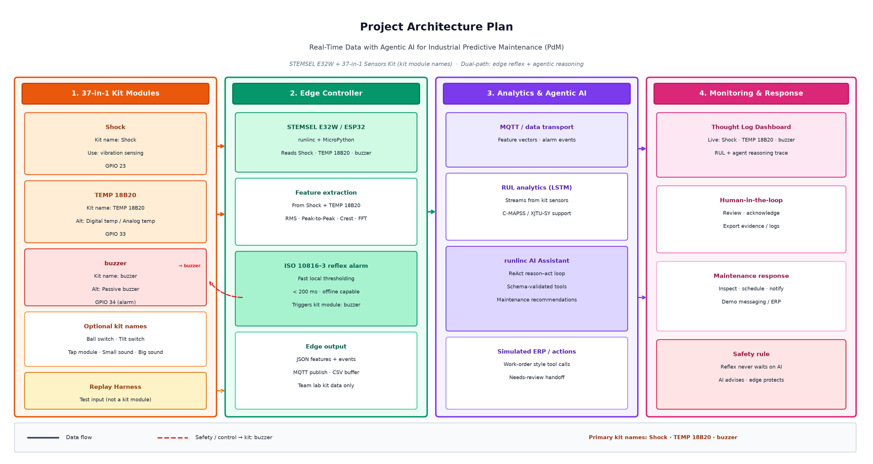
Figure 1. Project architecture plan — 37-in-1 kit modules (Shock, TEMP 18B20, buzzer) with STEMSEL E32W dual-path edge reflex and agentic AI.

7.2 Edge and reflex design
1 s windows, 50% overlap; RMS, peak-to-peak, crest factor, FFT bands. ISO 10816-3 reflex alarm on breach.
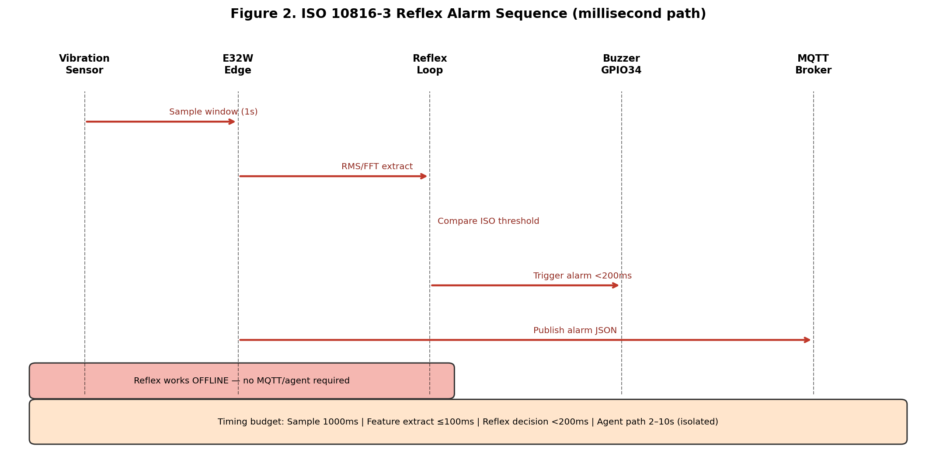
Figure 2. ISO 10816-3 reflex alarm sequence — millisecond path isolated from agent.

7.3 Data model and MQTT schema
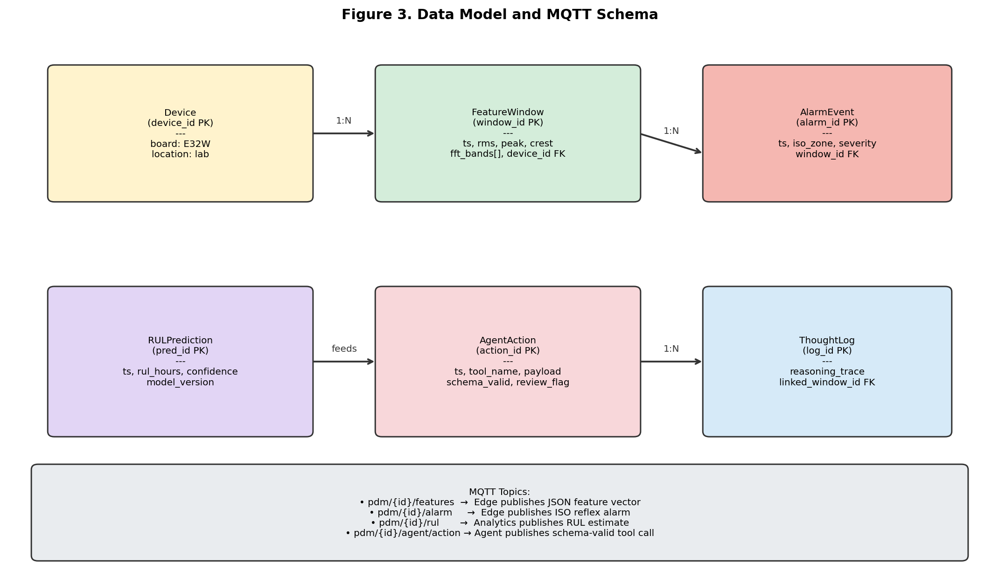
Figure 3. Data model and MQTT topic schema.

7.4 RUL analytical workflow
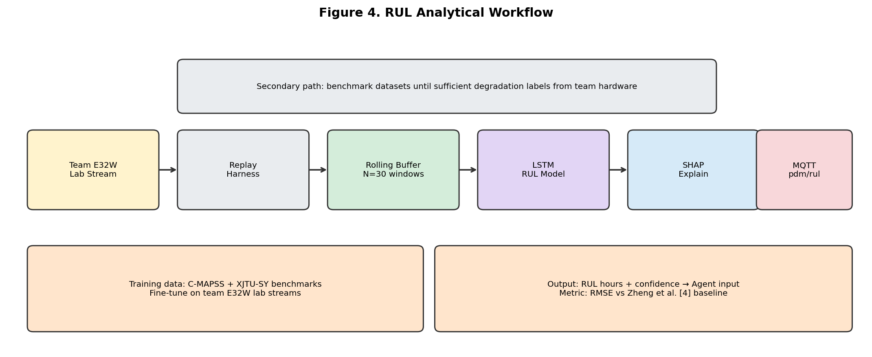
Figure 4. RUL analytical workflow — team E32W streams and benchmark training.

7.5 Agent and dashboard design
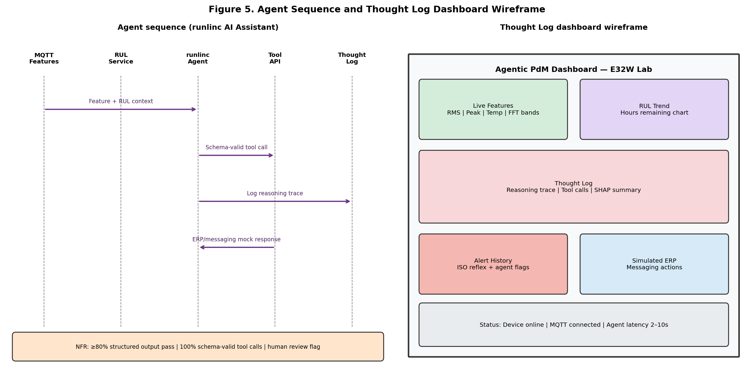
Figure 5. Agent sequence and Thought Log dashboard wireframe.

7.6 Preliminary prototype evidence
As a preliminary hardware smoke test, the team completed runlinc intermediate Project 14 (DS18B20 Temperature Sensor) on the client-supplied STEMSEL E32W. The sensor was connected on ESP32 port D4 (tempSensor) via the runlinc IDE; a live reading of 23.125 °C was obtained. This confirms E32W power, runlinc connectivity, MicroPython/JS loop execution, and basic sensor I/O before vibration (KY-002) integration. Figures 6–8 show the lab hardware, runlinc project screen, and temperature graph. Table 7 summarises the test record; meeting notes are in Appendix II.A.
Field | Detail
Test ID | HW-001
Date | 31 August 2026 (Week 8 lab / runlinc Project 14)
Platform | STEMSEL E32W (ESP32) — runlinc IDE (Project 14: DS18B20)
Test | DS18B20 temperature monitor on port D4 (tempSensor)
Procedure | Wire DS18B20 on E32W; configure D4 as DS18X20_IN in runlinc; Run Code; graph live °C
Result | PASS — live reading 23.125 °C (see Figures 6–8)
Witnesses | Team lab session (Amit, Subala, Asmita, Pavan); client hardware supplied
Evidence file | runlinc Project 14 screenshots; hardware photo; team logbook
Next step | Add KY-002 vibration (GPIO 23), buzzer (GPIO 34), MQTT feature publish

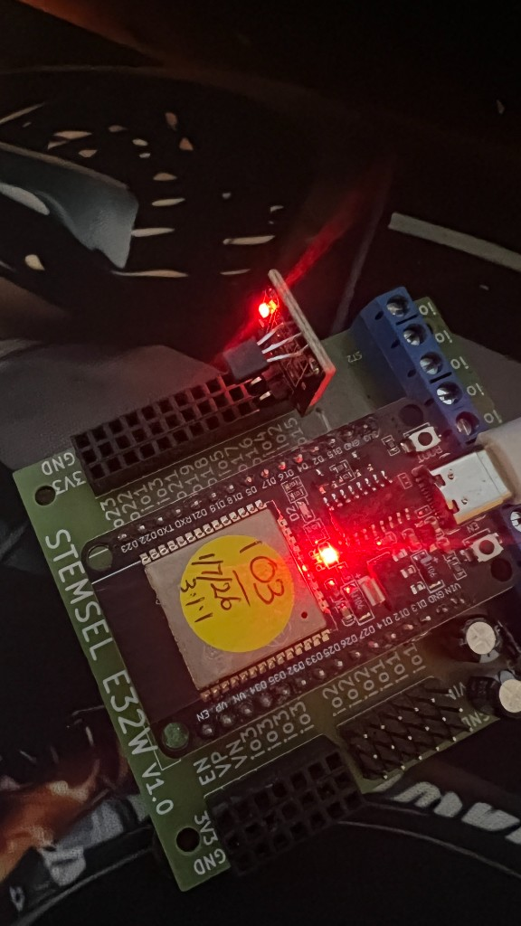
Figure 6. STEMSEL E32W lab hardware with DS18B20 temperature sensor (runlinc Project 14).
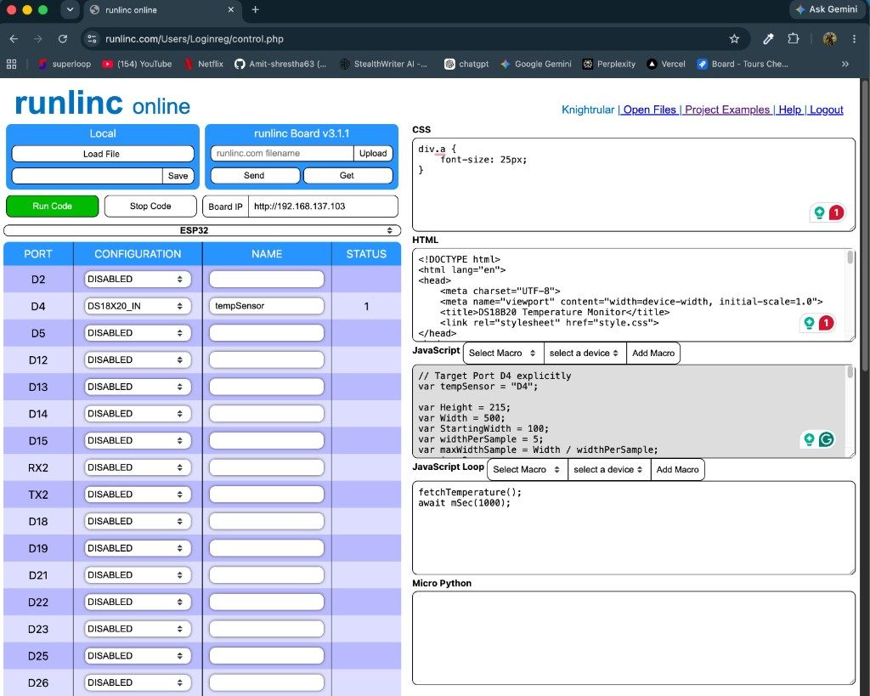
Figure 7. runlinc IDE — Project 14 DS18B20 Temperature Monitor (ESP32 port D4 / tempSensor).
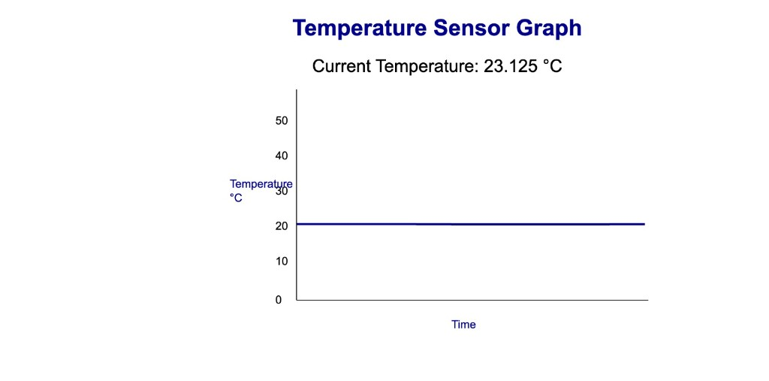
Figure 8. Live temperature reading from DS18B20 — 23.125 °C (team lab test).

7.7 Traceability matrix
Req | Design | Test | Owner
FR4 | Reflex loop | Buzzer on ISO breach | Subala
FR8 | LSTM model | C-MAPSS RMSE | Pavan
FR10 | Agent wrapper | 30-scenario suite | Amit
NFR2 | Dual-path | Agent offline test | Subala
NFR4 | Thought Log | Audit trail | Amit

8. Project Timeline, Resources and Budget

8.1 Weekly activities
Week | Activity | Deliverable | Owner
6 | Hotspot setup; runlinc login; connection troubleshooting | Meeting summary 17-Aug-2026.docx | All
7 | Hardware setup; LED blink (D2); runlinc Projects 14/15 | Meeting minutes 24-Aug-2026.docx | All
8 | A2 report; replay harness | Group report; MQTT design | All
9 | Edge features on E32W | RMS/peak/crest module | Subala
10 | FFT + ISO reflex | Timing report | Subala
11 | MQTT live stream | Feature topics live | Subala
12 | RUL baseline; A3 interim report | C-MAPSS results | Pavan
14 | Agent integration | Agent wrapper | Amit
16 | ERP mocks + scenarios | FastAPI + 30 cases | Amit, Pavan
18 | Dashboard + integration | Thought Log v1 | Amit
20 | System benchmark + demo | Final demo | All

8.2 Roles and responsibilities
Amit Shrestha (MIT252463) — Agent and integration lead. Accountable for runlinc AI Assistant wrapper, simulated ERP/messaging APIs, Thought Log dashboard, end-to-end integration test, and project management (WBS 1). Reviews MQTT schema and demo packaging.
Subala Shrestha (MIT252219) — Edge and hardware lead. Accountable for E32W lab setup, sensor wiring (KY-002 GPIO 23, temp GPIO 33, buzzer GPIO 34), RMS/peak/crest/FFT features, ISO 10816 reflex alarm, MQTT edge publish, and on-device timing benchmarks (WBS 2).
Teegala Pavan Reddy (MIT251400) — Data science and analytics lead. Accountable for replay harness, C-MAPSS/XJTU-SY ingestion, LSTM RUL baseline, SHAP explainability, agent evaluation scenarios, RUL publish to MQTT, and Gantt/schedule management (WBS 3).
Asmita Pandey (MIT250081) — Requirements and quality lead. Accountable for refined requirements A2, risk management plan, traceability matrix, client engagement documentation, and literature synthesis (WBS 4). Reviews agent authority and test evidence.
Activity | Amit | Subala | Asmita | Pavan
Edge features | I | R | C | C
RUL analytics | I | I | I | R
Agent layer | R | I | I | C
Requirements/risks | I | C | R | C
Schedule/Gantt | C | I | I | R
Report compile | R | C | C | C
Note: R = Responsible (does the work); C = Consulted (provides input); I = Informed (kept up to date). This is a simplified RACI matrix (Accountable is the same as Responsible for each row).

8.3 Work Breakdown Structure and Gantt chart
Figures 9–14 are screenshots from ProjectLibre (692_Agentic_AI_PdM_FIXED.pod). Figure 9 shows the resource Gantt chart with tasks assigned to each team member; red bars indicate critical-path tasks. Figures 10–13 show WBS diagrams for packages 1–4. Figure 14 shows the full WBS entry table.
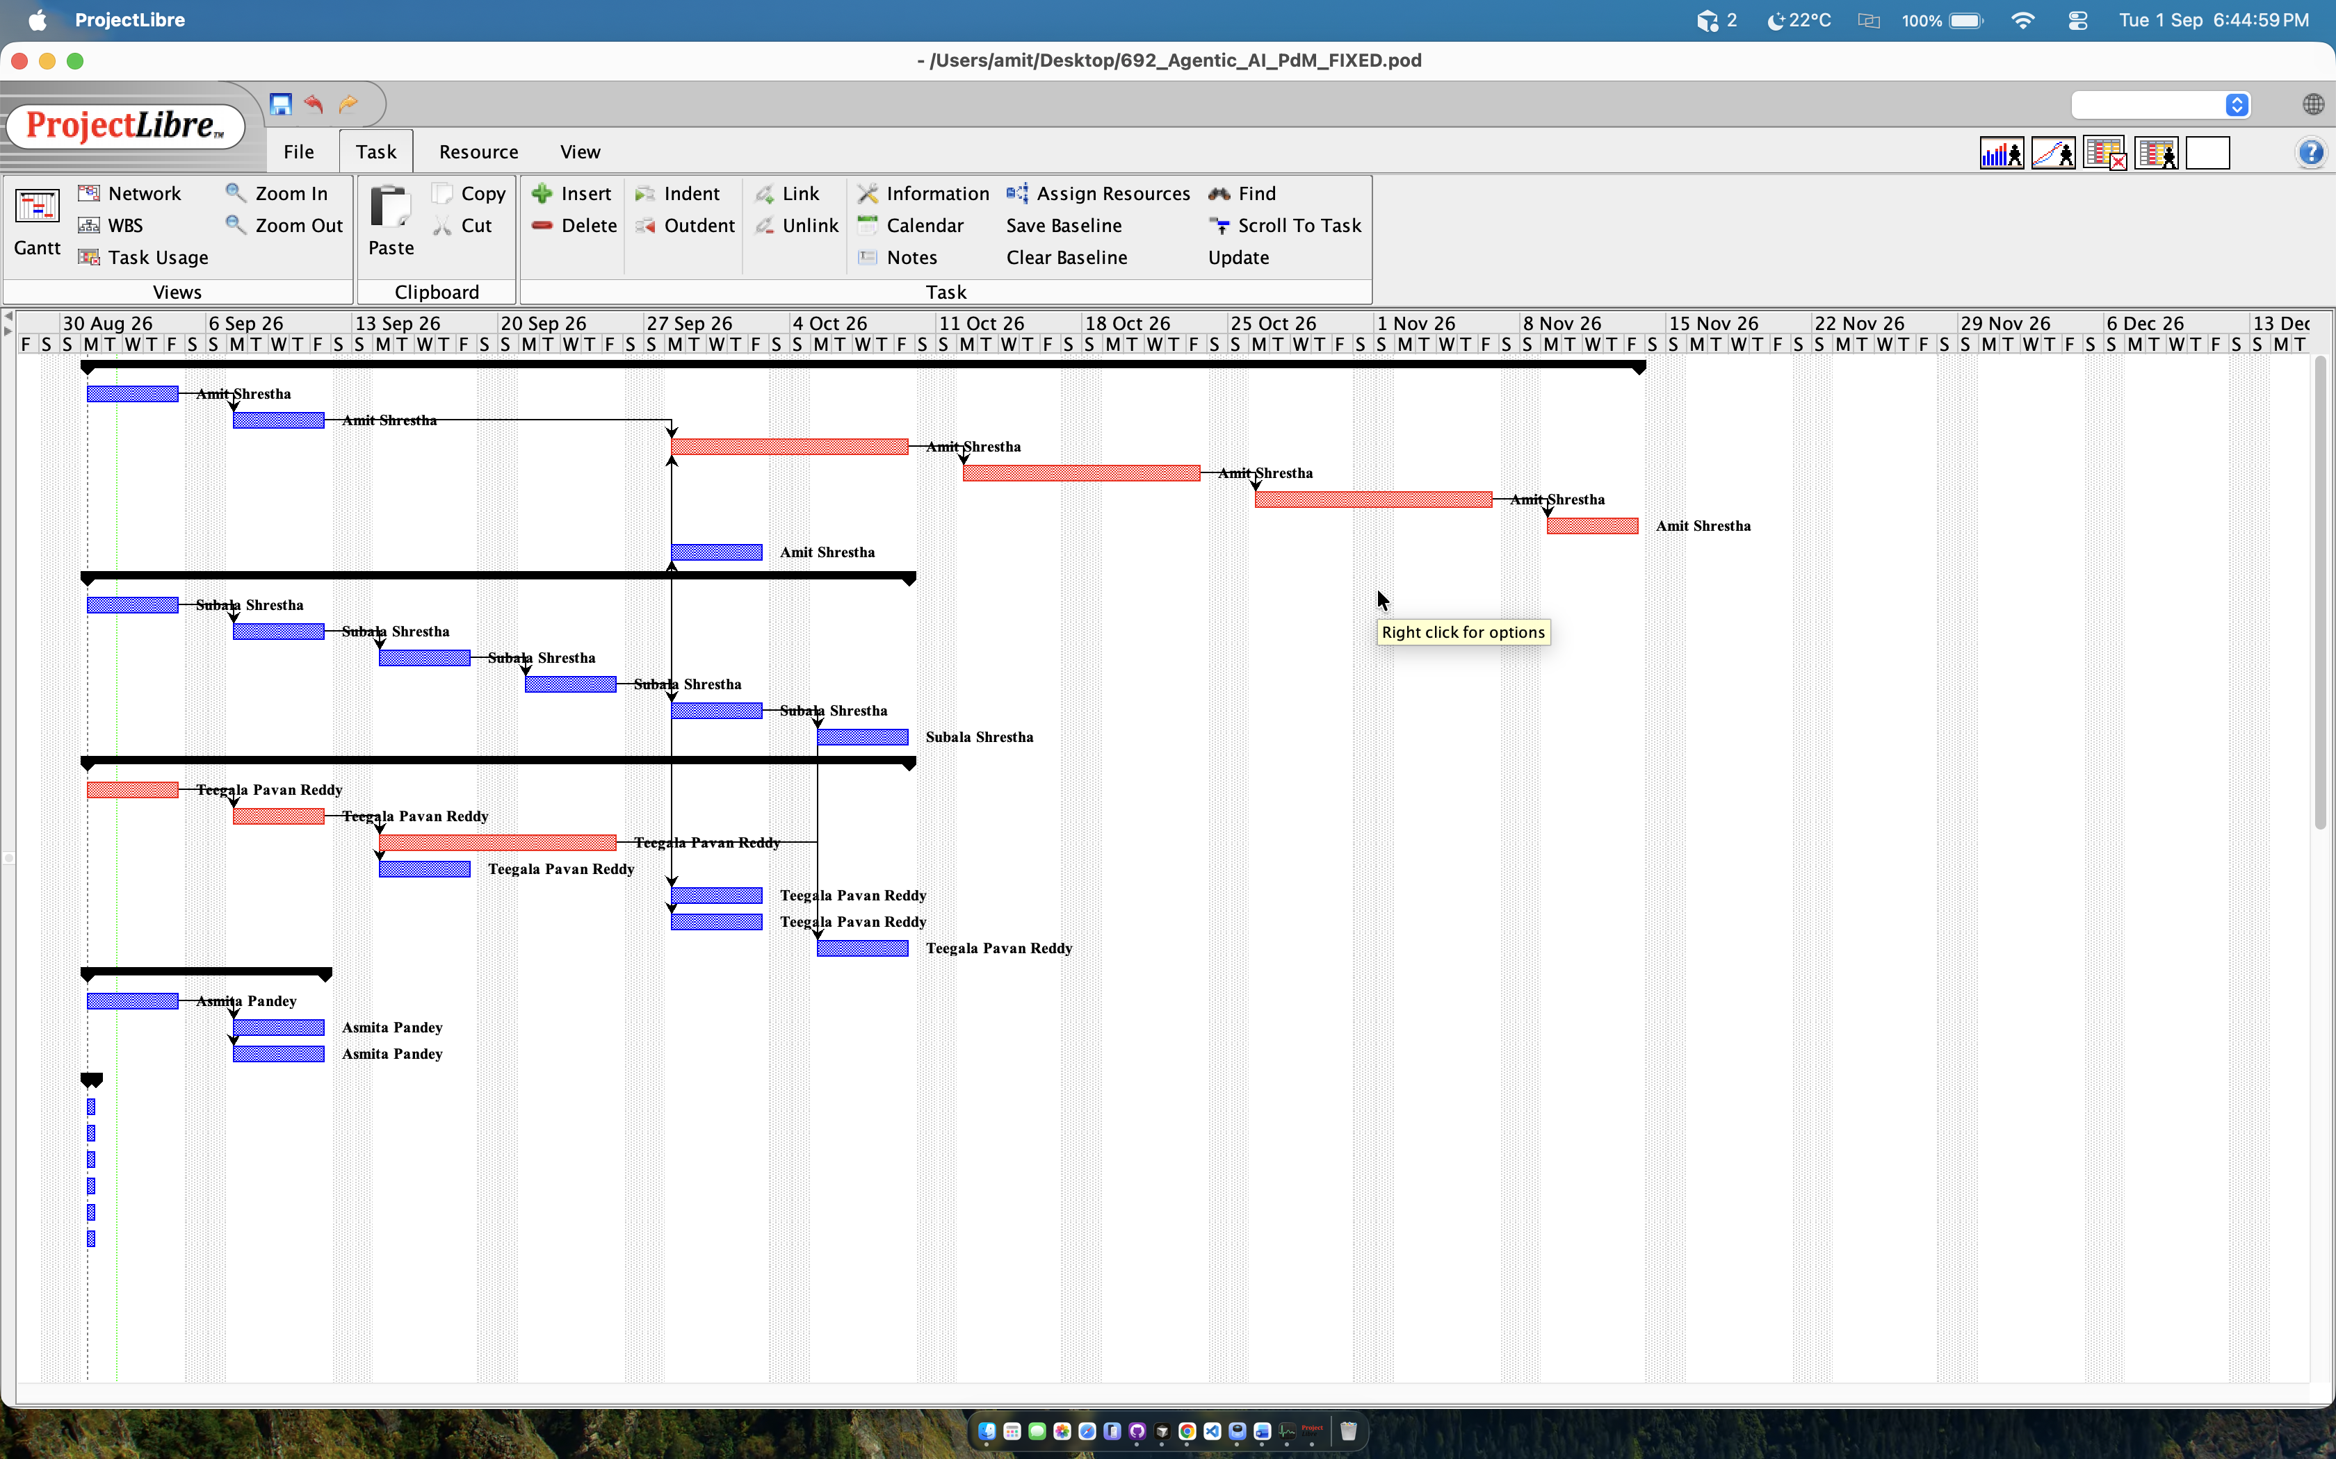
Figure 9. ProjectLibre Gantt chart — resource view (Weeks 6–20).

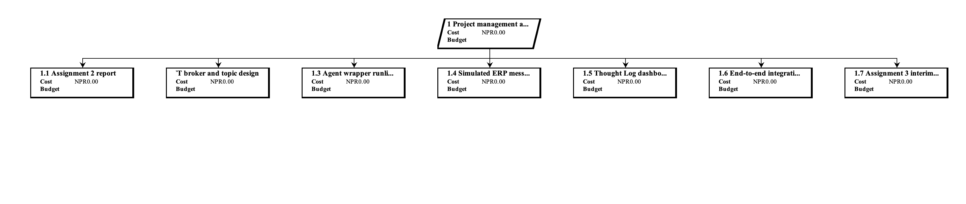
Figure 10. WBS 1 — Project management and integration.

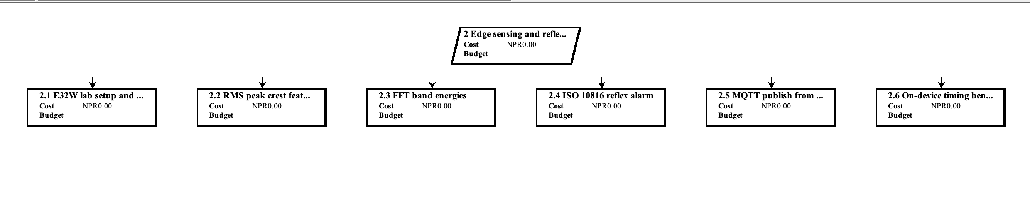
Figure 11. WBS 2 — Edge sensing and reflex E32W.

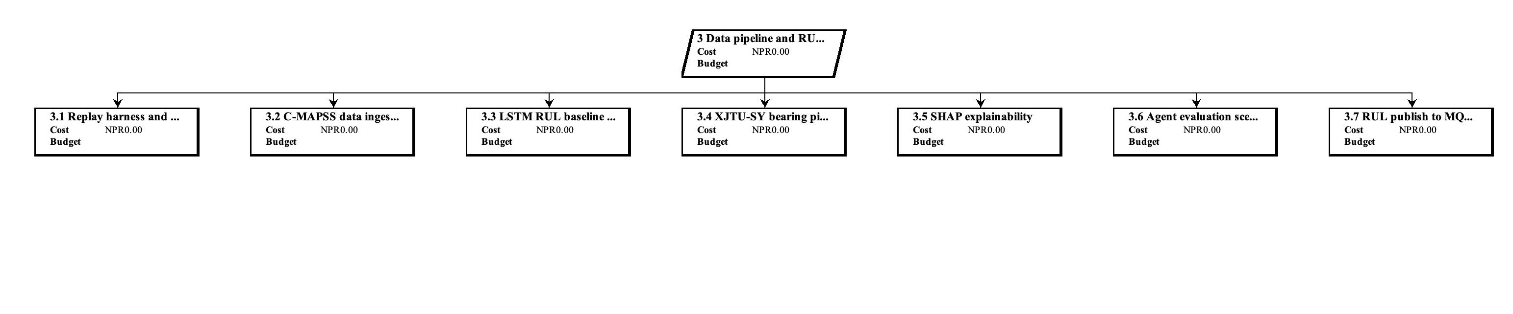
Figure 12. WBS 3 — Data pipeline and RUL analytics.

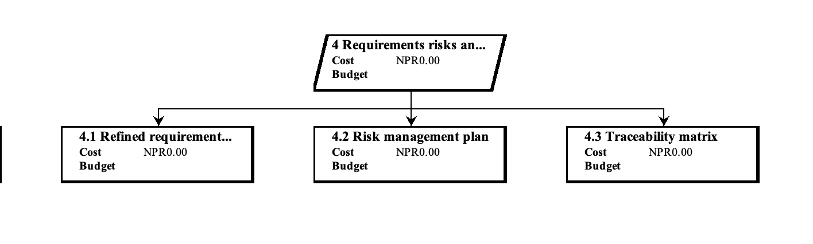
Figure 13. WBS 4 — Requirements, risks and client.

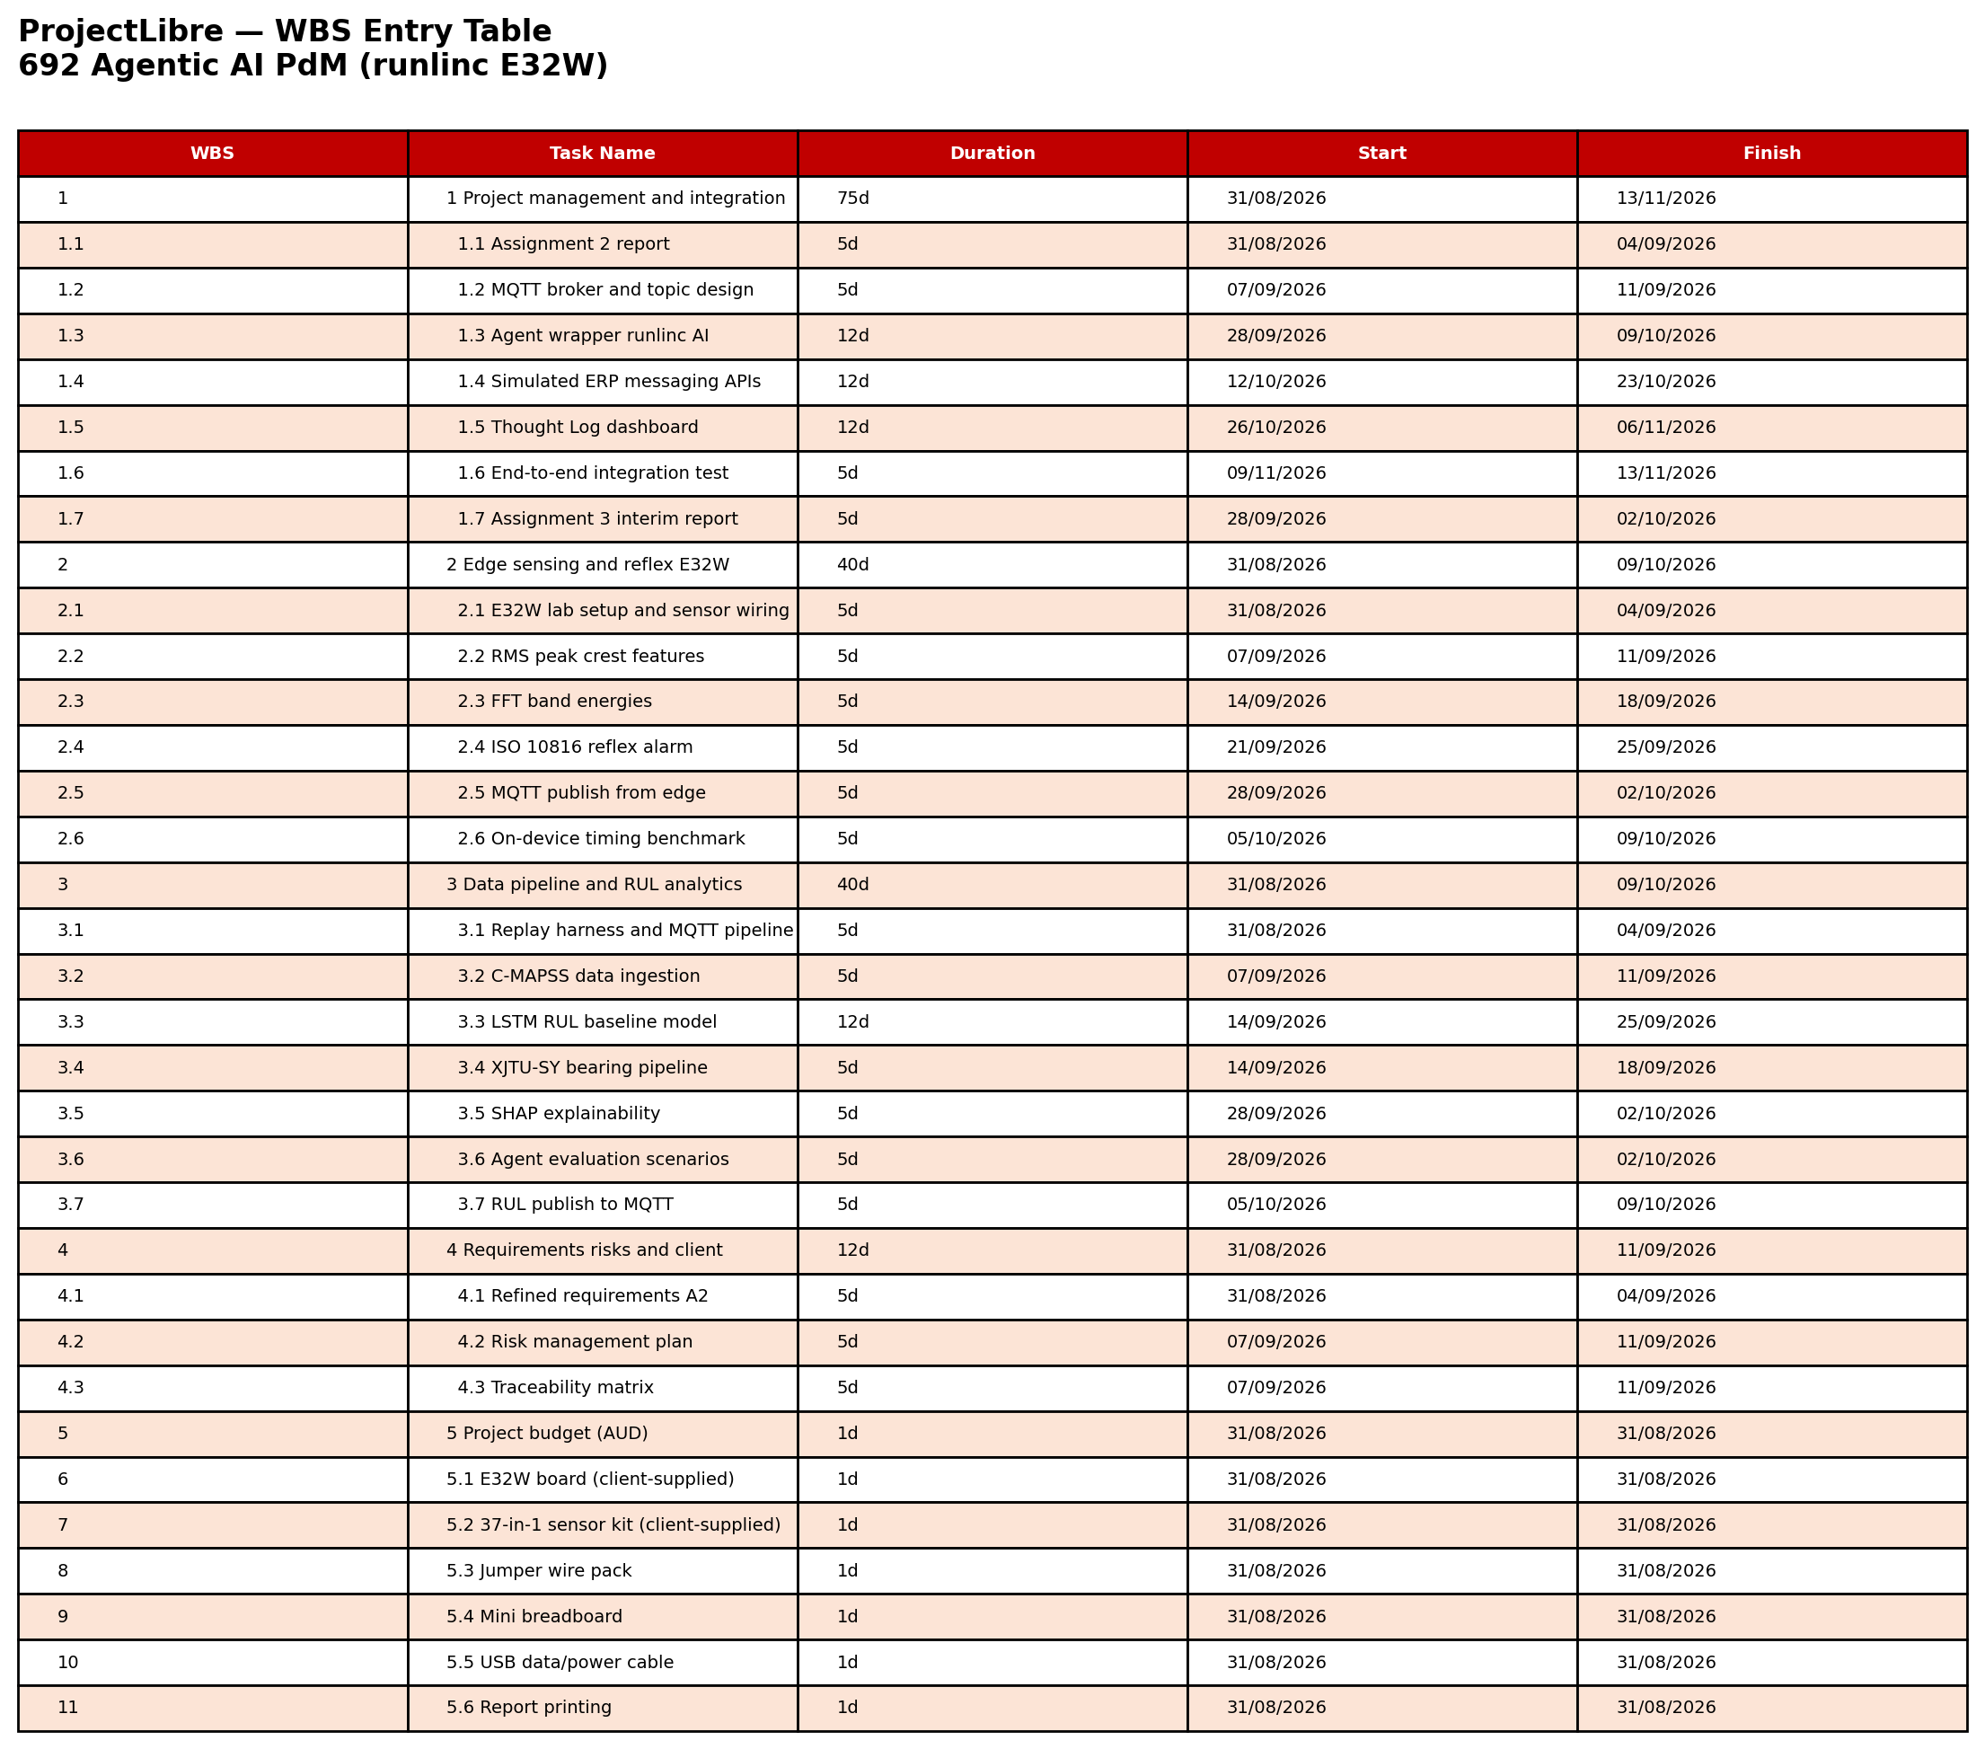
Figure 14. ProjectLibre WBS entry table (all tasks).

8.4 Milestones
ID | Milestone | Week
M1 | A1b baselined | 8
M2 | A2 plan approved | 9
M3 | Edge validated on E32W | 10
M4 | RUL baseline + A3 interim | 12
M5 | Agent demo | 16
M6 | Full system demo | 20

8.5 Resource and referenced budget
The client supplies the E32W platform, 37-in-1 sensor kit, and USB data/power cable. The team funds only minor prototyping accessories. Student labour (~400 h, 4 × ~100 h) and supervisor/client input are recorded as in-kind with zero direct cash cost.
Category | Item | Qty | Unit (AUD) | Total (AUD) | Reference
Hardware | STEMSEL E32W (ESP32) | 1 | 0.00 | 0.00 | Client-supplied [33]
Hardware | 37-in-1 sensor kit | 1 | 0.00 | 0.00 | Client-supplied (eLabtronics)
Hardware | USB data/power cable | 1 | 0.00 | 0.00 | Client-supplied
Hardware | Jumper wire pack | 1 | 9.95 | 9.95 | Jaycar estimate
Hardware | Mini breadboard | 1 | 8.50 | 8.50 | Lab prototyping
Hardware | Subtotal | — | — | 18.45
Software | MicroPython / runlinc IDE | 1 | 0.00 | 0.00 | Client platform
Software | Mosquitto, Python, TensorFlow | 1 | 0.00 | 0.00 | Open source
Software | Google Colab (free) | 1 | 0.00 | 0.00 | LSTM training
Software | Subtotal | — | — | 0.00
Labour | Student team (~400 h) | 4 | 0.00 | 0.00 | Capstone — no salary
Labour | Supervisor + client | — | 0.00 | 0.00 | In-kind
TOTAL | Minimum direct cash budget | — | — | 18.45 | Round to AUD 20

Budget component | Amount (AUD)
Hardware (team purchases) | 18.45
Software and cloud | 0.00
Other direct costs | 0.00
Labour (direct cost) | 0.00
Minimum total | 18.45
Recommended with contingency | 20.00

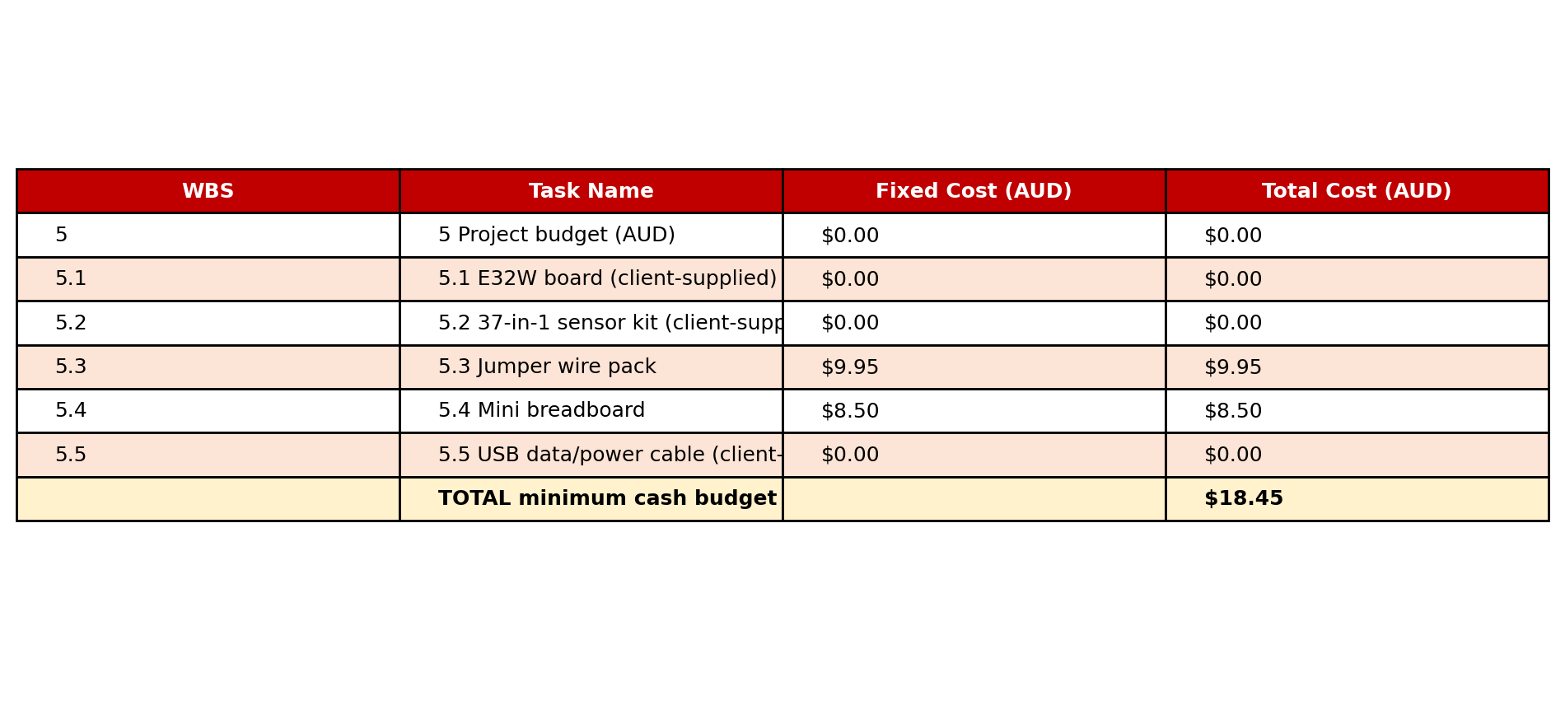
Figure 15. ProjectLibre WBS 5 cost table (minimum direct budget AUD 18.45).

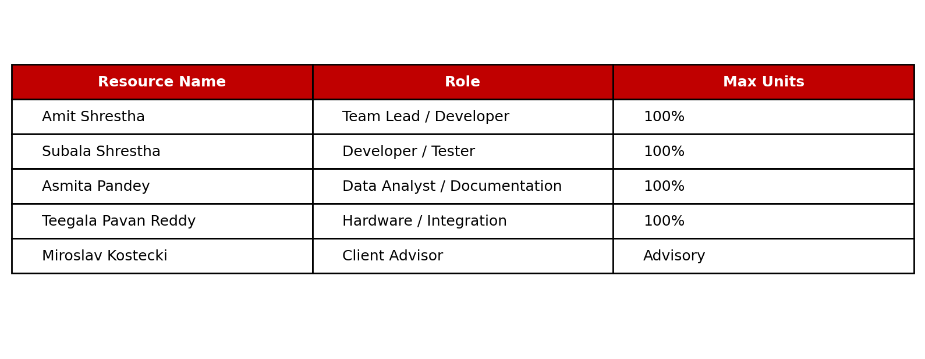
Figure 16. ProjectLibre resource sheet.

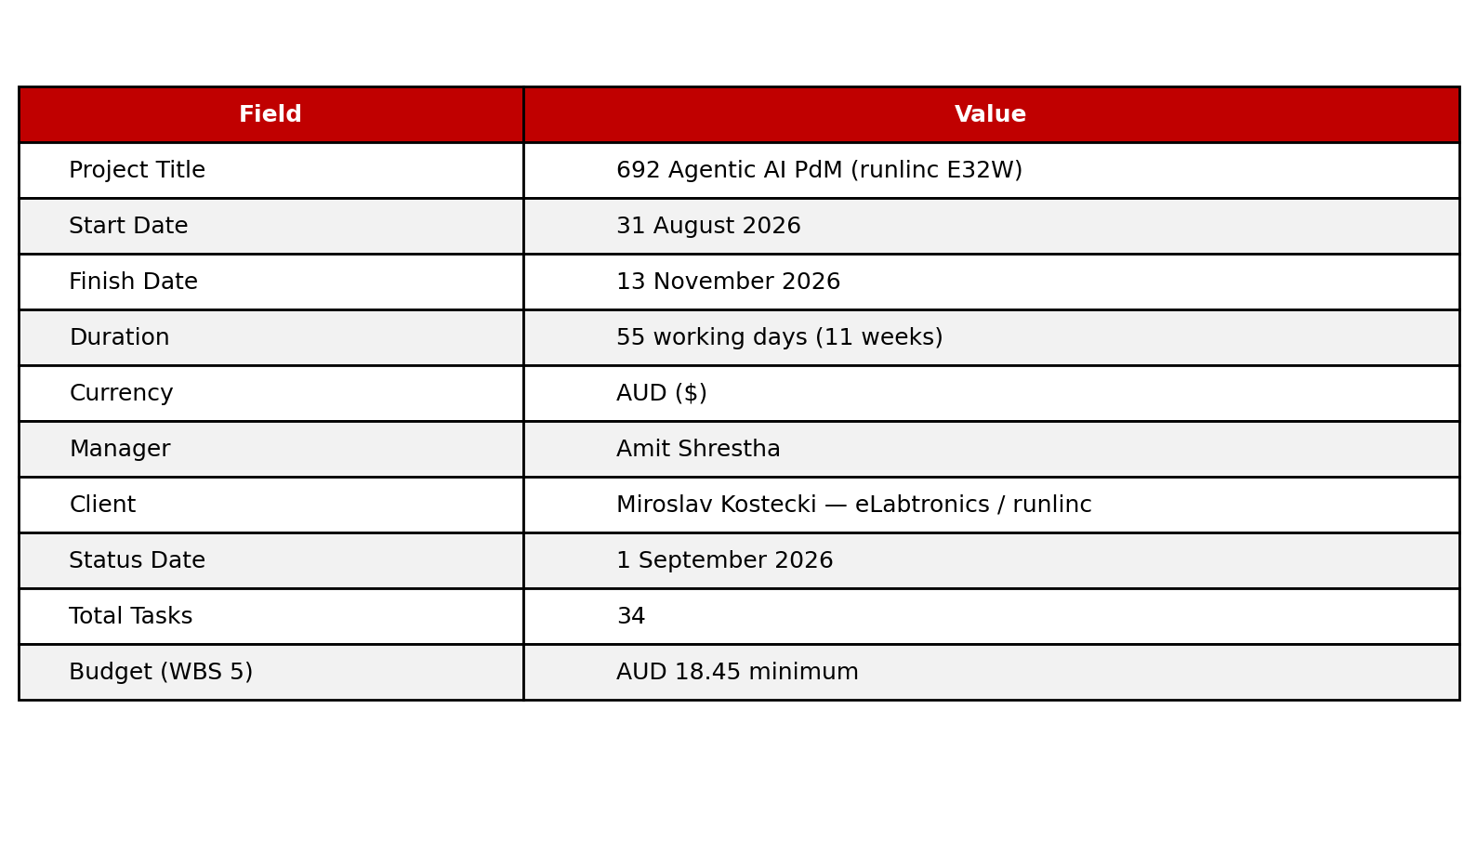
Figure 17. ProjectLibre project information.

9. Risk Management and Project Limitations
ID | Risk | Mitigation | Owner
R1 | Insufficient degradation labels from team E32W lab data | Use C-MAPSS/XJTU-SY benchmarks; induce controlled fault scenarios | Pavan
R2 | E32W hotspot/device connection failures (observed 17 Aug) | Follow runlinc setup guide; test hotspot IP; escalate to client | Subala
R3 | Lab sensor data may not represent factory conditions | Document test protocol; compare with published ESP32 studies [7, 8] | Asmita
R4 | FFT exceeds ESP32 SRAM budget | Optimised FFT; fewer frequency bands; window size tuning | Subala
R5 | MQTT/agent pipeline unavailable during demo | Replay harness; local reflex alarm continues independently | Amit
R6 | Agent inconsistency or invalid tool calls | JSON schema validation; 30-scenario test suite; human review flag | Amit

Limitations: team lab data on E32W may not fully represent factory operating conditions; ESP32 memory limits FFT; agent latency unsuitable for safety alarms; ERP simulated; primary data depends on team-led lab collection schedule.

10. Conclusion
This Assignment 2 report responds directly to Assignment 1b feedback: project-specific introduction, corrected and aligned RQs/objectives, critical literature synthesis, documented client engagement (meetings 10, 17, 24 August 2026), and team hardware data collection scope. The four-layer architecture (Figure 1) separates millisecond reflex alarms from agentic reasoning. Next steps: complete sensor wiring, live MQTT streaming, RUL baseline, and agent integration in MDA692.

11. References
[1] T. Zonta, C. A. da Costa, R. da Rosa Righi, M. J. de Lima, E. S. da Trindade, and G. P. Li, “Predictive maintenance in the Industry 4.0: A systematic literature review,” Computers & Industrial Engineering, vol. 150, art. no. 106889, Dec. 2020, doi: 10.1016/j.cie.2020.106889.
[2] F. Wu, Q. Wu, Y. Tan, and X. Xu, “Remaining useful life prediction based on deep learning: A survey,” Sensors, vol. 24, no. 11, art. no. 3454, May 2024, doi: 10.3390/s24113454.
[3] A. Saxena, K. Goebel, D. Simon, and N. Eklund, “Damage propagation modeling for aircraft engine run-to-failure simulation,” in Proc. Int. Conf. Prognostics and Health Management (PHM), Denver, CO, USA, Oct. 2008, pp. 1–9, doi: 10.1109/PHM.2008.4711414.
[4] S. Zheng, K. Ristovski, A. Farahat, and C. Gupta, “Long short-term memory network for remaining useful life estimation,” in Proc. IEEE Int. Conf. Prognostics and Health Management (ICPHM), Dallas, TX, USA, Jun. 2017, pp. 88–95, doi: 10.1109/ICPHM.2017.7998311.
[5] B. Wang, Y. Lei, N. Li, and N. Li, “A hybrid prognostics approach for estimating remaining useful life of rolling element bearings,” IEEE Transactions on Reliability, vol. 69, no. 1, pp. 401–412, Mar. 2020, doi: 10.1109/TR.2018.2882682.
[6] W. A. Smith and R. B. Randall, “Rolling element bearing diagnostics using the Case Western Reserve University data: A benchmark study,” Mechanical Systems and Signal Processing, vol. 64–65, pp. 100–131, Dec. 2015, doi: 10.1016/j.ymssp.2015.04.021.
[7] P. Kolok, M. Hodoň, P. Ševčík, L. Hotz, and N. Remy, “Low-cost IoT-based predictive maintenance using vibration,” Sensors, vol. 25, no. 21, art. no. 6610, Oct. 2025, doi: 10.3390/s25216610.
[8] S. Brito, G. Azinheira, J. Semião, N. Sousa, and S. P. Litrán, “Non-intrusive low-cost IoT-based hardware system for sustainable predictive maintenance of industrial pump systems,” Electronics, vol. 14, no. 14, art. no. 2913, Jul. 2025, doi: 10.3390/electronics14142913.
[9] J. Jeleńska, U. Jachymczyk, P. Knap, and M. Wiszniewski, “Design and validation of low-cost MEMS sensor networks for AI-based predictive maintenance in Industry 4.0,” in Proc. IEEE Int. Conf. Metrology for eXtended Reality, Artificial Intelligence and Neural Engineering (MetroXRAINE), 2025, doi: 10.1109/MetroXRAINE66377.2025.11340048.
[10] C. Banbury, V. J. Reddi, P. Torelli, J. Holleman, N. Jeffries, C. Kiraly, P. Montino, D. Kanter, S. Ahmed, D. Pau, et al., “MLPerf Tiny benchmark,” in Proc. Neural Information Processing Systems Track on Datasets and Benchmarks, 2021. [Online]. Available: https://arxiv.org/abs/2106.07597
[11] S. Yao, J. Zhao, D. Yu, N. Du, I. Shafran, K. Narasimhan, and Y. Cao, “ReAct: Synergizing reasoning and acting in language models,” in Proc. 11th Int. Conf. Learning Representations (ICLR), Kigali, Rwanda, May 2023. [Online]. Available: https://arxiv.org/abs/2210.03629
[12] T. Schick, J. Dwivedi-Yu, R. Dessì, R. Raileanu, M. Lomeli, L. Zettlemoyer, N. Cancedda, and T. Scialom, “Toolformer: Language models can teach themselves to use tools,” in Proc. 37th Conf. Neural Information Processing Systems (NeurIPS), New Orleans, LA, USA, Dec. 2023.
[13] J. T. Rayfield, S. Lin, N. Zhou, and D. C. Patel, “ReAct meets industrial IoT: Language agents for data access,” in Proc. 2025 Conf. Empirical Methods in Natural Language Processing: Industry Track, Suzhou, China, Nov. 2025, pp. 364–382, doi: 10.18653/v1/2025.emnlp-industry.24.
[14] N. Zhou, D. Patel, and A. Bhattacharyya, “Deployed AI agents for industrial asset management: CodeReAct framework for event analysis and work order automation,” in Proc. AAAI Conf. Artificial Intelligence, 2026, doi: 10.1609/aaai.v40i47.41453.
[15] L. Huang, W. Yu, W. Ma, W. Zhong, Z. Feng, H. Wang, Q. Chen, W. Peng, X. Feng, B. Qin, et al., “A survey on hallucination in large language models: Principles, taxonomy, challenges, and open questions,” ACM Transactions on Information Systems, vol. 43, no. 2, pp. 1–55, 2025, doi: 10.1145/3703155.
[16] A. K. M. Nor, S. R. Pedapati, M. Muhammad, and V. Leiva, “Overview of explainable artificial intelligence for prognostic and health management of industrial assets based on preferred reporting items for systematic reviews and meta-analyses,” Sensors, vol. 21, no. 23, art. no. 8020, Nov. 2021, doi: 10.3390/s21238020.
[17] S. Matzka, “Explainable artificial intelligence for predictive maintenance applications,” in Proc. 3rd Int. Conf. Artificial Intelligence for Industries (AI4I), Irvine, CA, USA, Sep. 2020, pp. 69–74, doi: 10.1109/AI4I49448.2020.00023.
[18] K. T. P. Nguyen, K. Medjaher, and T.-D. Tran, “A review of artificial intelligence methods for engineering prognostics and health management with implementation guidelines,” Artificial Intelligence Review, vol. 56, no. 4, pp. 3659–3709, 2023, doi: 10.1007/s10462-022-10260-y.
[19] R. van Dinter, B. Tekinerdogan, and C. Catal, “Predictive maintenance using digital twins: A systematic literature review,” Information and Software Technology, vol. 151, art. no. 107008, Nov. 2022, doi: 10.1016/j.infsof.2022.107008.
[20] W. Shi, J. Cao, Q. Zhang, Y. Li, and L. Xu, “Edge computing: Vision and challenges,” IEEE Internet of Things Journal, vol. 3, no. 5, pp. 637–646, Oct. 2016, doi: 10.1109/JIOT.2016.2579198.
[21] M. Satyanarayanan, “The emergence of edge computing,” Computer, vol. 50, no. 1, pp. 30–39, Jan. 2017, doi: 10.1109/MC.2017.9.
[22] N. Naik, “Choice of effective messaging protocols for IoT systems: MQTT, CoAP, AMQP and HTTP,” in Proc. IEEE Int. Systems Engineering Symposium (ISSE), Vienna, Austria, Oct. 2017, pp. 1–7, doi: 10.1109/SysEng.2017.8088251.
[23] A. Al-Fuqaha, M. Guizani, M. Mohammadi, M. Aledhari, and M. Ayyash, “Internet of Things: A survey on enabling technologies, protocols, and applications,” IEEE Communications Surveys & Tutorials, vol. 17, no. 4, pp. 2347–2376, 4th Quart. 2015, doi: 10.1109/COMST.2015.2444095.
[24] J. Wei, X. Wang, D. Schuurmans, M. Bosma, B. Ichter, F. Xia, E. Chi, Q. Le, and D. Zhou, “Chain-of-thought prompting elicits reasoning in large language models,” in Proc. 36th Conf. Neural Information Processing Systems (NeurIPS), New Orleans, LA, USA, Dec. 2022.
[25] P. Lewis et al., “Retrieval-augmented generation for knowledge-intensive NLP tasks,” in Proc. NeurIPS, 2020. [Online]. Available: https://proceedings.neurips.cc/paper/2020/hash/6b493230205f780e1bc26945df7481e5-Abstract.html and arXiv:2005.11401, doi: 10.48550/arXiv.2005.11401.
[26] S. M. Lundberg and S.-I. Lee, “A unified approach to interpreting model predictions,” in Proc. NeurIPS, 2017, pp. 4765–4774. [Online]. Available: https://proceedings.neurips.cc/paper/2017/hash/8a20a8621978632d76c43dfd28b67767-Abstract.html and arXiv:1705.07874, doi: 10.48550/arXiv.1705.07874.
[27] S. Amershi, D. Weld, M. Vorvoreanu, A. Fourney, B. Nushi, P. Collisson, J. Suh, S. Iqbal, P. N. Bennett, K. Inkpen, J. Teevan, R. Kikin-Gil, and E. Horvitz, “Guidelines for human-AI interaction,” in Proc. CHI Conf. Human Factors in Computing Systems, Glasgow, U.K., May 2019, pp. 1–13, doi: 10.1145/3290605.3300233.
[28] R. B. Randall, Vibration-Based Condition Monitoring: Industrial, Aerospace and Automotive Applications, 2nd ed. Chichester, U.K.: John Wiley & Sons, 2021.
[29] Mechanical Vibration — Evaluation of Machine Vibration by Measurements on Non-Rotating Parts — Part 3: Industrial Machines with Nominal Power Above 15 kW and Nominal Speeds Between 120 r/min and 15 000 r/min When Measured In Situ, ISO 10816-3:2009, International Organization for Standardization, Geneva, Switzerland, 2009.
[30] P. Warden and D. Situnayake, TinyML: Machine Learning with TensorFlow Lite on Arduino and Ultra-Low-Power Microcontrollers. Sebastopol, CA, USA: O’Reilly Media, 2020. [Online]. Available: https://www.oreilly.com/library/view/tinyml/9781492052036/
[31] Z. Xi et al., “The rise and potential of large language model based agents: A survey,” Science China Information Sciences, vol. 68, art. no. 121101, 2025, doi: 10.1007/s11432-024-4222-0 (also arXiv:2309.07864, doi: 10.48550/arXiv.2309.07864).
[32] L. Wang, C. Ma, X. Feng, Z. Zhang, H. Yang, J. Zhang, et al., “A survey on large language model based autonomous agents,” Frontiers of Computer Science, vol. 18, no. 6, art. no. 186345, 2024, doi: 10.1007/s11704-024-40231-1.
[33] eLabtronics, “runlinc: Rapid development platform for IoT, AI and STEM inventions.” Accessed: Aug.15,2026. [Online]. Available: https://runlinc.com
[34] Espressif Systems, “ESP32 series datasheet,” Espressif Systems, Shanghai, China. Accessed: Aug.15,2026. [Online]. Available: https://www.espressif.com/en/support/documents/technical-documents
[35] MicroPython, “Quick reference for the ESP32 — MicroPython documentation.” Accessed: Aug.15,2026. [Online]. Available: https://docs.micropython.org/en/latest/esp32/quickref.html
[36] A. H. Alaoui, A. Meddaoui, and M. Hain, “AI-driven predictive maintenance for Industry 4.0: A systematic review of models, methods, and challenges,” The International Journal of Advanced Manufacturing Technology, vol. 143, pp. 4861–4876, 2026. [Online]. Available: https://doi.org/10.1007/s00170-026-17531-w
[37] N. Ringler, D. Knittel, J.-C. Ponsart, M. Nouari, A. Yakob, and D. Romani, “Machine learning based real time predictive maintenance at the edge for manufacturing systems: A practical example,” in Proc. IEEE IAS Global Conf. Emerging Technologies (GlobConET), London, U.K., May 2023, doi: 10.1109/GlobConET56651.2023.10150033.https://ieeexplore.ieee.org/
[38] A. Fernández-Miguel, S. Ortíz-Marcos, M. Jiménez-Calzado, A. P. Fernández del Hoyo, F. E. García-Muiña, and D. Settembre-Blundo, “Agentic AI in smart manufacturing: Enabling human-centric predictive maintenance ecosystems,” Applied Sciences, vol. 15, no. 21, art. no. 11414, Oct. 2025, doi: 10.3390/app152111414.
[39] S. Gawde, S. Patil, S. Kumar, P. Kamat, K. Kotecha, and S. Alfarhood, “Explainable predictive maintenance of rotating machines using LIME, SHAP, PDP, ICE,” IEEE Access, vol. 12, pp. 29345–29361, 2024. [Online]. Available: https://doi.org/10.1109/ACCESS.2024.3367110
[40] S. Gupta and S. N. Shivhare, “Embedded TinyML for predictive maintenance: Vibration analysis on ESP32 with real-time fault detection in industrial equipment,” International Journal on Computational Modelling Applications, vol. 2, no. 2, pp. 1–17, 2025, doi: 10.63503/j.ijcma.2025.114.

Appendix I — Industry Client Details
Field | Confirmed detail
Project title | Real-Time Data with Agentic AI for Industrial Predictive Maintenance (PdM)
Company | eLabtronics; ABN 28 068 561 553
Address | 22–26 Peel Street, Adelaide SA 5000
Industry professional | Miroslav Kostecki, Chief Technology Officer (eLabtronics / runlinc)
Contact | projects@careerdc.com.au; via runlinc platform
Client profile | Developer of STEM and industrial inventor toolkits; runlinc browser-based IoT/AI platform
Hardware supplied | STEMSEL E32W (ESP32), 37-in-1 sensor kit, USB data/power cable
Data scope | Team collects all real-time data from supplied lab hardware; client factory plant data out of scope
Proposal status | Client and industry-supervisor signatures dated Assignment 1 (13 Aug 2026)

Full signed Appendix I form from Assignment 1 is retained in project records and available on request.

Appendix II — Annotated Literature Bibliography and Activity Log
SUBMISSION REQUIREMENT: Upload this file together with the group report on Moodle. The full annotated bibliography of 40 sources (10 per member, 2023–2026) is in: MDA691_Assignment2_Appendix_II_Literature.docx (also on team Desktop). Each member contributed peer-reviewed journal and conference sources as required. Distribution: Asmita — PdM/XAI/trust; Subala — edge/ESP32/vibration; Pavan — RUL/deep learning; Amit — agentic AI/tool use.

Appendix II.A — Weeks 5–8 Activity and Meeting Log
Week | Date | Activity / decision | Evidence
5 | 10 Aug 2026 | Project introduction; document review; meeting schedule agreed | Meeting minutes; logbook
6 | 17 Aug 2026 | Hotspot IP setup; device connection troubleshooting; runlinc login | Meeting summary 17-Aug-2026.docx
7 | 24 Aug 2026 | Hardware setup; LED blink test (D2); runlinc Projects 14/15 reviewed; later DS18B20 Project 14 lab test (Figs 6–8) | Meeting minutes 24-Aug-2026.docx; Table 7; Figures 6–8
8 | Sep 2026 | Supervisor feedback on A1b; A2 report preparation | Moodle feedback; this report

Appendix III — Response to Feedback on Assignment 1
The team reviewed written grade feedback and verbal comments from supervision and presentation sessions. Table A1 maps each Assignment 1b rubric criterion, marker feedback, score received, and corrective action in this report.
Criterion | A1 Score | Marker feedback (summary) | Action in Assignment 2 | Section
Introduction | 0.85/1 | Good overview but generic; needs E32W/runlinc focus | Rewritten project-specific intro naming E32W, runlinc, team hardware | §1
Problem domain & RQs | 0.65/1 | RQ4 misaligned; RQs need clarity | RQ4 corrected; 4 RQs only; full RQ–objective mapping table | §2.3–2.4
Literature review | 4/6 | Descriptive; needs critical comparison, gaps, recent refs | Critical comparison table §3; gap analysis; 40-source plan in App II | §3, App II
Aim & objectives | 1.3/2 | Objectives need measurability and RQ alignment | Measurable success criteria per objective; explicit RQ column | §2.4
Requirements (prelim.) | 3/4 | Limited client meeting evidence; lab vs factory constraints | Client meeting table §4.1; lab hardware scope clarified §4.2 | §4
References | 0.67/1 | Good range; minor IEEE formatting issues | IEEE format checked; numbering consistent §11 | §11
AI usage (general) | — | Add critical analysis and independent evaluation | Critical synthesis tables; explicit gap statement | §3, App III

AIII.1 Itemised responses to feedback
Introduction too generic. Reframed around eLabtronics, runlinc E32W, and team hardware data collection (not client plant). (§1)
RQ4 unrelated (circular economy/banking). Deleted incorrect RQ4. New RQ4 compares dual-path agentic PdM vs alert-only AI on latency and traceability. (§2.3)
Objectives broad and not measurable. Seven objectives rewritten with quantitative success criteria and RQ mapping (Table §2.4). (§2.4)
Literature descriptive only. Added §3.1–3.3 critical synthesis paragraphs, comparative table, and explicit research gap; 40 annotated sources in Appendix II. (§3, App II)
Limited client-meeting evidence. Three documented meetings (10, 17, 24 Aug 2026) with minutes and outcomes (§4.1, App II.A); LED blink prototype evidence (Table 7 / Figures 6–8). (§4.1, §7.6)
Missing diagrams and Gantt. Added Figures 1–17 including architecture, design diagrams, DS18B20 prototype evidence (Figs 6–8), Gantt, WBS, budget, and resources. (§7–8)
IEEE formatting inconsistencies. References reformatted to IEEE style with consistent numbering (§11). (§11)
Changes to §§1–4 since Assignment 1. §1: E32W/runlinc-specific intro. §2: corrected RQs and measurable objectives. §3: critical literature. §4: refined requirements, client evidence, team hardware procedure. (§§1–4)

