Assessment Cover Sheet
MDA691 Assignment 2
Student ID Number/s: | Student Last name/s: |  | Student First name/s:
MIT252463 | Shrestha |  | Amit
MIT251400 | Reddy |  | Teegala Pavan
MIT252219 | Shrestha |  | Subala
MIT250081 | Pandey |  | Asmita
Course: Master of Data Analytics |  |  | School: Melbourne Institute of Technology
Unit code: MDA691 | Unit title: Project Management and Research Methods
Due date: 13 September 2026 | Date submitted: 13 September 2026 |  | Campus: Melbourne Institute of Technology
Lecturer’s Name: Dr. Basharat Ali |  |  | Tutor: Dr. Basharat Ali
Student Declaration
I/We declare and certify that:
- the work contained in this assessment is my/our own work/group work, except where acknowledgement of sources is made;
- this assessment has not been submitted previously for academic credit in this or any other course;
- I/we have read MIT’s Plagiarism and Academic Misconduct Policy and Procedure, and I/we understand the consequences of engaging in plagiarism, collusion and contract cheating;
- a copy of the original assignment is retained by me/us and that I/we may be required to submit the original assignment to the Lecturer and/or Unit Co-ordinator upon request;
I/we have not plagiarised the work of others or participated in unauthorised collaboration or contract cheating when preparing this assessment.
MIT ID |  | Signature |  | Date
MIT252463 |  | Amit Shrestha |  | 13 September 2026
MIT251400 |  | Teegala Pavan Reddy |  | 13 September 2026
MIT252219 |  | Subala Shrestha |  | 13 September 2026
MIT250081 |  | Asmita Pandey |  | 13 September 2026

1. Introduction
This report turns the initial concept from the Assignment 1b into a project plan which is implementable and an intermediate design for the eLabtronics/runlinc [33]. The capstone is presented as a lab prototype on custom hardware provided by the client with the goal of using its embedded STEMSEL E32W (ESP32) [34] microcontroller programmed using the runlinc IDE (MicroPython) [35]. The team gathers all real-time sensor data from the team's own E32W lab kit, not the client factory or plant systems.
The proposed contribution is a two-path model with millisecond ISO 10816 reflex alarms [29] on the edge, but agentic reasoning (runlinc AI Assistant [33]) for maintenance advice, ERP tool simulation [12] and an auditable Thought Log dashboard [27], which runs at a slower rate than reflex alarms. These include planning, requirements refinement, and intermediate design; full implementation and demonstration will take place in MDA692.
This report is structured as follows: Section 2 presents the problem, the revised research questions and measurable goals; Section 3 provides a critical literature synthesis; Section 4 documents new requirements / client involvement since Assignment 1; Section 5 is mapping to the MDA512 data-science lifecycle; Section 6 is mapping to software engineering methods; Section 7 is the intermediate design with diagrams; Section 8 is timeline, roles, WBS, Gantt chart, and budget; Section 9 is risks and limitations. Appendices I-III include client information, annotated literature bibliography, and the Assignment 1 client feedback response.

1.1 Significance and contribution
With the rise of edge sensing, machine learning and AI agents [31], [32], [38], more and more industrial predictive maintenance systems [1], [36] are integrating all three, but very few published systems integrate all three, explicitly in a low-cost ESP32 platform [7], [40]. This project shows how traceable edge-to-agent workflows can be demonstrated on runlinc hardware [33], using data collected in the lab by the team, with the addition of public RUL benchmarks (C-MAPSS [3], XJTU-SY [5]).

2. Problem Domain, Research Questions and Objectives

2.1 Problem domain
Downtime, cost and safety risk are all the result of unplanned equipment failures [1]. While Industry 4.0 provides the capability for continuous condition monitoring through IIoT sensors [23], all cloud-based analytics [20], [21] add latency and dependency on connectivity. Agentic AI [11], [31] can be used for automation in maintenance, but cannot turn a blind eye to safety-critical reflex alarms [29]. This trade-off can be assessed in a controlled environment using the eLabtronics E32W platform [33], [34].

2.2 Research questions (revised)
RQ1: What are the challenges in reliably streaming real-time vibration and temperature features from the E32W (ESP32) for predictive maintenance analytics?
RQ2: What is the accuracy of RUL estimation by using LSTM models [2], [4] trained on benchmark datasets [3], [5] and tested with team hardware streams?
RQ3: How can an agentic AI layer (runlinc AI Assistant [33]) be used to help with maintenance decisions with traceability of the decisions made [27]?
RQ4: What are the pros and cons of using a reflex-alarm approach versus an agentic approach for generating alerts from AI [29], [11]?

2.3 Aim
Prototype and test an eLabtronics runlinc E32W device [33] to transform real-time condition data into trustworthy edge alarms, predictive RUL evidence [2], [4] and agent-assisted maintenance recommendations, and with full traceability..

2.4 Measurable objectives aligned to RQs
S.N | Objective | Success criterion | RQ | Week
1 | Real-time telemetry pipeline from E32W | Continuous stream ≥1 hr, and latency <2× real-time in replay, with no dropped windows. | RQ1 | 8
2 | Edge features on ESP32 | Baseline RMS, peak, crest, FFT, in 1s window; memory: ≤400 KB; NumPy tolerance: ±5%. | RQ1 | 9
3 | LSTM RUL model | RMSE ≤ Zheng et al. [4] baseline +10% on C-MAPSS FD001 | RQ2 | 12
4 | Agentic assessment layer | A minimum pass rate of ≥ 80% for 30-scenario suite is required. | RQ3 | 14
5 | Simulated ERP/messaging tools | 100%: All tool calls are schema valid; ≥ 5: All negative test cases are handled. | RQ3 | 16
6 | Thought Log dashboard | All sample actions are linked to feature-window ID (100%) | RQ3 | 18
7 | Dual-path benchmark | Agent: N/A, Agent API: offline | RQ4 | 20

3. Critical Literature Review Summary
Most of the literature in assignment 1b was descriptive. This report addresses the supervisor's comments by incorporating critical comparison, synthesis across themes, and research gap. A complete annotated bibliography (40 sources: 10 per member, 2023-2026, including peer-reviewed journal/conference papers) is due with this report and must be uploaded with this report as Appendix II (MDA691_Assignment2_Appendix_II_Literature.docx).

3.1 Critical synthesis

Edge hardware, RUL modelling and agentic orchestration are seen as separate concerns while being treated as background of the Industry 4.0 context in previous PdM surveys (Zonta et al. [1]). The feasibility of anomaly detection at low cost is illustrated in edge vibration studies for ESP32 (Kolok et al. [7]; Brito et al. [8]; Jeleńska et al. [9]; Gupta and Shivhare [40]) but it only attains the classification step [10], without providing RUL estimates or agent tool contracts or even auditable maintenance workflows. In contrast, the LSTM RUL approach (Zheng et al. [4] and Wu et al. [2]; Smith and Randall [6]) has a high benchmark accuracy, but requires cloud-scale compute and excludes millisecond safety reflexes.

Published deployments of agentic AI frameworks [11], [12], [13], [14] demonstrate the ability of tool-augmented LLMs to automate multi-step tasks, but do not necessarily restrict the schema of the tools for safety-critical maintenance tasks nor distinguish reflex alarms from deliberative reasoning. In explainability research (Nor et al. [16]; Huang et al. [15]; Matzka [17]; Nguyen et al. [18]), trust and hallucination dangers are highlighted to be valued when an agent makes a downtime or parts ordering suggestion. So, our design integrates: (i) deterministic ISO reflex on device, (ii) feature-vector RUL from validated models, and (iii) schema-validated agent tools [12], [14] and Thought Log, which is not integrated into the runlinc E32W platform [33], [38].

3.2 Comparative analysis
Theme | Representative work | Strength | Limitation vs our project | Our advance
PdM surveys | Zonta [1], Alaoui [36] | Broad Industry 4.0 context | No runlinc/ESP32 agentic integration | Platform-specific dual-path design
ESP32 vibration | Kolok [7], Gupta and Shivhare [40] | Low-cost edge anomaly ~73–92% | No RUL; no agent; lab only | RUL + agent + Thought Log on E32W
RUL deep learning | Wu [2], Zheng [4], BLTTNet 2025 [37] | Strong C-MAPSS benchmarks | Cloud-centric; not edge+agent | Feature-vector RUL fed to agent
Agentic AI | ReAct [11], Rayfield [13], Zhou et al. [14] | Tool use paradigm | Generic; fails naive industrial deploy | Schema-validated maintenance tools
XAI/trust | Nor [16], Huang [15], Gawde et al. [39] | Explainability, hallucination risks | Not linked to reflex/agent split | Thought Log + ISO reflex isolation

Research gap: There is no system that integrates the ESP32 edge reflex alarms, LSTM RUL [2], [4], and agentic maintenance tools [11], [13], [14] on the runlinc E32W [33] platform with lab telemetry gathered by the team. A summary of the gaps in prior work and how this project contributes to the state of practice is summarized in Table 1. This project is intended to address an identified research gap. The project will fill a gap in research..

3.3 Research gap and project positioning

The gap is more than just technical – architectural and operational. The factory PdM systems typically rely on constant connection to the cloud [19], [20] and manual acknowledgment of alarms. We take a student-team scale prototype built on client-provided hardware and test to see if it achieves measurable objectives in terms of reflex latency [29], RUL accuracy [2], [4] and agent traceability [27] within the first trimester of the design phase, based on lab data, not production plant telemetry. This places the project in the category of a "reproducible reference implementation" for the project eLabtronics/runlinc and not a "generic Industry 4.0 survey".

4. Refined Project Requirements Since Assignment 1

4.1 Client engagement evidence
Week | Date | Mode | Attendees | Evidence | Outcome
4 | 10/08/2026 | Online | Miroslav Kostecki; all team | Meeting minutes; logbook | Project intro; document review; meeting schedule agreed
6 | 17/08/2026 | Online/Lab | Miroslav; all team | Meeting summary 17-Aug-2026.docx | Hotspot setup; device connection troubleshooting; runlinc login
7 | 24/08/2026 | Online/Lab | Miroslav; all team | Meeting minutes 24-Aug-2026.docx | Hardware setup; LED blink test (D2); runlinc Projects 14/15; block diagram planning
8 | Sep 2026 | Supervision | Dr Basharat Ali | Moodle A1 feedback | Report improvements; literature; RQ alignment
Ongoing | Aug 2026 | runlinc platform | Team + client | Logbook | Client confirmed: team collects all real-time data from supplied E32W + 37-in-1 sensor kit

4.2 Data requirements (revised)

Primary data source: realtime data streams collected by the team from client supplied E32W and 37-in-1 sensor kit [34]. Client factory/plant telemetry is considered out of scope. When failure label is not sufficiently provided, the RUL model can be trained with the supplementary benchmark datasets such as C-MAPSS FD001 [3], XJTU-SY bearings [5], [6].

4.2.1 Team hardware data collection procedure
The team's hardware data collection procedure is as follows:
- use jumper wires to connect KY-002 vibration sensor (GPIO 23), temp sensor (GPIO 33), and buzzer (GPIO 34) to E32W.
- Connect to runlinc hotspot [33], program using runlinc IDE (MicroPython) [35].
- Conduct controlled laboratory tests (normal and induced vibration/temperature change).
- Store feature vectors with timestamps locally, export to CSV/JSON afterwards.
- Test MQTT pipeline [22], [23] using replay harness prior to live agent integration.
- Add C-MAPSS/XJTU-SY benchmarks [3], [5], [6] for RUL model training.

4.3 Functional requirements (refined)
ID | Requirement | Priority | Change since A1b
FR1 | Stream E32W telemetry in real time | Must | Clarified: team hardware not client plant
FR2–FR4 | Edge features + ISO local alarm | Must | Unchanged
FR5 | MQTT JSON feature publish | Must | Schema defined 7.3
FR8 | RUL from feature history | Must | Unchanged
FR10–FR12 | Agent + tools + Thought Log | Must | Added scenario-suite metric

4.4 Non-functional requirements (numeric targets)
ID | Requirement | Target | Verification
NFR1 | Feature extraction per window | ≤1000 ms | ESP32 timing log
NFR2 | Reflex isolated from agent | Alarm <200 ms; agent 2–10 s | API failure injection
NFR3 | Offline graceful degradation | Alarms active without MQTT/agent | Disconnect test
NFR4 | Traceability | 100% actions linked to window ID | Thought Log audit
NFR5 | Agent consistency | ≥90% same tool on repeat scenarios | 30-scenario suite

5. Data Science Project Lifecycle Mapping (MDA512)
The team maps project stages data science project lifecycle that is followed in MDA512 and CRISP-DM. There is a decision gate at the end of each stage, giving a tangible result before moving on to the next stage. If there is any uncertainty due to hardware access or agent behavior, the failed quality checks rollback to requirements or data preparation instead of going to deployment.
Stage | Activity | Deliverable | Week | Owner
1 Business understanding | Client meetings, problem, RQs | A1b + 2 | 4–8 | Asmita, Subala
2 Data understanding | Team E32W lab data collection; benchmark exploration | Data inventory 4.2; lab test log | 8–10 | Pavan
3 Data preparation | Windowing team hardware streams; replay harness | Feature pipeline 7.2 | 9–11 | Pavan, Subala
4 Modelling | LSTM RUL training | RUL model | 11–12 | Pavan
5 Evaluation | RMSE, SHAP, scenario suite | Eval report | 12–16 | Pavan, Amit
6 Deployment | MQTT, edge publish, dashboard | Prototype | 14–18 | Amit, Subala
7 Monitoring | Thought Log audit, benchmark | Week 20 demo | 18–20 | All

6. Software Engineering Methods

6.1 Iterative delivery and governance
A lightweight Agile approach is used because hardware access, client-data suitability, and agent behaviour [15], [31] create uncertainty. Work is planned in one-week iterations aligned with supervision meetings. Each sprint delivers a demonstrable increment mapped to objectives in Table 2.4.

6.2 Version control, review and Definition of Done
Protected main branch; short feature branches; pull request and one peer review before merge.
No raw client data, API keys, or model binaries in the repository; configuration uses environment variables.
Exploratory notebooks are converted into reproducible scripts/modules before integration.
A requirement is Done only when code, automated test, documentation, traceability link, and demo evidence exist.
Releases are tagged with dataset/feature/model/prompt versions for reproducibility.

6.3 Quality strategy and integration
Continuous integration runs linting, unit tests, JSON schema tests [12], [24], and a deterministic replay [25] on every merge request. Hardware tests remain a controlled manual gate. Architecture decision records (ADR) document the reflex/agent split [29], [11]. OpenAPI specifies mock ERP endpoints [12], [13]; the Thought Log serves [27] as the audit artefact.

7. Intermediate Project Design

7.1 Architecture overview
Figure 1 shows the four-layer architecture with team hardware as the primary data source
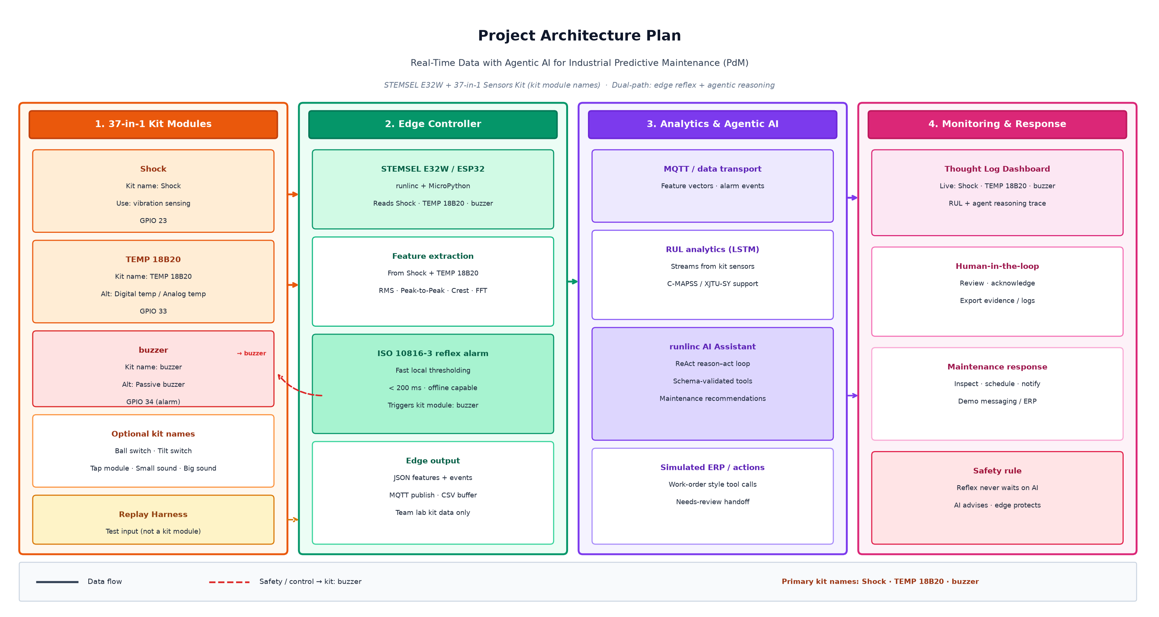
Figure 1. Project architecture plan — 37-in-1 kit modules (Shock, TEMP 18B20, buzzer) with STEMSEL E32W dual-path edge reflex and agentic AI.

7.2 Edge and reflex design
1 s windows, 50% overlap; RMS, peak-to-peak, crest factor, FFT bands [28]. ISO 10816-3 reflex alarm [29] on breach.
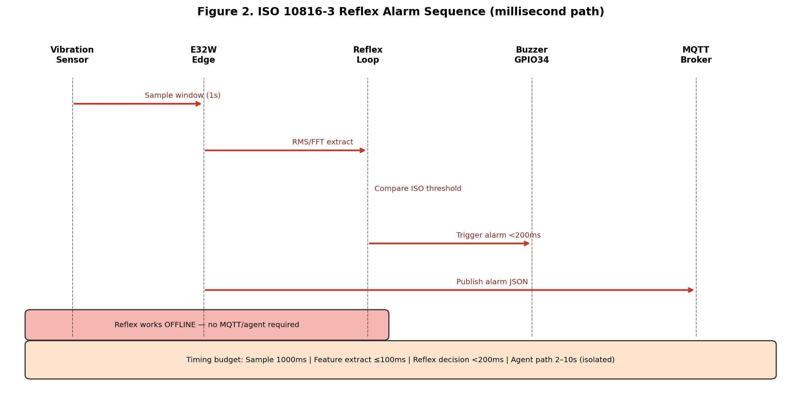
Figure 2. ISO 10816-3 reflex alarm sequence — millisecond path isolated from agent.

7.3 Data model and MQTT schema
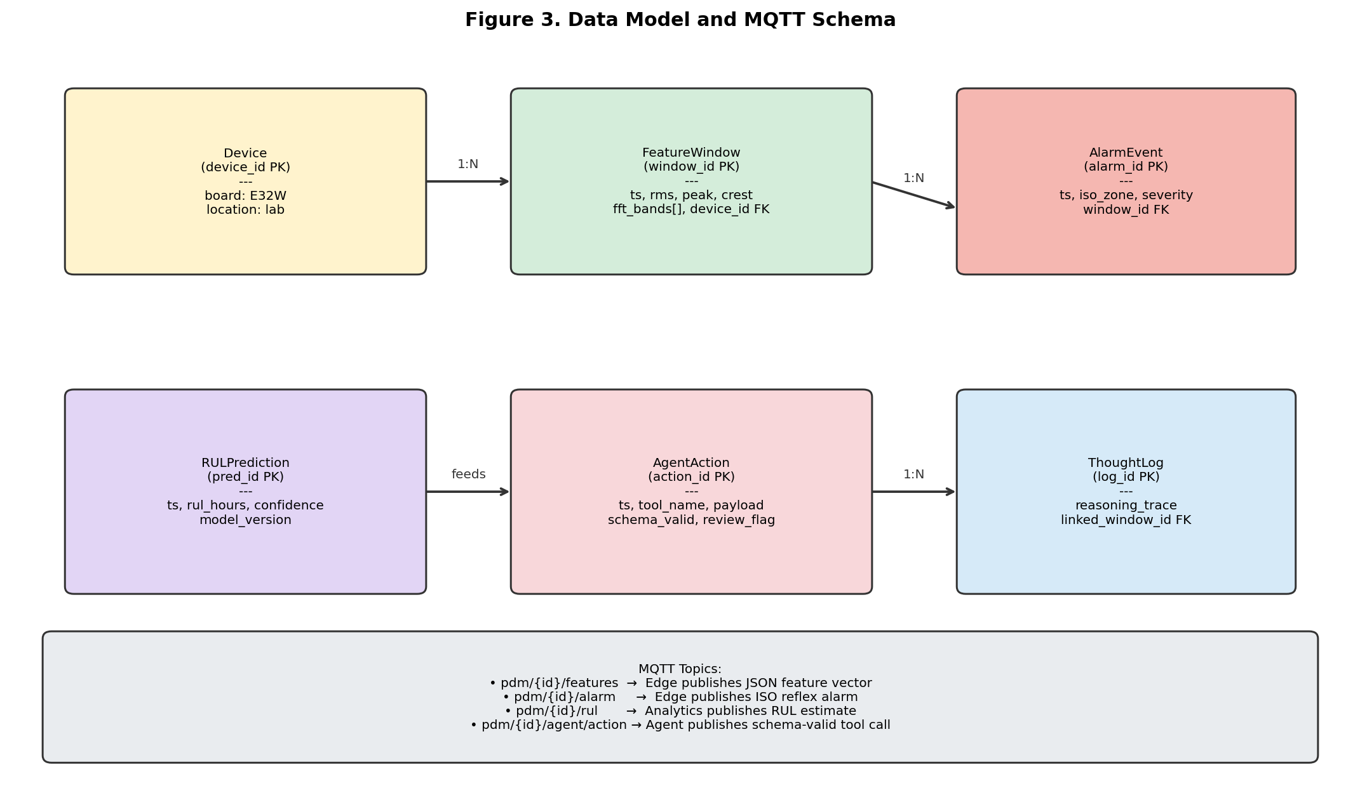
Figure 3. Data model and MQTT topic schema.

7.4 RUL analytical workflow
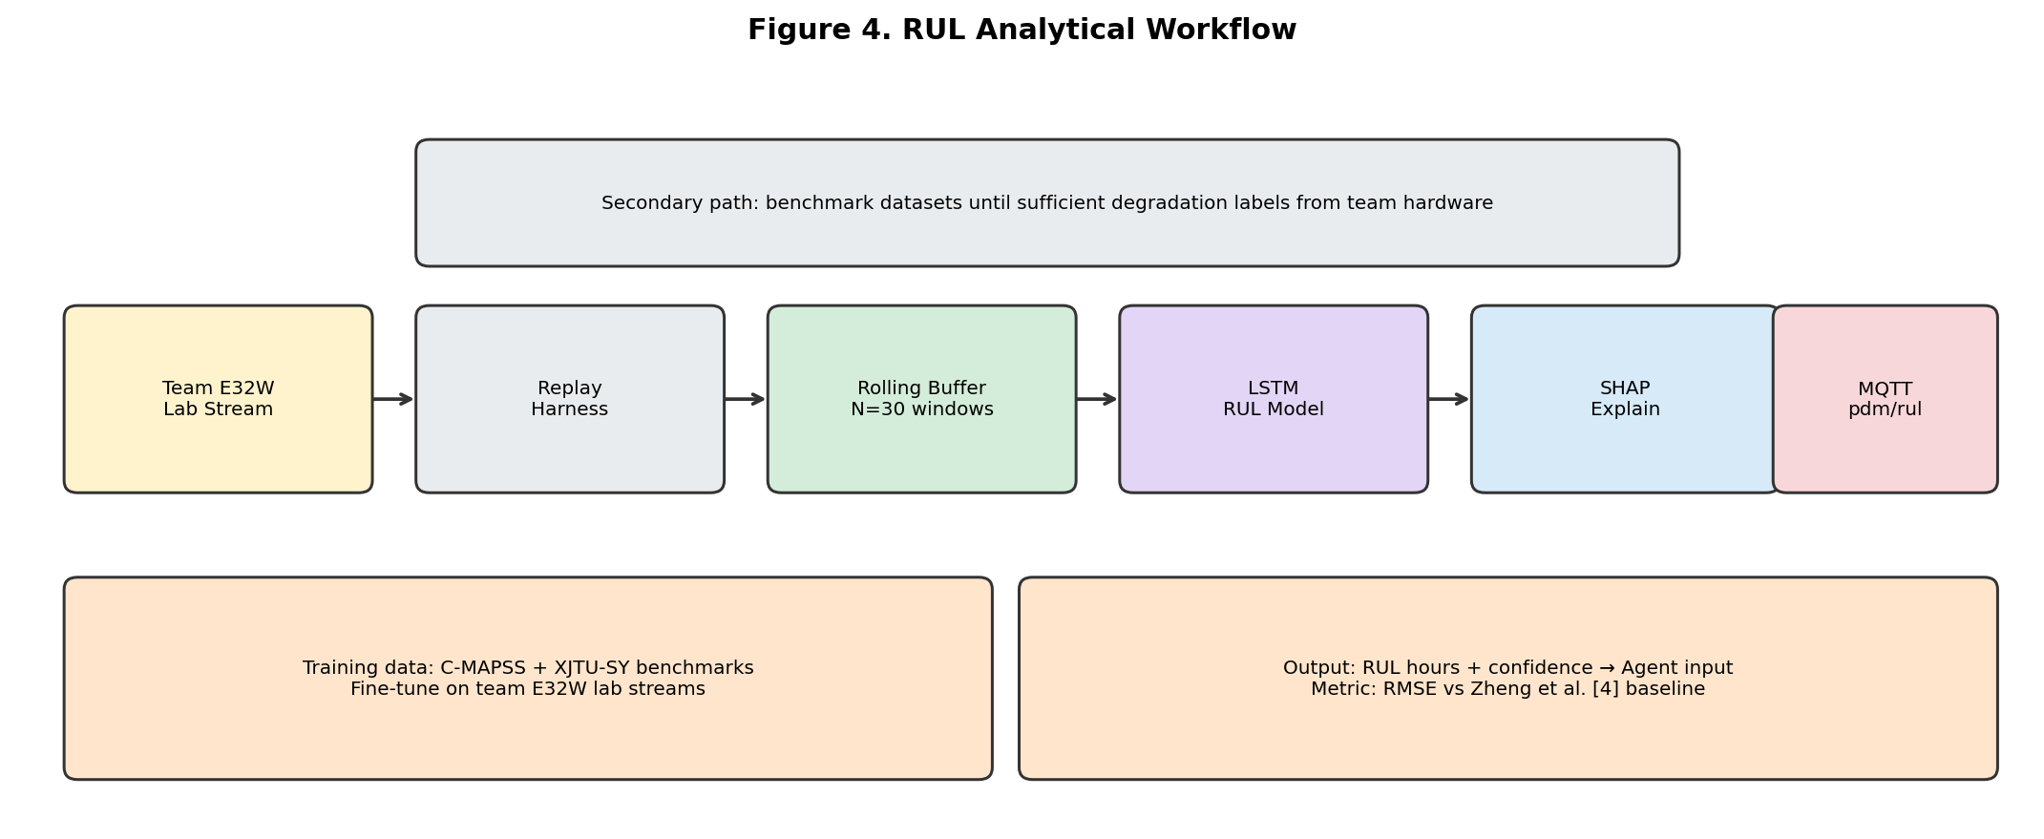
Figure 4. RUL analytical workflow — team E32W streams and benchmark training.

7.5 Agent and dashboard design
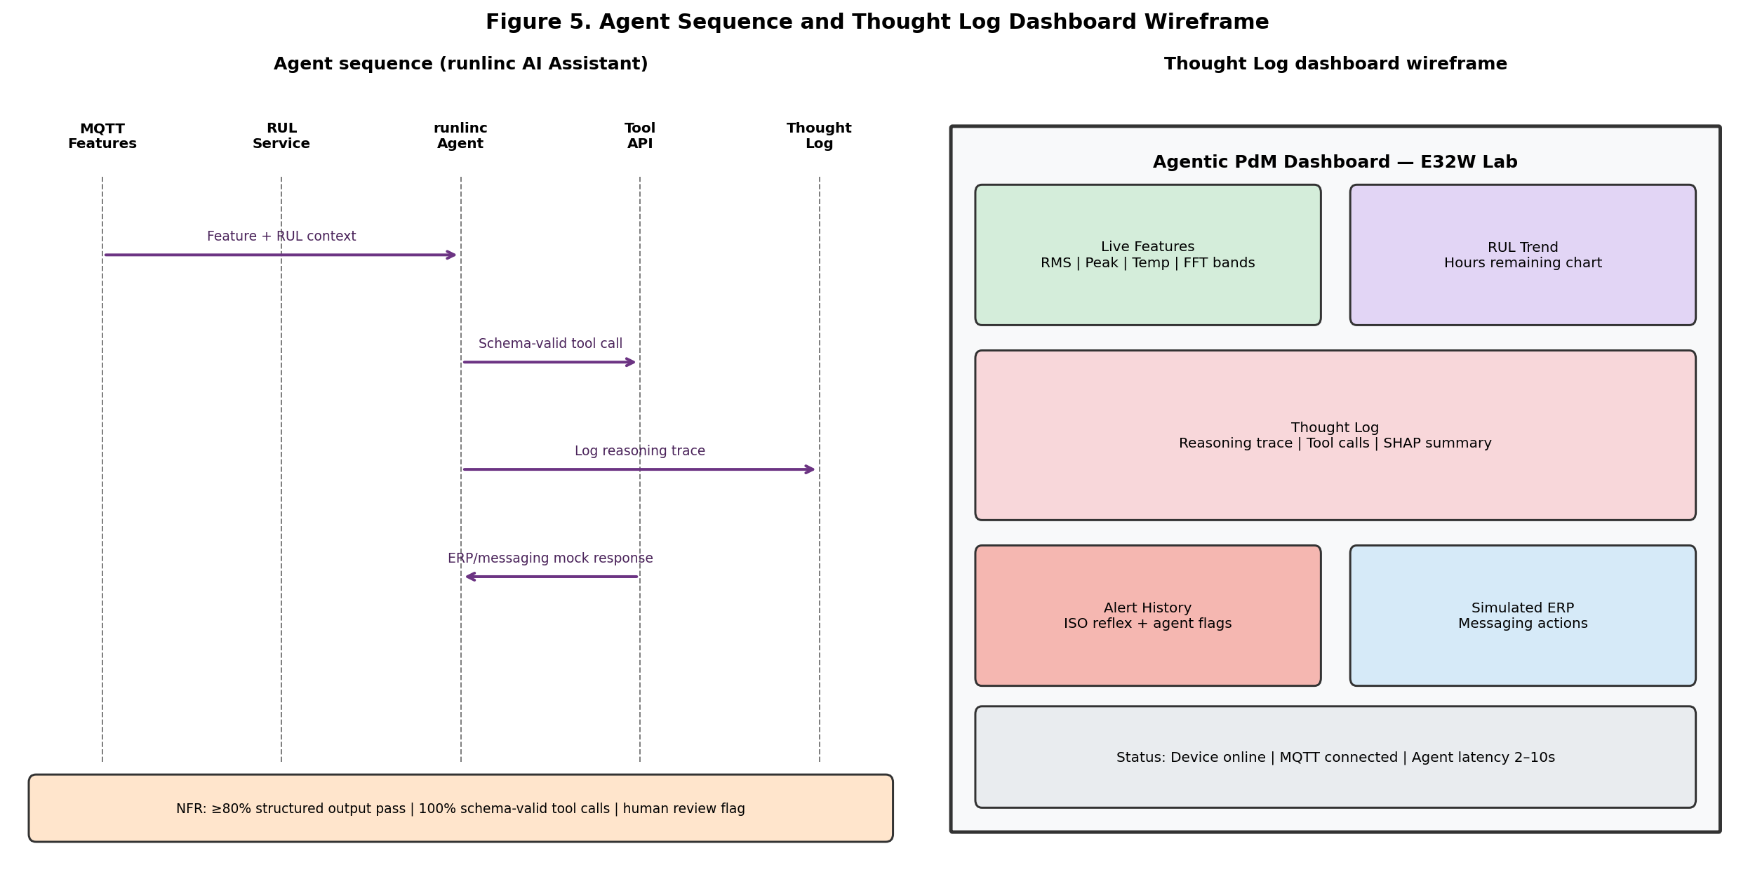
Figure 5. Agent sequence and Thought Log dashboard wireframe.

7.6 Preliminary prototype evidence
To conduct the preliminary hardware smoke test, the group successfully executed runlinc intermediate Project 14 (DS18B20 Temperature Sensor) on the STEMSEL E32W [34] provided by the client. The sensor was interfaced with the ESP32 pin D4 (tempSensor) using runlinc software [33] and a real-time output of 23.125 °C was received. This demonstrates E32W power, runlinc communication, MicroPython/JS loop execution [35], and sensor input/output prior to incorporating KY-002 vibration sensor. Figures 6-8 depict the lab hardware, runlinc project screen, and temperature data. Table 7 represents test documentation while meeting minutes are available in Appendix II.A.
Field | Detail
Test ID | HW-001
Date | 31 August 2026 (Week 8 lab / runlinc Project 14)
Platform | STEMSEL E32W (ESP32) - runlinc IDE (Project 14: DS18B20)
Test | DS18B20 temperature monitor on port D4 (tempSensor)
Procedure | Wire DS18B20 on E32W; configure D4 as DS18X20_IN in runlinc; Run Code; graph live °C
Result | PASS -live reading 23.125 °C (see Figures 6–8)
Witnesses | Team lab session (Amit, Subala, Asmita, Pavan); client hardware supplied
Evidence file | runlinc Project 14 screenshots; hardware photo; team logbook
Next step | Add KY-002 vibration (GPIO 23), buzzer (GPIO 34), MQTT feature publish

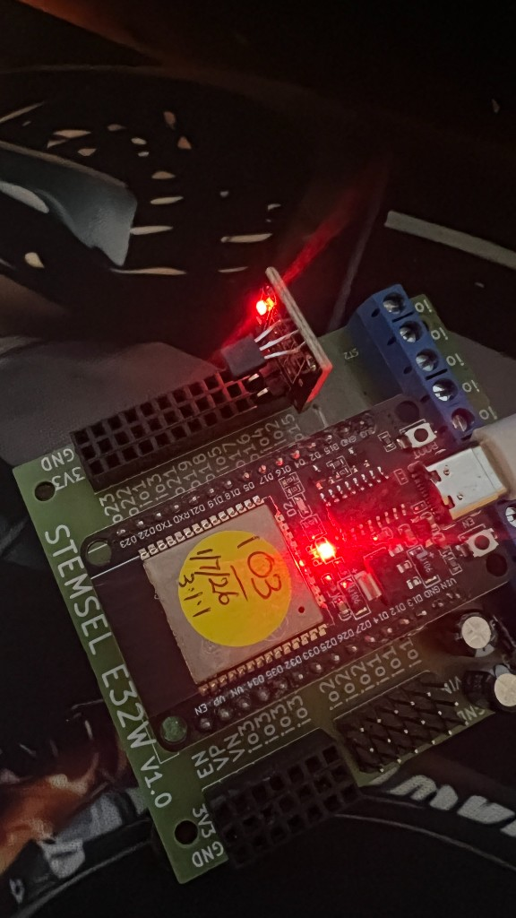
Figure 6. STEMSEL E32W lab hardware with DS18B20 temperature sensor (runlinc Project 14).
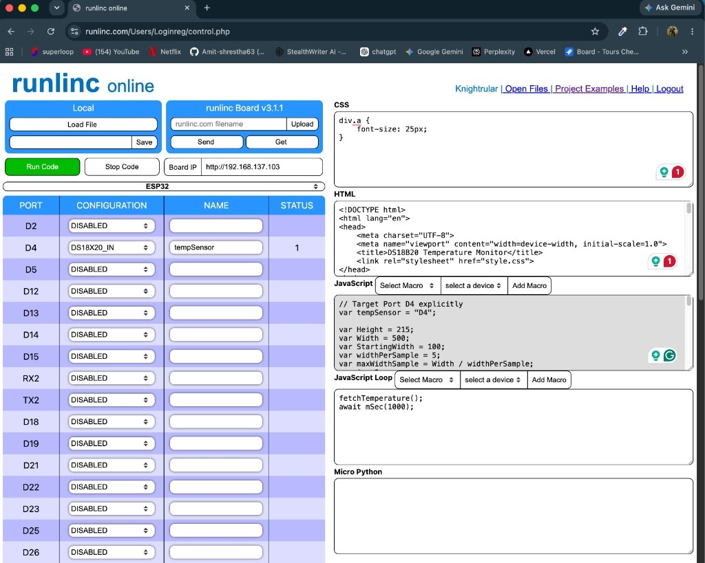
Figure 7. runlinc IDE — Project 14 DS18B20 Temperature Monitor (ESP32 port D4 / tempSensor).
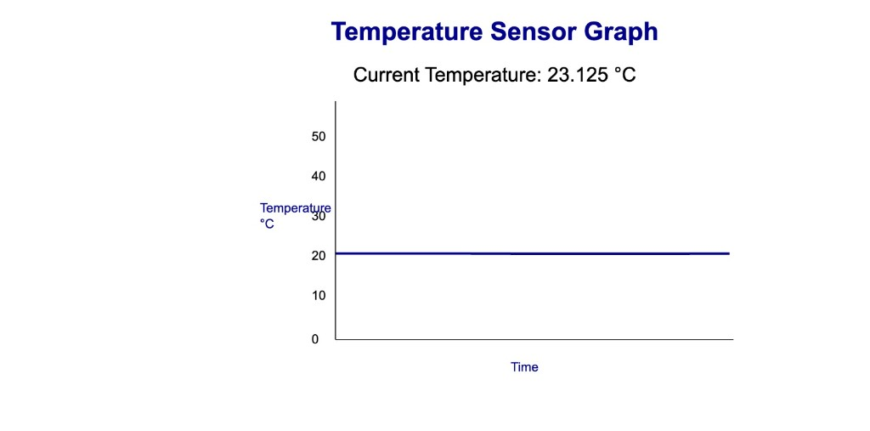
Figure 8. Live temperature reading from DS18B20 — 23.125 °C (team lab test).

7.7 Traceability matrix
Req | Design | Test | Owner
FR4 | Reflex loop | Buzzer on ISO breach | Subala
FR8 | LSTM model | C-MAPSS RMSE | Pavan
FR10 | Agent wrapper | 30-scenario suite | Amit
NFR2 | Dual-path | Agent offline test | Subala
NFR4 | Thought Log | Audit trail | Amit

8. Project Timeline, Resources and Budget

8.1 Weekly activities
Week | Activity | Deliverable | Owner
6 | Hotspot setup; runlinc login; connection troubleshooting | Meeting summary 17-Aug-2026.docx | All
7 | Hardware setup; LED blink (D2); runlinc Projects 14/15 | Meeting minutes 24-Aug-2026.docx | All
8 | A2 report; replay harness | Group report; MQTT design | All
9 | Edge features on E32W | RMS/peak/crest module | Subala
10 | FFT + ISO reflex | Timing report | Subala
11 | MQTT live stream | Feature topics live | Subala
12 | RUL baseline; A3 interim report | C-MAPSS results | Pavan
14 | Agent integration | Agent wrapper | Amit
16 | ERP mocks + scenarios | FastAPI + 30 cases | Amit, Pavan
18 | Dashboard + integration | Thought Log v1 | Amit
20 | System benchmark + demo | Final demo | All

8.2 Roles and responsibilities
Amit Shrestha (MIT252463) — Agent and integration lead.
Responsible for wrapper on runlinc AI Assistant, simulated ERP/messaging API [12], [13], Thought Log dashboard, full-stack integration testing, and project management (WBS 1). Reviews MQTT schema [22] and package for demo.
Subala Shrestha (MIT252219) — Edge and hardware lead.
Responsible for E32W lab set-up, wiring of sensors (KY-002 GPIO 23 [7], [40], temperature GPIO 33, buzzer GPIO 34), RMS/Peak/Crest/FFT functionalities [28], ISO 10816 reflex alarm [29], edge publishing to MQTT [22] and on
Teegala Pavan Reddy (MIT251400) — Data science and analytics lead.
Responsible for replay harness [25], C-MAPSS/XJTU-SY model input [3], [5], [6], LSTM RUL Baseline [2], [4], SHAP explainability [26], [39], evaluation scenarios, publishing of RUL data via MQTT [22], and management of Gantt schedules
Asmita Pandey (MIT250081) — Requirements and quality lead.
Responsible for refined requirements A2, risk management plan, traceability matrix, documentation of client interactions, and literature review (WBS 4). Checks agent's authority and testing evidence.
Activity | Amit | Subala | Asmita | Pavan
Edge features | I | R | C | C
RUL analytics | I | I | I | R
Agent layer | R | I | I | C
Requirements/risks | I | C | R | C
Schedule/Gantt | C | I | I | R
Report compile | R | C | C | C
Note: R = Responsible (does the work); C = Consulted (provides input); I = Informed (kept up to date). This is a simplified RACI matrix (Accountable is the same as Responsible for each row).

8.3 Work Breakdown Structure and Gantt chart
Figures 9–14 below are the screenshots taken from ProjectLibre (691_Agentic_AI_PdM_FIXED.pod). Figure 9 is the screenshot of the resource Gantt chart where tasks have been allotted to each team member and the red bars represent critical path tasks. Figures 10–13 are the WBS diagram of packages 1–4 respectively.
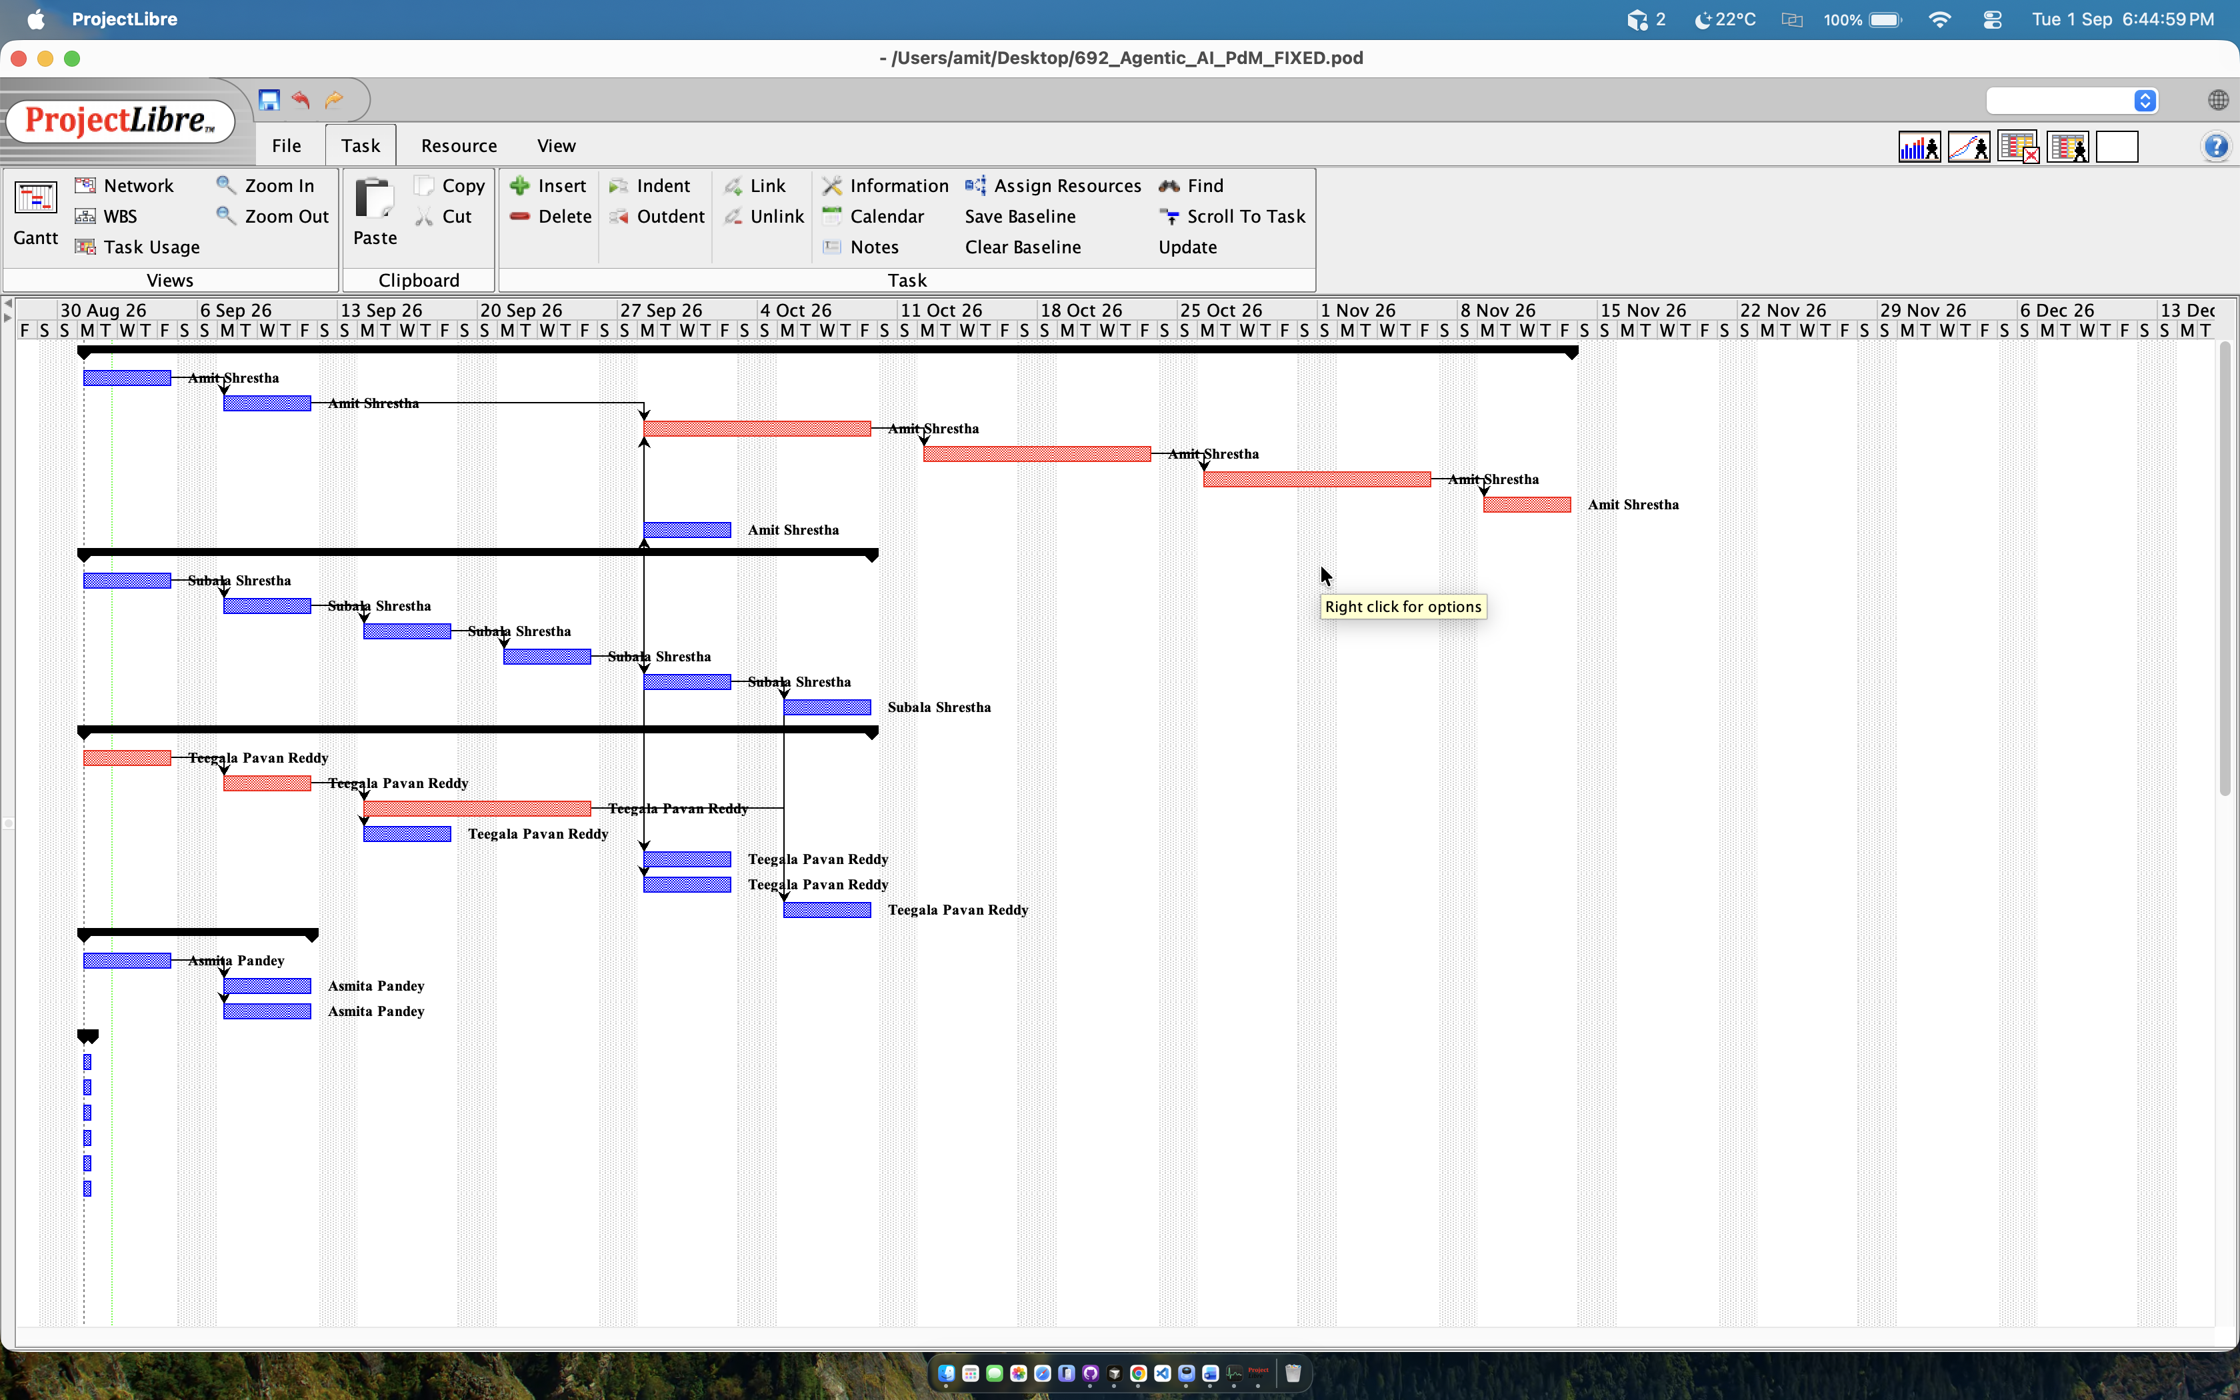
Figure 9. ProjectLibre Gantt chart — resource view (Weeks 6–20).

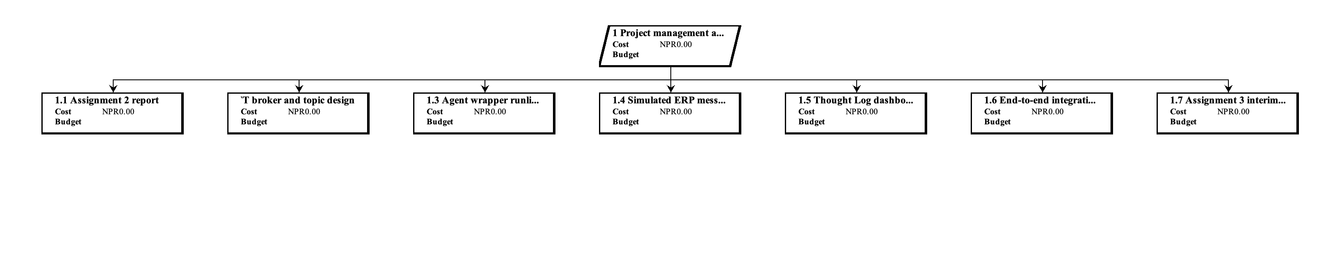
Figure 10. WBS 1 — Project management and integration.

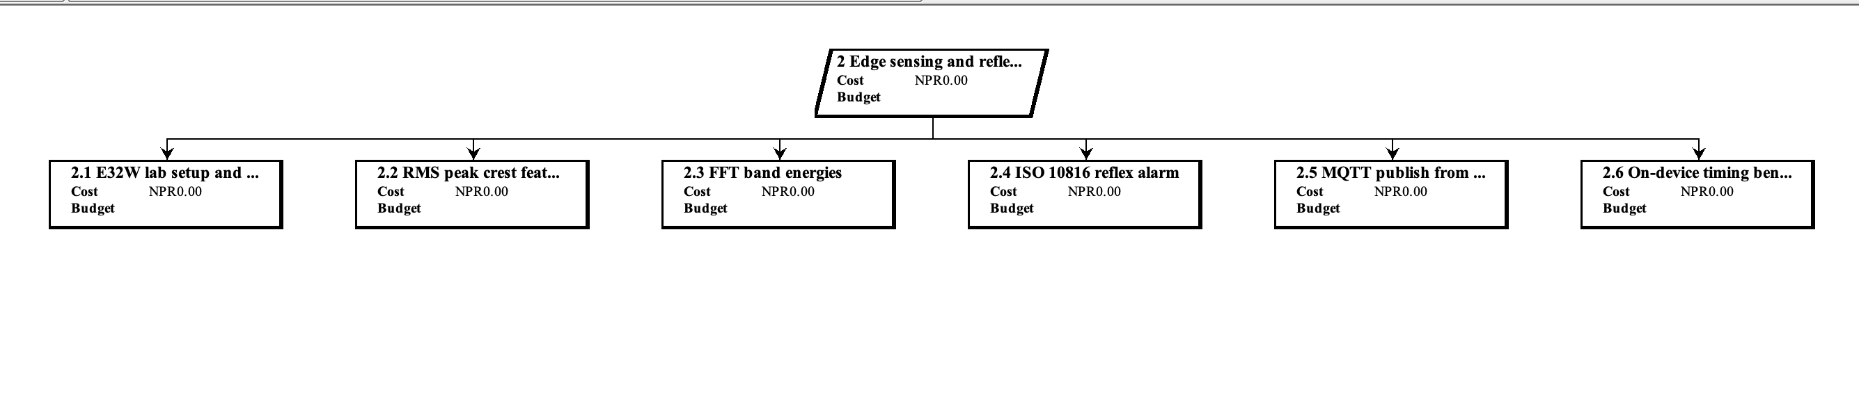
Figure 11. WBS 2 — Edge sensing and reflex E32W.

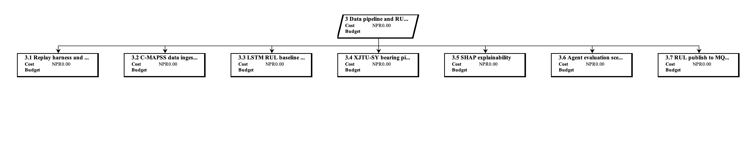
Figure 12. WBS 3 — Data pipeline and RUL analytics.

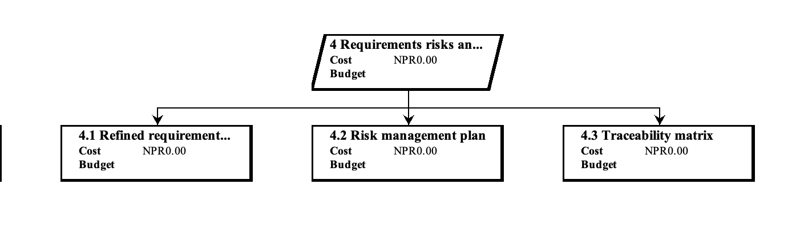
Figure 13. WBS 4 — Requirements, risks and client.

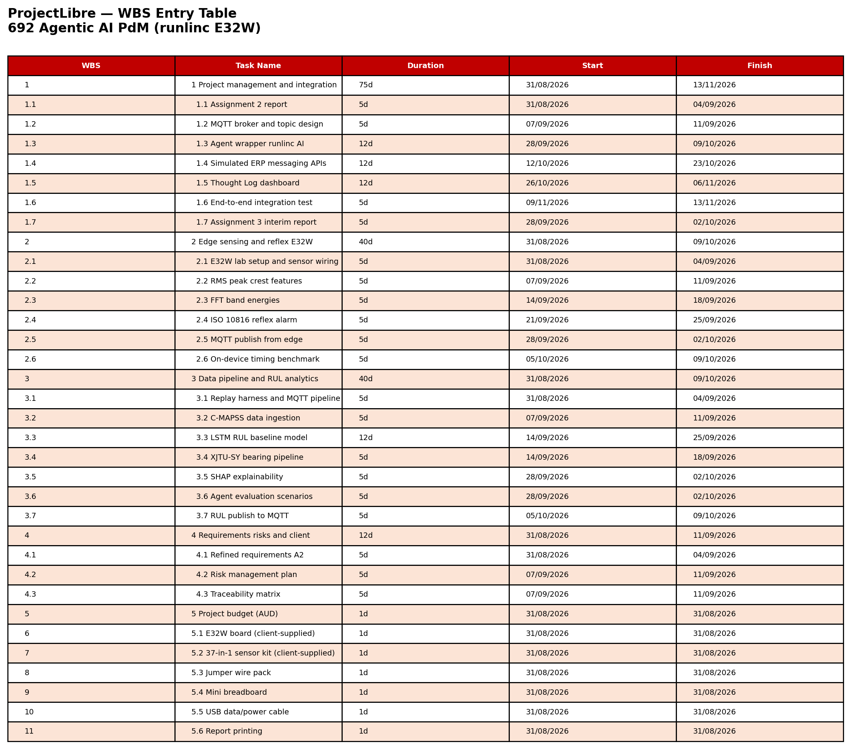
Figure 14. ProjectLibre WBS entry table (all tasks).

8.4 Milestones
ID | Milestone | Week
M1 | A1b baselined | 8
M2 | A2 plan approved | 9
M3 | Edge validated on E32W | 10
M4 | RUL baseline + A3 interim | 12
M5 | Agent demo | 16
M6 | Full system demo | 20

8.5 Resource and referenced budget
Client contribution includes E32W board, 37-in-1 sensors and the USB cable. Team spends money only on some accessories needed for prototyping. Human contribution (approx. 400 hours, 4 times approx. 100 hours) is valued as in-kind with zero money value.
Category | Item | Qty | Unit (AUD) | Total (AUD) | Reference
Hardware | STEMSEL E32W (ESP32) | 1 | 0.00 | 0.00 | Client-supplied [33]
Hardware | 37-in-1 sensor kit | 1 | 0.00 | 0.00 | Client-supplied (eLabtronics)
Hardware | USB data/power cable | 1 | 0.00 | 0.00 | Client-supplied
Hardware | Jumper wire pack | 1 | 9.95 | 9.95 | Jaycar estimate
Hardware | Mini breadboard | 1 | 8.50 | 8.50 | Lab prototyping
Hardware | Subtotal | — | — | 18.45
Software | MicroPython / runlinc IDE | 1 | 0.00 | 0.00 | Client platform
Software | Mosquitto, Python, TensorFlow | 1 | 0.00 | 0.00 | Open source
Software | Google Colab (free) | 1 | 0.00 | 0.00 | LSTM training
Software | Subtotal | — | — | 0.00
Labour | Student team (~400 h) | 4 | 0.00 | 0.00 | Capstone — no salary
Labour | Supervisor + client | — | 0.00 | 0.00 | In-kind
TOTAL | Minimum direct cash budget | — | — | 18.45 | Round to AUD 20

Budget component | Amount (AUD)
Hardware (team purchases) | 18.45
Software and cloud | 0.00
Other direct costs | 0.00
Labour (direct cost) | 0.00
Minimum total | 18.45
Recommended with contingency | 20.00

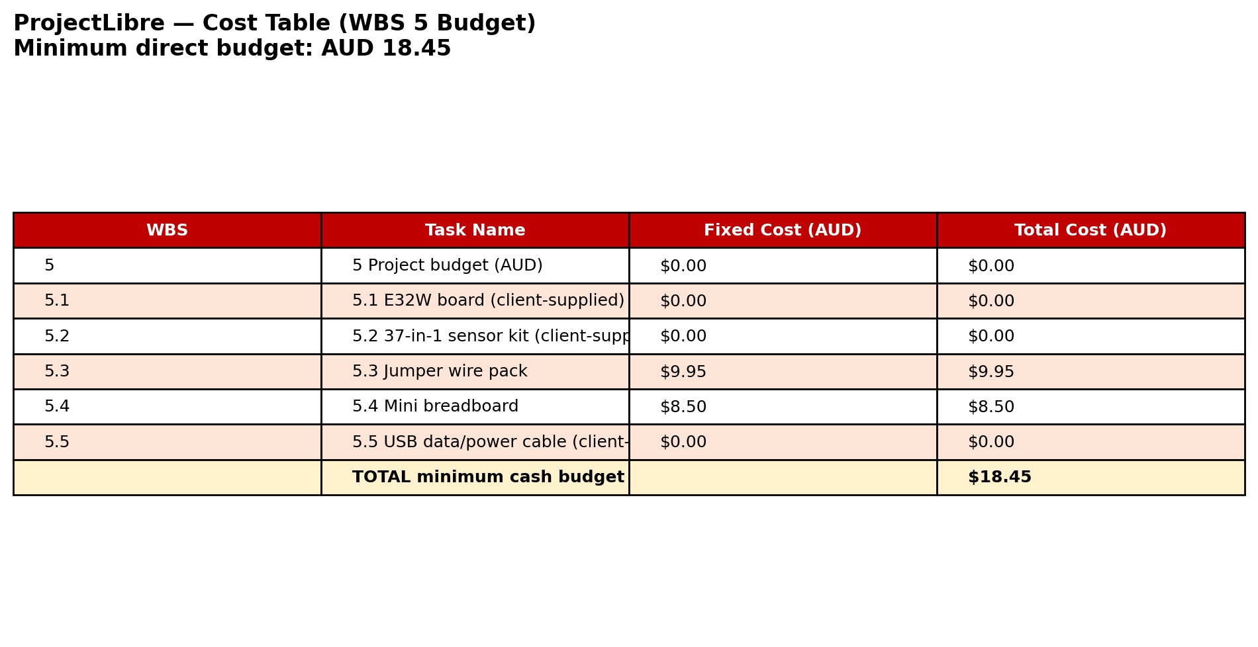
Figure 15. ProjectLibre WBS 5 cost table (minimum direct budget AUD 18.45).

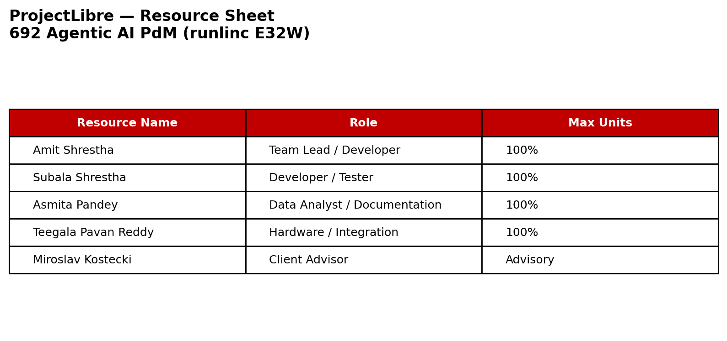
Figure 16. ProjectLibre resource sheet.

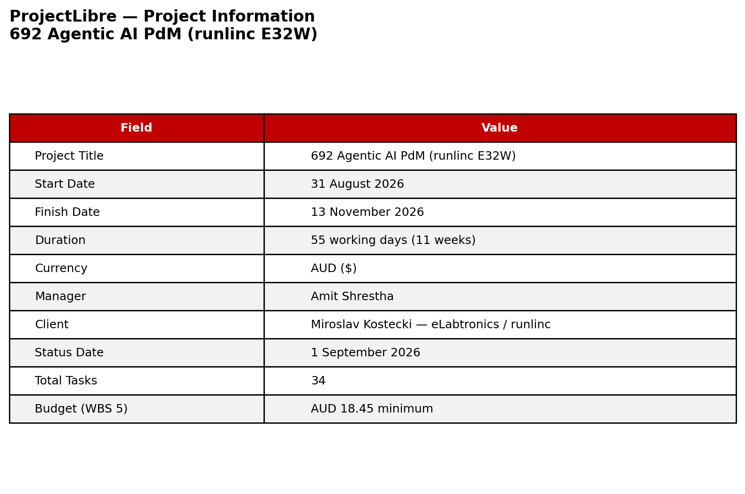
Figure 17. ProjectLibre project information.

9. Risk Management and Project Limitations
ID | Risk | Mitigation | Owner
R1 | Insufficient degradation labels from team E32W lab data | Use C-MAPSS/XJTU-SY benchmarks; induce controlled fault scenarios | Pavan
R2 | E32W hotspot/device connection failures (observed 17 Aug) | Follow runlinc setup guide; test hotspot IP; escalate to client | Subala
R3 | Lab sensor data may not represent factory conditions | Document test protocol; compare with published ESP32 studies [7, 8] | Asmita
R4 | FFT exceeds ESP32 SRAM budget | Optimised FFT; fewer frequency bands; window size tuning | Subala
R5 | MQTT/agent pipeline unavailable during demo | Replay harness; local reflex alarm continues independently | Amit
R6 | Agent inconsistency or invalid tool calls | JSON schema validation; 30-scenario test suite; human review flag | Amit
Limitations: E32W data obtained in the team lab might not be entirely representative of the operational conditions in the factory [19]; ESP32 memory constraints FFT [30], [34], [40]; agent delay inappropriate [15], [31] for safety alerts; ERP model is simulated; primary data relies on team lab schedules [7], [37].

10. Conclusion
Assignment 2 Report is in direct response to the feedback received from Assignment 1b: Project-specific introduction, revised RQs/ objectives alignment, synthesized literature review, engagement with the client [33] (10th, 17th, 24th August, 2026), and scope of hardware data acquisition in the team. Four-tier architecture (Figure 1 below) distinguishes millisecond reflex-based alarms [29] from agent reasoning [11], [13]. Next tasks will be wiring of sensors, live MQTT streams [22], baseline RUL [2], [4] and agent inclusion in MDA692.

11. References
[1] T. Zonta, C. A. da Costa, R. da Rosa Righi, M. J. de Lima, E. S. da Trindade, and G. P. Li, “Predictive maintenance in the Industry 4.0: A systematic literature review,” Computers & Industrial Engineering, vol. 150, art. no. 106889, Dec. 2020, doi: 10.1016/j.cie.2020.106889. https://doi.org/10.1016/j.cie.2020.106889
[2] F. Wu, Q. Wu, Y. Tan, and X. Xu, “Remaining useful life prediction based on deep learning: A survey,” Sensors, vol. 24, no. 11, art. no. 3454, May 2024, doi: 10.3390/s24113454. https://doi.org/10.3390/s24113454
[3] A. Saxena, K. Goebel, D. Simon, and N. Eklund, “Damage propagation modeling for aircraft engine run-to-failure simulation,” in Proc. Int. Conf. Prognostics and Health Management (PHM), Denver, CO, USA, Oct. 2008, pp. 1–9, doi: 10.1109/PHM.2008.4711414. https://doi.org/10.1109/PHM.2008.4711414
[4] S. Zheng, K. Ristovski, A. Farahat, and C. Gupta, “Long short-term memory network for remaining useful life estimation,” in Proc. IEEE Int. Conf. Prognostics and Health Management (ICPHM), Dallas, TX, USA, Jun. 2017, pp. 88–95, doi: 10.1109/ICPHM.2017.7998311. https://doi.org/10.1109/ICPHM.2017.7998311
[5] B. Wang, Y. Lei, N. Li, and N. Li, “A hybrid prognostics approach for estimating remaining useful life of rolling element bearings,” IEEE Transactions on Reliability, vol. 69, no. 1, pp. 401–412, Mar. 2020, doi: 10.1109/TR.2018.2882682. https://doi.org/10.1109/TR.2018.2882682
[6] W. A. Smith and R. B. Randall, “Rolling element bearing diagnostics using the Case Western Reserve University data: A benchmark study,” Mechanical Systems and Signal Processing, vol. 64–65, pp. 100–131, Dec. 2015, doi: 10.1016/j.ymssp.2015.04.021. https://doi.org/10.1016/j.ymssp.2015.04.021
[7] P. Kolok, M. Hodoň, P. Ševčík, L. Hotz, and N. Remy, “Low-cost IoT-based predictive maintenance using vibration,” Sensors, vol. 25, no. 21, art. no. 6610, Oct. 2025, doi: 10.3390/s25216610. https://doi.org/10.3390/s25216610
[8] S. Brito, G. Azinheira, J. Semião, N. Sousa, and S. P. Litrán, “Non-intrusive low-cost IoT-based hardware system for sustainable predictive maintenance of industrial pump systems,” Electronics, vol. 14, no. 14, art. no. 2913, Jul. 2025, doi: 10.3390/electronics14142913. https://doi.org/10.3390/electronics14142913
[9] J. Jeleńska, U. Jachymczyk, P. Knap, and M. Wiszniewski, “Design and validation of low-cost MEMS sensor networks for AI-based predictive maintenance in Industry 4.0,” in Proc. IEEE Int. Conf. Metrology for eXtended Reality, Artificial Intelligence and Neural Engineering (MetroXRAINE), 2025, doi: 10.1109/MetroXRAINE66377.2025.11340048. https://doi.org/10.1109/MetroXRAINE66377.2025.11340048
[10] C. Banbury, V. J. Reddi, P. Torelli, J. Holleman, N. Jeffries, C. Kiraly, P. Montino, D. Kanter, S. Ahmed, D. Pau, et al., “MLPerf Tiny benchmark,” in Proc. Neural Information Processing Systems Track on Datasets and Benchmarks, 2021. [Online]. Available: https://arxiv.org/abs/2106.07597
[11] S. Yao, J. Zhao, D. Yu, N. Du, I. Shafran, K. Narasimhan, and Y. Cao, “ReAct: Synergizing reasoning and acting in language models,” in Proc. 11th Int. Conf. Learning Representations (ICLR), Kigali, Rwanda, May 2023. [Online]. Available: https://arxiv.org/abs/2210.03629
[12] T. Schick, J. Dwivedi-Yu, R. Dessì, R. Raileanu, M. Lomeli, L. Zettlemoyer, N. Cancedda, and T. Scialom, “Toolformer: Language models can teach themselves to use tools,” in Proc. 37th Conf. Neural Information Processing Systems (NeurIPS), New Orleans, LA, USA, Dec. 2023. https://arxiv.org/abs/2302.04761
[13] J. T. Rayfield, S. Lin, N. Zhou, and D. C. Patel, “ReAct meets industrial IoT: Language agents for data access,” in Proc. 2025 Conf. Empirical Methods in Natural Language Processing: Industry Track, Suzhou, China, Nov. 2025, pp. 364–382, doi: 10.18653/v1/2025.emnlp-industry.24. https://doi.org/10.18653/v1/2025.emnlp-industry.24
[14] N. Zhou, D. Patel, and A. Bhattacharyya, “Deployed AI agents for industrial asset management: CodeReAct framework for event analysis and work order automation,” in Proc. AAAI Conf. Artificial Intelligence, 2026, doi: 10.1609/aaai.v40i47.41453. https://doi.org/10.1609/aaai.v40i47.41453
[15] L. Huang, W. Yu, W. Ma, W. Zhong, Z. Feng, H. Wang, Q. Chen, W. Peng, X. Feng, B. Qin, et al., “A survey on hallucination in large language models: Principles, taxonomy, challenges, and open questions,” ACM Transactions on Information Systems, vol. 43, no. 2, pp. 1–55, 2025, doi: 10.1145/3703155. https://doi.org/10.1145/3703155
[16] A. K. M. Nor, S. R. Pedapati, M. Muhammad, and V. Leiva, “Overview of explainable artificial intelligence for prognostic and health management of industrial assets based on preferred reporting items for systematic reviews and meta-analyses,” Sensors, vol. 21, no. 23, art. no. 8020, Nov. 2021, doi: 10.3390/s21238020. https://doi.org/10.3390/s21238020
[17] S. Matzka, “Explainable artificial intelligence for predictive maintenance applications,” in Proc. 3rd Int. Conf. Artificial Intelligence for Industries (AI4I), Irvine, CA, USA, Sep. 2020, pp. 69–74, doi: 10.1109/AI4I49448.2020.00023. https://doi.org/10.1109/AI4I49448.2020.00023
[18] K. T. P. Nguyen, K. Medjaher, and T.-D. Tran, “A review of artificial intelligence methods for engineering prognostics and health management with implementation guidelines,” Artificial Intelligence Review, vol. 56, no. 4, pp. 3659–3709, 2023, doi: 10.1007/s10462-022-10260-y. https://doi.org/10.1007/s10462-022-10260-y
[19] R. van Dinter, B. Tekinerdogan, and C. Catal, “Predictive maintenance using digital twins: A systematic literature review,” Information and Software Technology, vol. 151, art. no. 107008, Nov. 2022, doi: 10.1016/j.infsof.2022.107008. https://doi.org/10.1016/j.infsof.2022.107008
[20] W. Shi, J. Cao, Q. Zhang, Y. Li, and L. Xu, “Edge computing: Vision and challenges,” IEEE Internet of Things Journal, vol. 3, no. 5, pp. 637–646, Oct. 2016, doi: 10.1109/JIOT.2016.2579198. https://doi.org/10.1109/JIOT.2016.2579198
[21] M. Satyanarayanan, “The emergence of edge computing,” Computer, vol. 50, no. 1, pp. 30–39, Jan. 2017, doi: 10.1109/MC.2017.9. https://doi.org/10.1109/MC.2017.9
[22] N. Naik, “Choice of effective messaging protocols for IoT systems: MQTT, CoAP, AMQP and HTTP,” in Proc. IEEE Int. Systems Engineering Symposium (ISSE), Vienna, Austria, Oct. 2017, pp. 1–7, doi: 10.1109/SysEng.2017.8088251. https://doi.org/10.1109/SysEng.2017.8088251
[23] A. Al-Fuqaha, M. Guizani, M. Mohammadi, M. Aledhari, and M. Ayyash, “Internet of Things: A survey on enabling technologies, protocols, and applications,” IEEE Communications Surveys & Tutorials, vol. 17, no. 4, pp. 2347–2376, 4th Quart. 2015, doi: 10.1109/COMST.2015.2444095. https://doi.org/10.1109/COMST.2015.2444095
[24] J. Wei, X. Wang, D. Schuurmans, M. Bosma, B. Ichter, F. Xia, E. Chi, Q. Le, and D. Zhou, “Chain-of-thought prompting elicits reasoning in large language models,” in Proc. 36th Conf. Neural Information Processing Systems (NeurIPS), New Orleans, LA, USA, Dec. 2022. https://arxiv.org/abs/2201.11903
[25] P. Lewis et al., “Retrieval-augmented generation for knowledge-intensive NLP tasks,” in Proc. NeurIPS, 2020. [Online]. Available: https://proceedings.neurips.cc/paper/2020/hash/6b493230205f780e1bc26945df7481e5-Abstract.html and arXiv:2005.11401, doi: 10.48550/arXiv.2005.11401.
[26] S. M. Lundberg and S.-I. Lee, “A unified approach to interpreting model predictions,” in Proc. NeurIPS, 2017, pp. 4765–4774. [Online]. Available: https://proceedings.neurips.cc/paper/2017/hash/8a20a8621978632d76c43dfd28b67767-Abstract.html and arXiv:1705.07874, doi: 10.48550/arXiv.1705.07874.
[27] S. Amershi, D. Weld, M. Vorvoreanu, A. Fourney, B. Nushi, P. Collisson, J. Suh, S. Iqbal, P. N. Bennett, K. Inkpen, J. Teevan, R. Kikin-Gil, and E. Horvitz, “Guidelines for human-AI interaction,” in Proc. CHI Conf. Human Factors in Computing Systems, Glasgow, U.K., May 2019, pp. 1–13, doi: 10.1145/3290605.3300233. https://doi.org/10.1145/3290605.3300233
[28] R. B. Randall, Vibration-Based Condition Monitoring: Industrial, Aerospace and Automotive Applications, 2nd ed. Chichester, U.K.: John Wiley & Sons, 2021. https://doi.org/10.1002/9781119479819
[29] Mechanical Vibration — Evaluation of Machine Vibration by Measurements on Non-Rotating Parts — Part 3: Industrial Machines with Nominal Power Above 15 kW and Nominal Speeds Between 120 r/min and 15 000 r/min When Measured In Situ, ISO 10816-3:2009, International Organization for Standardization, Geneva, Switzerland, 2009. https://www.iso.org/standard/50527.html
[30] P. Warden and D. Situnayake, TinyML: Machine Learning with TensorFlow Lite on Arduino and Ultra-Low-Power Microcontrollers. Sebastopol, CA, USA: O’Reilly Media, 2020. [Online]. Available: https://www.oreilly.com/library/view/tinyml/9781492052036/
[31] Z. Xi et al., “The rise and potential of large language model based agents: A survey,” Science China Information Sciences, vol. 68, art. no. 121101, 2025, doi: 10.1007/s11432-024-4222-0 (also arXiv:2309.07864, doi: 10.48550/arXiv.2309.07864). https://doi.org/10.1007/s11432-024-4222-0
[32] L. Wang, C. Ma, X. Feng, Z. Zhang, H. Yang, J. Zhang, et al., “A survey on large language model based autonomous agents,” Frontiers of Computer Science, vol. 18, no. 6, art. no. 186345, 2024, doi: 10.1007/s11704-024-40231-1. https://doi.org/10.1007/s11704-024-40231-1
[33] eLabtronics, “runlinc: Rapid development platform for IoT, AI and STEM inventions.” Accessed: Aug. 15, 2026. [Online]. Available: https://runlinc.com
[34] Espressif Systems, “ESP32 series datasheet,” Espressif Systems, Shanghai, China. Accessed: Aug. 15, 2026. [Online]. Available: https://www.espressif.com/en/support/documents/technical-documents
[35] MicroPython, “Quick reference for the ESP32 — MicroPython documentation.” Accessed: Aug. 15, 2026. [Online]. Available: https://docs.micropython.org/en/latest/esp32/quickref.html
[36] A. H. Alaoui, A. Meddaoui, and M. Hain, “AI-driven predictive maintenance for Industry 4.0: A systematic review of models, methods, and challenges,” The International Journal of Advanced Manufacturing Technology, vol. 143, pp. 4861–4876, 2026. [Online]. Available: https://doi.org/10.1007/s00170-026-17531-w
[37] N. Ringler, D. Knittel, J.-C. Ponsart, M. Nouari, A. Yakob, and D. Romani, “Machine learning based real time predictive maintenance at the edge for manufacturing systems: A practical example,” in Proc. IEEE IAS Global Conf. Emerging Technologies (GlobConET), London, U.K., May 2023, doi: 10.1109/GlobConET56651.2023.10150033.https://ieeexplore.ieee.org/ https://doi.org/10.1109/GlobConET56651.2023.10150033
[38] A. Fernández-Miguel, S. Ortíz-Marcos, M. Jiménez-Calzado, A. P. Fernández del Hoyo, F. E. García-Muiña, and D. Settembre-Blundo, “Agentic AI in smart manufacturing: Enabling human-centric predictive maintenance ecosystems,” Applied Sciences, vol. 15, no. 21, art. no. 11414, Oct. 2025, doi: 10.3390/app152111414. https://doi.org/10.3390/app152111414
[39] S. Gawde, S. Patil, S. Kumar, P. Kamat, K. Kotecha, and S. Alfarhood, “Explainable predictive maintenance of rotating machines using LIME, SHAP, PDP, ICE,” IEEE Access, vol. 12, pp. 29345–29361, 2024. [Online]. Available: https://doi.org/10.1109/ACCESS.2024.3367110
[40] S. Gupta and S. N. Shivhare, “Embedded TinyML for predictive maintenance: Vibration analysis on ESP32 with real-time fault detection in industrial equipment,” International Journal on Computational Modelling Applications, vol. 2, no. 2, pp. 1–17, 2025, doi: 10.63503/j.ijcma.2025.114. https://doi.org/10.63503/j.ijcma.2025.114

Appendix I — Industry Client Details
Field | Confirmed detail
Project title | Real-Time Data with Agentic AI for Industrial Predictive Maintenance (PdM)
Company | eLabtronics; ABN 28 068 561 553
Address | 22–26 Peel Street, Adelaide SA 5000
Industry professional | Miroslav Kostecki, Chief Technology Officer (eLabtronics / runlinc)
Contact | projects@careerdc.com.au; via runlinc platform
Client profile | Developer of STEM and industrial inventor toolkits; runlinc browser-based IoT/AI platform
Hardware supplied | STEMSEL E32W (ESP32), 37-in-1 sensor kit, USB data/power cable
Data scope | Team collects all real-time data from supplied lab hardware; client factory plant data out of scope
Proposal status | Client and industry-supervisor signatures dated Assignment 1 (13 Aug 2026)

Full signed Appendix I form from Assignment 1 is retained in project records and available on request.

Appendix II — Annotated Literature Bibliography and Activity Log
SUBMISSION REQUIREMENT: Upload this file together with the group report on Moodle. The full annotated bibliography of 40 sources (10 per member, 2023–2026) is in: MDA691_Assignment2_Appendix_II_Literature.docx (also on team Desktop). Each member contributed peer-reviewed journal and conference sources as required. Distribution: Asmita -PdM/XAI/trust; Subala - edge/ESP32/vibration; Pavan - RUL/deep learning; Amit - agentic AI/tool use.

Appendix II.A — Weeks 5–8 Activity and Meeting Log
Week | Date | Activity / decision | Evidence
5 | 10 Aug 2026 | Project introduction; document review; meeting schedule agreed | Meeting minutes; logbook
6 | 17 Aug 2026 | Hotspot IP setup; device connection troubleshooting; runlinc login | Meeting summary 17-Aug-2026.docx
7 | 24 Aug 2026 | Hardware setup; LED blink test (D2); runlinc Projects 14/15 reviewed; later DS18B20 Project 14 lab test (Figs 6–8) | Meeting minutes 24-Aug-2026.docx; Table 7; Figures 6–8
8 | Sep 2026 | Supervisor feedback on A1b; A2 report preparation | Moodle feedback; this report

Appendix III — Response to Feedback on Assignment 1
Grades and remarks from grade reviews and supervision/presentation sessions were analyzed by the team. Table A1 shows all the criteria from the rubric for Assignment 1b, the feedback given by the marker, grades obtained, and corrective actions taken.
Criterion | A1 Score | Marker feedback (summary) | Action in Assignment 2 | Section
Introduction | 0.85/1 | Good overview, however generic; should have E32W/runl | This paper will look into Project E32W, RunLINC, team | 1
Problem domain & RQs | 0.65/1 | Question RQ4 is inconsistent; all RQ | Corrected RQ4; 4 research questions only; RQ-objective mapping table | 2.3–2.4
Literature review | 4/6 | Descriptive. Needs critical analysis, comparisons, gaps, and references. | Critical comparison chart 3; gap analysis; 40 sources plan in App II | 3, App II
Aim & objectives | 1.3/2 | Objectives need measurability and RQ alignment | Measurable success criteria per objective; explicit RQ column | 2.4
Requirements (prelim.) | 3/4 | Limited client meeting evidence; lab vs factory constraints | Client meeting table 4.1; lab hardware scope clarified 4.2 | 4
References | 0.67/1 | Good range; minor IEEE formatting issues | IEEE format checked; numbering consistent 11 | 11
AI usage (general) | ---- | Add critical analysis and independent evaluation | Critical synthesis tables; explicit gap statement | 3, App III

AIII.1 Itemised responses to feedback
Introduction too generic. Reframed around eLabtronics, runlinc E32W, and team hardware data collection (not client plant). (1)
RQ4 unrelated (circular economy/banking). Deleted incorrect RQ4. New RQ4 compares dual-path agentic PdM vs alert-only AI on latency and traceability. (2.3)
Objectives broad and not measurable. Seven objectives rewritten with quantitative success criteria and RQ mapping (Table 2.4). (2.4)
Literature descriptive only. Added 3.1–3.3 critical synthesis paragraphs, comparative table, and explicit research gap; 40 annotated sources in Appendix II. (3, App II)
Limited client-meeting evidence. Three documented meetings (10, 17, 24 Aug 2026) with minutes and outcomes (4.1, App II.A); LED blink prototype evidence (Table 7 / Figures 6–8). (4.1, 7.6)
Missing diagrams and Gantt. Added Figures 1–17 including architecture, design diagrams, DS18B20 prototype evidence (Figs 6–8), Gantt, WBS, budget, and resources. (7–8)
IEEE formatting inconsistencies. References reformatted to IEEE style with consistent numbering (11). (11)
Changes to 1–4 since Assignment 1. 1: E32W/runlinc-specific intro. 2: corrected RQs and measurable objectives. 3: critical literature. 4: refined requirements, client evidence, team hardware procedure. (1–4)

