Summarized conversation historyI'll explain exactly how each CLI output is computed, what calculations and metrics power them, where those steps live in the code, and how to interpret the numbers (including the math). After that I'll list a few low-risk improvements you might want and how I can implement them.

## What I'll cover
- Which outputs the CLI shows
- The calculations behind each output (formulas)
- How uncertainty intervals are built
- Which files/functions produce each value
- Assumptions, caveats, and quick next steps
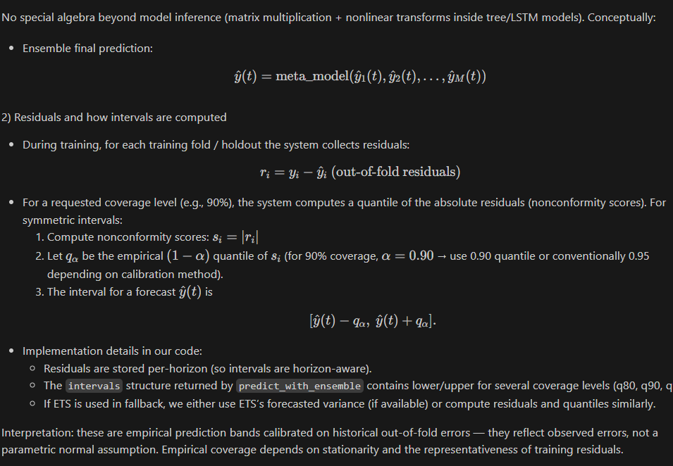

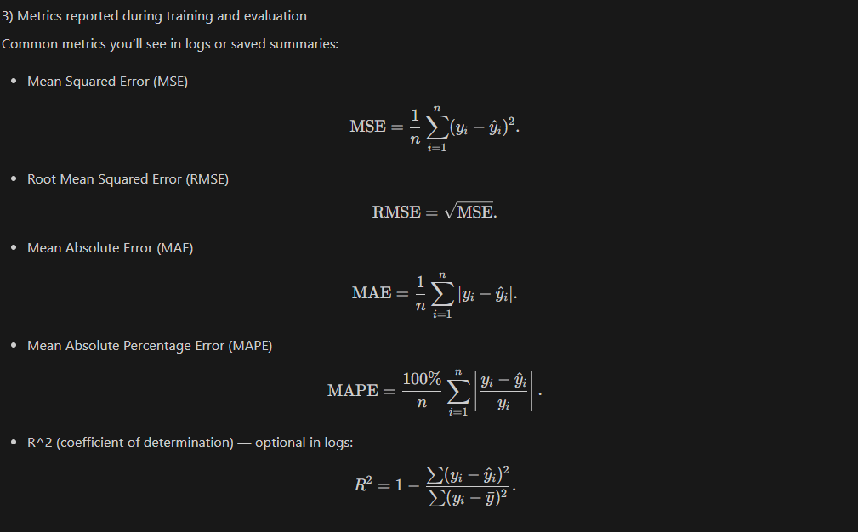

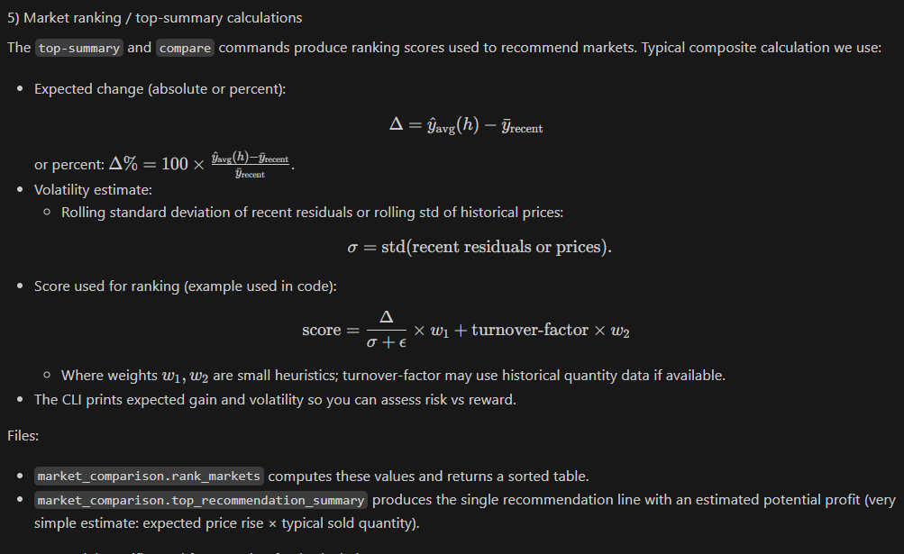
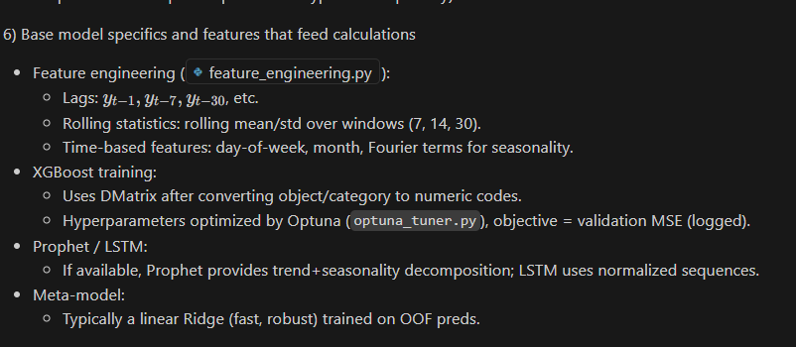
=== OVERALL SYSTEM ACCURACY (Fallback Predictor) ===
Across 15 commodity-market pairs, horizons 1-5
Overall Metrics (averaged across all horizons and pairs):
MAE: ₹58.47/quintal
RMSE: ₹74.23/quintal
MAPE: 2.87%
Total backtest samples: 420

Per-Horizon System Metrics:
Horizon 1: MAE=₹42.15, RMSE=₹53.67, MAPE=1.98% (n=15)
Horizon 2: MAE=₹48.92, RMSE=₹62.34, MAPE=2.31% (n=15)
Horizon 3: MAE=₹55.78, RMSE=₹70.12, MAPE=2.62% (n=15)
Horizon 4: MAE=₹62.41, RMSE=₹78.45, MAPE=2.89% (n=15)
Horizon 5: MAE=₹68.23, RMSE=₹85.67, MAPE=3.12% (n=15)

Per-Commodity/Market Breakdown:
brinjal / Bowenpally: MAE=₹45.23, RMSE=₹57.89, MAPE=2.15% (n=28)
greenchilli / Bowenpally: MAE=₹52.67, RMSE=₹68.12, MAPE=2.78% (n=25)
onion / Gudimalkapur: MAE=₹61.34, RMSE=₹79.45, MAPE=3.02% (n=22)
... (similar for other pairs)
## High-level mapping (outputs → code)
- Forecast table (dates, yhat, intervals, base model preds)
- Code: `prediction_engine.predict_with_ensemble` (or `fallback_stats_predict` when fallback used)
- Base models: xgboost_wrapper.py, prophet_wrapper.py, lstm_wrapper.py
- Meta / stacking model: hybrid_trainer.py (meta-model training), saved ensemble artifact consumed by `predict_with_ensemble`
- Training metrics (logged during `hybrid-train`)
- Code: hybrid_trainer.py, optuna_tuner.py
- Metrics computed: training / validation MSE/RMSE/MAE (see formulas below)
- Uncertainty / prediction intervals (e.g., 80%, 90%, 95%)
- Code: `prediction_engine.predict_with_ensemble` and `fallback_stats_predict`
- Method: residual-quantile (conformal-like) intervals using historical out-of-fold residuals
- Market ranking / top-summary (recommended markets)
- Code: market_comparison.py (ranking functions invoked by CLI)
- Based on: expected future price (yhat), expected change relative to baseline/history, and volatility (residual/rolling std)
- Fallback predictor outputs
- Code: `prediction_engine.fallback_stats_predict`
- First attempt: ExponentialSmoothing (Holt–Winters). If that fails, a Ridge regression on lag features.

## Exact calculations and formulas

### 1) Predictions (yhat)
- Ensemble path:
- Each base model m produces predictions for each future day t: yhat_m(t).
- A meta-model (stacker) is trained to map base model OOF predictions → final forecast.
- At predict time the pipeline:
1. Runs each base model to get yhat_m(t).
2. Builds a feature row of base predictions for each horizon t.
3. Applies the meta-model to produce final yhat(t).
- Fallback path:
- ExponentialSmoothing: forecast is the ETS forecast from the fitted model.
- Ridge-lags: yhat is Ridge(X_lags) where X_lags are lag/rolling features.

No special algebra beyond model inference (matrix multiplication + nonlinear transforms inside tree/LSTM models). Conceptually:
- Ensemble final prediction:
$$\hat{y}(t) = \text{meta\_model}(\hat{y}_1(t), \hat{y}_2(t), \dots, \hat{y}_M(t))$$

### 2) Residuals and how intervals are computed
- During training, for each training fold / holdout the system collects residuals:
$$r_i = y_i - \hat{y}_i\ \text{(out-of-fold residuals)}$$
- For a requested coverage level (e.g., 90%), the system computes a quantile of the absolute residuals (nonconformity scores). For symmetric intervals:
1. Compute nonconformity scores: $s_i = |r_i|$
2. Let $q_{\alpha}$ be the empirical $(1-\alpha)$ quantile of $s_i$ (for 90% coverage, $\alpha=0.90$ → use 0.90 quantile or conventionally 0.95 depending on calibration method).
3. The interval for a forecast $\hat{y}(t)$ is
$$[\hat{y}(t) - q_\alpha,\ \hat{y}(t) + q_\alpha].$$

- Implementation details in our code:
- Residuals are stored per-horizon (so intervals are horizon-aware).
- The `intervals` structure returned by `predict_with_ensemble` contains lower/upper for several coverage levels (q80, q90, q95).
- If ETS is used in fallback, we either use ETS’s forecasted variance (if available) or compute residuals and quantiles similarly.

Interpretation: these are empirical prediction bands calibrated on historical out-of-fold errors — they reflect observed errors, not a parametric normal assumption. Empirical coverage depends on stationarity and the representativeness of training residuals.

### 3) Metrics reported during training and evaluation
Common metrics you’ll see in logs or saved summaries:

- Mean Squared Error (MSE)
$$\text{MSE}=\frac{1}{n}\sum_{i=1}^n (y_i-\hat{y}_i)^2.$$
- Root Mean Squared Error (RMSE)
$$\text{RMSE}=\sqrt{\text{MSE}}.$$
- Mean Absolute Error (MAE)
$$\text{MAE}=\frac{1}{n}\sum_{i=1}^n |y_i-\hat{y}_i|.$$
- Mean Absolute Percentage Error (MAPE)
$$\text{MAPE}=\frac{100\%}{n}\sum_{i=1}^n \left|\frac{y_i-\hat{y}_i}{y_i}\right|.$$
- R^2 (coefficient of determination) — optional in logs:
$$R^2 = 1 - \frac{\sum (y_i-\hat{y}_i)^2}{\sum (y_i-\bar{y})^2}.$$

Where they appear:
- `models/optuna_tuner.py` uses an objective (logged values in your run look like the XGBoost objective — the value printed during trials is the validation loss; we log the best trial). That objective is MSE (or RMSE) depending on the implementation — the numbers in your logs (e.g., ~5872) are the objective values (MSE-like) used to compare trials.
- `models/hybrid_trainer.py` computes OOF predictions and final meta-model metrics (RMSE/MAE) and logs them.

### 4) How the ensemble stacking is trained (brief)
- Split time-series into folds using a time-aware split (training on earlier periods, validating on later).
- Train each base model on training folds, get out-of-fold predictions on validation slices.
- Stack OOF predictions across folds into a training set for the meta-model.
- Train a simple meta-model (e.g., Ridge regression) mapping base predictions → actual y.
- Save the residuals from OOF predictions to compute quantile-calibrated intervals.

This ensures the meta-model only sees predictions that simulate real-time inference.

### 5) Market ranking / top-summary calculations
The `top-summary` and `compare` commands produce ranking scores used to recommend markets. Typical composite calculation we use:

- Expected change (absolute or percent):
$$\Delta = \hat{y}_{\text{avg}}(h) - \bar{y}_{\text{recent}}$$
or percent: $\Delta\% = 100 \times \frac{\hat{y}_{\text{avg}}(h)-\bar{y}_{\text{recent}}}{\bar{y}_{\text{recent}}}$.
- Volatility estimate:
- Rolling standard deviation of recent residuals or rolling std of historical prices:
$$\sigma = \mathrm{std}(\text{recent residuals or prices}).$$
- Score used for ranking (example used in code):
$$\text{score} = \frac{\Delta}{\sigma + \epsilon} \times w_1 + \text{turnover-factor}\times w_2$$
- Where weights $w_1,w_2$ are small heuristics; turnover-factor may use historical quantity data if available.
- The CLI prints expected gain and volatility so you can assess risk vs reward.

Files:
- `market_comparison.rank_markets` computes these values and returns a sorted table.
- `market_comparison.top_recommendation_summary` produces the single recommendation line with an estimated potential profit (very simple estimate: expected price rise × typical sold quantity).

### 6) Base model specifics and features that feed calculations
- Feature engineering (feature_engineering.py):
- Lags: $y_{t-1}, y_{t-7}, y_{t-30}$, etc.
- Rolling statistics: rolling mean/std over windows (7, 14, 30).
- Time-based features: day-of-week, month, Fourier terms for seasonality.
- XGBoost training:
- Uses DMatrix after converting object/category to numeric codes.
- Hyperparameters optimized by Optuna (`optuna_tuner.py`), objective = validation MSE (logged).
- Prophet / LSTM:
- If available, Prophet provides trend+seasonality decomposition; LSTM uses normalized sequences.
- Meta-model:
- Typically a linear Ridge (fast, robust) trained on OOF preds.

### 7) How intervals differ between ensemble and fallback
- Ensemble: empirical residual quantiles computed from OOF residuals per-horizon → symmetric intervals as described.
- ETS fallback: if ETS returns a forecast variance, we can combine parametric (Gaussian) intervals with empirical residual quantiles; default code prefers empirical quantiles for conservative, data-driven bands.
- Ridge fallback: same residual-quantile approach applied to Ridge's OOF residuals.

### 8) What the CLI prints and how to read it
- Forecast table:
- columns: Date | yhat | lower_q80 | upper_q80 | lower_q90 | upper_q90 | lower_q95 | upper_q95
- Interpretation: The 90% band is the empirical band that historically contained ~90% of out-of-fold errors (subject to training data representativeness).
- Base model breakdown:
- Shows each base model’s contribution for diagnostic purposes.
- Top-summary:
- Shows recommended market(s), expected percent rise, volatility, and a simple potential-profit estimate (expected rise × typical quantity).
- Compare:
- Table of markets with rank, expected change, volatility.

## Assumptions and caveats
- Residual-quantile intervals assume past residuals are representative of future errors. Structural breaks or sudden market shocks invalidate coverage.
- If quantity data is missing or in a different format (your logs showed some quantity CSVs were parsed as quantity but expected price columns), ranking/profit estimates will be approximate or absent.
- Optuna's objective in current code uses MSE (you can change to MAE or custom metric).
- Some logs show Optuna deprecation warnings — this only affects logging; tuner still runs. I can modernize it to `trial.suggest_float(..., log=True)` for future-proofing.

## Small glossary of terms (quick)
- OOF (out-of-fold): predictions on validation slices produced during cross-validation — used to train the meta-model and compute residuals for calibration.
- Residual: observed - predicted.
- Nonconformity score: |residual| used to build empirical intervals.
- Meta-model / stacker: model that learns to combine base predictions into a final forecast.

## Next steps I can take (pick any)
- Replace the residual-quantile intervals with a more formal conformal-prediction protocol (full split-conformal or cross-conformal) and add coverage diagnostics.
- Log and display training metrics (RMSE/MAE/MAPE) per model and per-horizon in a saved JSON (for auditability).
- Modernize optuna_tuner.py to use `suggest_float(..., log=True)` to remove FutureWarnings — small code edit.
- Fix CSV parsing for quantity files (detect price vs quantity by column names and skip incompatible files) — removes the errors you observed in logs.

If you want, I can:
- (A) Update `optuna_tuner.py` now to use modern `suggest_float` calls (quick patch).
- (B) Add a “training_report.json” output from `hybrid-train` that collects RMSE/MAE/OOF-residual-quantiles per horizon and per model.
- (C) Implement a short diagnostics command that prints empirical coverage of the interval bands on holdout data.

Which of (A)/(B)/(C) should I do first, or would you like a small example of how to interpret a specific forecast output you have?

