**ASSIGNMENT -4**

**1.**

%% mean ,max , min, mid point%%

a=imread('eight.tif');

figure,subplot(3,2,1);

imshow(a)

title('Original');

b=imnoise(a);

med=b;

min=b;

max=b;

mid=b;

subplot(3,2,2);imshow(b)

title('Salt and Pepper noise');

W=zeros(9);

[m,n]=size(a);

for i=2:1:m-1

for j=2:1:n-1

val=1;

for a=i-1:1:i+1

for b=j-1:1:j+1

W(val)=b(a,b);

val=val+1;

end

end

W=sort(W);

med(i,j)=W(5);

min(i,j)=W(1);

max(i,j)=W(9);

mid(i,j)=round((W(1)+W(9))/2);

end

end

subplot(3,2,3);imshow(med);

title('Median Filtering');

subplot(3,2,4);imshow(min)

title('Minimum Filtering');

subplot(3,2,5);imshow(max)

title('Maximim Filtering');

subplot(3,2,6);imshow(mid)

title('Mean Filtering');

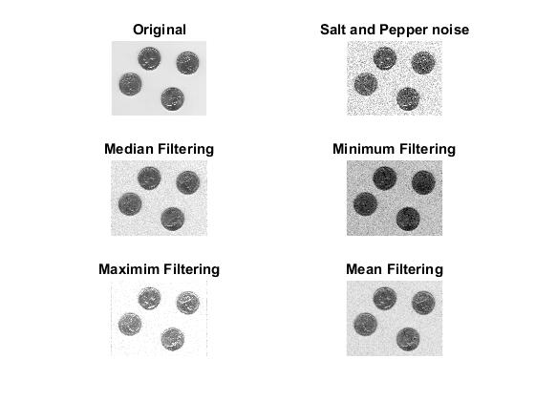

**2.**

%adaptive median filter%

a=imread('eight.tif');

figure,

subplot(3,1,1)

imshow(a)

title('Original');

a1=imnoise(a);

imadmed=a1;

subplot(3,1,2);imshow(a1)

title('Salt and Pepper noise');

smax=7;

s=3;

[m,n]=size(a);

if s==3

x=1;

A=zeros(s*s);

elseif s==5

x=2;

A=zeros(s*s);

elseif s==7

x=3;

A=zeros(s*s);

end

for i=4:1:m-3

for j=4:1:n-3

b=a1(i,j);

imadmed(i,j)=p4_2_func(b,s,i,j,imadmed,smax);

end

end

subplot(3,1,3);imshow(imadmed)

title('Adaptive Median Filtering');

