**EXPERIMENT 05**

**Name: Amit Pandharikar**

**Class: CS-A**

**Roll-no: EN19CS301042**

**Subject: CGMM**

**AIM**

To drawing a man moving with Umbrella under Rain using programming.

**PROGRAM**

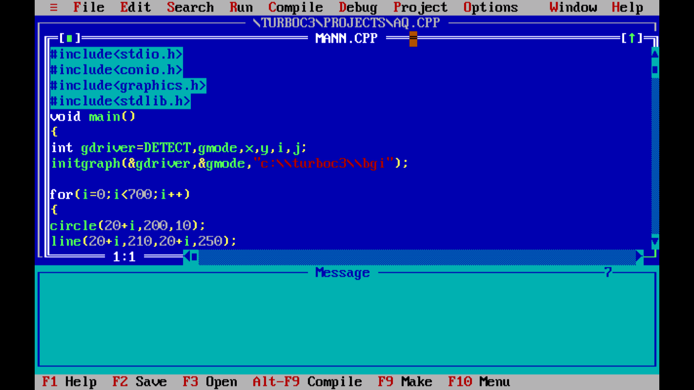

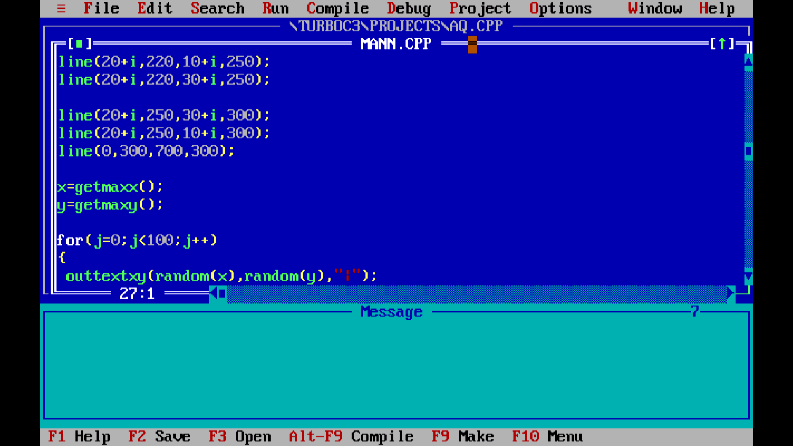

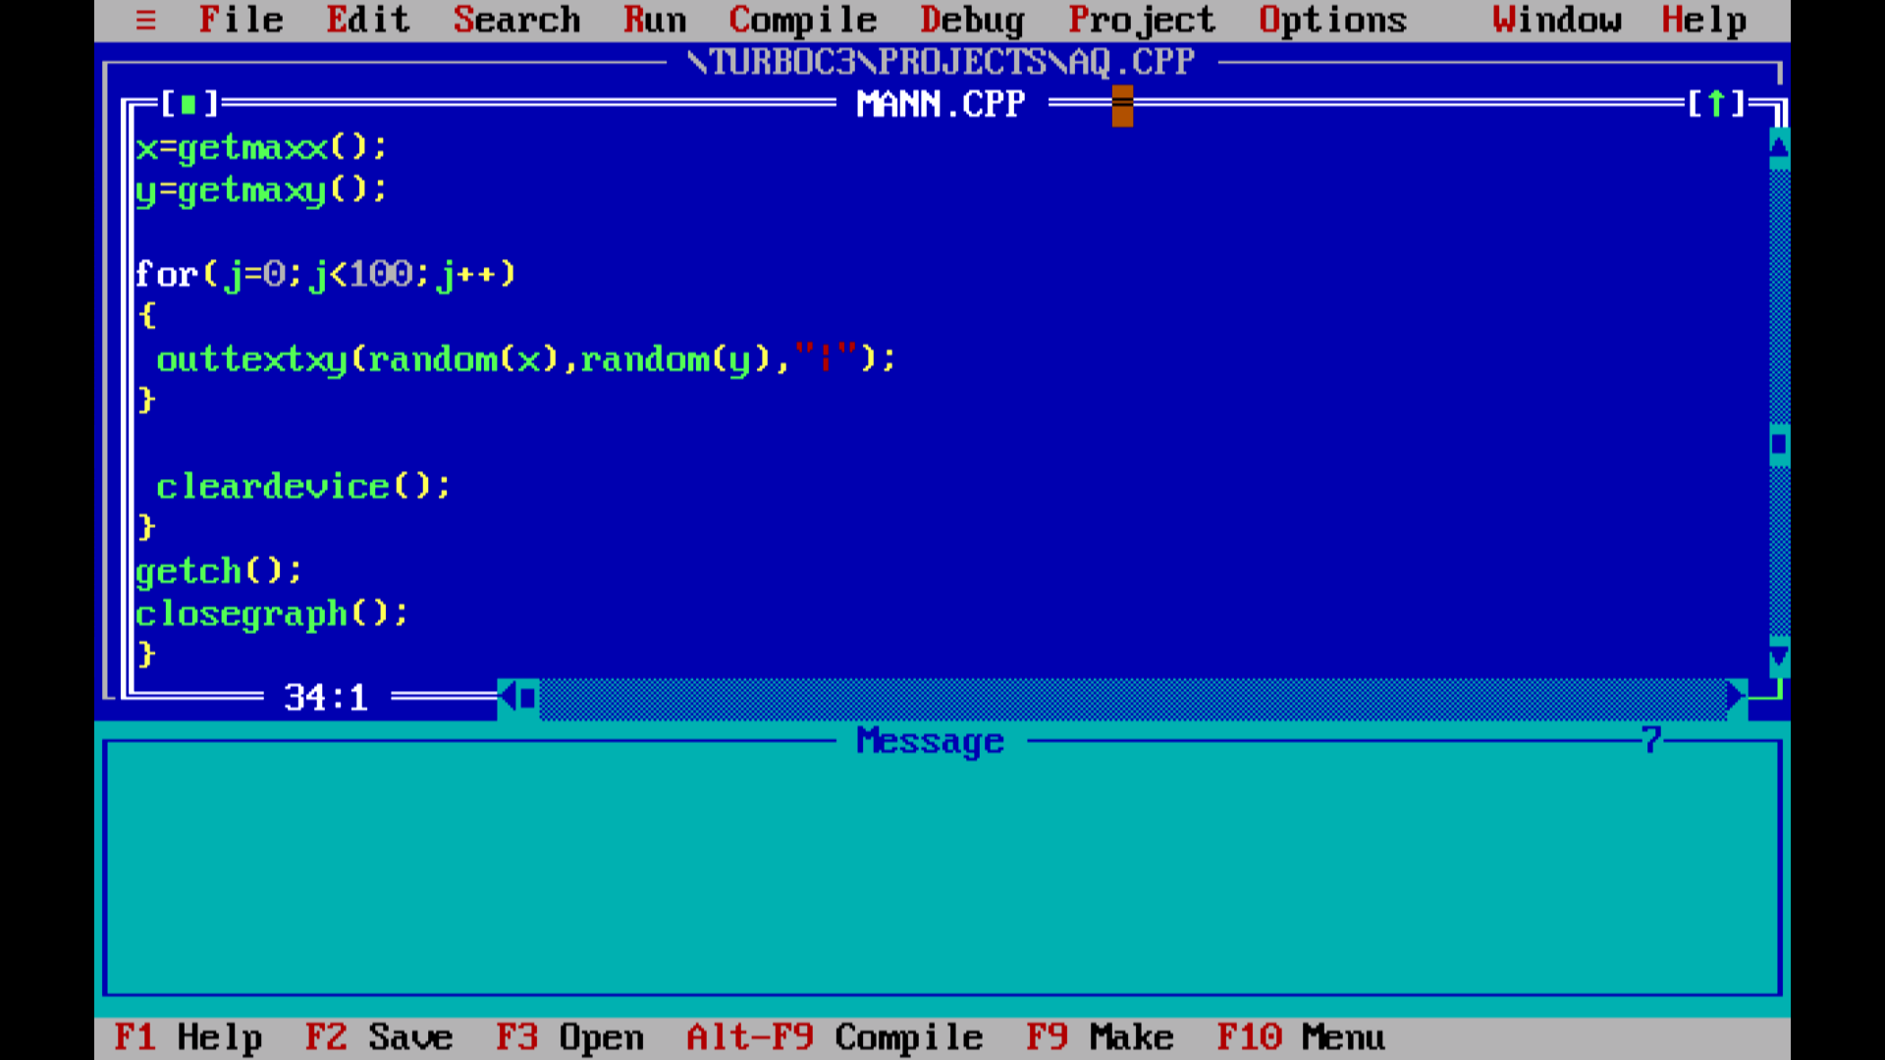

**OUTPUT**

