**EXPERIMENT 04**

**Name: Amit Pandharikar**

**Class: CS-A**

**Roll-No: EN19CS301042**

**Subject: CGMM**

**AIM**

To make moving car using programming.

**PROGRAM**

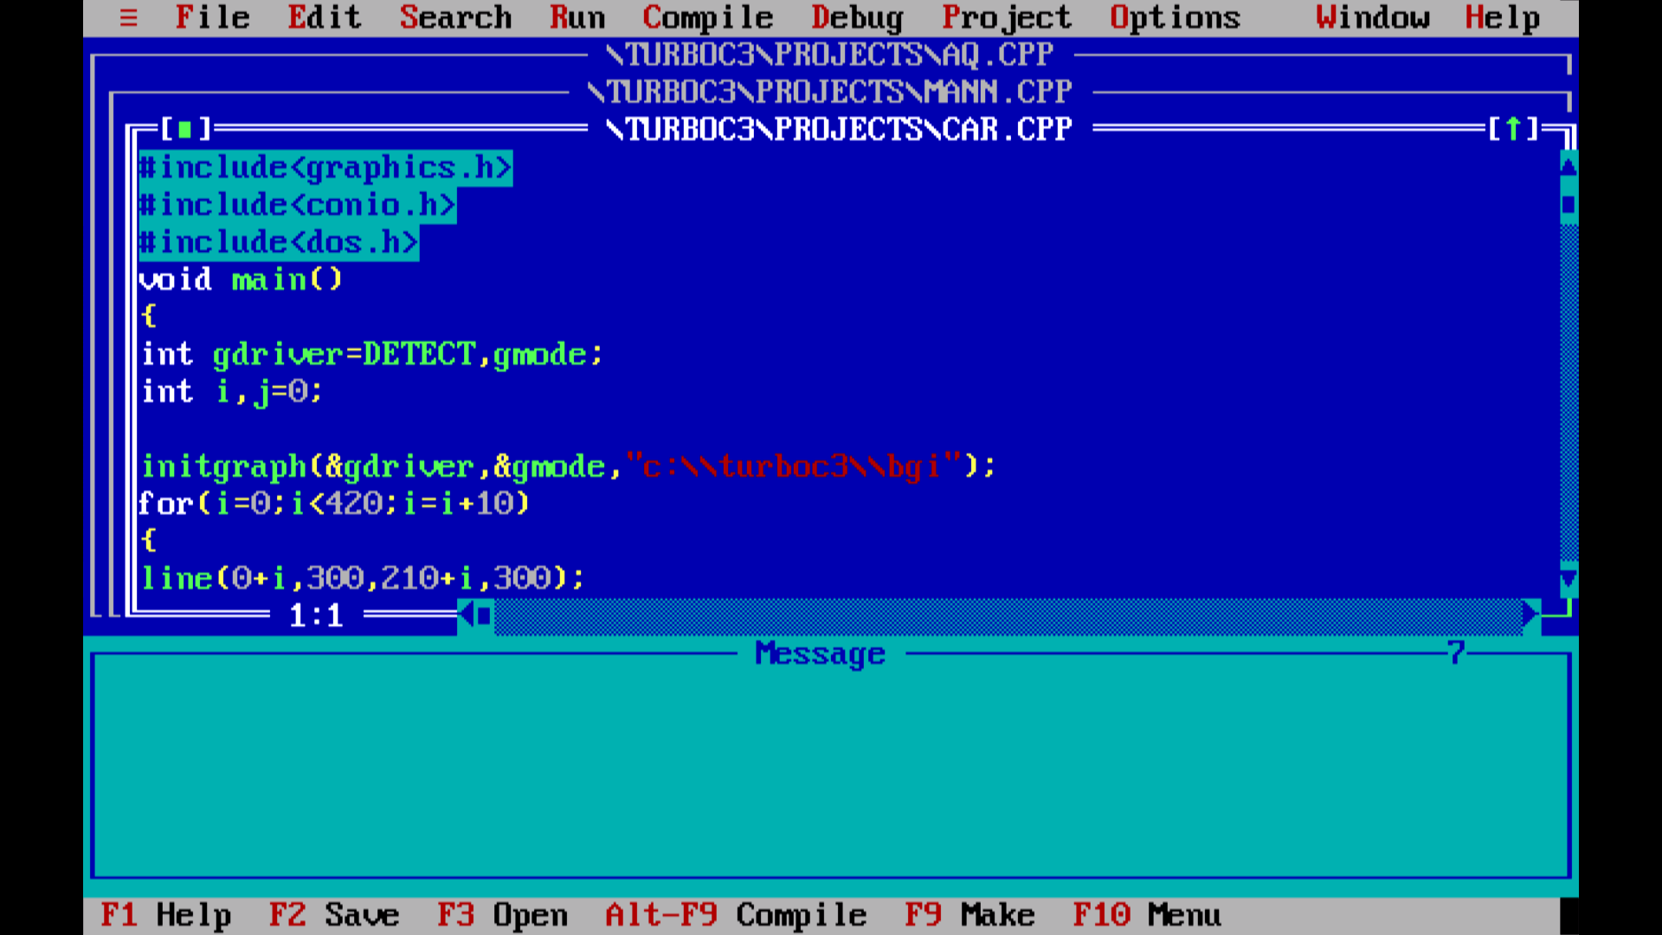

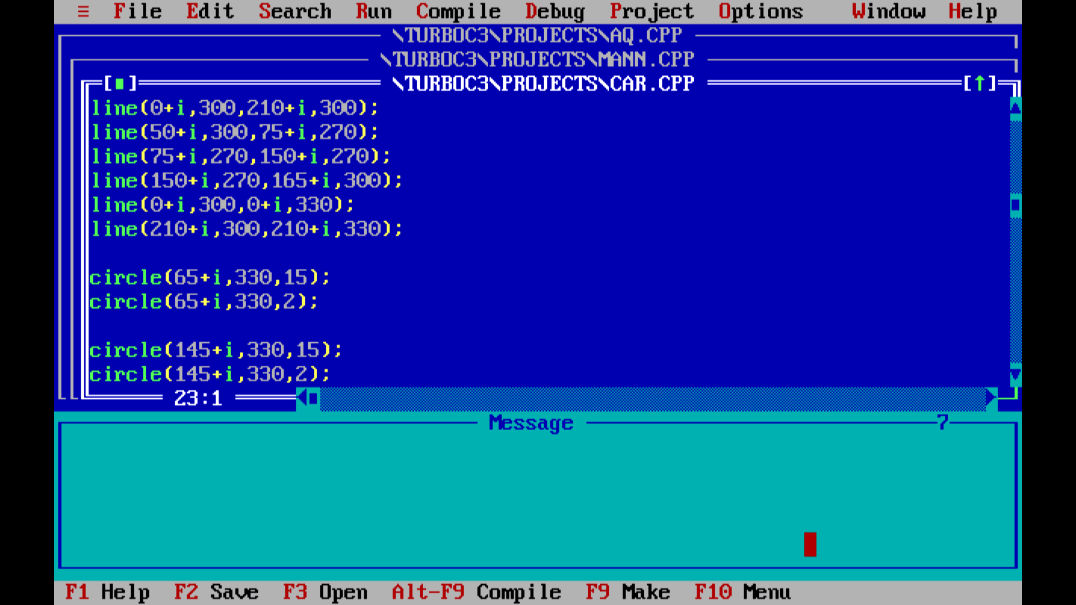

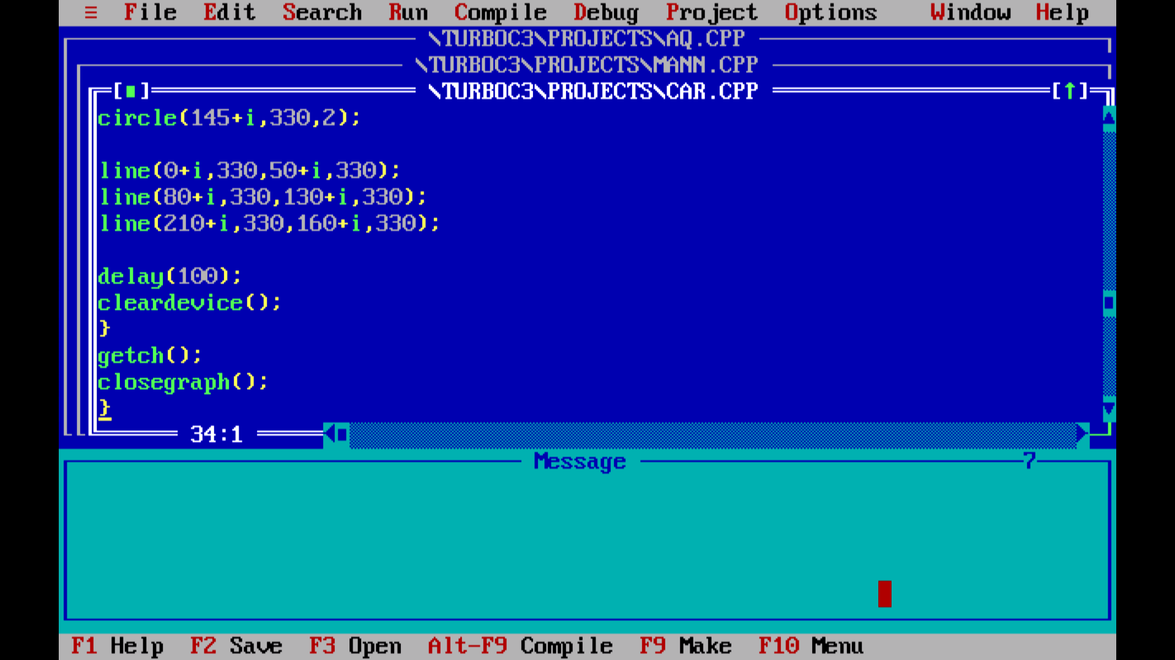

**OUTPUT**

