**Experiment 07**

**Name: Amit Pandharikar**

**Roll-no: EN19CS301042**

**Class: CS-A**

**Subject: CGMM**

**AIM**

**To make moving kite using programming.**

**PROGRAM**

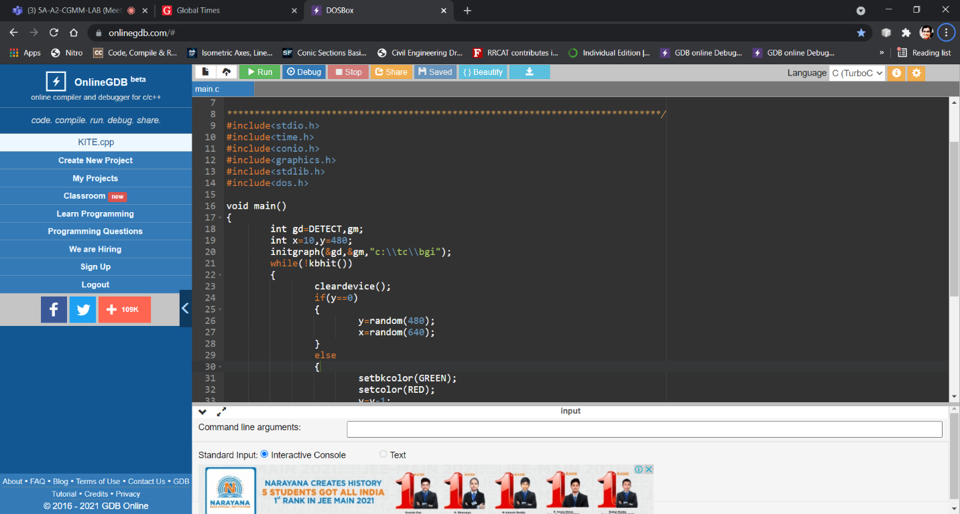

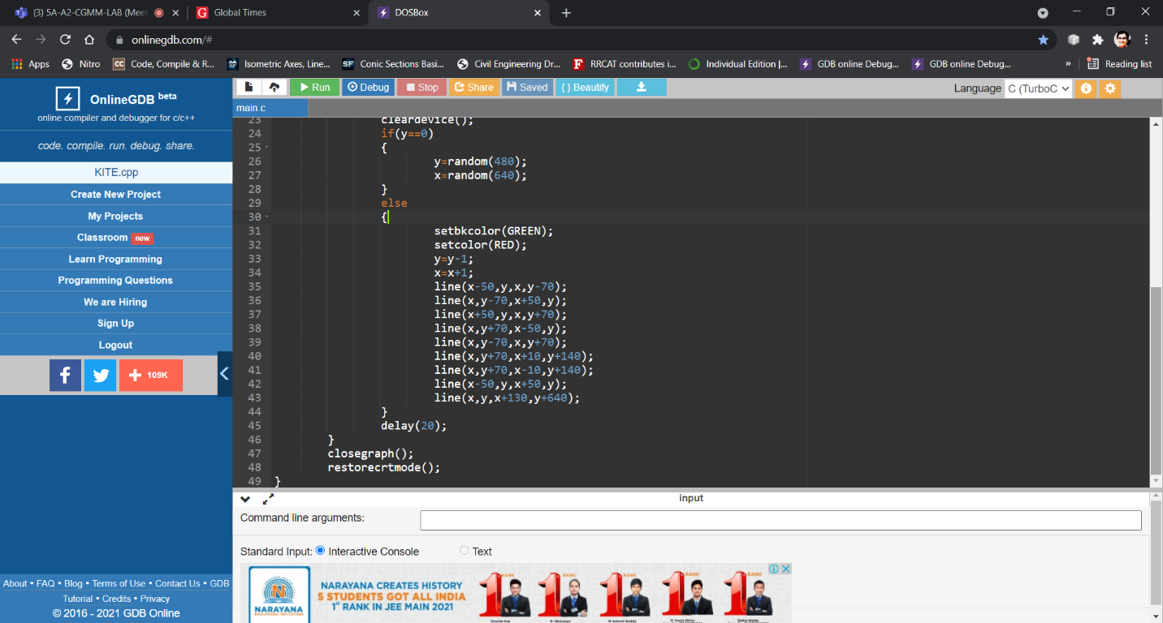

**OUTPUT**

