**EXPERIMENT 03**

Name: Amit Pandharikar

Roll-no: EN19CS301042

Subject: Computer Graphics and Multimedia

**AIM**

To make “House” using basic shapes in Computer Graphics.

**PROGRAM**

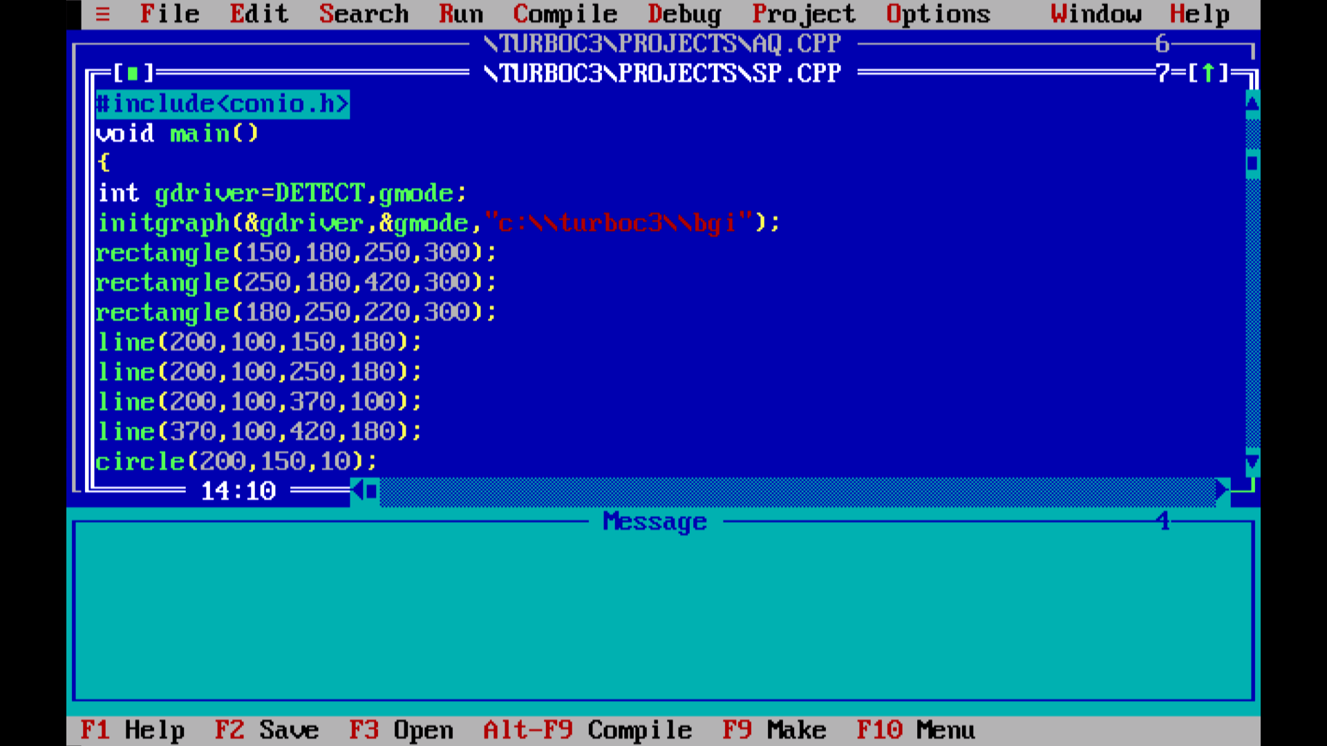

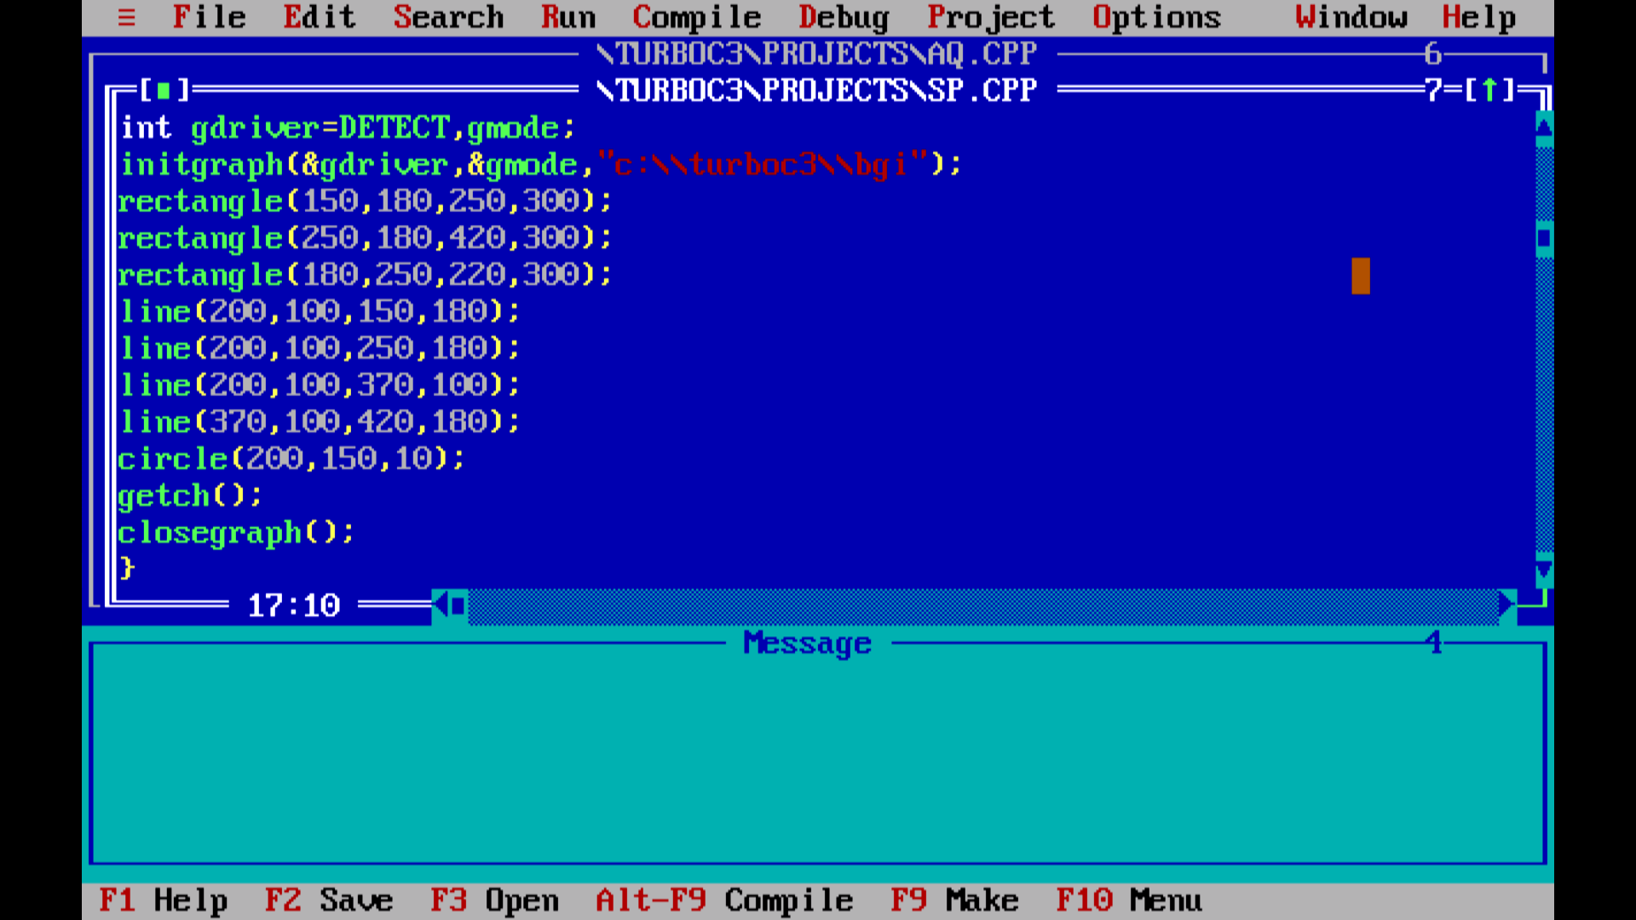

**OUTPUT**

