COMPUTATIONAL FLUID DYNAMICS ASSIGNMENT – 2



**Submitted by,**

**Name – Amit Kumar Roll No – 224103303**

**Branch – Fluids & Thermal**

# (1). FTCS

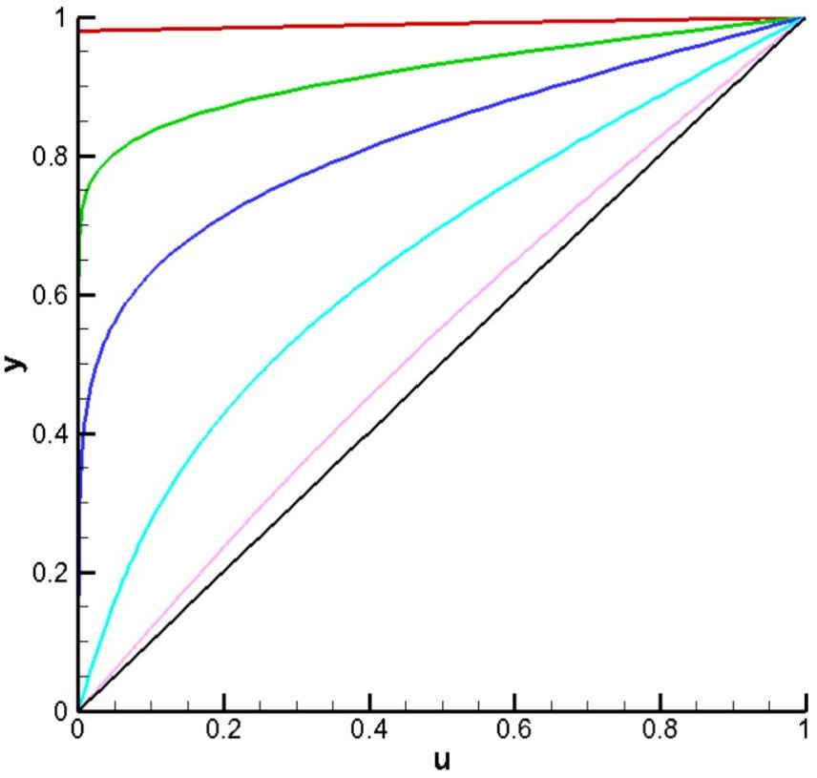

1. t = 0 : Number of iterations = 1
2. t = 0.5 : Number of iterations = 101
3. t = 2.5 : Number of iterations = 500
4. t = 10 : Number of iterations = 2000
5. t = 25 : Number of iterations = 5001
6. Steady state : error is order of 0.000001, Number of iterations = 11635

# 2 (b). BTCS (Tridiagonal Matrix Algorithm)

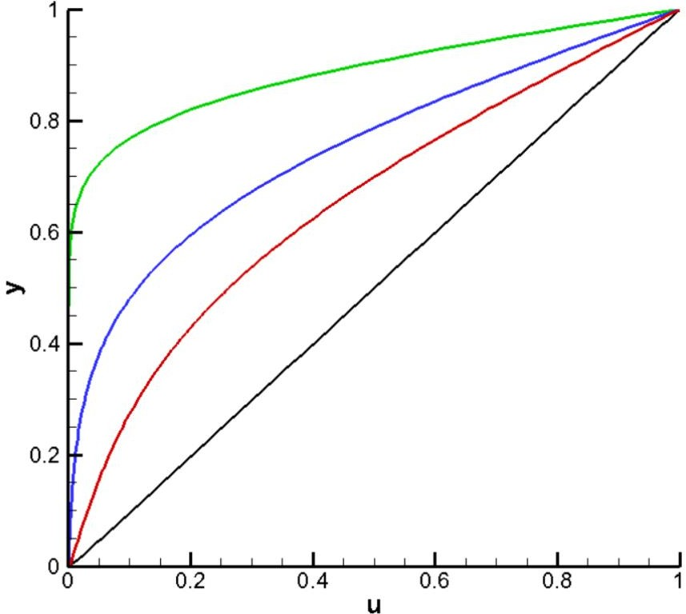

1. t = 1 : Number of iterations = 101
2. t = 5 : Number of iterations = 501
3. t = 10 : Number of iterations = 1001
4. Steady state : Error is order of 0.000001 , Number of iterations = 6226

# 2 (c). Crank Nicloson

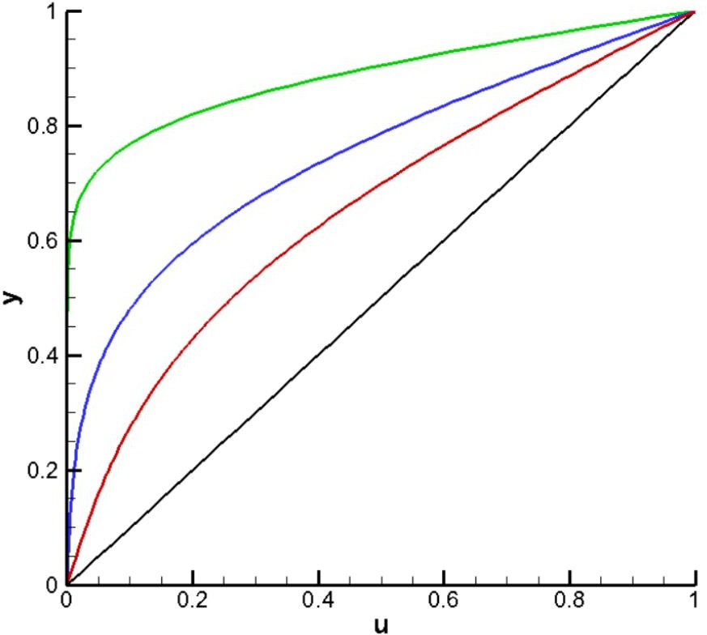

* 1. t = 1 : Number of iterations = 101
  2. t = 5 : Number of iterations = 501
  3. t = 10 : Number of iterations = 1001
  4. Steady state : Error is order of 0.000001 , Number of iterations = 6187