**Exercise-1**

Before we start, recall this jargon:

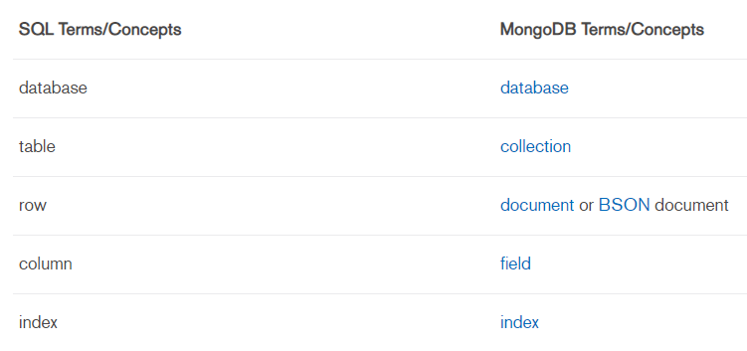

This exercise involves using the mongo shell. Mongo shell is already installed on your device. Instructions to open the shell are given below:

* open terminal
* $mongo --host 10.100.60.11 --port 27017
  + (MongoDB uses default port as 27017 across devices)

A prompt ‘>’ should appear indicating the mongo shell.

We will also be using a GUI client for MongoDB to view and edit data. To connect to the database from the client follow these steps:

* open application ‘MongoDB Compass Community’

You will see the new connection window.

* select **Fill in connection fields individually** option
* fill in the details as follows: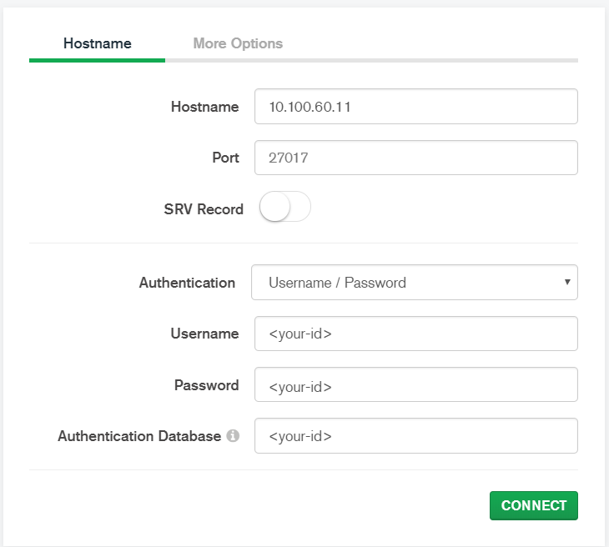

Now, type use <your-id> in the terminal. You can also type ‘db’ to get the database name on which you are working.

Authenticate using db.auth(‘<your-id>’,’<your-id>’)

**CRUD operations- Create, Read, Update, Delete**

In case of any clarifications in syntax, visit [here](https://docs.mongodb.com/manual/mongo/)

**Create:**

In the database that we have been provided, multiple collections can be created. Explicit creation of a collection can be done using:

db.createCollection(‘posts’)

Creation of a collection is implicit upon insertion of a document in the collection. Use a text editor to type your commands with indentation and then copy them to shell for ease of use.

db.posts.insert({

title:'Biden Takes Command of Race, Winning Three States Including Michigan',

body:'Joseph R. Biden Jr. widened his advantage over Bernie Sanders in the Democratic primary race, capturing Mississippi and Missouri as well as Michigan, with support from both black and white voters.',

category: 'News',

views:'4',

tags:['news','events'],

user:{

name: 'John Doe',

status: 'author',

},

date: Date(),

})

Notice the aggregation of **user** collection within the **posts** collection. Also, notice the creation of the **_id field** for each inserted document.

show collections is another useful command to view all the collections created. Don’t forget to view the changes in the Compass Client as we type in commands.

db.myCollection.insertMany(),db.myCollection.insertOne() can be used to insert multiple,single documents.

**Question 1: Write a mongo shell command to insert the posts given in /data/posts/posts.txt.**

**Read:**

Read operations retrieves documents from a collection; i.e. queries a collection for documents. Mongo provides db.myCollection.find()

This is equivalent to **select * from myCollection**

use .pretty()to get the output in indented form