**Introduction**

We will be creating a database called “M-Flix” database. It has the following collections:

* comments:

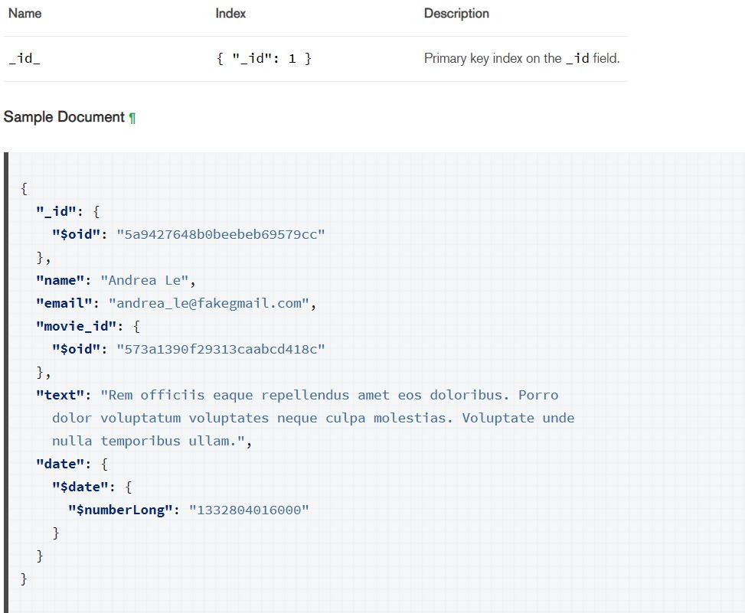

* movies:

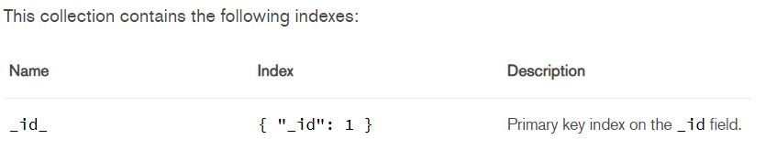

Take a look at its sample document [here](https://docs.atlas.mongodb.com/sample-data/sample-mflix/#sample-mflix-movies).

* sessions:

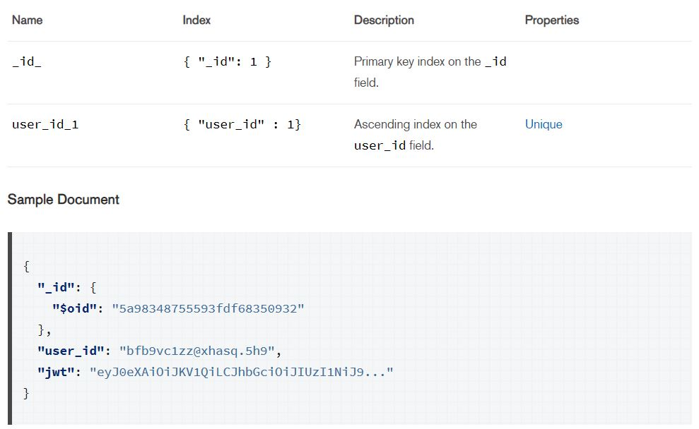

* theatres:

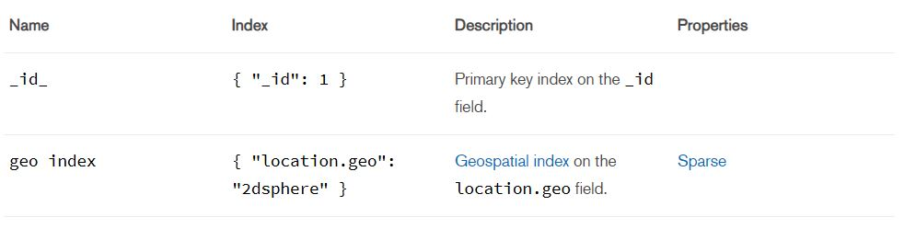

A sample document is available [here](https://docs.atlas.mongodb.com/sample-data/sample-mflix/#sample-mflix-theaters).

* users:

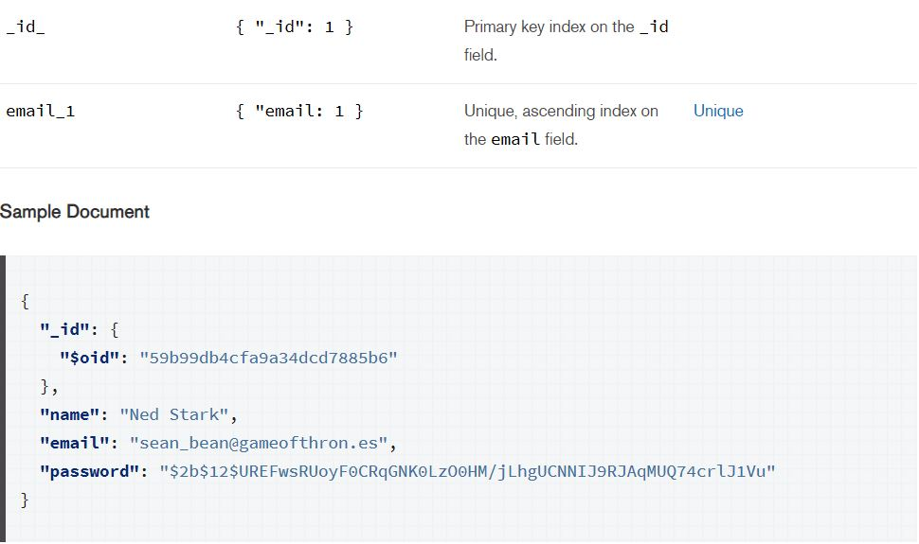

**Setting Up the database**

Right now, we do not have the database from which we can do the operations. We need to set up the database and its corresponding collections ( *remember, collections are just like tables from relational databases* ). First, go to the folder /data/mflix. These are your collection files. Now, we need to import these .json files into our database. To do so, open the terminal and type the following command:

mongoimport --db <dbName> --collection <collectionName> --file <filePath><fileName> --jsonArray

where:

* dbName is the database name. You can choose any name for your database. Right now, the chosen name is ‘mflix’.
* collectionName is the name of the collection. Again, this can be anything that you like. The name should be relevant to the documents that the collection holds.
* filePath is the path of the file where your collection ( .json file) exists.
* fileName is the collection file (.json file).
* --jsonArray accepts the data import with multiple Mongo database documents within a single JSON array.

This will create a collection in our database.

Similarly, repeat this procedure for all the collections.

**Some helpful commands**

1. use mflix: switches to the database mflix. So, this becomes our current database.
2. show collections: shows all the collections present in the current database.
3. show databases: shows all the databases present.
4. db.<collectionName>.find(): for querying in the collection.
5. db.<collectionName>.insertOne(): inserts a new document into the collection.
6. db.<collectionName>.insertMany(): inserts multiple documents into the collection.
7. db.<collectionName>.updateOne(): updates one existing document in the collection.
8. db.<collectionName>.updateMany(): updates multiple existing documents in the collection.
9. db.<collectionName>.deleteOne(): deletes an existing document from the collection.
10. db.<collectionName>.deleteMany(): deletes multiple existing documents from the collection.
11. db.<collectionName>.drop(): removes or drops an entire collection.
12. db.<collectionName>.createIndex(): creates an index on the collection.

**Questions**

For the mflix database, using the mongo shell,

1. Show all the movies released after 1900. Only project the title and year of the movie.
2. Show all the movies with IMDB rating greater than or equal to 8. Only project the title of the movie.
3. Petyr Baelish is known for his witty remarks. Show all the comment texts that the user named “Petyr Baelish” made.
4. Determine the movie with the most number of comments.
5. Determine which state has the maximum number of theatres. Only project the state and the number of theatres.
6. Which 5 users made the maximum number of comments? Only project the usernames and the number of comments they made.

**References**

**#** [**https://www.tutorialspoint.com/mongodb/mongodb_query_document.htm**](https://www.tutorialspoint.com/mongodb/mongodb_query_document.htm)

**#** [**https://docs.mongodb.com/manual/tutorial/query-embedded-documents/**](https://docs.mongodb.com/manual/tutorial/query-embedded-documents/)

**#** [**https://www.tutorialspoint.com/mongodb/mongodb_aggregation.htm**](https://www.tutorialspoint.com/mongodb/mongodb_aggregation.htm)