Pumpkin Seed Classification System Using Machine Learning
Project Report

Submitted By: Amit Suresh Powar
B.Tech (Computer Science & Engineering)
D Y Patil College of Engineering and Technology

Abstract
This project presents a Machine Learning-based web application for classifying pumpkin seeds using morphological features. A Random Forest classifier is implemented and deployed using Flask for real-time predictions.

Problem Statement
To develop a machine learning-based system capable of accurately classifying pumpkin seeds based on measurable physical attributes and deploy it as a web application.

Technologies Used
Programming Language: Python
Libraries: Pandas, NumPy, Scikit-learn, Flask, Pickle
Frontend: HTML, CSS
Algorithm: Random Forest Classifier

System Architecture
The overall architecture of the system is shown below:
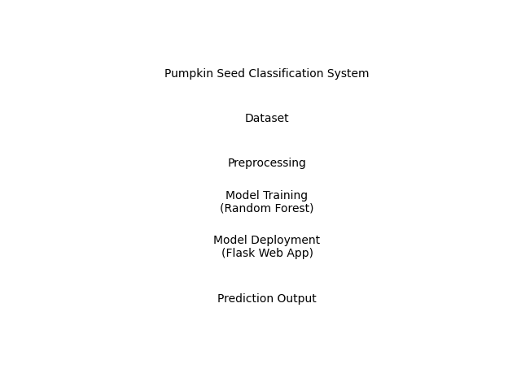

Methodology
1. Data Preprocessing
2. Train-Test Split
3. Feature Scaling using MinMaxScaler
4. Model Training using Random Forest
5. Model Evaluation using Accuracy and Classification Report
6. Deployment using Flask Web Framework

Workflow of Web Application
The prediction workflow is shown below:
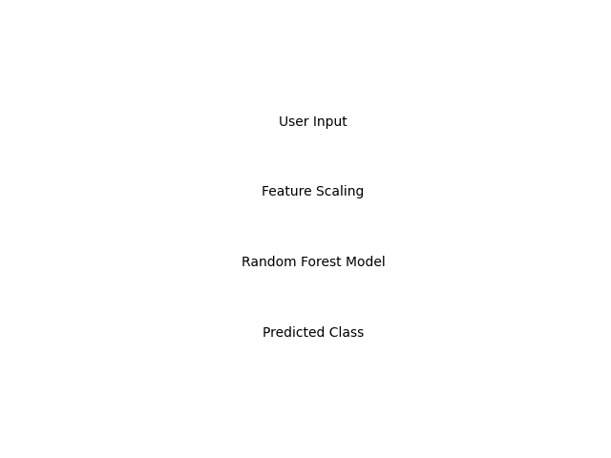

Advantages
• High Accuracy
• Automated Classification
• User-Friendly Interface
• Real-Time Prediction

Future Enhancements
• Add more seed varieties
• Deploy on cloud platform
• Integrate database storage
• Add graphical dashboard

Conclusion
The Pumpkin Seed Classification System successfully demonstrates the practical implementation of machine learning in agricultural classification. The Random Forest model provides accurate predictions and can be extended further.

