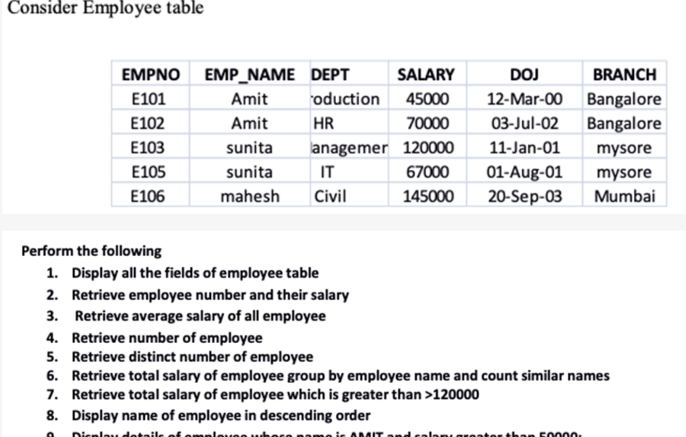

1)Select * from Employee ;

2)Select EMPNO , SALARY from Employee;

3)Select avg(Salary) from Employee;

4)Select count(*) from Employee;

5)Select Distinct (EMPNO) from Employee ;

6)Select EMP_NAME , SUM (SALARY) , Count(EMP_NAME) from Employee group by EMP_NAME;

7)Select EMPNO , SUM (SALARY) from Employee group by EMP_NAME having SUM(SALARY) > 120000;

8)Select EMP_NAME from Employee order by EMP_NAME desc;

9)Select * from Employee where EMP_NAME="AMIT" and SALARY > 500000