- What is variable in javascript?
Variable is container that holds a value and data.

- Types of Variables in Javascript?
- Var –
- var work with function and global scop.
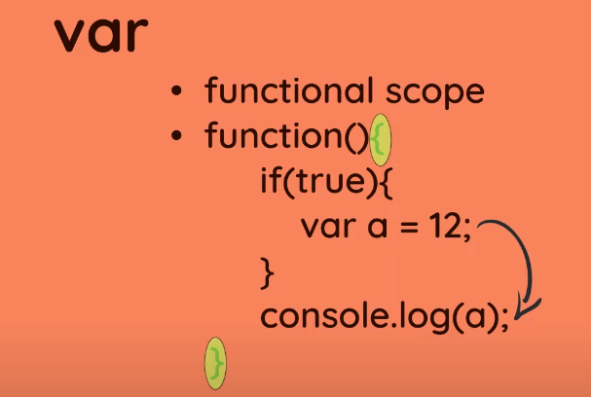
- We can reaassingn the var value.

- Let –
- let is a block scop variable.
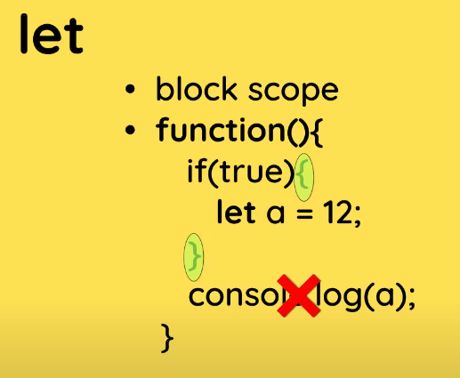
- We can reaassingn the let value.
- Const –
- const is a also block level scop variable.
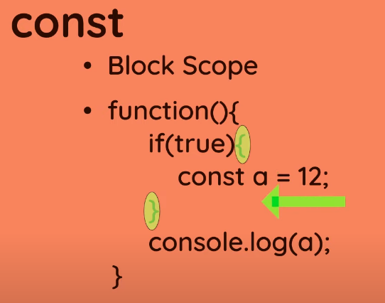

- But we can not chage the const value.
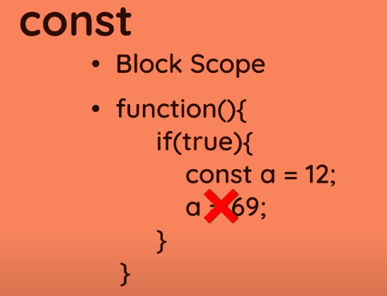

- Rules to declear variables
