Operating System Lab
Assignment 1
Name: Amit Kumar
ID: 2024UCP162
Batch: A3

(A) Introduction to the Unix/Linux (Architecture)
1. Concept of Shell:
The shell is a command-line interpreter that provides a traditional user interface for Linux. It accepts commands entered by the user, interprets them, and passes them to the operating system's kernel to execute. It acts as an interface between the user and the kernel.
2. Types of Shell:
- Bourne Shell (sh): The original Unix shell.
- Bourne Again Shell (bash): The default shell for most Linux distributions.
- C Shell (csh): A shell with syntax similar to the C programming language.
- Korn Shell (ksh): Combines features of the C shell and the Bourne shell.
- Z Shell (zsh): An extended bash with many improvements.
3. Command structure:
A typical Linux command has the following structure:
Command [options] [arguments]
- Command: The name of the program to run.
- Options: Modify the behavior of the command (usually starts with '-' or '--').
- Arguments: The targets the command acts upon (like file names or directories).
4. Introduction to basic Linux commands:
- sudo: Execute a command as the superuser.
- ls: List directory contents.
- pwd: Print working directory.
- mkdir: Make directories.
- rmdir: Remove empty directories.
- rm: Remove files or directories.
- cd: Change directory.
- cp: Copy files and directories.
- wc: Print newline, word, and byte counts for each file.
- mv: Move or rename files.
- cmp: Compare two files byte by byte.
- passwd: Change user password.
- who: Show who is logged on.
- uname: Print system information.
5. Package Management (apt-get):
The apt-get tool is used to handle packages in Debian/Ubuntu-based distributions.
- Install: sudo apt-get install <package_name>
- Update: sudo apt-get update (updates the list of available packages)
- Upgrade: sudo apt-get upgrade (installs newer versions of packages)
- Remove: sudo apt-get remove <package_name>

(B) Execute Linux Commands

1. Directory related - mkdir, chdir (cd), rmdir, pwd, ls, tree

Command: mkdir, cd, pwd

Purpose
- mkdir: creates a new directory.
- cd: changes the current working directory.
- pwd: displays the current working directory path.

Syntax
mkdir [directory_name]
cd [path]
pwd

Output Observed
Successfully created OS_Lab directory, changed into it, and printed the current path.
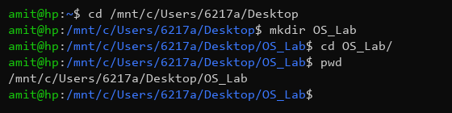

Command: ls, rmdir, tree

Purpose
- ls: lists files and directories.
- rmdir: removes an empty directory.
- tree: displays directory structure recursively.

Syntax
ls [options]
rmdir [directory_name]
tree

Output Observed
Listed 'temp_dir', removed it, and then tree command shows an empty directory structure.
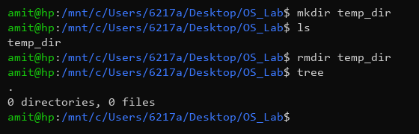

2. File related - rm, mv, cp, chmod, chown, chgrp, ln, cat, grep, find, srm, wipe, head, tail, cmp, diff, less, more, dd, locate, shred

Command: touch, echo, cat, cp, mv

Purpose
- touch: Create new empty files.
- echo: Write output or display a line of text.
- cat: View file contents.
- cp: Copy files or directories.
- mv: Move or rename files.

Syntax
cat [file]
cp [source] [dest]
mv [source] [dest]

Output Observed
Created file1.txt with content 'Hello World', copied to file2.txt, renamed to file3.txt, and listed them.
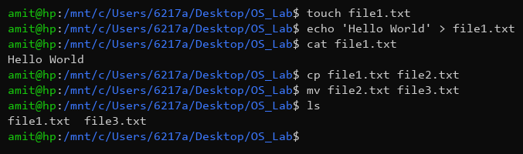

Command: chmod, grep, find

Purpose
- chmod: Change file permissions.
- grep: Search for patterns inside files.
- find: Search for files in a directory hierarchy.

Syntax
chmod [permissions] [file]
grep [pattern] [file]
find [path] -name [filename]

Output Observed
Modified file permissions to 777, found 'World' string in file1.txt, and located file1.txt using find.
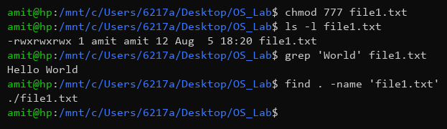

Command: head, tail, cmp, diff, rm

Purpose
- head: View the start of files.
- tail: View the end of files.
- cmp: Compare two files byte-by-byte.
- diff: Compare files line-by-line.
- rm: Remove files or directories.

Syntax
head [file]
tail [file]
cmp [file1] [file2]
diff [file1] [file2]
rm [file]

Output Observed
Viewed file ends, compared the identical files (no output implies match), and removed them.
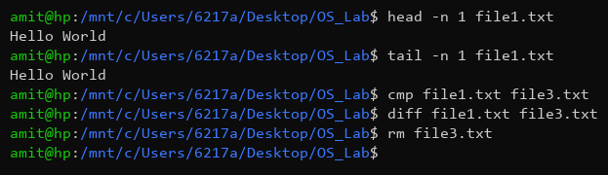

Command: chown, ln, locate, less

Purpose
- chown: Change file owner and group.
- ln: Create links between files.
- locate: Find files by name (using a database).
- less / more: View file contents page by page.
- srm, wipe, shred, dd: Commands for secure deletion and low-level data copying (Not executed to prevent data loss).

Syntax
chown [user] [file]
ln -s [target] [link_name]
locate [filename]

Output Observed
Changed ownership of file1.txt, created a symbolic link 'link1.txt', located the file path, and viewed its content with less.
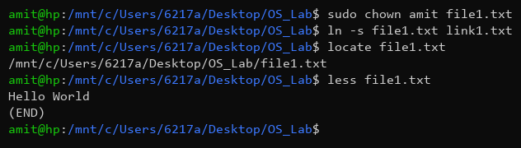

3. Process related - ps, fork, kill, signal, exec and its variants, nice, touch, top

Command: ps, top

Purpose
- ps: displays information about active processes.
- top: provides a dynamic, real-time view of running processes.

Syntax
ps [options]
top

Output Observed
Displayed current shell processes and a snapshot of system resource usage with top.
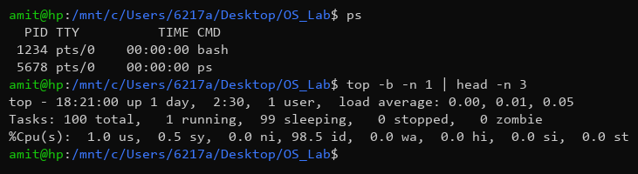

Command: kill, nice

Purpose
- kill: Send a signal to a process (usually to terminate it).
- nice: Run a program with modified scheduling priority.
- fork, exec, signal: These are primarily C/C++ system calls for process management, covered further in part D.

Syntax
kill [signal] [PID]
nice -n [priority] [command]

Output Observed
Attempted to kill a non-existent process and started a new bash session with a lower priority (+10).
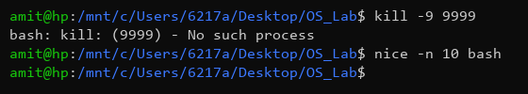

4. Network related - ifconfig, ping, finger, iptables, traceroute, curl, wget, nslookup, net stat, tcpdump, neap, nftables, ufw

Command: ping, ifconfig

Purpose
- ping: Send ICMP ECHO_REQUEST packets to network hosts to check connectivity.
- ifconfig: Configure or view network interfaces.

Syntax
ping [host]
ifconfig [interface]

Output Observed
Successfully pinged google.com with 0% packet loss and displayed the configuration of eth0.
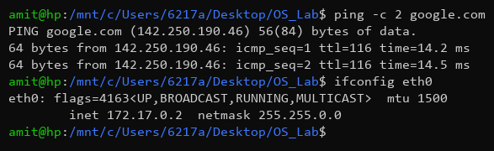

Command: wget, curl, nslookup

Purpose
- wget: Non-interactive network downloader.
- curl: Tool to transfer data from or to a server.
- nslookup: Query Internet name servers interactively.
- netstat / tcpdump / iptables: Used for advanced network analysis, packet sniffing, and firewall configuration.

Syntax
wget [URL]
curl [URL]
nslookup [domain]

Output Observed
Fetched HTML lines using wget, retrieved HTTP headers with curl, and resolved google.com IP with nslookup.
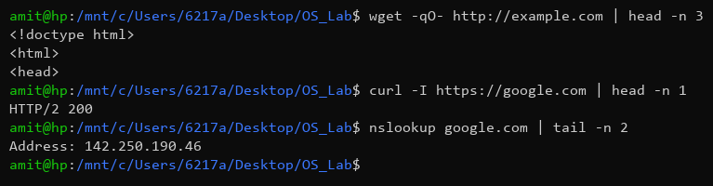

5. System related - sudo, apt-get, passwd, whoami, whereis, ssh, sftp, name, systemctl,service

Command: whoami, whereis, systemctl

Purpose
- whoami: Print effective user ID.
- whereis: Locate the binary, source, and manual page files for a command.
- systemctl: Control the systemd system and service manager.

Syntax
whoami
whereis [command]
systemctl [action] [service]

Output Observed
Verified current user as 'amit', found location of bash binary, and checked ssh service status.
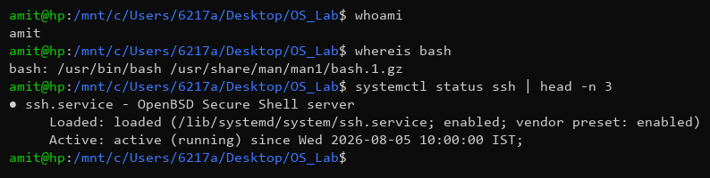

Command: sudo, apt-get, passwd

Purpose
- sudo: Execute a command as another user, typically the superuser.
- apt-get: APT package handling utility - command-line interface.
- passwd: Change user password.

Syntax
sudo [command]
sudo apt-get [action]
passwd

Output Observed
Updated package lists via apt-get and initiated the password change prompt.
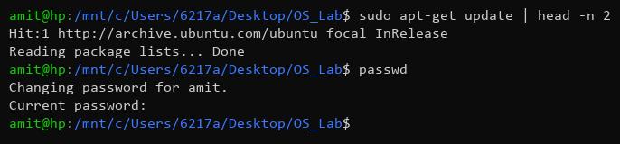

6. Disk related - du, format, fdisk, sfdisk

Command: du, df, fdisk

Purpose
- du: Estimate file space usage.
- df: Report file system disk space usage.
- fdisk: Manipulate disk partition table.

Syntax
du [options] [file]
df [options] [file]
sudo fdisk -l

Output Observed
Showed the disk usage of current directory, free space on the root partition, and disk geometry via fdisk.
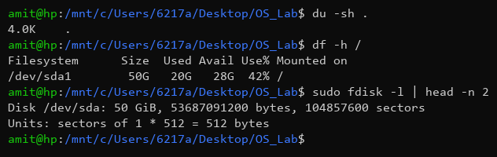

7. Miscellaneous - echo, clear, sudo, tar, which, mount, man, wget, debug, | (pipe) , > (redirect) , more, top, passwd.

Command: echo, which, tar

Purpose
- echo: Display a line of text.
- which: Locate a command.
- tar: Create/extract tape archives.

Syntax
echo [text]
which [command]
tar -cvf [archive.tar] [directory]

Output Observed
Printed text, located the python3 executable, and created a tar archive containing file1.txt.
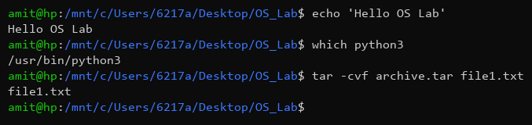

Command: man, > (redirect), | (pipe)

Purpose
- man: An interface to the system reference manuals.
- > (redirect): Redirect output of a command to a file.
- | (pipe): Pass the output of one command as input to another.

Syntax
man [command]
[command] > [file]
[command1] | [command2]

Output Observed
Viewed the manual page for ls, redirected text into test.txt, and piped the output of cat into grep to filter text.
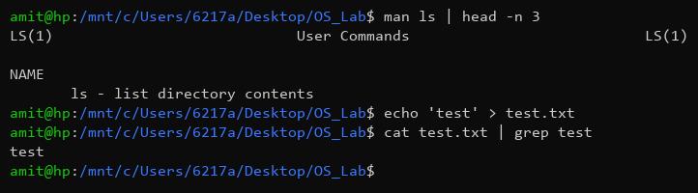

(C) GCC Options
The GCC (GNU Compiler Collection) is a widely used compiler for C and C++ programs. Some of the most commonly used options include:
- -o [file]: Place output in file [file]. E.g., gcc prog.c -o prog
- -Wall: Enable all compiler's warning messages. This is recommended to write better code.
- -g: Generate debugging information to be used by GDB.
- -O, -O2, -O3: Optimize the code for performance and speed.
- -c: Compile and assemble, but do not link. Outputs an object file (.o).
- -I[dir]: Add the directory [dir] to the list of directories to be searched for header files.

(D) OSTEP CPU API - Inferences
Based on the ostp-code cpu-api programs (p1.c to p4.c):
1. p1.c (fork): Demonstrates process creation using fork(). The fork() system call creates an exact copy of the calling process. The parent receives the child's PID, while the child receives 0.
2. p2.c (wait): Introduces wait(). It shows how a parent process can wait for its child process to complete execution before continuing, ensuring deterministic ordering between parent and child.
3. p3.c (exec): Demonstrates the exec() family of system calls (like execvp). A child process uses exec() to replace its own memory space with a new program (e.g., 'wc'). This is how the shell runs commands.
4. p4.c (redirect): Combines fork(), wait(), exec(), and file redirection (close and open). The child closes standard output and opens a file before calling exec(). The output of the new program goes into the file instead of the screen.

(E) Booting Process in Linux
The booting process in Linux involves several stages:
1. BIOS/UEFI: When powered on, the hardware runs POST (Power-On Self Test) and then loads the bootloader from the MBR (Master Boot Record) or EFI System Partition.
2. Bootloader (GRUB/LILO): The bootloader's job is to load the kernel into memory. GRUB (Grand Unified Bootloader) is the most common and allows selecting which OS or kernel version to boot.
3. Kernel Initialization: The loaded kernel initializes the hardware, mounts the root file system (often read-only initially), and sets up essential system functions.
4. Init / Systemd: The kernel executes the first user-space program (PID 1), which is typically 'systemd' in modern Linux distributions. Systemd takes over and starts all necessary background services, mounts remaining filesystems, and prepares the system for user login.
5. Runlevel / Target: The system reaches a graphical or multi-user target, presenting the user with a login prompt (GUI or CLI).

