OS Lab Assignment 3

Task A: File Information Script
The code for Task A is a Bash script designed to take a filename as an argument and display important information about that file. The execution involves checking the file's existence and using the 'stat' command to extract and format its size, permissions, owner, and last modification time.
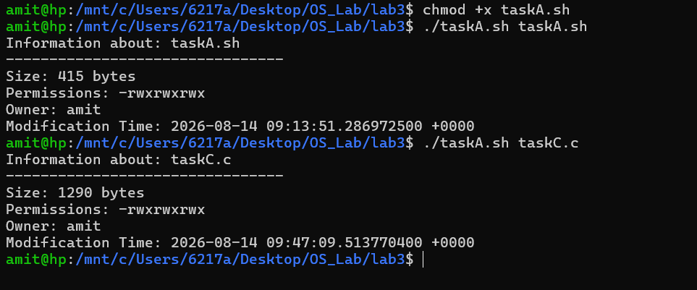

Task B: System Information Script
The code for Task B is a Bash script that gathers and displays various system details. During execution, it runs several Linux commands to fetch and print the operating system version, CPU details, memory usage, disk storage, and network interface information.
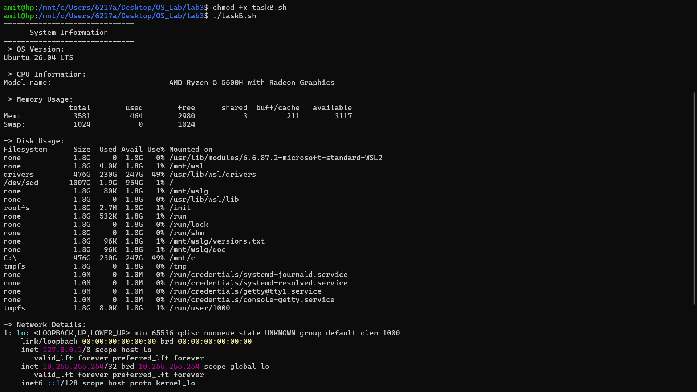

Task C: Simple Shell in C
The code for Task C is a C program that simulates a basic command-line shell. Upon execution, it runs a continuous loop that displays a prompt, reads user input, and uses the 'fork()' and 'execvp()' system calls to spawn a child process and execute the requested command, while the parent process waits for completion using 'wait()'.
