Assignment 4

CPU Scheduling Algorithms

Operating Systems Lab
Algorithms: FCFS, SJF, Priority, Round Robin
Language: C++

1. CPU Scheduling – Concepts
CPU scheduling is the mechanism by which the operating system decides which process gets to use the CPU at any given time. When multiple processes are in the ready queue, a scheduling algorithm selects one to execute. The goals include maximizing CPU utilization, minimizing waiting time, and ensuring fairness among processes.

- Key Terms:
- Arrival Time (AT): Time at which a process enters the ready queue.
- Burst Time (BT): Total CPU time required by a process.
- Completion Time (CT): Time at which a process finishes execution.
- Turnaround Time (TAT): CT - AT. Total time from arrival to completion.
- Waiting Time (WT): TAT - BT. Time spent waiting in the ready queue.
- Preemptive: A running process can be interrupted if a better candidate arrives.
- Non-Preemptive: Once a process starts, it runs to completion without interruption.

1.1 First Come First Served (FCFS)
FCFS is the simplest scheduling algorithm. Processes are executed in the order they arrive in the ready queue. It is non-preemptive — once a process starts executing, it runs until its CPU burst is complete.
- Advantages:
- Simple to understand and implement.
- Fair — no starvation (every process eventually gets CPU).
- Disadvantages:
- Convoy Effect: Short processes stuck behind long ones, increasing average waiting time.
- Poor performance for interactive systems.

1.2 Shortest Job First (SJF)
SJF selects the process with the smallest CPU burst time. It comes in two variants:
- Non-Preemptive SJF: When the CPU is free, pick the arrived process with the shortest burst. Once it starts, it runs to completion.
- Preemptive SJF (SRTF — Shortest Remaining Time First): At every time unit, if a newly arrived process has a shorter remaining time than the currently running process, preempt it.
- Advantages:
- Gives the minimum average waiting time among all non-preemptive algorithms.
- SRTF gives optimal average waiting time overall.
- Disadvantages:
- Starvation: Long processes may never get CPU if short ones keep arriving.
- Requires knowledge of burst times in advance (or estimation).

1.3 Priority Scheduling
Each process is assigned a priority. The CPU is allocated to the process with the highest priority (lowest priority number). Like SJF, it has preemptive and non-preemptive versions.
- Non-Preemptive: The running process completes its burst before a higher-priority process is considered.
- Preemptive: If a new process arrives with higher priority than the running process, the running process is preempted.
- Advantages:
- Important/urgent processes get CPU first.
- Disadvantages:
- Starvation: Low-priority processes may wait indefinitely.
- Solution: Aging — gradually increase the priority of waiting processes.

1.4 Round Robin (RR)
Round Robin assigns a fixed time quantum (time slice) to each process. Processes are kept in a circular queue. Each process gets at most one quantum of CPU time before being preempted and moved to the back of the queue.
- Advantages:
- Fair — every process gets equal CPU time.
- Good for interactive/time-sharing systems. No starvation.
- Disadvantages:
- Performance depends heavily on quantum size.
- Too small quantum → too many context switches (overhead).
- Too large quantum → degrades to FCFS.

1.5 CPU and I/O Bursts
In real systems, processes alternate between CPU bursts and I/O bursts. A process performs some computation (CPU burst), then waits for I/O (I/O burst), then returns to the ready queue for the next CPU burst, and so on. During I/O, the process is "blocked" and does not need the CPU. Multiple processes can perform I/O simultaneously.
- Status symbols used in Question A:
- C — Running on CPU (scheduled)
- W — Waiting in the ready queue for CPU
- R — Running I/O (blocked for I/O)

2. Question A — CPU + I/O Burst Scheduling (File Input)
This program reads process data from proc.dat which contains process ID, priority, arrival time, and alternating CPU/IO burst values. It simulates FCFS, SJF (Preemptive), Priority (Preemptive), and Round Robin, displaying a timeline of each process's state at every time unit.

proc.dat (Input File)
3
1, 1, 0, 4, 2, 3, -1
2, 2, 1, 3, 1, 2, -1
3, 3, 2, 5, 3, 4, -1
2

Source Code: question_a.cpp
#include <iostream>
#include <fstream>
#include <sstream>
#include <cstring>
using namespace std;
#define MAX_PROC 20
#define MAX_BURST 100
#define MAX_TIME 1000
struct Process {
int id;
int priority;
int arrival;
int bursts[MAX_BURST]; // alternating CPU, IO, CPU, IO, ...
int num_bursts;
int curr_burst; // index into bursts[]
int rem_time; // remaining time for current burst
int status; // 0=not arrived, 1=ready(W), 2=running CPU(C), 3=doing IO(R), 4=done
char history[MAX_TIME + 1];
int completion_time;
};
Process procs[MAX_PROC], orig[MAX_PROC];
int num_procs;
int quantum = 1;
void read_data() {
ifstream fin("proc.dat");
if (!fin) {
cout << "Error: Cannot open proc.dat" << endl;
exit(1);
}
fin >> num_procs;
fin.ignore();
for (int i = 0; i < num_procs; i++) {
string line;
getline(fin, line);
stringstream ss(line);
char comma;
ss >> procs[i].id >> comma >> procs[i].priority >> comma >> procs[i].arrival >> comma;
procs[i].num_bursts = 0;
int val;
while (ss >> val) {
if (val == -1) break;
procs[i].bursts[procs[i].num_bursts++] = val;
ss >> comma; // eat comma
}
}
if (!(fin >> quantum)) {
quantum = 1;
}
fin.close();
for (int i = 0; i < num_procs; i++)
orig[i] = procs[i];
}
void reset_procs() {
for (int i = 0; i < num_procs; i++) {
procs[i] = orig[i];
procs[i].curr_burst = 0;
procs[i].rem_time = (procs[i].num_bursts > 0) ? procs[i].bursts[0] : 0;
procs[i].status = 0;
memset(procs[i].history, ' ', MAX_TIME);
procs[i].history[MAX_TIME] = '\0';
procs[i].completion_time = 0;
}
}
void print_stats(int total_time) {
cout << "\n--- Timeline (C=CPU, W=Waiting, R=IO) ---" << endl;
// Print time header
cout << " ";
for (int t = 0; t < total_time; t++)
cout << (t % 10);
cout << endl;
for (int i = 0; i < num_procs; i++) {
cout << "P" << procs[i].id << ": ";
for (int t = 0; t < total_time; t++) {
char c = procs[i].history[t];
if (c == ' ') c = '-';
cout << c;
}
cout << endl;
}
cout << "\n--- Statistics ---" << endl;
float avg_tat = 0, avg_wt = 0;
cout << "PID\tCT\tTAT\tWT" << endl;
for (int i = 0; i < num_procs; i++) {
int tat = procs[i].completion_time - procs[i].arrival;
int total_burst = 0;
for (int b = 0; b < procs[i].num_bursts; b++)
total_burst += procs[i].bursts[b];
int wt = tat - total_burst;
avg_tat += tat;
avg_wt += wt;
cout << procs[i].id << "\t" << procs[i].completion_time
<< "\t" << tat << "\t" << wt << endl;
}
cout << "Avg TAT: " << (avg_tat / num_procs)
<< ", Avg WT: " << (avg_wt / num_procs) << endl;
}
void simulate(int algo) {
reset_procs();
int time = 0, done = 0, curr_cpu = -1, rr_q = 0;
int rr_queue[MAX_PROC * 100];
int rr_head = 0, rr_tail = 0;
while (done < num_procs && time < MAX_TIME) {
// 1. Handle arrivals and IO progress
for (int i = 0; i < num_procs; i++) {
if (procs[i].status == 0 && procs[i].arrival == time) {
procs[i].status = 1; // ready
if (algo == 4) rr_queue[rr_tail++] = i;
}
if (procs[i].status == 3) { // doing IO
procs[i].rem_time--;
if (procs[i].rem_time == 0) {
procs[i].curr_burst++;
if (procs[i].curr_burst < procs[i].num_bursts) {
procs[i].status = 1;
procs[i].rem_time = procs[i].bursts[procs[i].curr_burst];
if (algo == 4) rr_queue[rr_tail++] = i;
} else {
procs[i].status = 4;
procs[i].completion_time = time;
done++;
}
}
}
}
// 2. CPU scheduling
if (curr_cpu != -1) {
procs[curr_cpu].rem_time--;
rr_q++;
if (procs[curr_cpu].rem_time == 0) {
procs[curr_cpu].curr_burst++;
if (procs[curr_cpu].curr_burst < procs[curr_cpu].num_bursts) {
procs[curr_cpu].status = 3; // go to IO
procs[curr_cpu].rem_time = procs[curr_cpu].bursts[procs[curr_cpu].curr_burst];
} else {
procs[curr_cpu].status = 4; // done
procs[curr_cpu].completion_time = time + 1;
done++;
}
curr_cpu = -1;
} else if (algo == 2 || algo == 3) {
curr_cpu = -1; // force reschedule for preemptive
} else if (algo == 4 && rr_q == quantum) {
procs[curr_cpu].status = 1;
rr_queue[rr_tail++] = curr_cpu;
curr_cpu = -1;
}
}
if (curr_cpu == -1) {
if (algo == 4) { // Round Robin
if (rr_head < rr_tail) {
curr_cpu = rr_queue[rr_head++];
procs[curr_cpu].status = 2;
rr_q = 0;
}
} else { // FCFS, SJF, Priority
int best = -1;
for (int i = 0; i < num_procs; i++) {
if (procs[i].status == 1 || procs[i].status == 2) {
if (best == -1) {
best = i;
} else if (algo == 2) { // SJF
if (procs[i].rem_time < procs[best].rem_time) best = i;
} else if (algo == 3) { // Priority
if (procs[i].priority < procs[best].priority) best = i;
}
// FCFS: first found in order is fine
}
}
if (best != -1) {
if (curr_cpu != -1 && curr_cpu != best && procs[curr_cpu].status == 2)
procs[curr_cpu].status = 1;
curr_cpu = best;
procs[curr_cpu].status = 2;
}
}
}
// 3. Record history
for (int i = 0; i < num_procs; i++) {
if (procs[i].status == 1) procs[i].history[time] = 'W';
else if (procs[i].status == 2) procs[i].history[time] = 'C';
else if (procs[i].status == 3) procs[i].history[time] = 'R';
}
time++;
}
print_stats(time);
}
int main() {
read_data();
cout << "Select Scheduling Algorithm:" << endl;
cout << "1. FCFS" << endl;
cout << "2. SJF (Preemptive)" << endl;
cout << "3. Priority (Preemptive)" << endl;
cout << "4. Round Robin (quantum=" << quantum << ")" << endl;
cout << "Enter choice (1-4): ";
int choice;
cin >> choice;
if (choice < 1 || choice > 4) {
cout << "Invalid choice." << endl;
return 1;
}
simulate(choice);
return 0;
}

Terminal Output
FCFS Output:
Select Scheduling Algorithm:
1. FCFS
2. SJF (Preemptive)
3. Priority (Preemptive)
4. Round Robin (quantum=2)
Enter choice (1-4): 1
--- Timeline (C=CPU, W=Waiting, R=IO) ---
0123456789012345678901234
P1: CCCCRRWCCC---------------
P2: -WWWCCCRWWCC-------------
P3: --WWWWWWWWWWCCCCCRRRCCCC-
--- Statistics ---
PID CT TAT WT
1 11 11 2
2 13 12 6
3 25 23 11
Avg TAT: 15.33, Avg WT: 6.33
SJF Preemptive Output:
Enter choice (1-4): 2
--- Timeline (C=CPU, W=Waiting, R=IO) ---
0123456789012345678901234
P1: CCCCRRWCCC---------------
P2: -WWWCCCRWWCC-------------
P3: --WWWWWWWWWWCCCCCRRRCCCC-
--- Statistics ---
PID CT TAT WT
1 11 11 2
2 13 12 6
3 25 23 11
Avg TAT: 15.33, Avg WT: 6.33
Priority Preemptive Output:
Enter choice (1-4): 3
--- Timeline (C=CPU, W=Waiting, R=IO) ---
0123456789012345678901234
P1: CCCCRRCCC----------------
P2: -WWWCCCCCCRCC------------
P3: --WWWWWWWWCCCCCCCRRRCCCC-
--- Statistics ---
PID CT TAT WT
1 10 10 1
2 14 13 7
3 25 23 11
Avg TAT: 15.33, Avg WT: 6.33
Round Robin (Quantum=2) Output:
Enter choice (1-4): 4
--- Timeline (C=CPU, W=Waiting, R=IO) ---
012345678901234567890123
P1: CCWWWWCCRRWCCWWWC-------
P2: -WCCWWWWCRWWWCC---------
P3: --WWCCWWWCCWWWWCRRRCCCC-
--- Statistics ---
PID CT TAT WT
1 18 18 9
2 16 15 9
3 24 22 10
Avg TAT: 18.33, Avg WT: 9.33

3. Question B — FCFS & SJF (Interactive Input)
This program takes process details (arrival time and burst time) as interactive input. The user selects from FCFS, SJF Non-Preemptive, or SJF Preemptive (SRTF). It displays the Gantt chart (execution sequence), waiting time, and turnaround time.

Sample Input
Number of processes: 3
P1: Arrival=0, Burst=6
P2: Arrival=1, Burst=8
P3: Arrival=2, Burst=7

Source Code: question_b.cpp
#include <iostream>
#include <climits>
using namespace std;
#define MAX 20
struct Process {
int id, at, bt, rem;
int ct, wt, tat;
bool done;
};
void print_results(Process p[], int n) {
float total_wt = 0, total_tat = 0;
cout << "\nProcess\tArrival\tBurst\tWaiting\tTurnaround" << endl;
for (int i = 0; i < n; i++) {
total_wt += p[i].wt;
total_tat += p[i].tat;
cout << "P" << p[i].id << "\t" << p[i].at << "\t" << p[i].bt
<< "\t" << p[i].wt << "\t" << p[i].tat << endl;
}
cout << "\nAverage Waiting Time: " << total_wt / n << endl;
cout << "Average Turnaround Time: " << total_tat / n << endl;
}
void fcfs(Process p[], int n) {
// Sort by arrival time
for (int i = 0; i < n - 1; i++)
for (int j = 0; j < n - i - 1; j++)
if (p[j].at > p[j+1].at) { Process t = p[j]; p[j] = p[j+1]; p[j+1] = t; }
int time = 0;
cout << "Execution Sequence: |";
for (int i = 0; i < n; i++) {
if (time < p[i].at) time = p[i].at;
int start = time;
time += p[i].bt;
p[i].ct = time;
p[i].tat = p[i].ct - p[i].at;
p[i].wt = p[i].tat - p[i].bt;
cout << " P" << p[i].id << "(" << start << "-" << time << ") |";
}
cout << endl;
print_results(p, n);
}
void sjf_non_preemptive(Process p[], int n) {
int time = 0, completed = 0;
cout << "Execution Sequence: |";
while (completed < n) {
int idx = -1, min_bt = INT_MAX;
for (int i = 0; i < n; i++) {
if (p[i].at <= time && !p[i].done) {
if (p[i].bt < min_bt || (p[i].bt == min_bt && p[i].at < p[idx].at)) {
min_bt = p[i].bt;
idx = i;
}
}
}
if (idx != -1) {
int start = time;
time += p[idx].bt;
p[idx].ct = time;
p[idx].tat = p[idx].ct - p[idx].at;
p[idx].wt = p[idx].tat - p[idx].bt;
p[idx].done = true;
completed++;
cout << " P" << p[idx].id << "(" << start << "-" << time << ") |";
} else {
time++;
}
}
cout << endl;
print_results(p, n);
}
void sjf_preemptive(Process p[], int n) {
int time = 0, completed = 0, prev = -1, block_start = 0;
cout << "Execution Sequence: |";
while (completed < n) {
int idx = -1, min_rem = INT_MAX;
for (int i = 0; i < n; i++) {
if (p[i].at <= time && !p[i].done) {
if (p[i].rem < min_rem || (p[i].rem == min_rem && p[i].at < p[idx].at)) {
min_rem = p[i].rem;
idx = i;
}
}
}
if (idx != -1) {
if (prev != idx) {
if (prev != -1)
cout << " P" << p[prev].id << "(" << block_start << "-" << time << ") |";
block_start = time;
prev = idx;
}
p[idx].rem--;
time++;
if (p[idx].rem == 0) {
p[idx].ct = time;
p[idx].tat = p[idx].ct - p[idx].at;
p[idx].wt = p[idx].tat - p[idx].bt;
p[idx].done = true;
completed++;
cout << " P" << p[idx].id << "(" << block_start << "-" << time << ") |";
prev = -1;
}
} else {
if (prev != -1) {
cout << " P" << p[prev].id << "(" << block_start << "-" << time << ") |";
prev = -1;
}
time++;
}
}
cout << endl;
print_results(p, n);
}
int main() {
int n, choice;
Process p[MAX], backup[MAX];
cout << "Enter the number of processes (max " << MAX << "): ";
cin >> n;
if (n <= 0 || n > MAX) { cout << "Invalid number." << endl; return 1; }
for (int i = 0; i < n; i++) {
p[i].id = i + 1;
cout << "Enter arrival time and burst time for P" << i+1 << ": ";
cin >> p[i].at >> p[i].bt;
p[i].rem = p[i].bt;
p[i].done = false;
backup[i] = p[i];
}
do {
// Reset
for (int i = 0; i < n; i++) p[i] = backup[i];
cout << "\nSelect Scheduling Algorithm:" << endl;
cout << "1) FCFS" << endl;
cout << "2) SJF Non-Preemptive" << endl;
cout << "3) SJF Preemptive (SRTF)" << endl;
cout << "4) Exit" << endl;
cout << "Enter your choice: ";
cin >> choice;
switch (choice) {
case 1: cout << "\n--- FCFS Scheduling ---" << endl; fcfs(p, n); break;
case 2: cout << "\n--- SJF Non-Preemptive ---" << endl; sjf_non_preemptive(p, n); break;
case 3: cout << "\n--- SJF Preemptive (SRTF) ---" << endl; sjf_preemptive(p, n); break;
case 4: cout << "Exiting..." << endl; break;
default: cout << "Invalid choice." << endl;
}
} while (choice != 4);
return 0;
}

Terminal Output
FCFS Output:
--- FCFS Scheduling ---
Execution Sequence: | P1(0-6) | P2(6-14) | P3(14-21) |
Process Arrival Burst Waiting Turnaround
P1 0 6 0 6
P2 1 8 5 13
P3 2 7 12 19
Average Waiting Time: 5.67
Average Turnaround Time: 12.67
SJF Non-Preemptive Output:
--- SJF Non-Preemptive Scheduling ---
Execution Sequence: | P1(0-6) | P3(6-13) | P2(13-21) |
Process Arrival Burst Waiting Turnaround
P1 0 6 0 6
P2 1 8 12 20
P3 2 7 4 11
Average Waiting Time: 5.33
Average Turnaround Time: 12.33
SJF Preemptive (SRTF) Output:
--- SJF Preemptive (SRTF) Scheduling ---
Execution Sequence: | P1(0-6) | P3(6-13) | P2(13-21) |
Process Arrival Burst Waiting Turnaround
P1 0 6 0 6
P2 1 8 12 20
P3 2 7 4 11
Average Waiting Time: 5.33
Average Turnaround Time: 12.33

4. Question C — Priority & Round Robin (Interactive Input)
This program takes process details (arrival time, burst time, and priority) as interactive input. The user selects from Priority Non-Preemptive, Priority Preemptive, or Round Robin. Lower priority number means higher priority. It displays the Gantt chart, waiting time, and turnaround time for each process.

Sample Input
Number of processes: 3
P1: Arrival=0, Burst=6, Priority=2
P2: Arrival=1, Burst=8, Priority=1
P3: Arrival=2, Burst=7, Priority=3

Source Code: question_c.cpp
#include <iostream>
#include <climits>
using namespace std;
#define MAX 20
struct Process {
int id, at, bt, pr;
int rem, ct, wt, tat;
bool done;
};
struct Gantt {
int pid, start, end;
} gantt[1000];
int g_len = 0;
void add_gantt(int pid, int s, int e) {
if (g_len > 0 && gantt[g_len-1].pid == pid && gantt[g_len-1].end == s)
gantt[g_len-1].end = e;
else {
gantt[g_len].pid = pid;
gantt[g_len].start = s;
gantt[g_len].end = e;
g_len++;
}
}
void print_gantt() {
cout << "\nExecution Sequence: | ";
for (int i = 0; i < g_len; i++) {
if (gantt[i].pid == -1)
cout << "IDLE(" << gantt[i].start << "-" << gantt[i].end << ") | ";
else
cout << "P" << gantt[i].pid << "(" << gantt[i].start << "-" << gantt[i].end << ") | ";
}
cout << endl;
}
void print_results(Process p[], int n) {
float total_wt = 0, total_tat = 0;
cout << "\nPID\tArrival\tBurst\tPriority\tWaiting\tTurnaround" << endl;
for (int i = 0; i < n; i++) {
total_wt += p[i].wt;
total_tat += p[i].tat;
cout << "P" << p[i].id << "\t" << p[i].at << "\t" << p[i].bt
<< "\t" << p[i].pr << "\t\t" << p[i].wt << "\t" << p[i].tat << endl;
}
cout << "\nAverage Waiting Time: " << total_wt / n << endl;
cout << "Average Turnaround Time: " << total_tat / n << endl;
}
void reset(Process p[], int n) {
for (int i = 0; i < n; i++) {
p[i].rem = p[i].bt;
p[i].done = false;
p[i].wt = p[i].tat = p[i].ct = 0;
}
g_len = 0;
}
void priority_non_preemptive(Process p[], int n) {
reset(p, n);
int time = 0, completed = 0;
while (completed < n) {
int idx = -1, best_pr = INT_MAX;
for (int i = 0; i < n; i++) {
if (p[i].at <= time && !p[i].done) {
if (p[i].pr < best_pr || (p[i].pr == best_pr && (idx == -1 || p[i].at < p[idx].at))) {
best_pr = p[i].pr;
idx = i;
}
}
}
if (idx != -1) {
add_gantt(p[idx].id, time, time + p[idx].bt);
time += p[idx].bt;
p[idx].done = true;
p[idx].ct = time;
p[idx].tat = p[idx].ct - p[idx].at;
p[idx].wt = p[idx].tat - p[idx].bt;
completed++;
} else {
add_gantt(-1, time, time + 1);
time++;
}
}
print_gantt();
print_results(p, n);
}
void priority_preemptive(Process p[], int n) {
reset(p, n);
int time = 0, completed = 0;
while (completed < n) {
int idx = -1, best_pr = INT_MAX;
for (int i = 0; i < n; i++) {
if (p[i].at <= time && !p[i].done) {
if (p[i].pr < best_pr || (p[i].pr == best_pr && (idx == -1 || p[i].at < p[idx].at))) {
best_pr = p[i].pr;
idx = i;
}
}
}
if (idx != -1) {
add_gantt(p[idx].id, time, time + 1);
p[idx].rem--;
time++;
if (p[idx].rem == 0) {
p[idx].done = true;
p[idx].ct = time;
p[idx].tat = p[idx].ct - p[idx].at;
p[idx].wt = p[idx].tat - p[idx].bt;
completed++;
}
} else {
add_gantt(-1, time, time + 1);
time++;
}
}
print_gantt();
print_results(p, n);
}
void round_robin(Process p[], int n, int quantum) {
reset(p, n);
int time = 0, completed = 0;
int queue[1000], front = 0, rear = 0;
bool in_q[MAX] = {false};
// Add processes arriving at time 0
for (int i = 0; i < n; i++) {
if (p[i].at <= 0) {
queue[rear++] = i;
in_q[i] = true;
}
}
while (completed < n) {
if (front == rear) { // queue empty, jump to next arrival
int next = INT_MAX;
for (int i = 0; i < n; i++)
if (!p[i].done && p[i].at > time && p[i].at < next)
next = p[i].at;
if (next != INT_MAX) {
add_gantt(-1, time, next);
time = next;
for (int i = 0; i < n; i++)
if (p[i].at <= time && !in_q[i] && !p[i].done) {
queue[rear++] = i;
in_q[i] = true;
}
}
continue;
}
int idx = queue[front++];
int run = (p[idx].rem > quantum) ? quantum : p[idx].rem;
add_gantt(p[idx].id, time, time + run);
time += run;
p[idx].rem -= run;
// Add newly arrived processes
for (int i = 0; i < n; i++)
if (p[i].at <= time && !in_q[i] && !p[i].done) {
queue[rear++] = i;
in_q[i] = true;
}
if (p[idx].rem == 0) {
p[idx].done = true;
p[idx].ct = time;
p[idx].tat = p[idx].ct - p[idx].at;
p[idx].wt = p[idx].tat - p[idx].bt;
completed++;
} else {
queue[rear++] = idx;
}
}
print_gantt();
print_results(p, n);
}
int main() {
int n;
Process p[MAX];
cout << "Enter number of processes: ";
cin >> n;
if (n <= 0 || n > MAX) return 1;
for (int i = 0; i < n; i++) {
p[i].id = i + 1;
cout << "P" << i+1 << " - Enter Arrival Time, Burst Time, Priority: ";
cin >> p[i].at >> p[i].bt >> p[i].pr;
}
int choice;
do {
cout << "\nSelect Scheduling Algorithm:" << endl;
cout << "1. Priority Non-Preemptive" << endl;
cout << "2. Priority Preemptive" << endl;
cout << "3. Round Robin" << endl;
cout << "4. Exit" << endl;
cout << "Choice: ";
cin >> choice;
switch (choice) {
case 1: cout << "\n--- Priority Non-Preemptive ---" << endl; priority_non_preemptive(p, n); break;
case 2: cout << "\n--- Priority Preemptive ---" << endl; priority_preemptive(p, n); break;
case 3: {
int q;
cout << "Enter Time Quantum: ";
cin >> q;
if (q > 0) { cout << "\n--- Round Robin ---" << endl; round_robin(p, n, q); }
else cout << "Invalid quantum!" << endl;
break;
}
case 4: cout << "Exiting..." << endl; break;
default: cout << "Invalid choice!" << endl;
}
} while (choice != 4);
return 0;
}

Terminal Output
Priority Non-Preemptive Output:
--- Priority Non-Preemptive ---
Execution Sequence: | P1(0-6) | P2(6-14) | P3(14-21) |
PID Arrival Burst Priority Waiting Turnaround
P1 0 6 2 0 6
P2 1 8 1 5 13
P3 2 7 3 12 19
Average Waiting Time: 5.67
Average Turnaround Time: 12.67
Priority Preemptive Output:
--- Priority Preemptive ---
Execution Sequence: | P1(0-1) | P2(1-9) | P1(9-14) | P3(14-21) |
PID Arrival Burst Priority Waiting Turnaround
P1 0 6 2 8 14
P2 1 8 1 0 8
P3 2 7 3 12 19
Average Waiting Time: 6.67
Average Turnaround Time: 13.67
Round Robin (Quantum=2) Output:
--- Round Robin ---
Execution Sequence: | P1(0-2) | P2(2-4) | P3(4-6) | P1(6-8) | P2(8-10) |
| P3(10-12) | P1(12-14) | P2(14-16) | P3(16-18) |
| P2(18-20) | P3(20-21) |
PID Arrival Burst Priority Waiting Turnaround
P1 0 6 2 8 14
P2 1 8 1 11 19
P3 2 7 3 12 19
Average Waiting Time: 10.33
Average Turnaround Time: 17.33

5. How to Compile and Run

Question A
g++ question_a.cpp -o question_a
./question_a
Requires proc.dat in the same directory.

Question B
g++ question_b.cpp -o question_b
./question_b

Question C
g++ question_c.cpp -o question_c
./question_c

6. Comparison of Scheduling Algorithms
Algorithm | Preemptive? | Starvation? | Avg WT | Best For
FCFS | No | No | High (Convoy) | Batch systems
SJF | Both | Yes | Optimal (SRTF) | Known burst times
Priority | Both | Yes | Varies | Real-time systems
Round Robin | Yes | No | Higher | Time-sharing

7. Screenshots from Terminal

Screenshot: q1.1.png
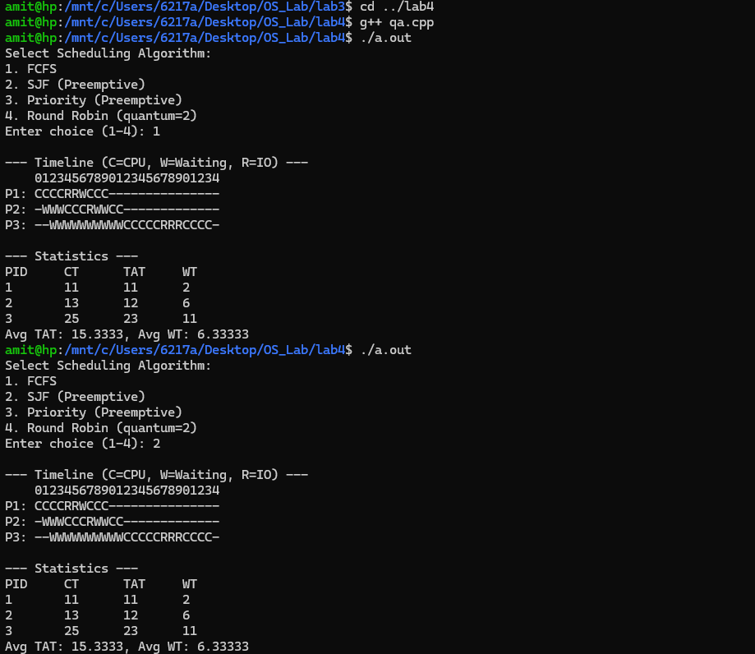

Screenshot: q1.2.png
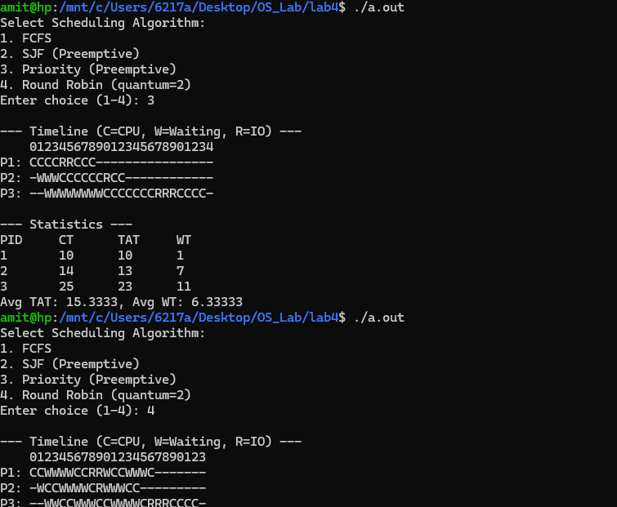

Screenshot: q2.png
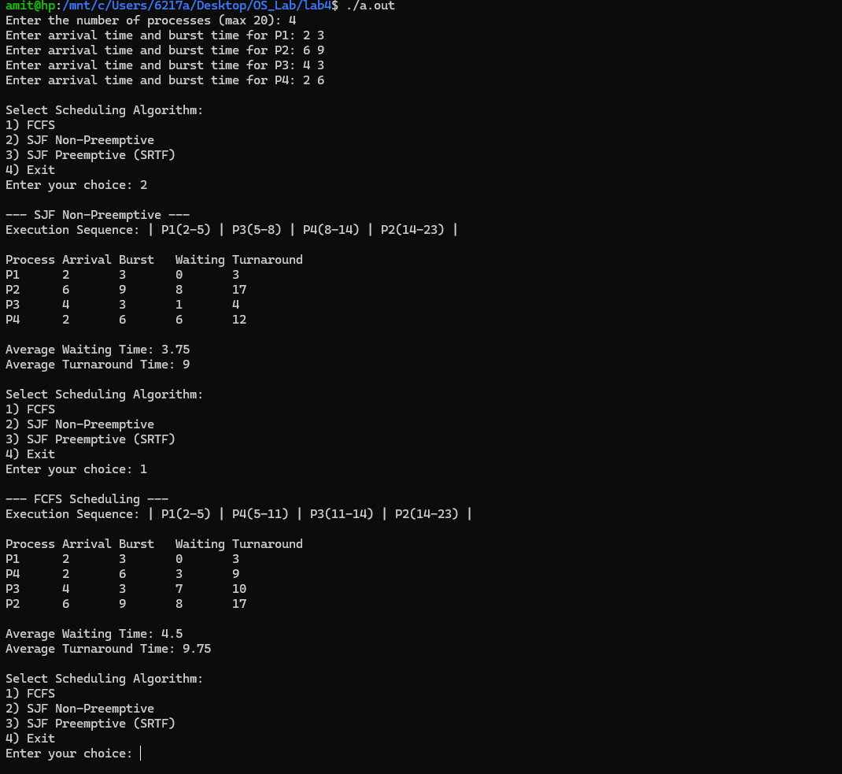

Screenshot: q3.png
