Assignment 5 — Inter-Process Communication Using Pipes
Operating Systems Lab | Amit Kumar

Objective
To create three processes using fork() that communicate via POSIX pipes. Process 1 reads a file and sends text to Process 2, which formats spacing and punctuation. Process 2 forwards the cleaned text to Process 3, which title-cases every word, prints the result, counts words, and sends the count back to Process 1.

Concepts Used
Pipe: A unidirectional, kernel-managed byte-stream channel between related processes. Created using pipe(fd), where fd[0] is the read end and fd[1] is the write end. Data flows FIFO; read() blocks when empty, write() blocks when full. Each process must close the pipe ends it does not use — otherwise the reader never gets EOF and hangs forever.
fork(): Creates a child process that inherits copies of all open file descriptors, including pipe ends. The parent and child share no memory, so pipes are the communication channel. waitpid() is used by the parent to reap children and avoid zombie processes.
Communication Structure: Three pipes form a pipeline — Pipe 1 carries raw text from Process 1 → 2, Pipe 2 carries formatted text from Process 2 → 3, and Pipe 3 carries the word count (as a raw integer) from Process 3 → 1.

Output
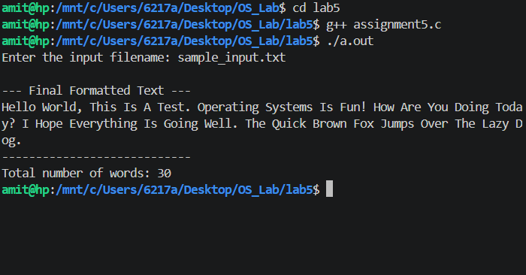
Figure: Compilation and execution of assignment5.c on Linux terminal
The program reads sample_input.txt (which has irregular spacing and mixed case), formats the text, converts each word to title case.

