AKS UNIVERSITY, SATNA (M.P.)
Department of Computer Science / Information Technology

UML DESIGN DOCUMENT
FOR
QR-BASED VISITOR MANAGEMENT SYSTEM
(FastAPI + React.js + PostgreSQL)

Document Type | UML Design Document
Project | QR-Based Visitor Management System v2.0
Prepared By | Amit Kushwaha
Organization | MP Online Private Limited
University | AKS University, Satna (M.P.)
Version | v1.0
Date | April 2026
Total Diagrams | 9 UML Diagrams (All standard types)

# | Diagram Type | Description
1 | Use Case Diagram | Actors, use cases, and system boundary
2 | Class Diagram | ORM models, attributes, methods, and relationships
3 | Sequence Diagram (Registration) | Visitor registration & QR generation message flow
4 | Sequence Diagram (QR Scan) | Check-in and check-out scan flow
5 | Activity Diagram | Forgot password complete workflow
6 | Component Diagram | System architecture components and dependencies
7 | State Diagram | Visit lifecycle state machine
8 | ER Diagram | Database entity relationships and schema
9 | Deployment Diagram | Infrastructure, servers, and external services

1. Introduction

1.1 Purpose
This UML Design Document provides a comprehensive visual representation of the QR-Based Visitor Management System (VMS) v2.0, developed as an internship project at MP Online Private Limited. The document uses nine standard UML diagram types to model the system from different perspectives — behavioral, structural, and architectural.

These diagrams serve as the formal design specification for the system and provide a clear blueprint of how each component, class, actor, and process interacts within the application.

1.2 System Overview
Application | QR-Based Visitor Management System (VMS v2.0)
Backend | Python 3.11 + FastAPI 0.111 + Uvicorn
Frontend | React.js 18 + React Router v6 + Axios
Database | PostgreSQL 15 + SQLAlchemy 2.0 ORM
Auth | JWT (HS256) + bcrypt password hashing
Email | SMTP via Gmail TLS port 587
DB Tables | branches, users, visitors, visits, audit_logs, password_reset_tokens
User Roles | Guard, Admin, Super Admin
Key Features | QR registration, camera photo, SMTP email, live dashboard, forgot password, audit log

2. Use Case Diagram

2.1 Overview
The Use Case Diagram shows all actors interacting with the VMS system and the use cases (features) they can perform. The system boundary (dashed rectangle) separates internal system functions from external actors.

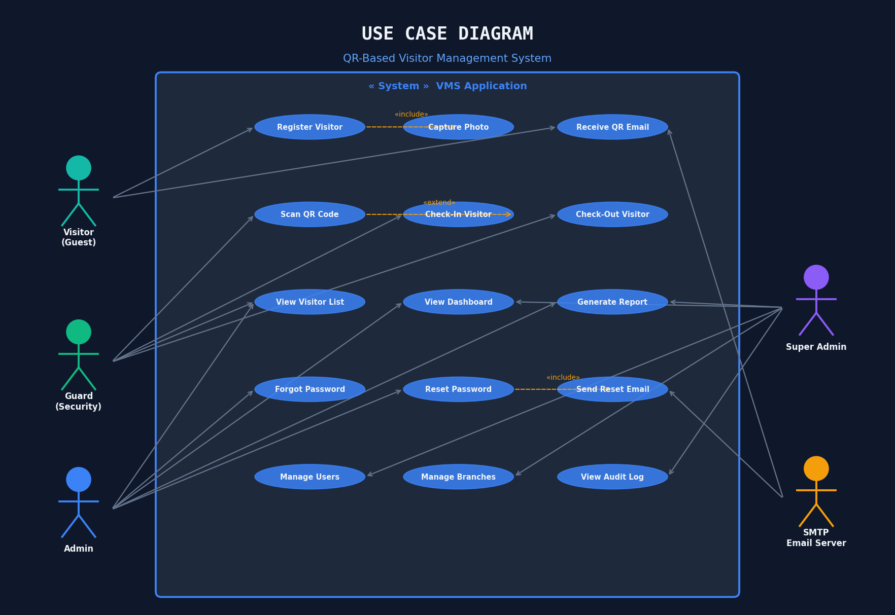
Figure 2.1 — Use Case Diagram: Actors and System Interactions

2.2 Actors
Actor | Description and Primary Use Cases
Visitor (Guest) | Walk-in visitor who registers via web form, receives QR code by email, and presents it at the security desk.
Guard (Security) | Security personnel who scans QR code for check-in/check-out, registers visitors on-behalf, and views visitor list.
Admin | Branch administrator who accesses the real-time dashboard, views reports, and manages visitors for their branch.
Super Admin | System-wide administrator with all admin privileges plus user management, branch management, and audit log access.
SMTP Email Server | External Gmail SMTP server that delivers QR code emails and password reset emails to visitors and users.

2.3 Key Relationships
- «include» — Register Visitor includes Capture Photo (photo is part of registration flow)
- «include» — Forgot Password includes Send Reset Email (email is mandatory part of flow)
- «extend» — Scan QR Code extends to either Check-In or Check-Out based on current visit status
- Inheritance — Super Admin inherits all Admin use cases; Admin inherits all Guard use cases

3. Class Diagram

3.1 Overview
The Class Diagram shows the six SQLAlchemy ORM model classes that map directly to PostgreSQL database tables. Each class shows its attributes (with data types and constraints) and key methods. Relationships between classes show cardinality (1:N associations).

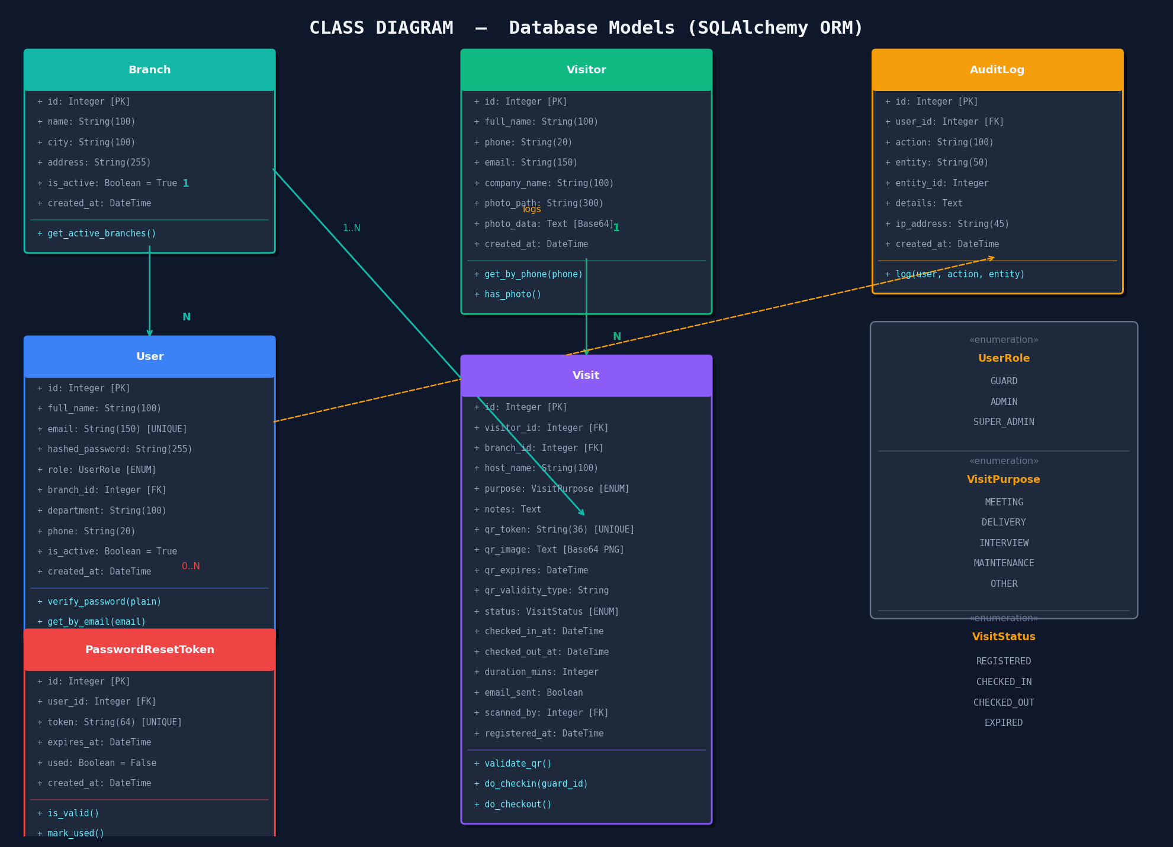
Figure 3.1 — Class Diagram: ORM Models with Attributes, Methods, and Relationships

3.2 Classes and Relationships
Class | DB Table | Key Attributes & Purpose
Branch | branches | id (PK), name, city, address, is_active. Represents an office location.
User | users | id, email (UNIQUE), hashed_password, role (ENUM), branch_id (FK). System users with RBAC.
PasswordResetToken | password_reset_tokens | token (UNIQUE), expires_at, used. Stores time-limited (30 min) tokens for password reset.
Visitor | visitors | phone (lookup key), full_name, photo_data (Base64 TEXT). Unique visitor identities.
Visit | visits | qr_token (UNIQUE UUID), status (ENUM), checked_in/out timestamps, duration_mins. One visit per registration.
AuditLog | audit_logs | action, entity, entity_id, ip_address. Immutable record of all significant system actions.

3.3 Enumerations
Enum | Values
UserRole | GUARD | ADMIN | SUPER_ADMIN
VisitPurpose | MEETING | DELIVERY | INTERVIEW | MAINTENANCE | OTHER
VisitStatus | REGISTERED | CHECKED_IN | CHECKED_OUT | EXPIRED

4. Sequence Diagram — Visitor Registration

4.1 Overview
This sequence diagram shows the complete message flow when a visitor registers through the web form. It covers all interactions from form submission to QR code display and email delivery, across all system layers: Browser, React Frontend, FastAPI Backend, PostgreSQL Database, QR Module, and SMTP Email Server.

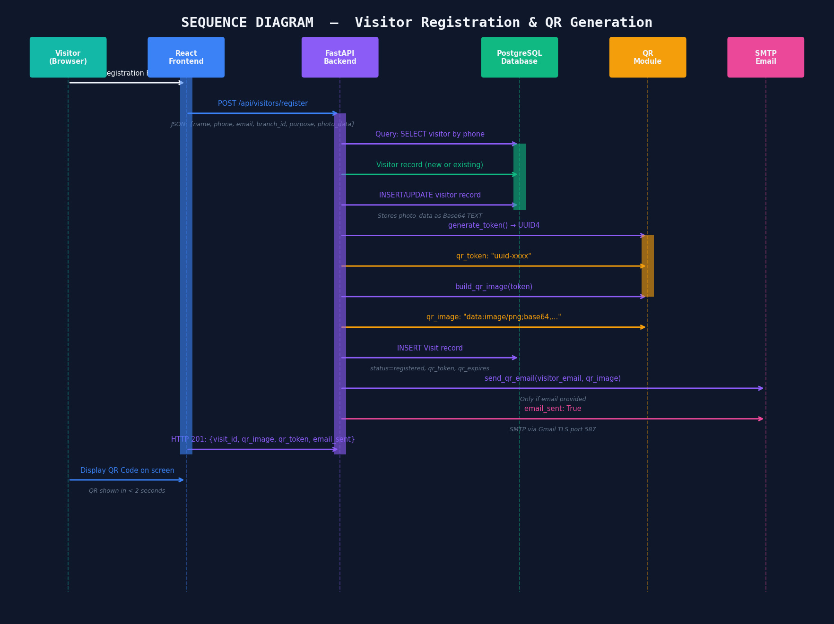
Figure 4.1 — Sequence Diagram: Visitor Registration & QR Code Generation

4.2 Flow Description
Step | Actor | Action
1 | Visitor | Fills registration form with name, phone, email, company, purpose, branch, and optional photo
2 | Frontend | Sends POST /api/visitors/register with JSON payload including optional Base64 photo_data
3 | Backend | Queries DB for existing visitor by phone number (returning visitor detection)
4 | Backend | Creates or updates Visitor record; stores photo_data as Base64 TEXT in PostgreSQL
5 | QR Module | Generates UUID4 token via generate_token(); creates PNG QR image via build_qr_image()
6 | Backend | INSERTs Visit record: status=registered, qr_token, qr_expires, branch_id, purpose
7 | SMTP | Sends HTML email with inline QR image (CID reference) via Gmail SMTP TLS — only if email provided
8 | Frontend | Receives HTTP 201 response with qr_image (Base64 PNG) and displays QR on screen in < 2 sec

5. Sequence Diagram — QR Code Scan

5.1 Overview
This sequence diagram shows the smart QR scan flow executed when a security guard scans a visitor's QR code. The system auto-detects whether to perform a check-in (first scan) or check-out (second scan) based on the current visit status. Two ALT frames show the branching logic.

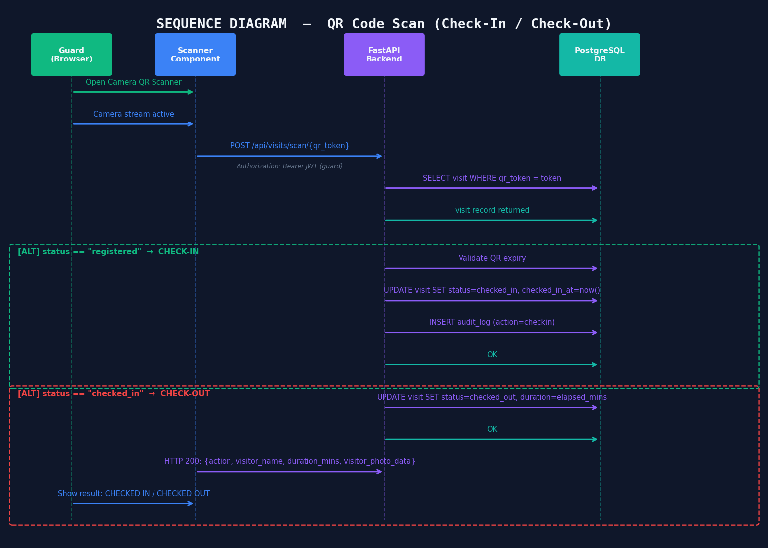
Figure 5.1 — Sequence Diagram: QR Scan — Check-In & Check-Out

5.2 Smart Scan Logic
Condition | Action Taken | Response
status == registered AND qr_expires > now() | Update status to checked_in, record checked_in_at timestamp | HTTP 200: action=checked_in, visitor name and photo
status == checked_in | Update status to checked_out, calculate duration_mins | HTTP 200: action=checked_out, duration_mins shown
status == registered AND qr_expires < now() | No update — QR rejected | HTTP 400: QR code has expired
status == checked_out OR expired | No update — visit already closed | HTTP 400: Visit already completed
Token not found in DB | No action | HTTP 404: Visit not found

6. Activity Diagram — Forgot Password

6.1 Overview
The Activity Diagram models the complete workflow of the forgot password feature, showing every decision point, branch, and action from the moment the user requests a reset link to the final password change and redirect.

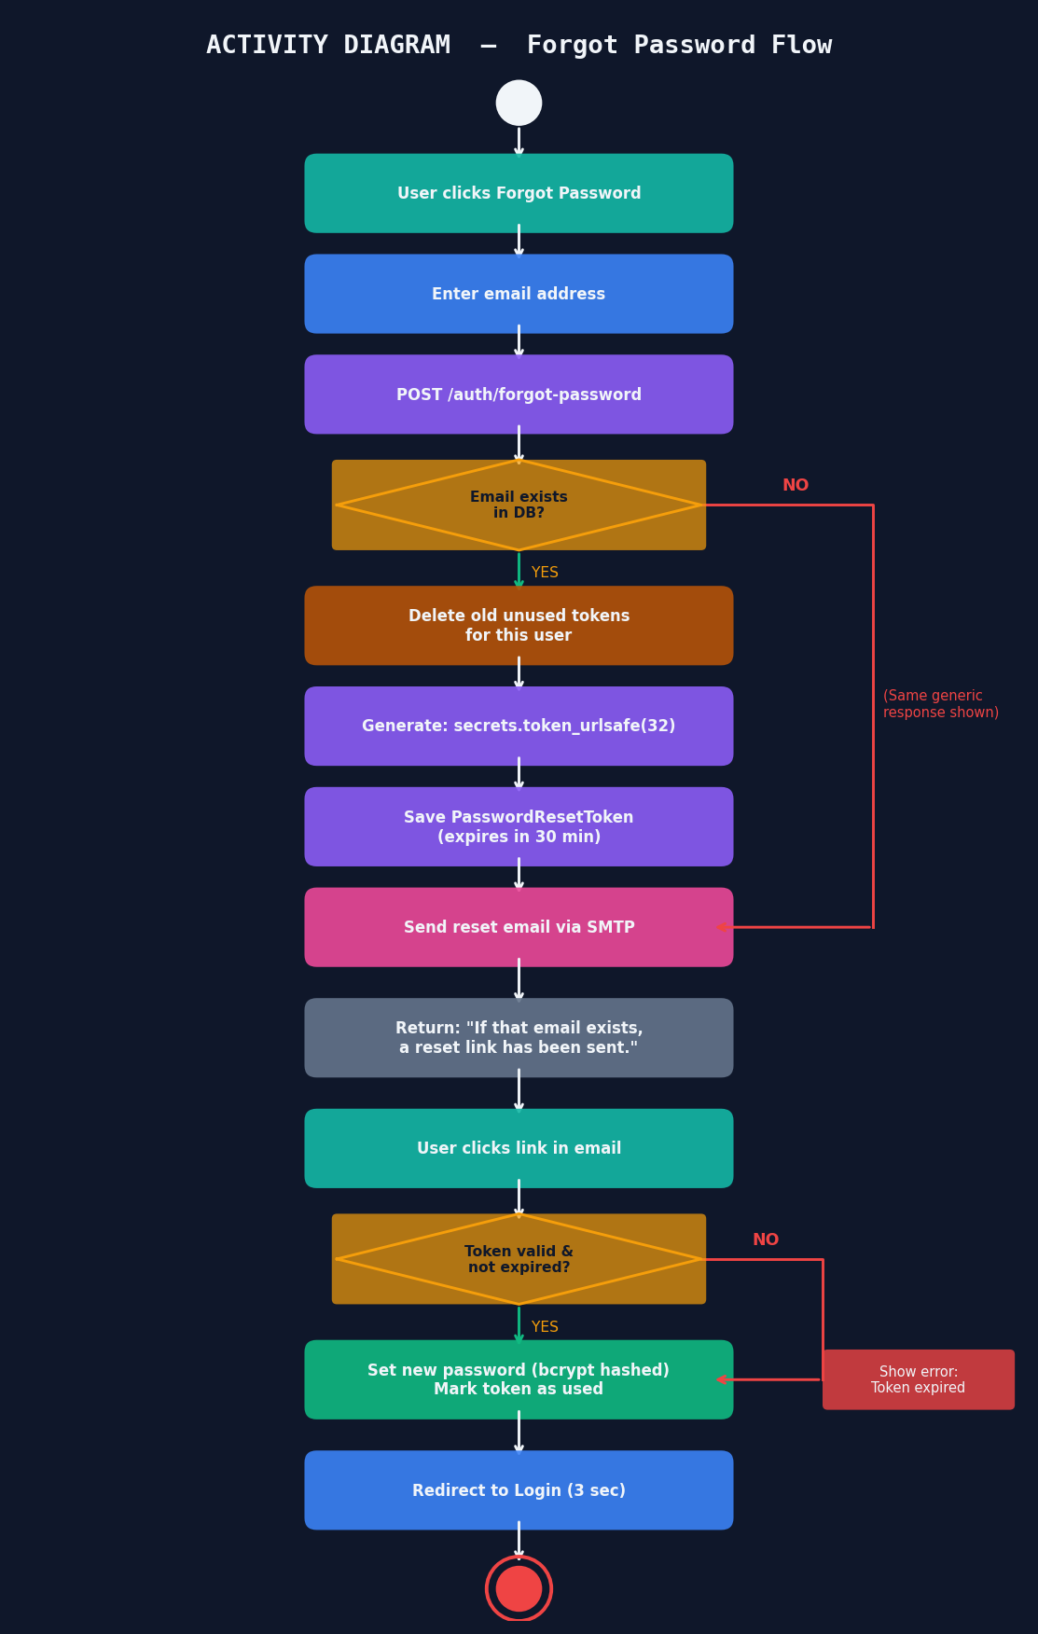
Figure 6.1 — Activity Diagram: Forgot Password Workflow

6.2 Activity Flow
# | Activity | Details
1 | Request Reset | User navigates to /forgot-password and submits their email address
2 | Email Check | [Decision] Does the email exist in the database as an active user?
3a | Email Found | [YES] Delete any old unused tokens, generate secrets.token_urlsafe(32), save with 30-min expiry, send SMTP email
3b | Email Not Found | [NO] Return same success message (prevents email enumeration attack)
4 | Click Link | User receives email and clicks the reset link containing the token in the URL query string
5 | Token Check | [Decision] Is the token valid (exists in DB, not used, not expired)?
6a | Token Valid | [YES] Update hashed_password with new bcrypt hash, mark token.used=True
6b | Token Invalid | [NO] Show error: Token expired or already used. Redirect to /forgot-password
7 | Redirect | Show success message; auto-redirect to /login page after 3 seconds

7. Component Diagram

7.1 Overview
The Component Diagram shows all major software components of the VMS, their internal structure, and how they communicate. It covers the Presentation Layer (React.js), Application Layer (FastAPI), Data Layer (PostgreSQL), and External Services (SMTP).

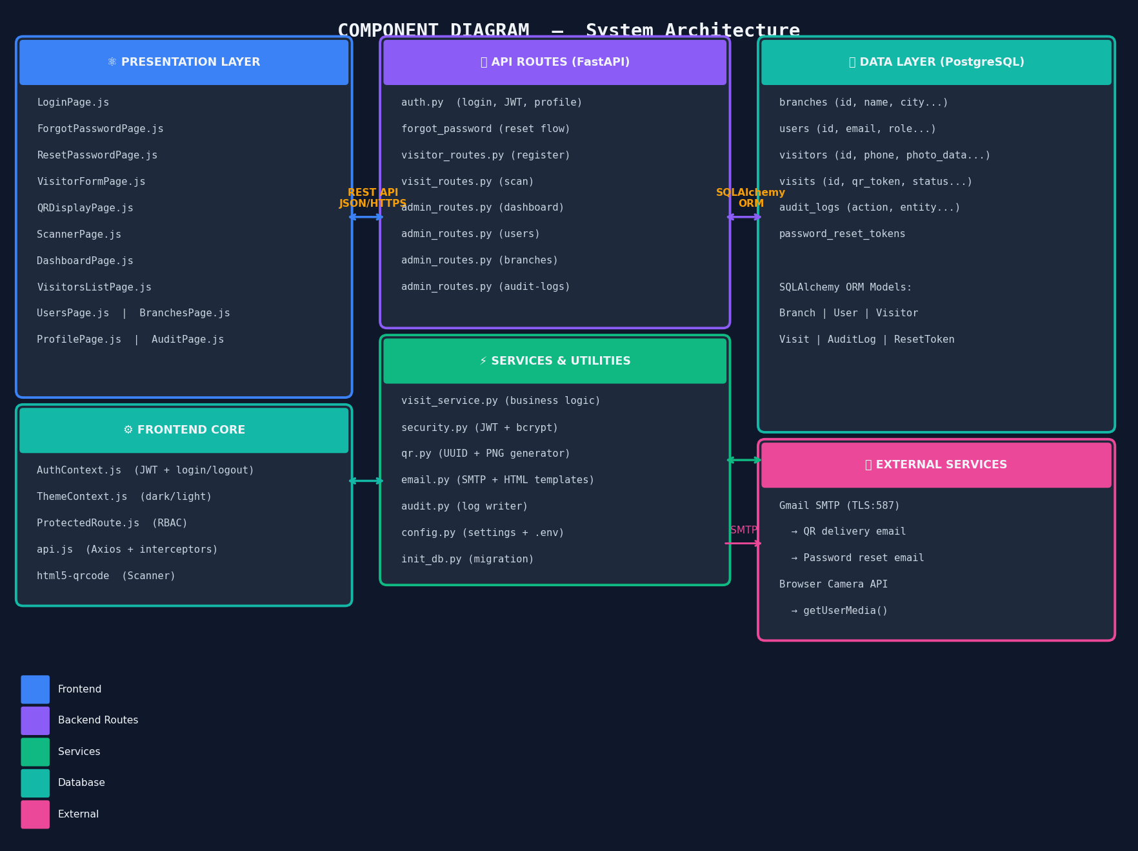
Figure 7.1 — Component Diagram: System Architecture Components

7.2 Component Descriptions
Component | Responsibility
Presentation Layer | 12 React.js pages with role-based routing. AuthContext manages JWT token. ThemeContext handles dark/light mode. html5-qrcode handles camera scanning.
Frontend Core | AuthContext (login/logout/JWT), ThemeContext (dark/light), ProtectedRoute (RBAC guard), Axios with request+response interceptors, api.js abstraction layer.
API Routes | FastAPI route modules: auth.py (JWT auth + forgot password), visitor_routes.py (registration), visit_routes.py (scan), admin_routes.py (dashboard + CRUD).
Services & Utils | visit_service.py (business logic), security.py (JWT+bcrypt), qr.py (UUID+PNG gen), email.py (SMTP templates), audit.py (log writer), config.py (env settings).
Data Layer | PostgreSQL 15 with 6 tables, 3 ENUMs, UNIQUE indexes on qr_token/token/email. SQLAlchemy ORM models. Auto-migration via init_db.py.
External Services | Gmail SMTP (TLS:587) for QR delivery and password reset emails. Browser getUserMedia() API for camera capture.

8. State Diagram — Visit Lifecycle

8.1 Overview
The State Diagram models the lifecycle of a Visit record from creation to completion. Each state represents a distinct phase of the visit, and transitions show the events and guard conditions that trigger state changes.

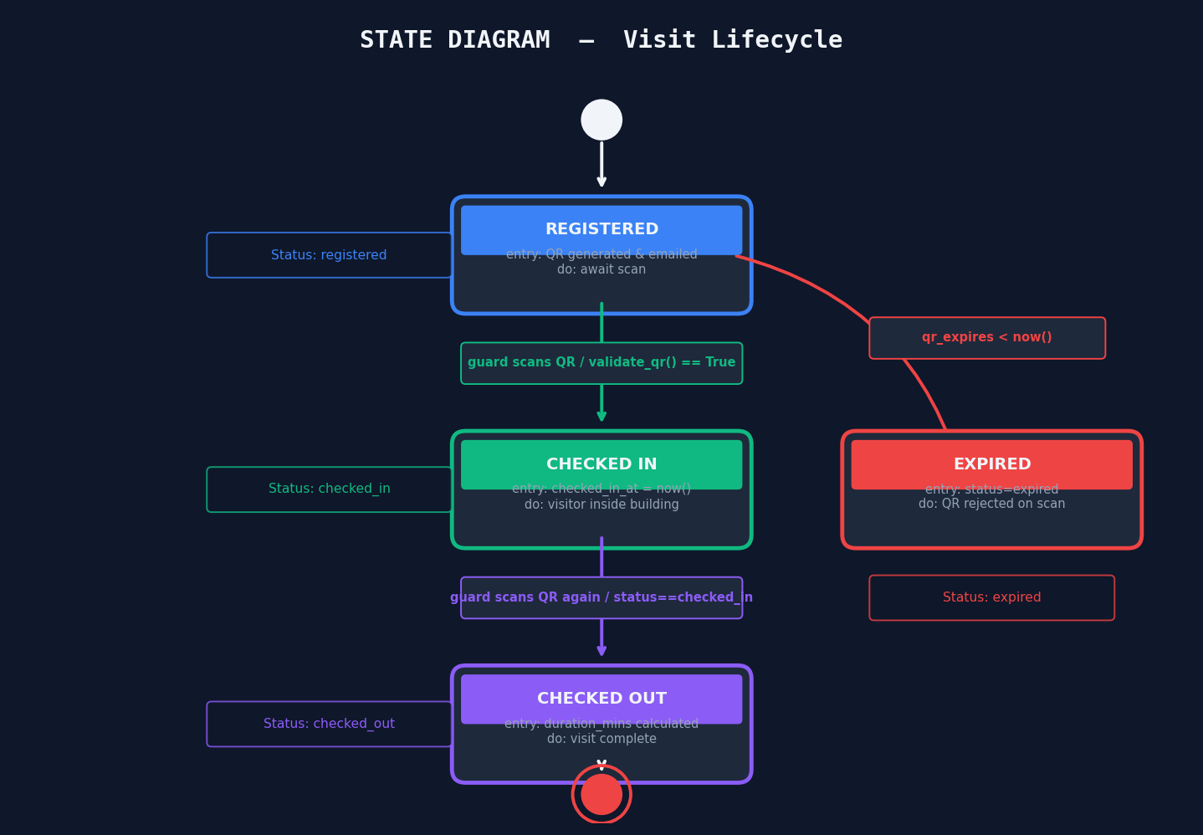
Figure 8.1 — State Diagram: Visit Status Lifecycle

8.2 States and Transitions
State | Entry Condition | Description
REGISTERED | On successful visitor registration | QR generated and emailed. Visit awaiting check-in scan. QR may expire if not used in time.
CHECKED_IN | Guard scans valid QR (status=registered, not expired) | Visitor is physically inside the building. checked_in_at timestamp recorded. Dashboard shows visitor in 'Currently Inside'.
CHECKED_OUT | Guard scans same QR again (status=checked_in) | Visit complete. duration_mins calculated. Visitor has left the building. Final state — no further transitions.
EXPIRED | qr_expires timestamp < now() when scanned | QR code was not used before expiry. Scan attempt rejected with HTTP 400. Visit closed without check-in.

9. Entity Relationship Diagram

9.1 Overview
The ER Diagram shows all six database entities (tables), their attributes with data types and constraints, and the relationships between them with cardinality notation. This is the foundation of the entire data model.

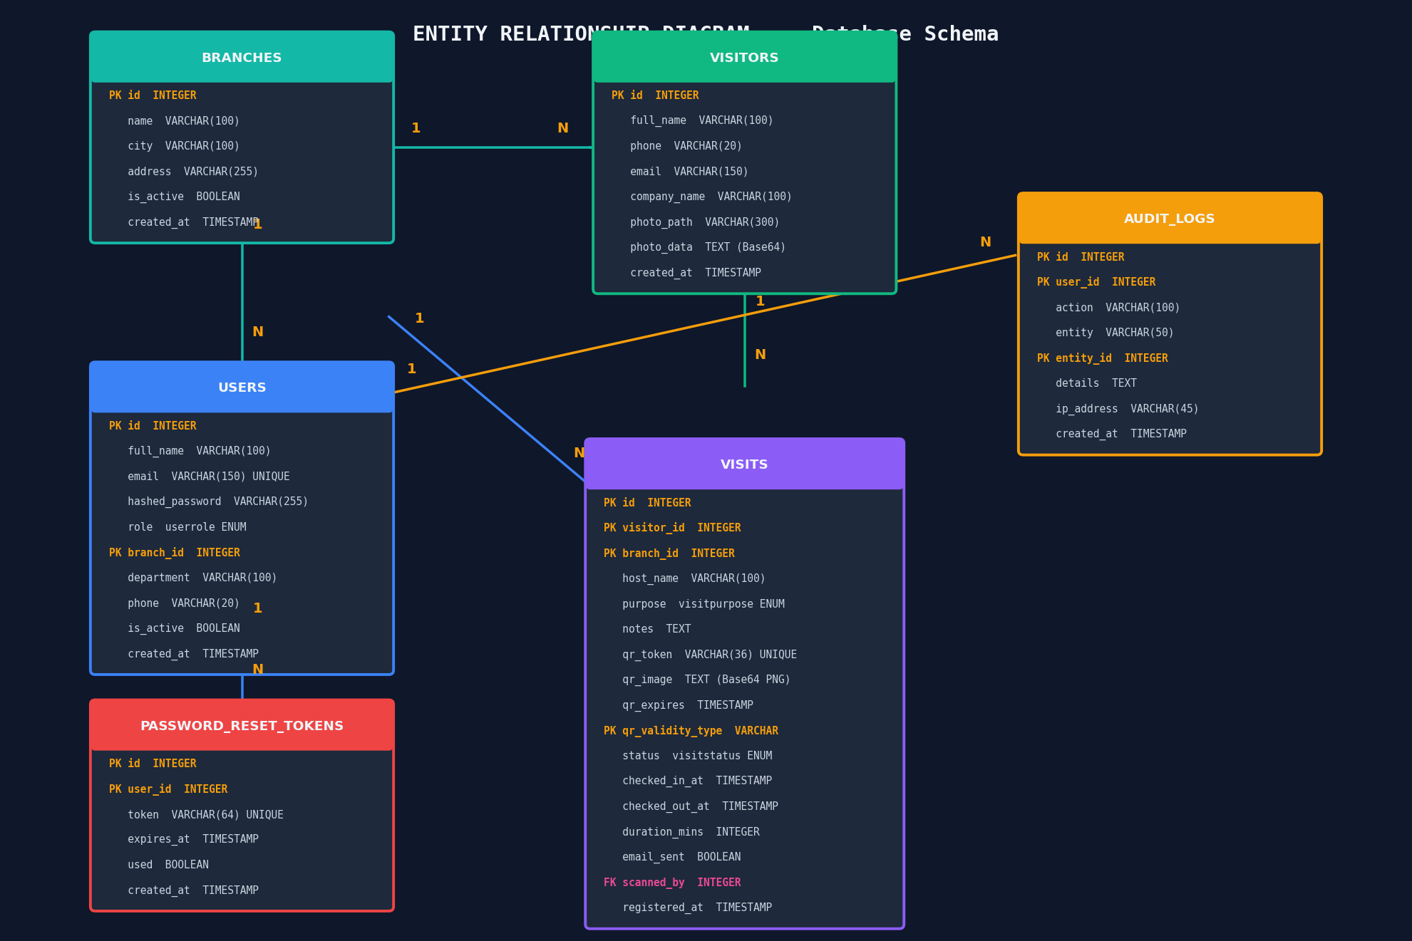
Figure 9.1 — ER Diagram: Database Schema and Relationships

9.2 Entity Descriptions
Entity (Table) | PK / FK | Key Columns & Notes
branches | PK: id | name, city, address, is_active, created_at. Root entity — all users and visits belong to a branch.
users | PK: id  FK: branch_id | email (UNIQUE), hashed_password (bcrypt), role (ENUM: guard/admin/super_admin), department, phone, is_active.
password_reset_tokens | PK: id  FK: user_id | token VARCHAR(64) UNIQUE, expires_at, used BOOLEAN. One-to-many with User (user can request multiple resets).
visitors | PK: id | phone (lookup key), full_name, email, company_name, photo_path, photo_data (TEXT — Base64 image stored in DB).
visits | PK: id  FK: visitor_id  FK: branch_id  FK: scanned_by | qr_token VARCHAR(36) UNIQUE, qr_image TEXT, qr_expires, qr_validity_type, status ENUM, checked_in/out_at, duration_mins, email_sent.
audit_logs | PK: id  FK: user_id | action VARCHAR(100), entity, entity_id, details TEXT, ip_address, created_at. Immutable — never updated or deleted.

9.3 Relationships Summary
From | Cardinality | To | Description
Branch | 1 : N | User | One branch has many users assigned to it
Branch | 1 : N | Visit | One branch has many visit records
Visitor | 1 : N | Visit | One visitor can have many visit instances (returns)
User | 1 : N | Visit (scanned_by) | One guard can scan many visits
User | 1 : N | AuditLog | One user can have many audit log entries
User | 1 : N | PasswordResetToken | One user can request multiple password resets

10. Deployment Diagram

10.1 Overview
The Deployment Diagram shows the physical deployment of the VMS system across nodes (machines/environments), including the client device, application server, database server, and external services. It shows what software runs on each node and how nodes communicate.

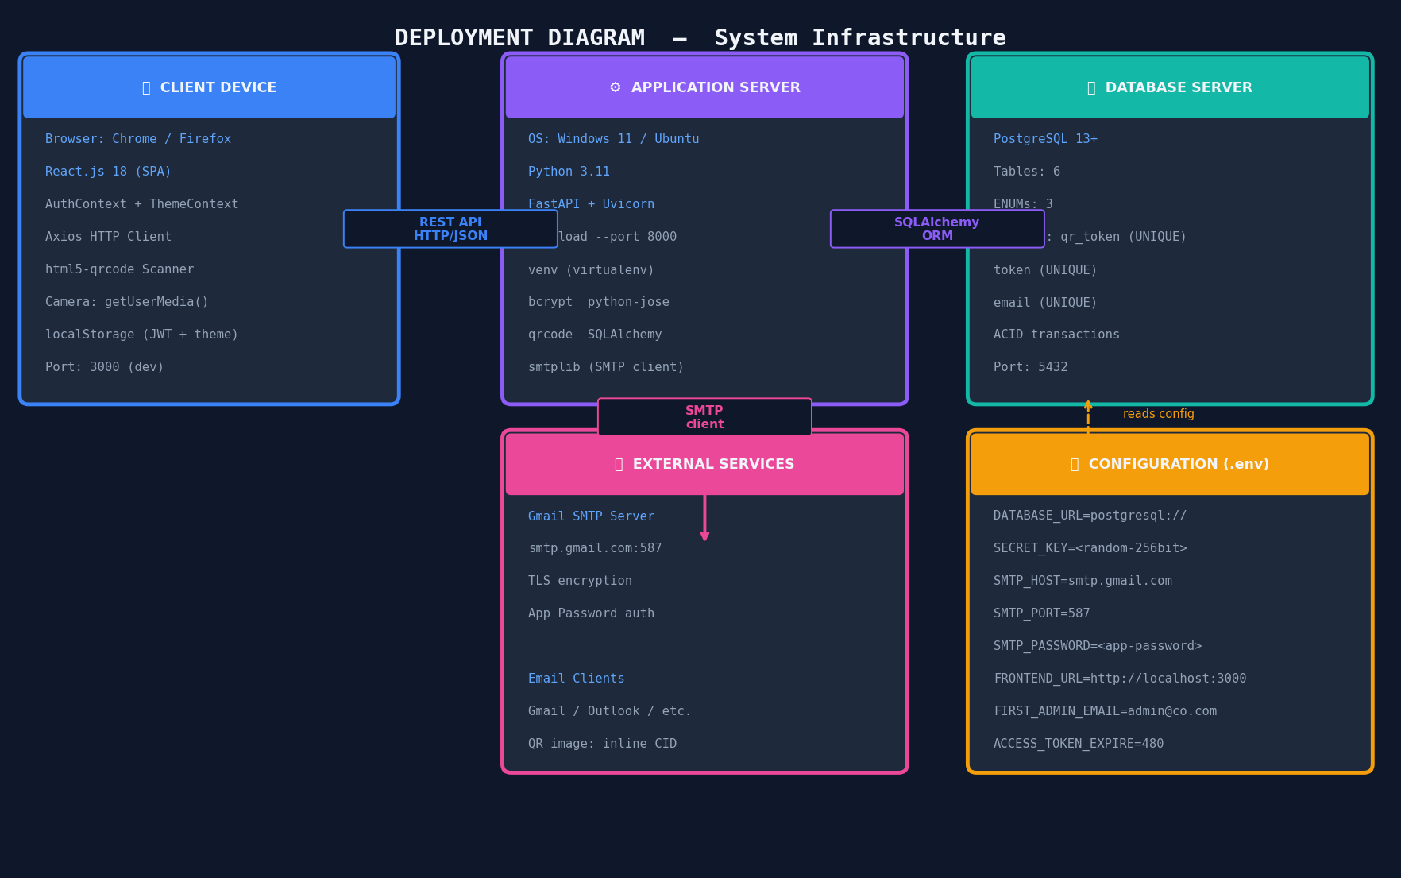
Figure 10.1 — Deployment Diagram: Infrastructure and Node Configuration

10.2 Node Descriptions
Node | Deployed Artifacts & Configuration
Client Device | Any modern browser (Chrome 124+, Firefox, Edge). Hosts React.js SPA served from port 3000. Uses html5-qrcode for camera-based scanning. JWT stored in localStorage.
Application Server | Windows 11 / Ubuntu 24. Python 3.11 + FastAPI + Uvicorn (port 8000). Virtual environment (venv). All Python packages: bcrypt, python-jose, qrcode, SQLAlchemy, smtplib.
Database Server | PostgreSQL 15 running on port 5432. 6 tables, 3 ENUM types, UNIQUE indexes. Accessed via SQLAlchemy ORM using psycopg2-binary driver. Stores photo_data as TEXT.
External: Gmail SMTP | smtp.gmail.com on port 587 with TLS encryption. Authenticated with Gmail App Password (16-char). Delivers QR code HTML emails and password reset links.
Configuration (.env) | DATABASE_URL, SECRET_KEY, SMTP credentials, FRONTEND_URL, FIRST_ADMIN_EMAIL/PASSWORD, ACCESS_TOKEN_EXPIRE_MINUTES, QR_EXPIRY_HOURS.

10.3 Communication Protocols
Connection | Protocol | Details
Browser → FastAPI | HTTP REST / JSON | Axios sends requests to http://localhost:8000/api with Authorization: Bearer JWT header
FastAPI → PostgreSQL | SQLAlchemy ORM | psycopg2-binary driver over TCP port 5432. Connection string from DATABASE_URL env var.
FastAPI → Gmail SMTP | SMTP + TLS | Python smtplib connects to smtp.gmail.com:587, STARTTLS, login with App Password, sends HTML email
Browser → Camera | WebRTC / MediaAPI | navigator.mediaDevices.getUserMedia() streams video for QR scanning and photo capture

11. Summary

11.1 Diagrams Overview
# | Diagram | UML Type | Key Insight
1 | Use Case | Behavioral | 5 actors, 15 use cases, include/extend relationships
2 | Class | Structural | 6 ORM model classes with 3 ENUMs and 1:N relationships
3 | Sequence (Registration) | Behavioral | 14-step message flow across 6 system layers
4 | Sequence (QR Scan) | Behavioral | Smart scan with ALT frames for check-in vs check-out
5 | Activity (Forgot PW) | Behavioral | 10-step workflow with 2 decision diamonds and security guards
6 | Component | Structural | 5 component groups with 28 named sub-components
7 | State (Visit) | Behavioral | 4 states with guard conditions on all 5 transitions
8 | ER Diagram | Structural | 6 entities, 6 relationships, PK/FK/UNIQUE constraints shown
9 | Deployment | Physical | 4 nodes, 4 communication protocols, .env config details

11.2 Design Principles Applied
- Separation of Concerns — Frontend (React), Backend (FastAPI), and Database (PostgreSQL) are fully decoupled layers communicating via REST API.
- Role-Based Access Control — Three-tier RBAC (Guard < Admin < Super Admin) enforced at both frontend routing and backend dependency injection levels.
- Stateless Authentication — JWT tokens enable horizontal scaling without server-side session storage.
- Database Normalization — All 6 tables are in 3NF, eliminating data redundancy while maintaining referential integrity via foreign keys.
- Security by Design — bcrypt hashing (cost 12), JWT expiry, SMTP App Passwords, SQL injection prevention via ORM, and enumeration-safe API responses.
- Event Sourcing — The audit_logs table provides an immutable record of all significant system events for compliance and debugging.

— End of UML Design Document —
QR-Based VMS | UML Document v1.0 | Amit Kushwaha | AKS University | MP Online Private Limited | April 2026

