A

**REPORT**

**ON**

**INDUSTRIAL TRAINNING ON “e-Banking”**

**Taken at**

**“Technoglobe, Jaipur”**

**Submitted in partial fulfillment for the award of Degree of Integrated MCA of Shekhawati Institute of Management, Sikar “2 January 2017 to 20th April2017 ”**

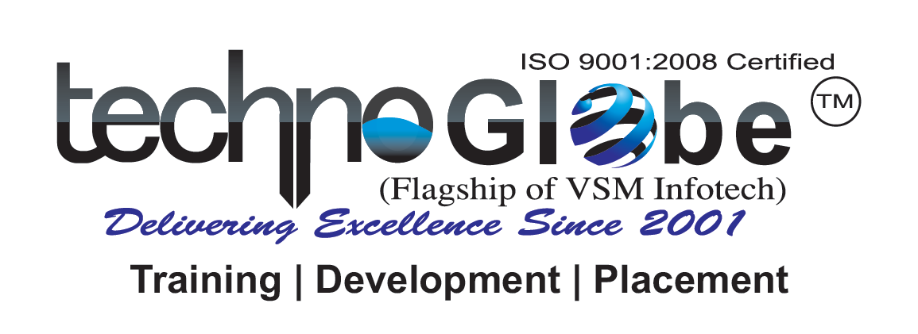

**Submitted to: Submitted by:**

**COMPANY PROFILE**

We at **Technoglobe** have an in-depth understanding and significant insights into the working of various industries, which we have consolidated into a leverage able knowledge base. Our domain expertise in these ' verticals' enables us to provide innovative, customized and flexible technology solutions knowledge to the students that address the entire range of an industry's business needs. It will help students to be global and extra ordinary professionals. Our business knowledge is complemented by a wide spectrum of information technology skills. Our technological proficiency and service skills in these 'horizontals' enables us to create IT professionals.

Our 'capability framework', enables us to devise the most technologically advanced and cost-effective solutions in every business and technology domain. The same we deliver to our students which make them potential employees for MNCs.

**TO WHOM SO EVER IT MAY CONCERN**

This is here by to certify that Vikas Gadhwal, MCA 3rd Year of Shekhawati Institute of Management, Sikar has successfully completed his Industrial Training at **Technoglobe, Jaipur**, on “E-Banking” Training Period: 2 January2017 to 20nd April 2017.

Dr. Cherry Jain

(Center Manager)