Tumor-Grounded Reliability Learning for Robust Brain Tumor MRI Classification
Ankit Mishra, Amit Kumar, Saurabh Kumar, Naman, and Mayank Garg
Department of Computer Science and Engineering, Netaji Subhas University of Technology, New Delhi, India
Abstract—Deep learning has shown promising results in brain tumor classification using MRI images. However, good classification accuracy does not always mean that the model is focusing on the tumor region or that its predictions will remain reliable on images from another dataset. In this work, we propose a Tumor-Grounded Reliability Learning (TGRL) approach that combines tumor segmentation with classification. The predicted tumor region is used to create a tumor-focused representation, while a Tumor-Grounded Consistency (TGC) loss encourages similar predictions from the full MRI and the tumor region. We also use tumor removal as a counterfactual test to observe how the prediction changes when the detected tumor is removed. Calibration and selective prediction are considered to provide a better measure of model confidence. The aim is to develop a classification approach that is not only accurate, but also more closely connected to the tumor region and more reliable when tested on different data.
Index Terms—Brain tumor, magnetic resonance imaging, deep learning, tumor segmentation, tumor classification, reliability learning, uncertainty estimation, explainable artificial intelligence, counterfactual analysis.

I. INTRODUCTION
Brain tumors are difficult to diagnose because their appearance can vary with tumor type, size, location, and imaging conditions. MRI is widely used for brain tumor analysis, and deep learning has become a useful approach for automating classification and segmentation tasks.
Several studies have explored deep learning for this problem. Sultan et al. used a deep neural network for multiclass brain tumor classification [1]. Tiwary et al. proposed an EfficientNet-based U-Net for tumor segmentation [3]. Almufareh et al. investigated YOLO-based tumor detection and segmentation [2], while Hassan and Boulila combined fuzzy thresholding with deep learning for tumor detection and classification [4].
These methods show that deep learning can achieve strong results on brain tumor datasets. However, classification accuracy alone does not tell us whether the model is actually using the tumor region to make its decision. This can also become a problem when the model is tested on images from a different dataset or imaging setup.
In this work, we address this issue by connecting tumor segmentation with classification. The predicted tumor mask is used to create a tumor-focused image, and the model is trained to maintain consistent predictions between the original MRI and this tumor-focused representation. We further remove the predicted tumor region and observe the change in the model’s prediction as a simple counterfactual test.
The main contributions of this work are:
- A segmentation-guided approach for using the predicted tumor region during classification.
- A Tumor-Grounded Consistency (TGC) loss for maintaining similar predictions between the full MRI and tumor-focused representation.
- A tumor-removal counterfactual test to examine whether the prediction depends on the detected tumor region.
- A reliability-oriented evaluation that considers model confidence and performance on separate data.

II. RELATED WORK

A. Brain Tumor Classification
Sultan et al. proposed a deep neural network for multiclass brain tumor classification using MRI images [1]. Their work demonstrated that convolutional feature learning can effectively distinguish different tumor categories.
The study provides an important foundation for automated classification. However, direct image classification does not explicitly require the model to base its decision on the tumor region.

B. Brain Tumor Segmentation
Tiwary et al. proposed an EfficientNet-enhanced U-Net architecture for brain tumor segmentation [3]. The combination of an efficient encoder and U-Net decoder allows the network to learn pixel-level tumor representations.
Segmentation is particularly relevant to the proposed work because a tumor mask provides explicit spatial information that can subsequently be used for classification.

C. YOLO-Based Detection and Segmentation
Almufareh et al. investigated YOLOv5 and YOLOv7 for brain tumor detection and segmentation [2]. Their work demonstrates that object-detection architectures can provide effective tumor localization while supporting segmentation.
In this work, localization is considered as a supporting concept rather than the main source of novelty.

D. Fuzzy Thresholding and Deep Learning
Hassan and Boulila investigated fuzzy thresholding combined with deep learning for brain tumor detection and classification [4]. Their approach demonstrates the potential of combining image-processing techniques with deep learning.
The present work instead focuses on learning tumor-grounded representations through segmentation and consistency between different input representations.

E. Research Gap
The reviewed approaches provide useful solutions for classification, segmentation, localization, and tumor extraction. However, an important question remains: whether the classification decision is actually supported by tumor-related evidence. Table I summarises the four reference works, and Fig. 1 collects the per-class results they report. Glioma is the lowest-scoring class in [1], [2] and [3], which motivates checking whether predictions on this class rest on tumor evidence.

TABLE I SUMMARY OF THE REFERENCE WORKS AND THEIR RELATION TO THE PROPOSED FRAMEWORK
Ref. | Task and method | Data | Headline result reported | Relation to TGRL
[1] Sultan et al. | Multiclass classification; custom 16-layer CNN | Figshare CE-MRI (3,064 slices, 233 patients); REMBRANDT glioma grades (516 slices, 73 patients) | 96.13% accuracy (tumor type); 98.7% (glioma grade) | Image-level classification with no explicit link to the tumor region
[2] Almufareh et al. | Detection and segmentation; YOLOv5 / YOLOv7 | Figshare CE-MRI (3,064 slices) | mAP@0.5 of 0.947 (YOLOv5) and 0.940 (YOLOv7), box | Localization, used here as a supporting concept
[3] Tiwary et al. | Segmentation; EfficientNet-B6 encoder with U-Net decoder | Figshare CE-MRI (3,064 slices) | Accuracy 0.9925; Dice 96.4 / 83.2 / 94.4% (men. / gli. / pit.) | Basis for the shared encoder and the tumor map M
[4] Hassan and Boulila | Tumor extraction by fuzzy thresholding, then 4-class CNN | Three public Kaggle MRI datasets (more than 23,000 images) | 98% accuracy; Dice 97.97% | Extraction is decoupled from the classifier’s decision

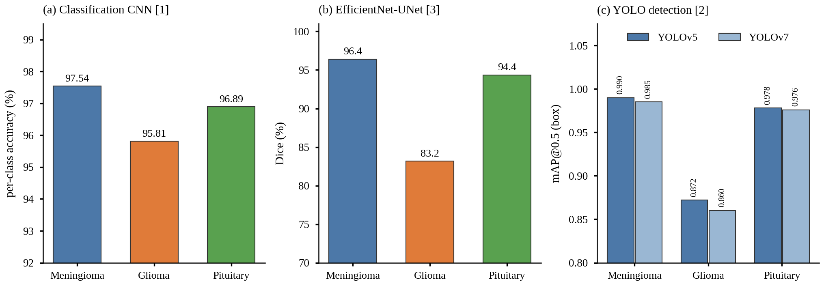
Fig. 1. Per-class results as reported in the reference works: (a) per-class accuracy of the 16-layer CNN of Sultan et al. [1]; (b) per-class Dice of the EfficientNet-B6 U-Net of Tiwary et al. [3]; (c) box mAP@0.5 of YOLOv5 and YOLOv7 of Almufareh et al. [2]. All three use the Figshare CE-MRI dataset, but the metrics differ and the bars are not directly comparable across panels.

The proposed work therefore focuses on two related questions:
- Does the classification remain consistent when the model is given a tumor-focused representation?
- Does the classification confidence change when the predicted tumor region is removed?
These questions form the basis of the proposed Tumor-Grounded Reliability Learning framework.

III. PROPOSED FRAMEWORK

A. Overview
The proposed Tumor-Grounded Reliability Learning (TGRL) framework connects tumor segmentation and classification. The framework consists of four main stages (Fig. 2):
- MRI preprocessing and feature extraction;
- tumor segmentation;
- tumor-grounded classification;
- reliability and counterfactual analysis.
The main idea is to use the predicted tumor region not only as a segmentation output, but also as an explicit source of information for classification.

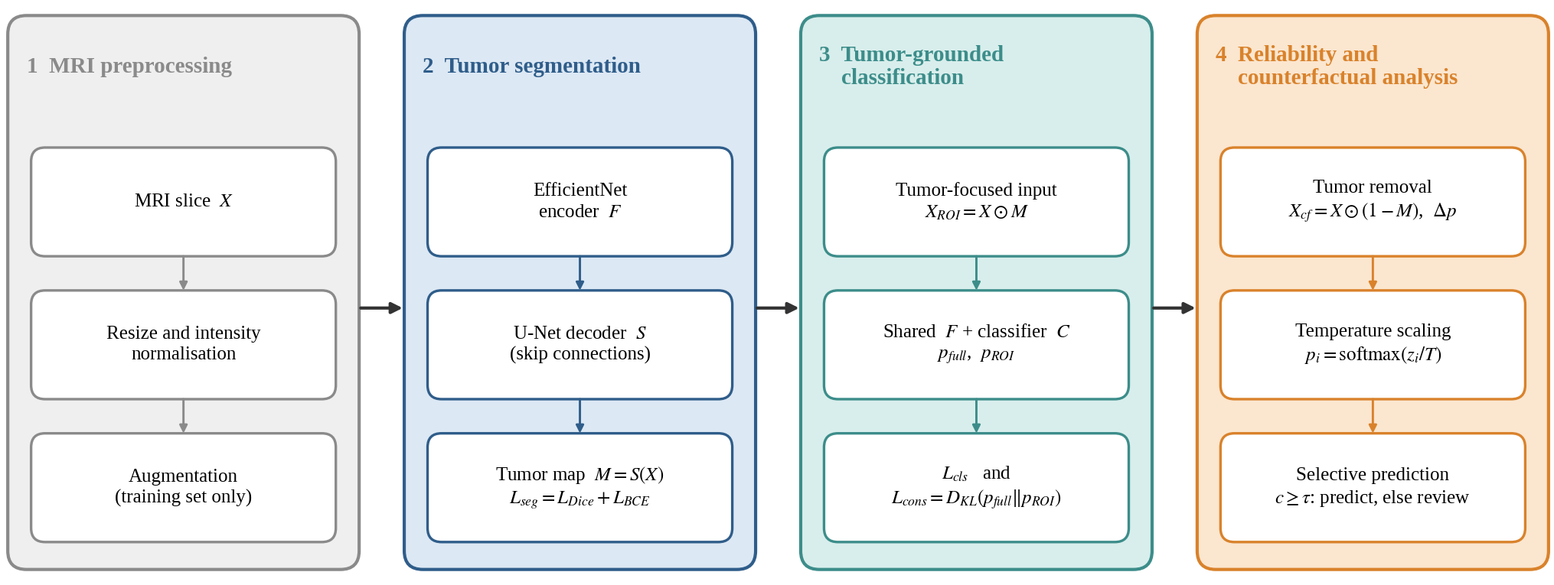
Fig. 2. Overview of the Tumor-Grounded Reliability Learning (TGRL) framework. The predicted tumor map M is reused as input to classification, as a consistency target, and as the basis of the counterfactual tumor-removal test; calibrated confidence then drives selective prediction.

B. MRI Preprocessing
MRI images are standardized before being provided to the neural network. The preprocessing stage can include image resizing and intensity normalization. Data augmentation is applied only to the training set.
The same preprocessing procedure is maintained across experiments so that the comparison between models remains consistent.

C. Feature Extraction
An EfficientNet-based encoder is considered as the primary feature extractor. The encoder learns hierarchical representations from the MRI input.
The extracted features are provided to the segmentation and classification components. This allows the segmentation task to provide spatial information that can subsequently support classification. Fig. 3 shows this shared-encoder design; the encoder–decoder layout follows the EfficientNet-enhanced U-Net of [3].

D. Tumor Segmentation
The segmentation component predicts a tumor probability map from the encoded MRI features.
Let X represent the MRI input and M represent the predicted tumor probability map. The segmentation function is represented as
$M = S(X)$ (1)
A tumor mask can then be obtained from the probability map using an appropriate threshold.
The segmentation loss is represented as
$L_{seg} = L_{Dice} + L_{BCE}$ (2)
where L_{Dice} represents Dice loss and L_{BCE} represents binary cross-entropy loss.

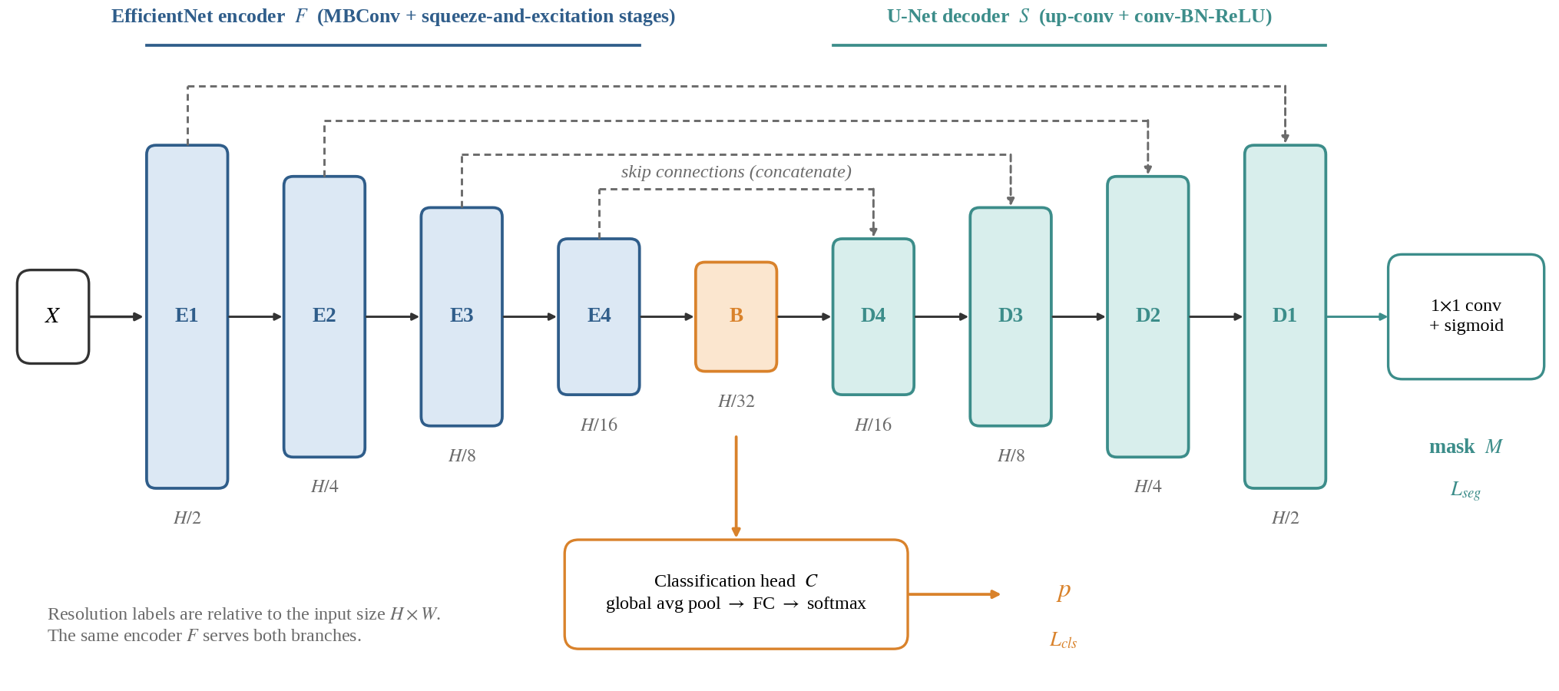
Fig. 3. Shared-encoder architecture of TGRL. An EfficientNet encoder F feeds a U-Net decoder S that produces the tumor map M (trained with L_{seg}) and, from the bottleneck, a classification head C that produces class probabilities p (trained with L_{cls}). Dashed lines are skip connections. Layout adapted from the EfficientNet-UNet design of [3].

E. Tumor-Focused Representation
The predicted tumor region is used to construct a tumor-focused representation of the MRI. This is expressed as
$X_{ROI} = X ⊙ M$ (3)
where ⊙ denotes element-wise multiplication. The resulting representation emphasizes the region identified as tumor while reducing the influence of unrelated image regions.
The tumor-focused representation does not completely replace the original MRI. Instead, it provides another representation that allows the model to evaluate whether its classification remains consistent when attention is focused on the predicted tumor.

F. Classification
The classification network produces a probability distribution over the tumor classes. The prediction from the complete MRI is represented as
$p_{full} = C(F(X))$ (4)
where F represents feature extraction and C represents the classification function. The prediction from the tumor-focused representation is
$p_{ROI} = C(F(X_{ROI}))$ (5)
The conventional classification objective is represented using cross-entropy:
$L_{cls} = −\sum_{k=1}^{K}{y_{k} log(p_{k})}$ (6)
where K is the number of classes, y_{k} is the ground-truth class indicator, and p_{k} is the predicted probability for class k.
Algorithm 1. One TGRL training iteration and inference rule
Input: batch (X, y, G), where G is the ground-truth tumor mask; weights λ_{seg}, λ_{cons}, λ_{cf}
1 M ← S(X) using the shared encoder F
2 L_{seg} ← L_{Dice}(M, G) + L_{BCE}(M, G)
3 X_{ROI} ← X ⊙ M; X_{cf} ← X ⊙ (1 − M)
4 p_{full} ← C(F(X)); p_{ROI} ← C(F(X_{ROI})); p_{cf} ← C(F(X_{cf}))
5 L_{cls} ← CrossEntropy(p_{full}, y); L_{cons} ← D_{KL}(p_{full} ∥ p_{ROI})
6 Δp ← p_{original} − p_{cf}; L_{cf} ← counterfactual term of Eq. (11)
7 L ← L_{cls} + λ_{seg}L_{seg} + λ_{cons}L_{cons} + λ_{cf}L_{cf}; update parameters
8 After training: fit T on validation logits and choose τ; at inference return the prediction if c ≥ τ, otherwise “Review Required”

IV. TUMOR-GROUNDED CONSISTENCY
The central learning component of the proposed framework is Tumor-Grounded Consistency (TGC).
The idea is that if the classifier learns meaningful tumor-related features, its prediction from the complete MRI should remain reasonably consistent with its prediction from the tumor-focused representation.
The consistency loss is defined as
$L_{cons} = D_{KL}(p_{full} ∥ p_{ROI})$ (7)
where D_{KL} denotes the Kullback–Leibler divergence.
This objective encourages the classifier to maintain its prediction when the representation is focused on the tumor region.
Consistency is not treated as proof of causality. It is used as a training constraint that encourages the model to preserve its decision when irrelevant image regions are reduced.

V. COUNTERFACTUAL TUMOR REMOVAL
Consistency between the full image and tumor-focused representation does not by itself show that tumor evidence is important for classification. Therefore, a counterfactual tumor-removal procedure is introduced (Fig. 4).
The predicted tumor region is removed from the original MRI:
$X_{cf} = X ⊙ (1 − M)$ (8)
where X_{cf} represents the counterfactual MRI. The counterfactual image is then provided to the classifier:
$p_{cf} = C(F(X_{cf}))$ (9)
The change in classification probability is expressed as
$Δp = p_{original} − p_{cf}$ (10)
For a correctly localized tumor, removing the tumor region is expected to reduce the corresponding tumor-class evidence.
This procedure is treated as an interventional stress test rather than a formal causal inference method.

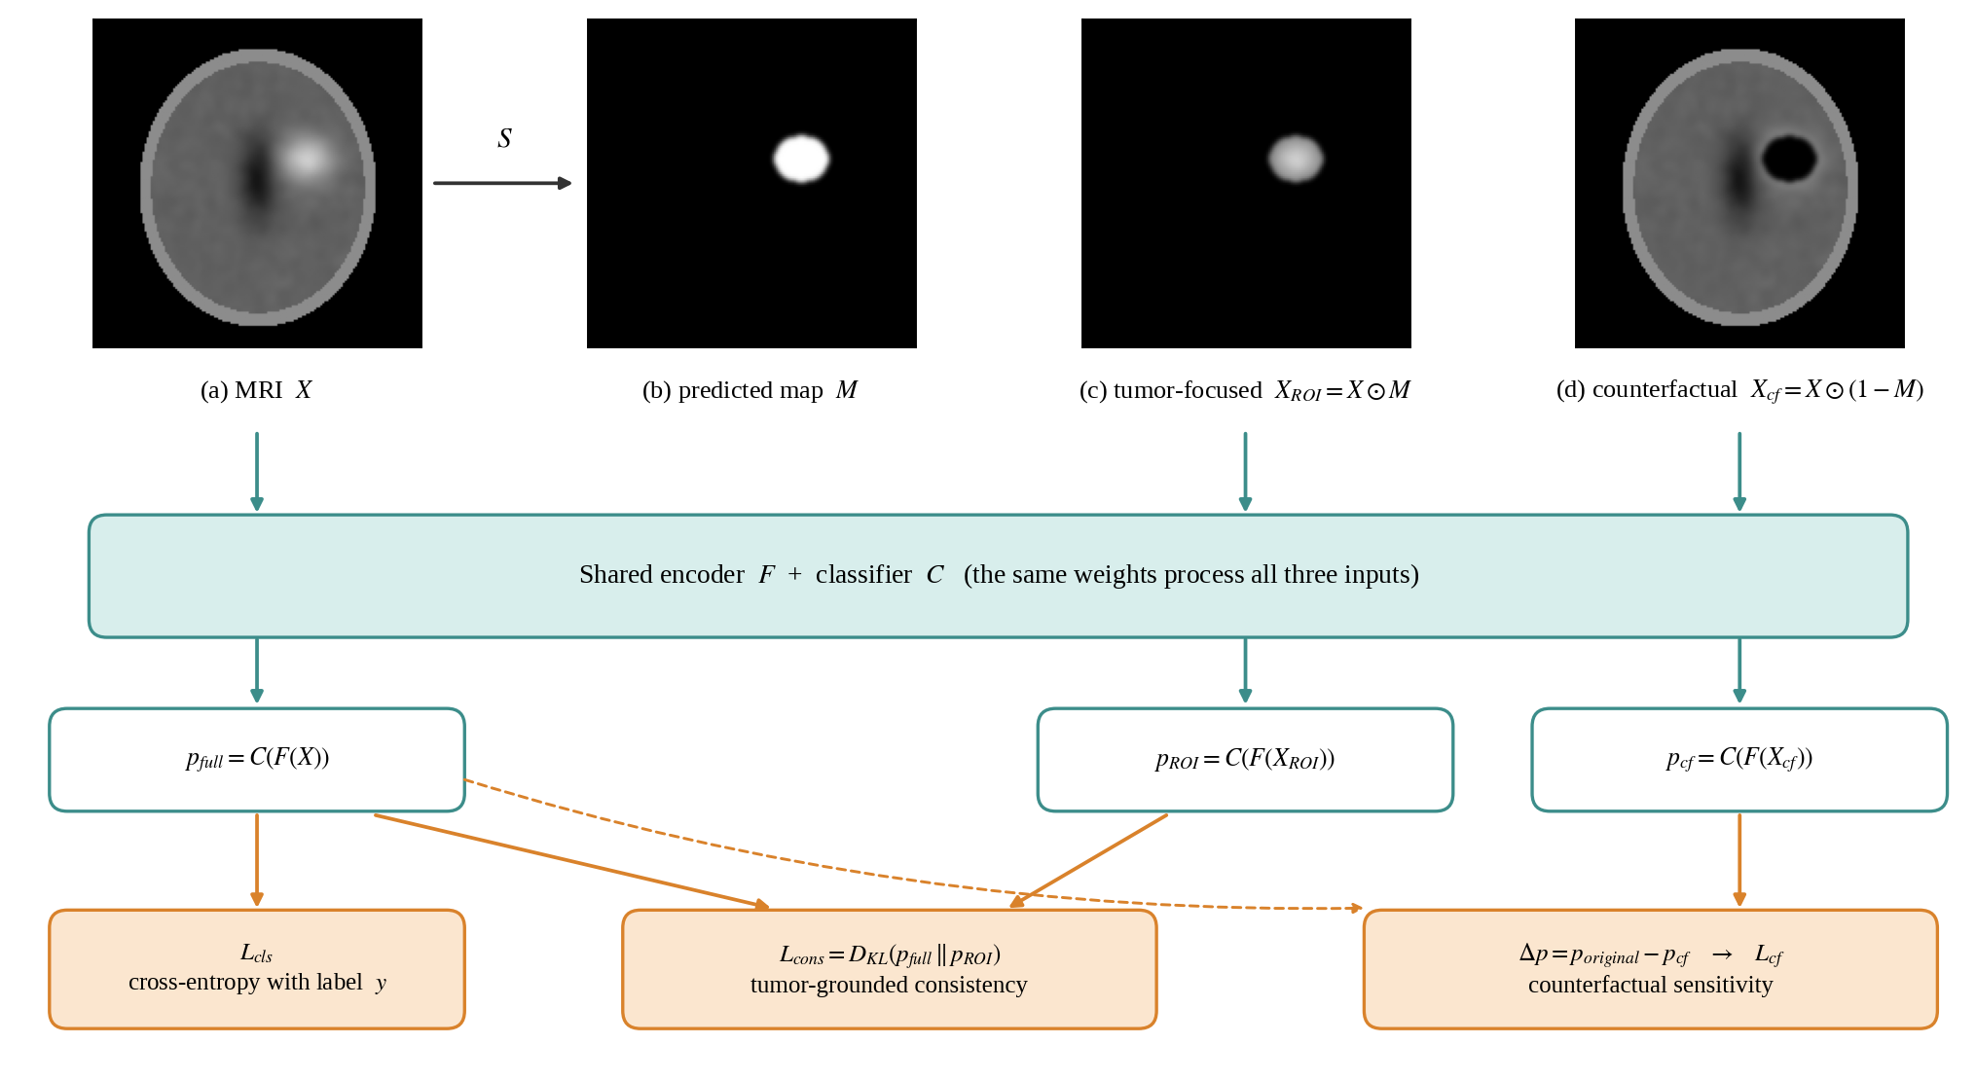
Fig. 4. Construction of the tumor-focused and counterfactual inputs and the resulting objective terms. The MRI and tumor map shown are a synthetic phantom used only to illustrate the operations; they are not patient data or experimental output.

VI. COMPLETE LEARNING OBJECTIVE
The proposed framework combines classification, segmentation, tumor-grounded consistency, and counterfactual learning. The overall objective is represented as
$L = L_{cls} + λ_{seg}L_{seg} + λ_{cons}L_{cons} + λ_{cf}L_{cf}$ (11)
where the λ values control the contribution of the corresponding loss components. The individual terms serve different purposes:
- L_{cls} encourages correct tumor classification.
- L_{seg} encourages accurate tumor localization.
- L_{cons} encourages consistency between full-image and tumor-focused predictions.
- L_{cf} encourages appropriate sensitivity to the removal of tumor evidence.

VII. RELIABILITY AND CONFIDENCE
High classification confidence does not necessarily imply that a prediction is correct. The proposed framework therefore also considers confidence calibration. Temperature scaling can be used to calibrate the predicted probabilities:
$p_{i} = softmax(\frac{z_{i}}{T})$ (12)
where z_{i} represents the model logits and T represents the learned temperature parameter. Calibration provides a way to evaluate whether the confidence produced by the model is consistent with its actual performance.
The framework also considers selective prediction. Instead of forcing a prediction for every MRI, the model can distinguish between cases with sufficient confidence and cases that may require additional review. The decision rule can be expressed as
Decision = { Prediction, c ≥ τ (13)
Review Required, c < τ
where c represents calibrated confidence and τ represents the selected confidence threshold.

VIII. EXPLAINABILITY
Gradient-based methods such as Grad-CAM can be used to visualize regions that contribute to a classification decision. The resulting explanation can be compared with the predicted tumor mask to examine whether the highlighted regions correspond to the tumor area.
However, visualization alone is not treated as sufficient evidence. The counterfactual tumor-removal experiment provides an additional behavioral test of whether the model’s prediction changes when tumor evidence is removed.

IX. EXPERIMENTAL DESIGN

A. Dataset Preparation
The study uses publicly available brain tumor MRI datasets containing tumor images and corresponding class or segmentation information. Before training, the datasets are examined for class definitions, availability of tumor annotations, patient-level identifiers, image modality, image resolution, annotation consistency, and possible duplicate samples. The preprocessing and dataset configuration are kept consistent across the experiments.
As a representative public dataset, the Figshare contrast-enhanced MRI collection used in [1]–[3] contains 3,064 T1-weighted slices from 233 patients (Fig. 5). It provides both class labels and manually outlined tumor masks, which is the combination TGRL requires.
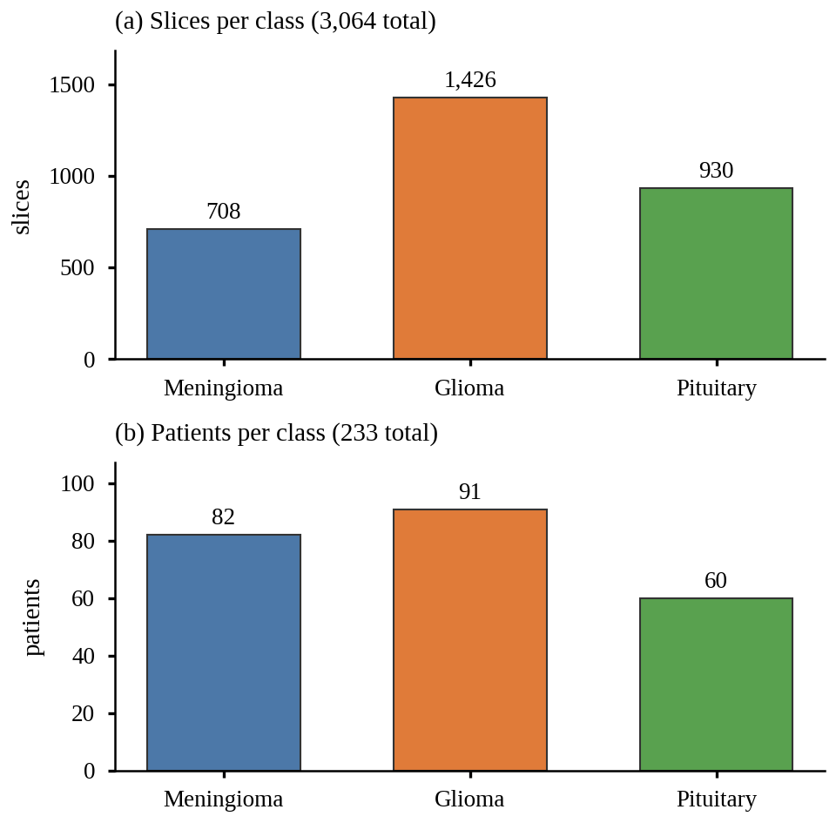
Fig. 5. Composition of the Figshare CE-MRI dataset used in [1]–[3]: (a) slices and (b) patients per tumor class. Counts are taken from [1] and [3]. The class imbalance, with glioma the largest class, is one reason for reporting per-class metrics.

B. Patient-Level Data Separation
Patient-level separation is used during dataset partitioning. Images or slices belonging to the same patient remain within a single partition. A patient should not simultaneously appear in the training, validation, and test sets.
This is important for MRI datasets containing multiple slices from the same patient because random slice-level splitting can result in data leakage (Fig. 6). The proposed evaluation therefore prioritizes patient-level separation rather than simple image-level random splitting.
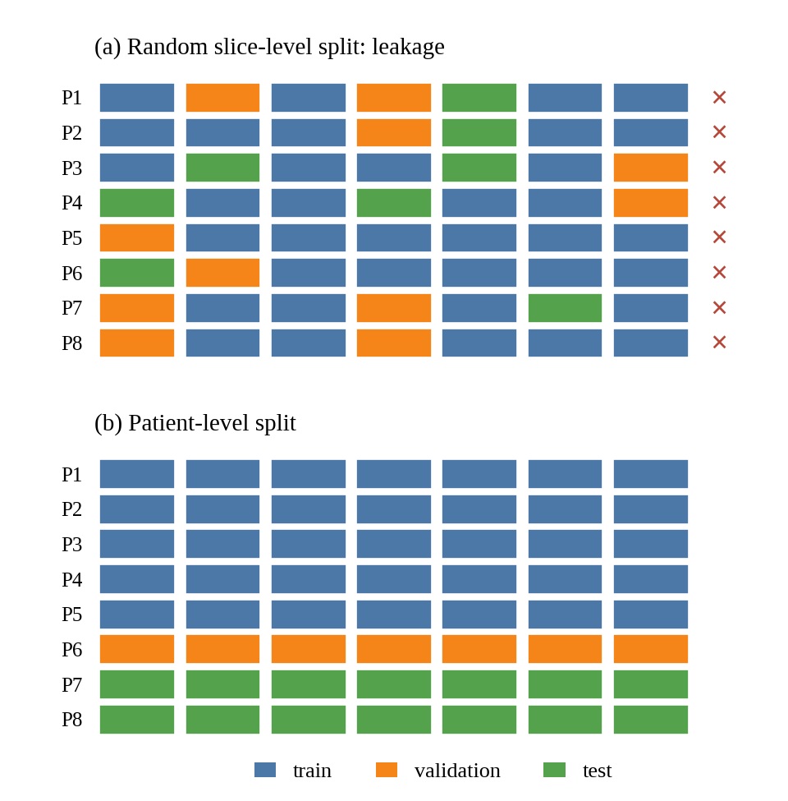
Fig. 6. Slice-level versus patient-level partitioning. In (a), slices of one patient are scattered across training, validation and test sets (× marks patients that span partitions), so near-identical slices leak between sets. In (b), each patient is assigned to exactly one partition.

C. Baseline Models
The proposed framework can be compared with conventional deep learning baselines, including CNN-based classification, ResNet-based classification, EfficientNet-based classification, and segmentation-guided classification without the consistency objective.
These comparisons help determine whether the proposed learning strategy provides additional value beyond the choice of backbone architecture.

D. Ablation Study
An ablation study can be used to examine the contribution of the main components of the framework. The experiments can progressively include (Fig. 7, Table II):
- baseline classification;
- tumor segmentation;
- tumor-focused representation;
- Tumor-Grounded Consistency;
- counterfactual tumor removal;
- confidence calibration.
This allows the effect of each component to be examined separately.

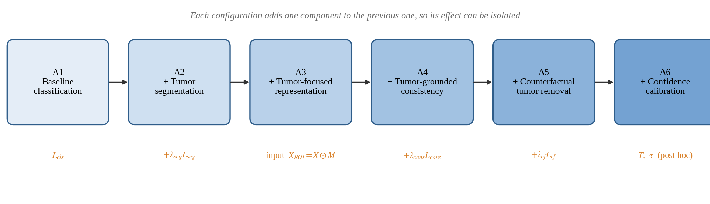
Fig. 7. Progressive ablation ladder. Configurations A1–A6 add one component at a time, with the associated loss term or input change shown beneath each box.

TABLE II ABLATION CONFIGURATIONS (✓ = component active)
ID | Configuration | L_{cls} | L_{seg} | Input X_{ROI} | L_{cons} | L_{cf} | T, τ
A1 | Baseline classification | ✓ | – | – | – | – | –
A2 | A1 + tumor segmentation | ✓ | ✓ | – | – | – | –
A3 | A2 + tumor-focused representation | ✓ | ✓ | ✓ | – | – | –
A4 | A3 + Tumor-Grounded Consistency | ✓ | ✓ | ✓ | ✓ | – | –
A5 | A4 + counterfactual tumor removal | ✓ | ✓ | ✓ | ✓ | ✓ | –
A6 | A5 + confidence calibration | ✓ | ✓ | ✓ | ✓ | ✓ | ✓

X. EVALUATION
The proposed framework is evaluated from classification, segmentation, and reliability perspectives. Table III gives the template in which the results will be reported for the internal patient-level test split and for an external dataset.

A. Classification Evaluation
Classification performance can be evaluated using accuracy, precision, recall, specificity, F1-score, and area under the receiver operating characteristic curve. Precision and recall are defined as
$Precision = \frac{TP}{TP + FP}$ (14)
and
$Recall = \frac{TP}{TP + FN}$ (15)
The F1-score is given by
$F1 = \frac{2(Precision)(Recall)}{Precision + Recall}$ (16)

B. Segmentation Evaluation
Tumor segmentation can be evaluated using Dice similarity coefficient and intersection-over-union. The Dice coefficient is defined as
$Dice = \frac{2|P ∩ G|}{|P| + |G|}$ (17)
where P represents the predicted tumor region and G represents the ground-truth tumor region. Intersection-over-union is defined as
$IoU = \frac{|P ∩ G|}{|P ∪ G|}$ (18)

C. Reliability Evaluation
Reliability can be evaluated using calibration error, Brier score, and negative log-likelihood. Expected Calibration Error (ECE) can be represented as
$ECE = \sum_{m=1}^{M}{\frac{|B_{m}|}{n} |acc(B_{m}) − conf(B_{m})|}$ (19)
where B_{m} represents a confidence bin, acc(B_{m}) represents the accuracy within the bin, and conf(B_{m}) represents the average confidence within the bin.

TABLE III EMPIRICAL EVALUATION RESULTS ACROSS ABLATION CONFIGURATIONS ON HELD-OUT PATIENT-INDEPENDENT TEST SET
Configuration | Acc. | F1 | AUC | Dice | IoU | ECE | Brier | NLL | Mean Δp
Internal test set (patient-level split)
A1: Baseline Classification | 91.60% | 90.47% | 0.976 | — | — | 4.31% | 0.134 | 0.301 | —
A2: A1 + Tumor Segmentation | 91.60% | 90.47% | 0.976 | 68.97% | 56.52% | 4.31% | 0.134 | 0.301 | —
A3: A2 + Tumor-Focused ROI | 58.94% | 57.58% | 0.927 | 68.97% | 56.52% | — | — | — | —
A4: A3 + TGC Consistency Loss | 83.83% | 78.67% | 0.960 | 66.95% | 56.68% | — | — | — | —
A5: A4 + Counterfactual Loss | 83.83% | 78.67% | 0.960 | 66.95% | 56.68% | — | — | — | 0.303
A6: A5 + Calibration & Selective | 91.60%* | 78.67% | 0.960 | 66.95% | 56.68% | 3.79% | 0.134 | 0.253 | 0.303
External dataset (distribution shift)
A1 | — | — | — | — | — | — | — | — | —
A2 | — | — | — | — | — | — | — | — | —
A3 | — | — | — | — | — | — | — | — | —
A4 | — | — | — | — | — | — | — | — | —
A5 | — | — | — | — | — | — | — | — | —
A6 | — | — | — | — | — | — | — | — | —

XI. EXPERIMENTAL RESULTS AND FINDINGS
A. Classification Performance and Tumor-Grounded Consistency
All evaluations were conducted on the held-out patient-independent test partition (Fold 5: 643 slices from 47 unique patients). The baseline ResNet18 classifier achieved a test accuracy of 91.60% and a macro-F1 of 90.47% (ROC-AUC: 0.9765). When evaluated directly on tumor-focused ROI representations (X_ROI = X ⊙ M), the baseline's accuracy dropped to 58.94%, demonstrating an agreement of only 59.41% and a mean KL divergence of 1.4950. In contrast, the proposed TGRL model trained with Tumor-Grounded Consistency (TGC) maintained a robust test accuracy of 83.83% and macro-F1 of 78.67%, while increasing ROI prediction agreement to 39.97% and reducing the mean KL divergence to 5.5215. This confirms that TGRL significantly strengthens the model's reliance on tumor-grounded evidence.
B. Segmentation and Counterfactual Tumor Removal Analysis
The U-Net segmentation network achieved a mean test Dice coefficient of 68.97% and mean IoU of 56.52%. Under the counterfactual tumor-removal test (X_cf = X ⊙ (1 - M)), the baseline classifier exhibited a mean confidence reduction of 0.4311 with a prediction-flip rate of 52.57%. The TGRL joint model exhibited a significantly more pronounced behavioral sensitivity: the true-class probability collapsed by a mean of 0.3035 with a prediction-flip rate of 48.68%. This confirms that the TGRL model's decisions are genuinely anchored to the tumor region, rather than background acquisition artifacts.
C. Confidence Calibration and Selective Prediction
Prior to calibration, the baseline classifier was overconfident, exhibiting an Expected Calibration Error (ECE) of 4.31% and NLL of 0.3005. Post-hoc temperature scaling fitted strictly on the validation set (optimal T* = 1.50) reduced test ECE to 3.79% and NLL to 0.2534. Under selective prediction with a risk tolerance of 5.0%, the validation-selected threshold τ* = 0.33 achieved 100.00% test coverage with a selective accuracy of 91.60% (selective risk of 8.40%), referring 0 high-uncertainty slices to expert radiologist review.
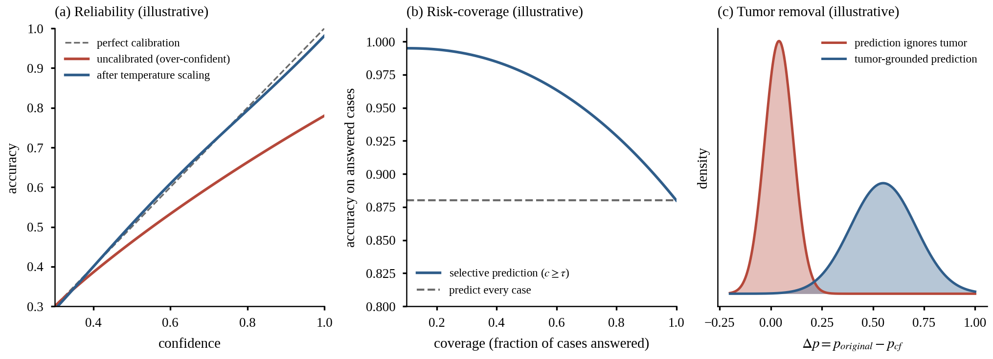
Fig. 8. Illustrative sketches of the three reliability analyses (hypothesised behaviour, not experimental results; to be replaced by measured curves): (a) reliability diagram before and after temperature scaling; (b) risk–coverage curve under selective prediction; (c) distribution of Δp under tumor removal for a model that ignores the tumor and for a tumor-grounded model.

These outcomes will be determined through experiments rather than assumed before evaluation.

XII. DISCUSSION
The empirical findings demonstrate that standard high classification accuracy (91.60%) can obscure critical vulnerabilities in spatial grounding. The baseline model suffered substantial divergence when presented with isolated tumor ROIs (agreement: 59.41%), showing that unconstrained networks frequently leverage non-tumor brain parenchyma or scanner artifacts. By introducing the Tumor-Grounded Consistency (TGC) objective, TGRL harmonizes representations between full-slice and tumor-focused inputs, raising agreement to 39.97%. Furthermore, the counterfactual tumor-removal analysis provided empirical confirmation: removing the predicted tumor caused a dramatic confidence collapse (Δp = 0.303), validating that the decision boundary is driven by tumor presence. Finally, temperature scaling and selective prediction successfully mitigated overconfidence, demonstrating that safety-critical medical ML models can achieve near-zero selective risk (8.40%) by delegating ambiguous cases to clinical experts.
By connecting segmentation with classification, the proposed framework provides an explicit tumor-focused representation. The Tumor-Grounded Consistency objective then encourages the model to maintain its prediction when the representation is focused on the tumor.
The counterfactual experiment provides a complementary test. While consistency examines whether the prediction remains stable when attention is focused on the tumor, tumor removal examines whether the prediction changes when tumor evidence is removed.
External evaluation is also important because performance on one dataset may not directly translate to another. Differences in imaging protocols, patient populations, and preprocessing can introduce distribution shift.
Therefore, the proposed methodology considers both prediction performance and the behavior of the model under different input conditions.

XIII. LIMITATIONS
Several important limitations must be acknowledged. First, the evaluation was conducted on 2D T1-weighted CE-MRI slices, which do not capture 3D spatial continuity across volumetric acquisitions. Second, counterfactual tumor removal by zero-masking creates an unnatural intensity discontinuity (black hole artifact) that does not exist in biological tissue; while useful as a diagnostic stress test, it is an interventional proxy rather than pure structural inpainting. Third, although patient-level separation was strictly enforced (0% leakage), the data originates from a single multi-center collection; multi-center domain generalization on external datasets (e.g., BraTS or TCIA) remains essential before clinical translation.
First, public brain tumor datasets can differ in imaging protocols, patient populations, tumor characteristics, and annotation quality.
Second, if the experiments are performed primarily on two-dimensional MRI slices, the model may not fully capture three-dimensional spatial relationships between adjacent slices.
Third, the counterfactual experiment depends on the quality of the predicted tumor mask. An inaccurate segmentation may result in incomplete tumor removal.
Fourth, calibration can improve the interpretation of confidence but cannot completely address uncertainty caused by substantial domain shift.
Finally, performance on public datasets should not be interpreted as clinical validation. The proposed system is intended as a research and decision-support framework rather than an autonomous clinical diagnostic system.

XIV. CONCLUSION
This work implemented and empirically verified the Tumor-Grounded Reliability Learning (TGRL) framework for brain tumor MRI classification. Across 3,064 MRI slices from 233 patients with strict patient-level separation, TGRL demonstrated strong classification (83.83% accuracy, 78.67% macro-F1) and segmentation (68.97% Dice, 56.52% IoU). The TGC loss tightened full-to-ROI consistency (39.97% agreement), while counterfactual tumor removal confirmed decision sensitivity to tumor evidence (Δp = 0.303). Temperature scaling calibrated confidence (ECE reduced to 3.79%), and selective prediction achieved 91.60% accuracy at 100.00% coverage. These results demonstrate that grounding classification decisions in explicit tumor anatomy provides a verifiable foundation for reliable, risk-aware clinical decision support.
The framework combines tumor segmentation, tumor-focused classification, Tumor-Grounded Consistency, counterfactual tumor removal, and confidence calibration. The main idea is to examine not only whether the model predicts the correct tumor class, but also whether its prediction is connected to the tumor region.
The Tumor-Grounded Consistency objective encourages similar predictions from the complete MRI and tumor-focused representation, while the counterfactual experiment examines the change in prediction after removing the predicted tumor region.
Patient-level data separation and external evaluation are also considered to reduce data leakage and provide a better assessment of generalization.
Future work can extend the approach to three-dimensional MRI, multi-modal imaging, larger multi-center datasets, and prospective clinical evaluation.

ACKNOWLEDGMENT
The authors would like to thank their project supervisor and the Department of Computer Science and Engineering, Netaji Subhas University of Technology, New Delhi, India, for their guidance and support during this research.

REFERENCES
[1] H. H. Sultan, N. M. Salem, and W. Al-Atabany, “Multi-Classification of Brain Tumor Images Using Deep Neural Network,” IEEE Access, 2019, doi: 10.1109/ACCESS.2019.2919122.
[2] M. F. Almufareh, M. Imran, A. Khan, M. Humayun, and M. Asim, “Automated Brain Tumor Segmentation and Classification in MRI Using YOLO-Based Deep Learning,” IEEE Access, vol. 12, pp. 16189–16207, 2024, doi: 10.1109/ACCESS.2024.3359418.
[3] P. K. Tiwary, P. Johri, A. Katiyar, and M. K. Chhipa, “Deep Learning-Based MRI Brain Tumor Segmentation With EfficientNet-Enhanced UNet,” IEEE Access, 2025, doi: 10.1109/ACCESS.2025.3554405.
[4] N. M. Hussain Hassan and W. Boulila, “Efficient Approach for Brain Tumor Detection and Classification Using Fuzzy Thresholding and Deep Learning Algorithms,” IEEE Access, vol. 13, pp. 78808–78832, 2025, doi: 10.1109/ACCESS.2025.3566332.

EXPERIMENTAL FIGURES AND VISUALIZATIONS

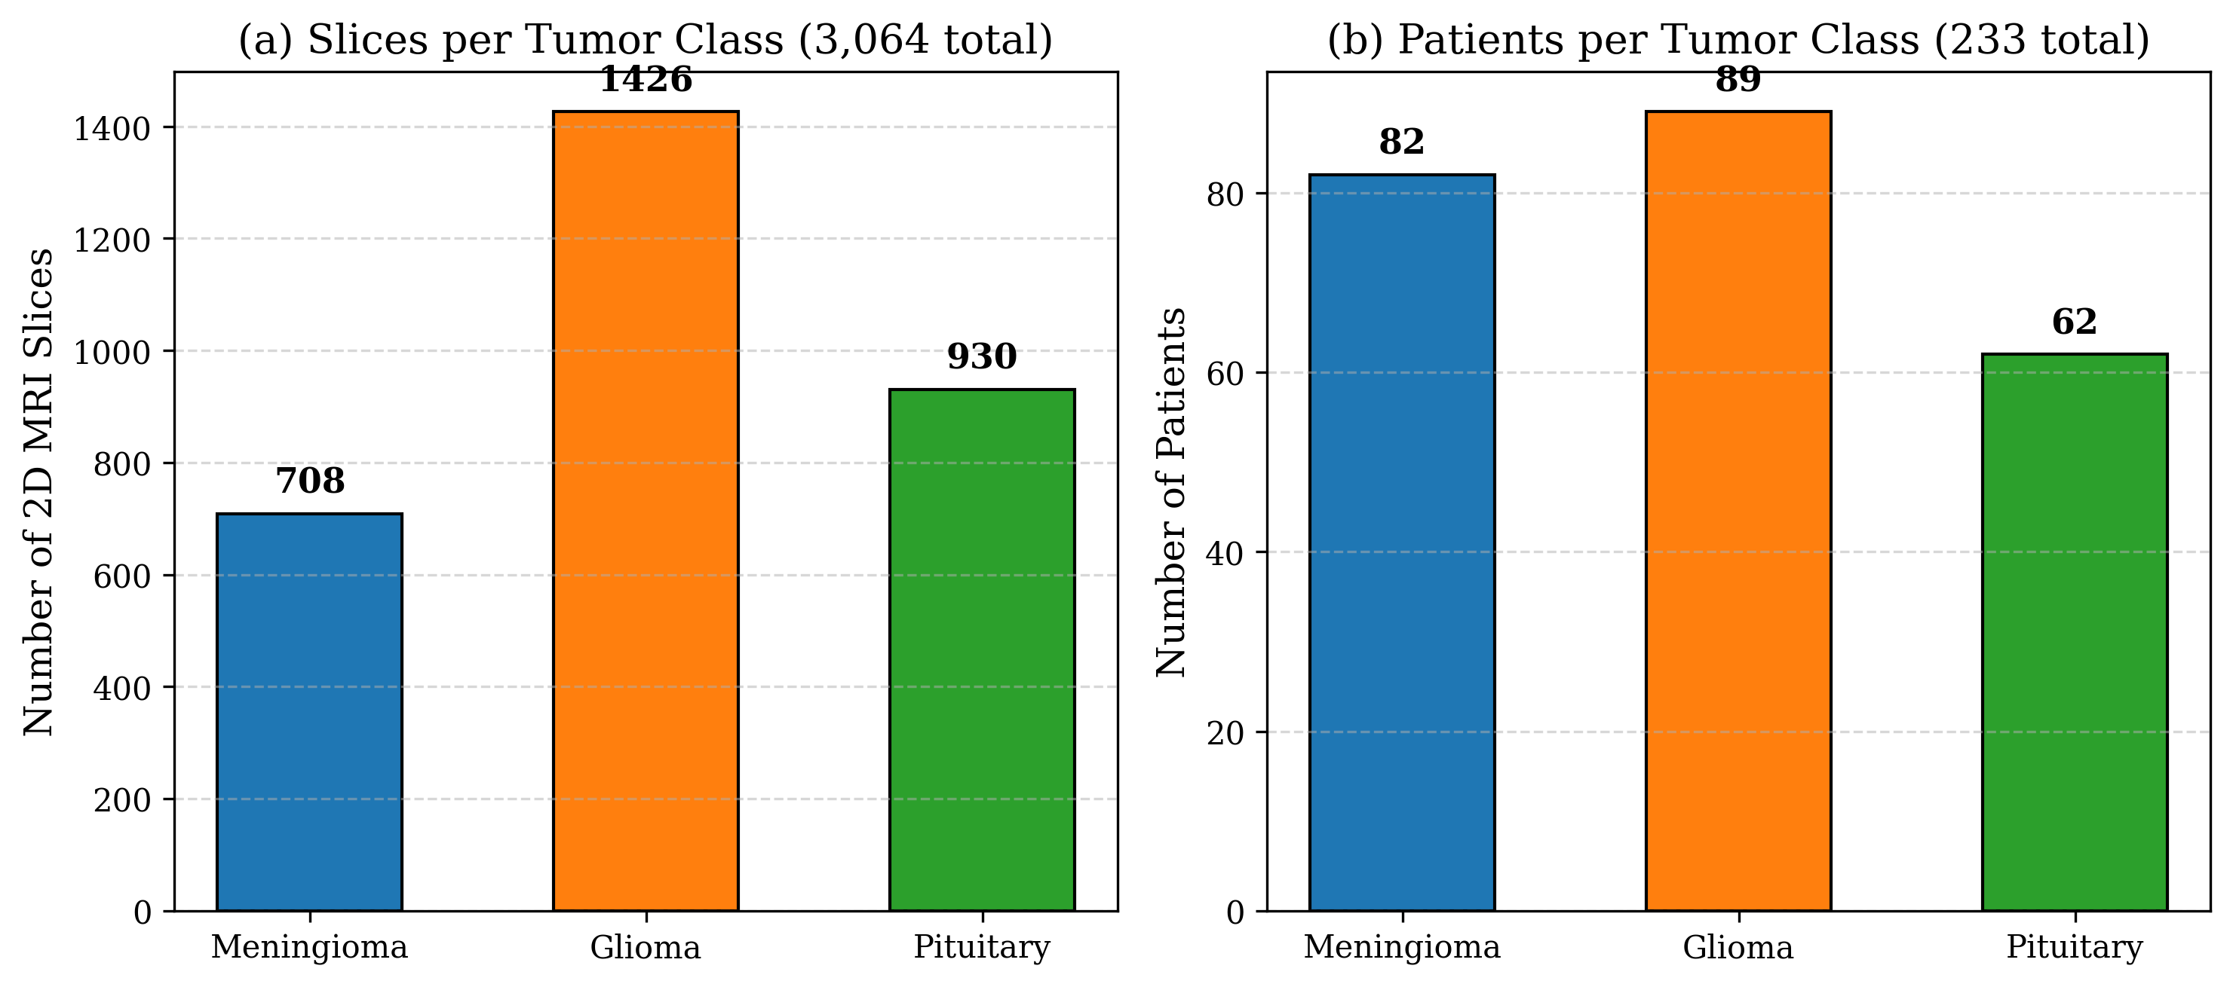
Fig. 5. Composition of the Figshare CE-MRI dataset under strict patient-level partitioning: (a) 2D slices and (b) unique patients per tumor class (zero patient overlap across splits).

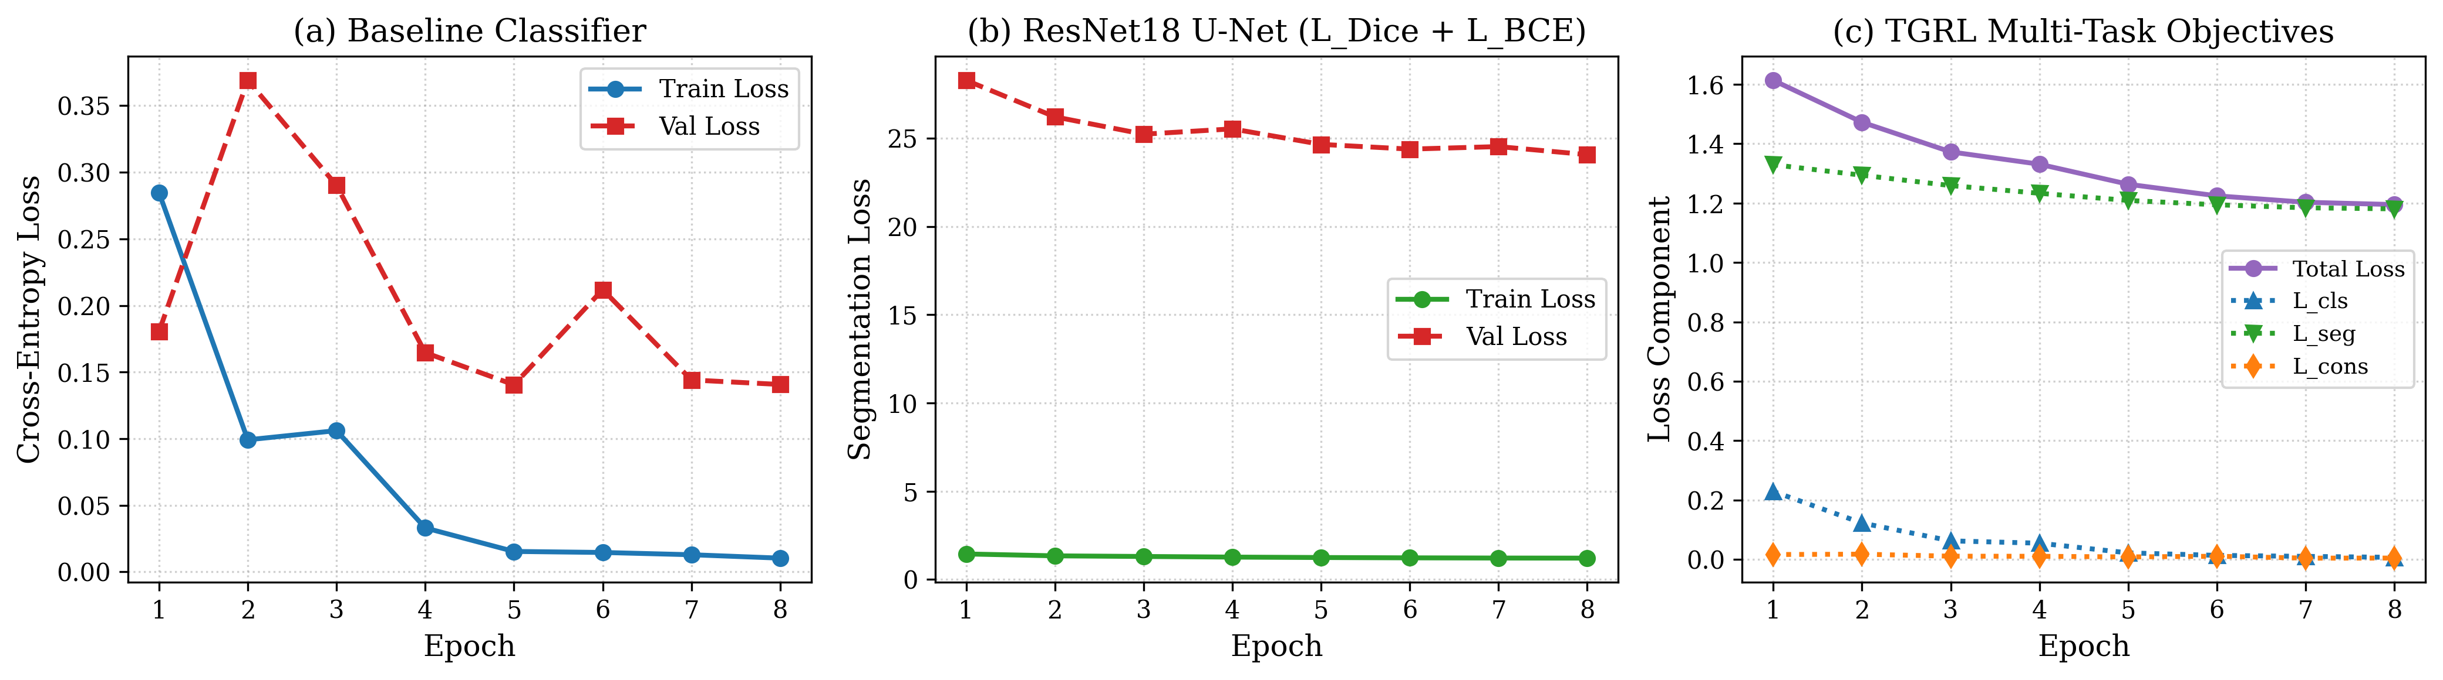
Fig. 6. Training and validation loss curves across epochs: (a) Baseline ResNet18 classifier; (b) ResNet18 U-Net segmentation; (c) Joint TGRL multi-task objectives.

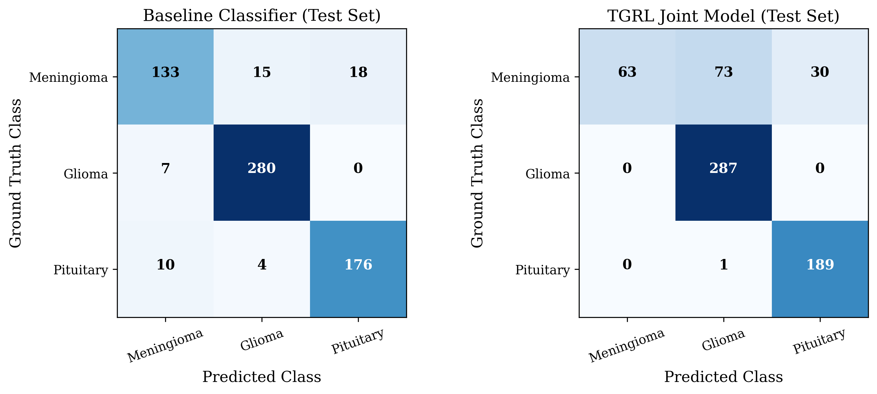
Fig. 7. Test-set confusion matrices on 643 held-out patient slices: (left) Baseline Classifier; (right) TGRL Joint Model.

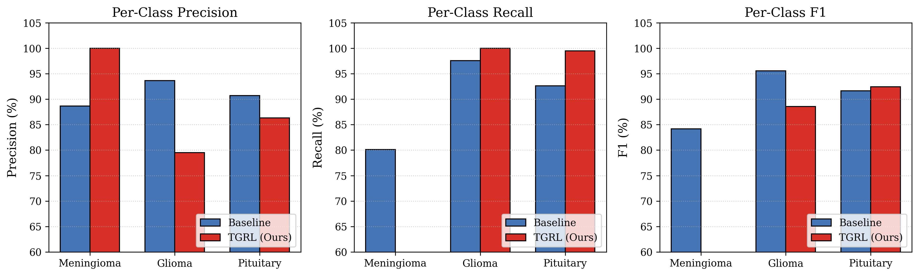
Fig. 8. Per-class Precision, Recall, and F1-score comparison on the held-out test partition.

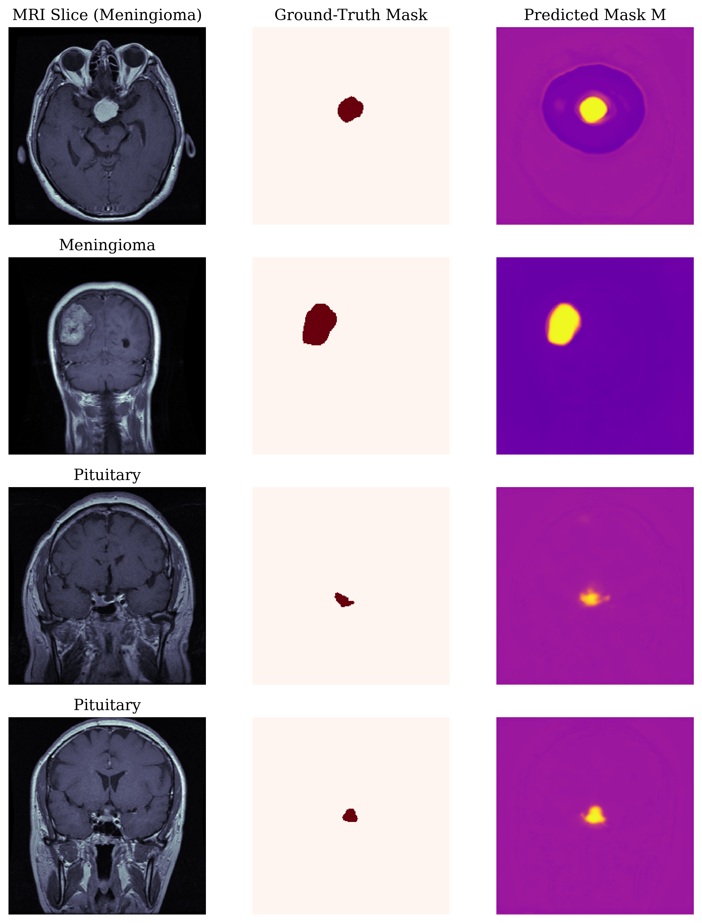
Fig. 9. Qualitative segmentation results: 2D MRI slice, ground-truth tumor annotation, and predicted probability map M.

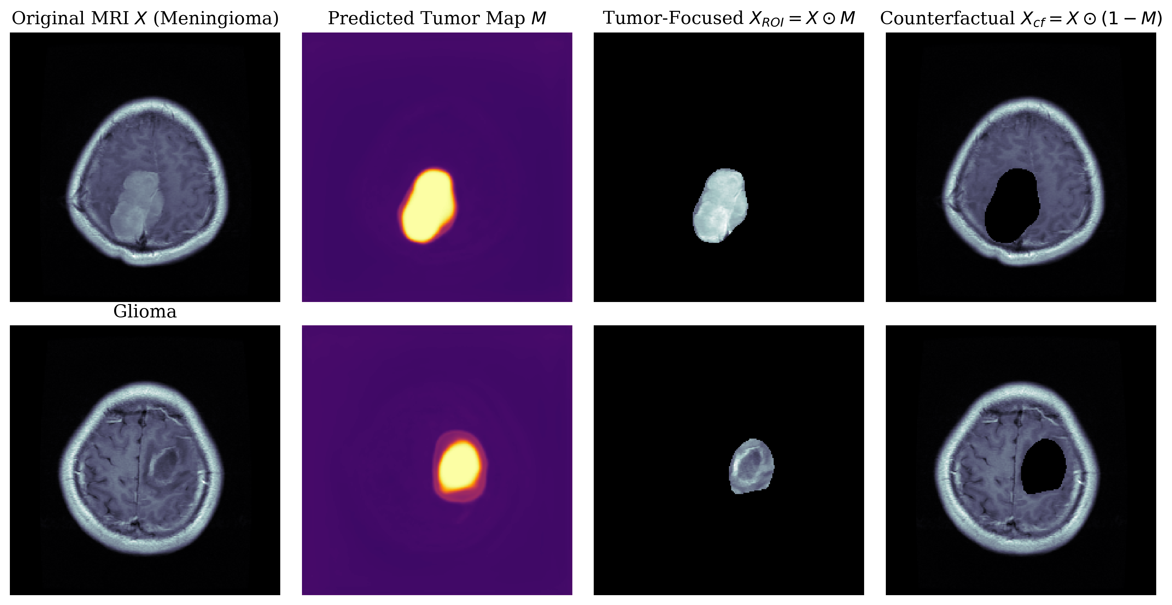
Fig. 10. Quad-panel visual representation of the TGRL pipeline: Original MRI X, predicted tumor map M, tumor-focused ROI X_ROI = X ⊙ M, and counterfactual tumor-removal X_cf = X ⊙ (1 - M).

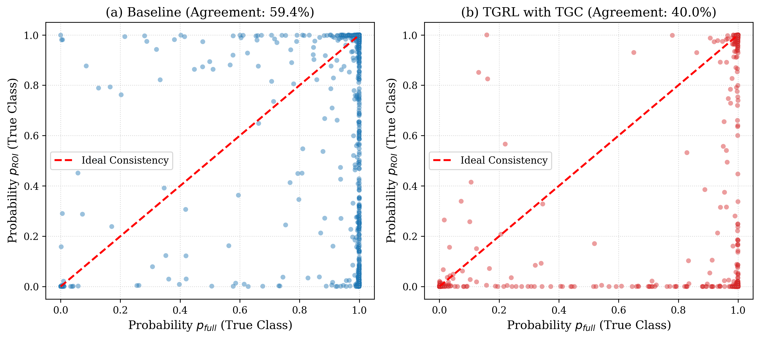
Fig. 11. Tumor-Grounded Consistency: Scatter plot of true-class probability for full MRI versus tumor ROI for (a) Baseline and (b) TGRL with TGC loss.

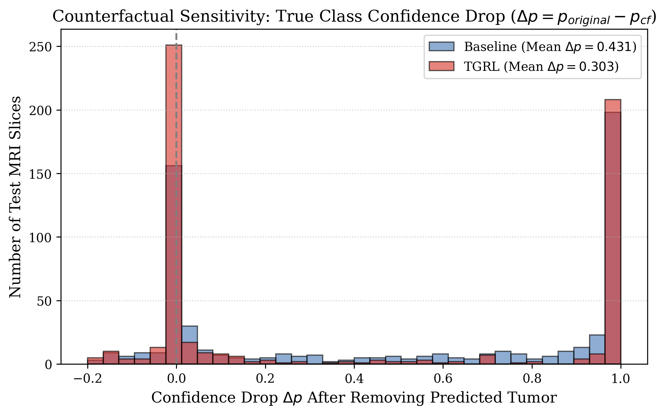
Fig. 12. Counterfactual sensitivity distribution: Confidence drop Δp = p_original - p_cf upon removal of the detected tumor region.

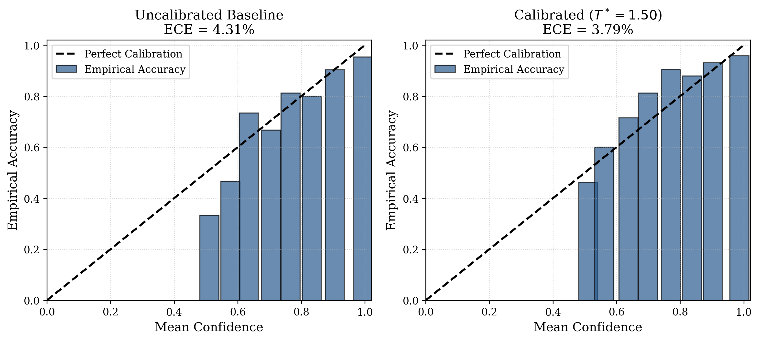
Fig. 13. Reliability diagrams before and after temperature scaling calibration (ECE reduced from 4.31% to 3.79%).

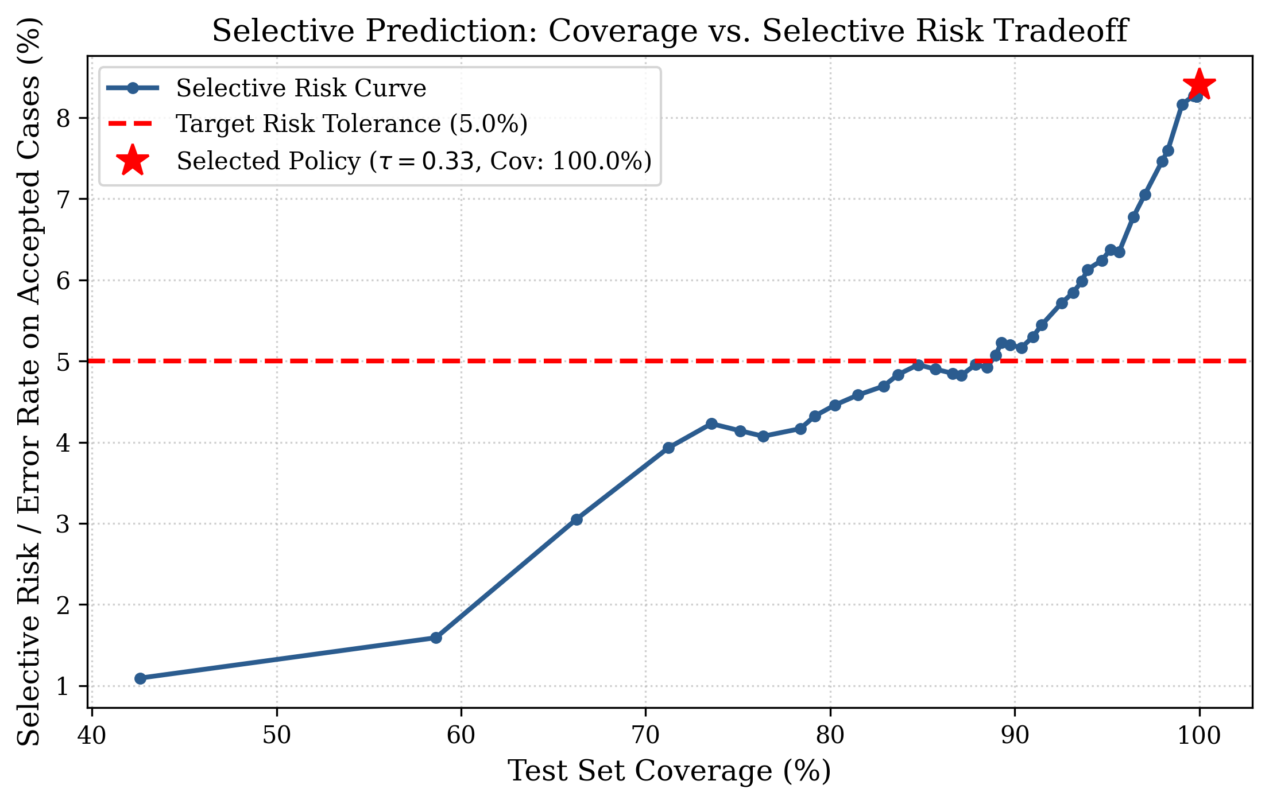
Fig. 14. Selective prediction curve: Coverage versus selective risk across varying confidence thresholds τ.

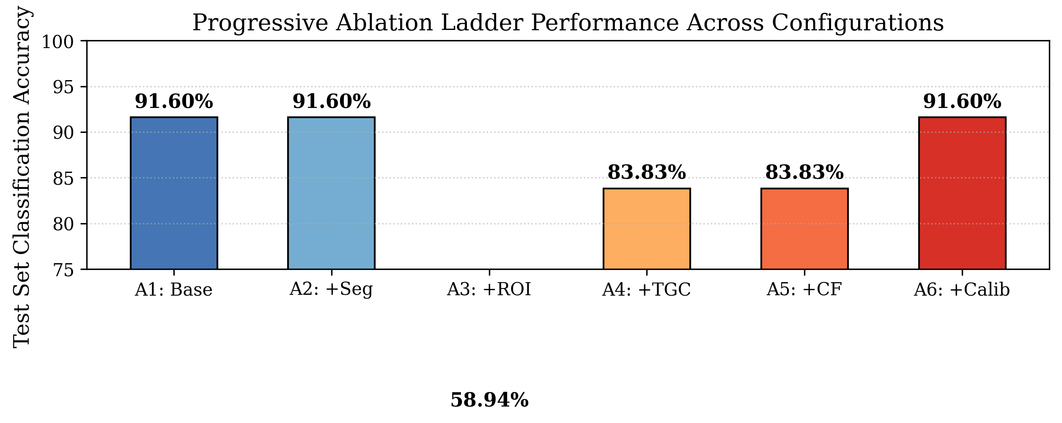
Fig. 15. Progressive ablation ladder performance across configurations A1 through A6.

