The Sesame Robot: Design and Development of an Open-Source ESP32-Based Expressive Quadruped
An Accessible, Fully 3D-Printed Walking Robot with WiFi Control, a JSON API, and a Reactive OLED Face
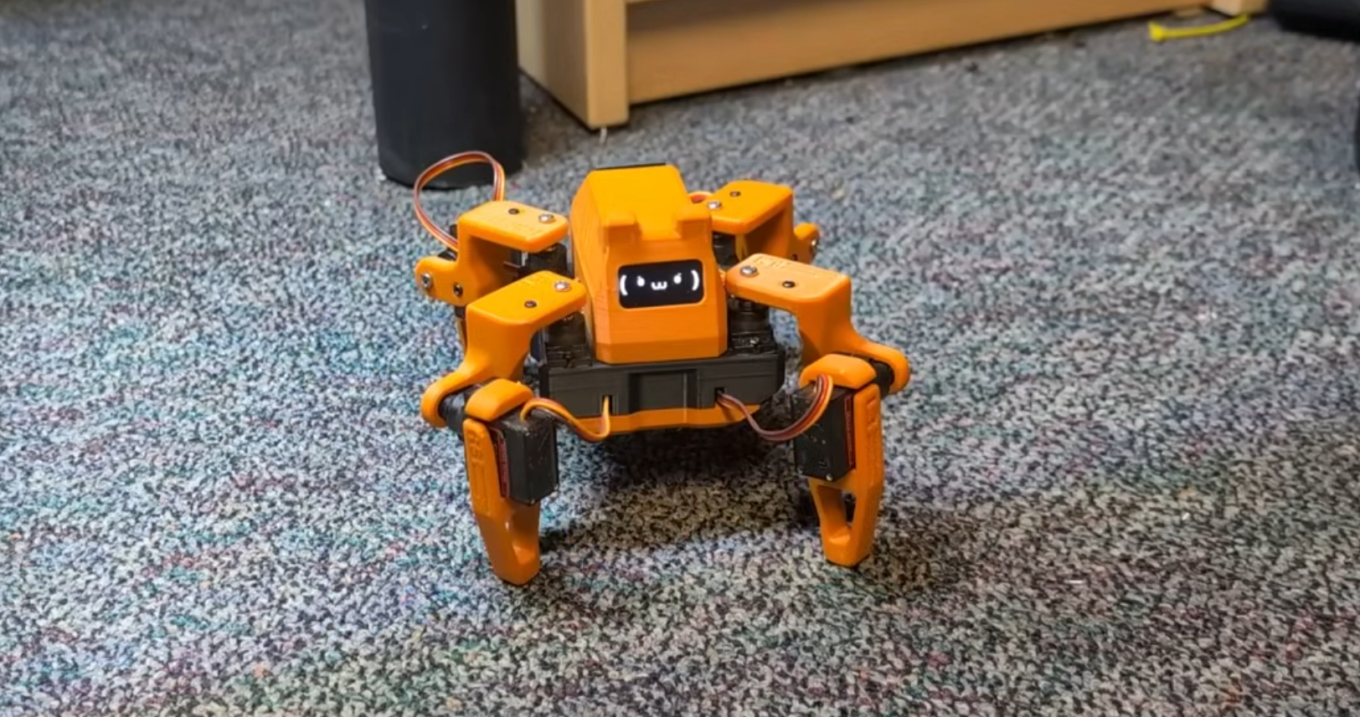
The completed Sesame Robot: 3D-printed quadruped chassis, 8x MG90S servos, and a live OLED expression. (Source: project repository, docs/build-guide/assets/sesame-done.png)

Abstract
This report documents Sesame, an open-source, ESP32-based quadruped robot released under the Apache 2.0 license by Dorian Todd. Sesame uses eight MG90S servo motors (two per leg) driven directly from ESP32 GPIO pins for locomotion, a 128x64 SSD1306 OLED for a reactive, movement-synchronized face, and a dual-mode WiFi stack (simultaneous Access Point and Station) exposing both a legacy URL-parameter interface and a modern JSON REST API. The mechanical design is fully 3D-printable in PLA across eleven parts, and the electrical design supports either a hand-wired Lolin S2 Mini build or a purpose-built power/data distribution PCB (the Sesame Distro Board, now at revision V3.1). The project ships nineteen pre-programmed poses and gaits and is supported by three companion tools: Sesame Studio (a desktop pose/animation composer that generates firmware-ready C++), the Sesame Simulator (a Rust-based physics simulation environment), and the Sesame Companion App (Python-based voice and remote control). This report covers the system architecture, functional decomposition, firmware implementation, bill of materials, and evaluation criteria drawn directly from the project's own repository and documentation.

Keywords
ESP32; quadruped robot; MG90S servo; SSD1306 OLED; open-source robotics; WiFi captive portal; JSON REST API; ESP32Servo; 3D-printed robot; expressive robot; gait control; Sesame Robot.

Introduction
Sesame is an open-source, ESP32-based quadruped (four-legged, eight-servo) robot created by Dorian Todd and released under the Apache 2.0 license. The project targets makers and engineers of varying skill levels, requiring only basic soldering ability, roughly $50 to $60 in components, access to a 3D printer, and familiarity with the Arduino IDE. Unlike many hobby quadrupeds that focus purely on locomotion, Sesame places equal emphasis on expressive character: a 128x64 OLED screen acts as a reactive face that is synchronized with the robot's movements, giving the platform a distinct personality.
This report documents the Sesame Robot as published in its official repository: the mechanical design, the printed circuit boards, the ESP32 firmware, the companion desktop and mobile tooling, and the network-facing control API. The repository bundles CAD/STL files, build and wiring guides, base and expanded firmware, and debugging firmware, making the entire pipeline — from raw filament to a walking, talking robot — reproducible by a third party.

Problem Statement
Accessible legged-robotics platforms are scarce: most either require expensive proprietary hardware, provide no path from mechanical design to working firmware, or omit the human-facing layer (expression, remote control, and animation tooling) that makes a robot engaging rather than merely functional. Sesame addresses this by providing a complete, low-cost, fully open build — mechanical, electrical, and software — that a single hobbyist can source, print, wire, flash, and animate without proprietary tools.

Literature Review
Sesame's servo-driven, eight-degree-of-freedom leg architecture (two servos per leg, four legs) follows the common hobby-quadruped pattern seen in small SPI/PWM-servo walkers, but couples it with a purpose-built power-and-data distribution PCB (the Sesame Distro Board, now at revision V3.1) rather than a generic servo driver breakout. The firmware runs on the Arduino-ESP32 core and uses the ESP32Servo library for hardware-timer-based PWM generation, the Adafruit SSD1306/GFX stack for the OLED, and the ESP32's built-in WebServer, DNSServer, and ESPmDNS libraries to implement a captive portal and a JSON REST API. This combination of dual-mode WiFi (simultaneous Access Point and Station), a scriptable JSON API, and a desktop animation composer (Sesame Studio) is unusual among open hobby quadrupeds and forms the technical core of this review.

Research Gap
Most open-source quadruped kits stop at the mechanical/firmware boundary: they explain how to assemble the robot and flash a fixed set of gaits, but leave animation authoring, remote control, and third-party integration as an exercise for the builder. Sesame closes this gap with three purpose-built software layers — Sesame Studio (a Python desktop app that visually poses the robot and auto-generates C++ servo-angle code), the Sesame Simulator (a Rust/WebAssembly physics simulator with URDF-accurate kinematics for testing gaits without hardware), and the Sesame Companion App (a Python application that adds voice-assistant integration over the JSON API). This report treats the interaction between these four layers (mechanical, PCB/firmware, control API, and authoring tools) as the object of study.

Objectives
1. Build a four-legged, eight-servo (two per leg) quadruped robot around a single ESP32 controller.
2. Drive all eight MG90S servos directly from ESP32 GPIO pins via the ESP32Servo library — no external PWM driver.
3. Render a synchronized, expressive face on a 128x64 SSD1306 OLED during every movement and pose.
4. Provide dual-mode WiFi (simultaneous Access Point + Station) with a captive portal and a JSON REST API.
5. Reproduce the full build from an openly licensed CAD/STL part set (eleven PLA-printed parts).
6. Support multiple electrical build paths: hand-wired Lolin S2 Mini or a purpose-built Sesame Distro Board (V1-V3.1).
7. Ship a pre-programmed animation library (19 poses/gaits) plus tooling (Sesame Studio) to author custom ones.
8. Keep the entire stack open source (Apache 2.0) and reproducible by makers with basic soldering skills.

Proposed Methodology
The build methodology follows the five stages documented in the repository's own Getting Started guide: (1) gather parts per the Bill of Materials, choosing between the Lolin S2 Mini hand-wired build or a Sesame Distro Board (V1/V2/V3.1); (2) 3D print the eleven-part PLA part set (four leg-pair joints per side, an internal frame, a bottom cover, and a top cover); (3) assemble and wire the frame following the build and wiring guides, using 30AWG silicone wire for signal lines and 22AWG for power/ground rails; (4) flash the modular Arduino-ESP32 firmware, selecting the correct servoPins array and I2C pin definitions for the chosen board; and (5) author custom poses and animations in Sesame Studio, which exports directly to firmware-ready C++ calls.
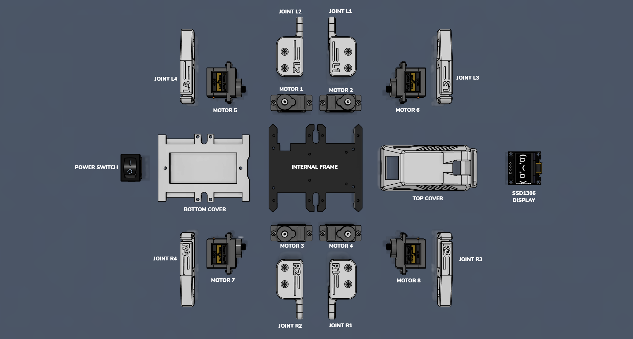
Figure 1: Exploded part inventory — eight MG90S servos, eight printed leg joints (L1-L4, R1-R4), internal frame, top/bottom covers, OLED, and power switch. (Source: docs/build-guide)

System Architecture
The system is centered on a single ESP32 module (a Lolin S2 Mini for hand-wired builds, or an ESP32-S3-based Sesame Distro Board V2/V3.1 for PCB builds). All eight MG90S servos are driven directly from ESP32 GPIO pins through the ESP32Servo library — there is no external PWM driver IC — with hardware timers 0-3 allocated for jitter-free 50 Hz pulses and a staggered per-servo activation delay (motorCurrentDelay, default 20 ms) to prevent brownouts from simultaneous inductive loads. The SSD1306 OLED communicates over the same I2C bus used for the display alone (400 kHz fast mode). Power is delivered from a battery or USB-C PD source through a 3 A buck converter to a shared 5 V rail feeding both the ESP32 and the servos. Network connectivity is dual-mode: the ESP32 simultaneously hosts a WiFi Access Point (for direct captive-portal control) and, optionally, joins an existing WiFi network in Station mode for LAN-wide JSON API access.
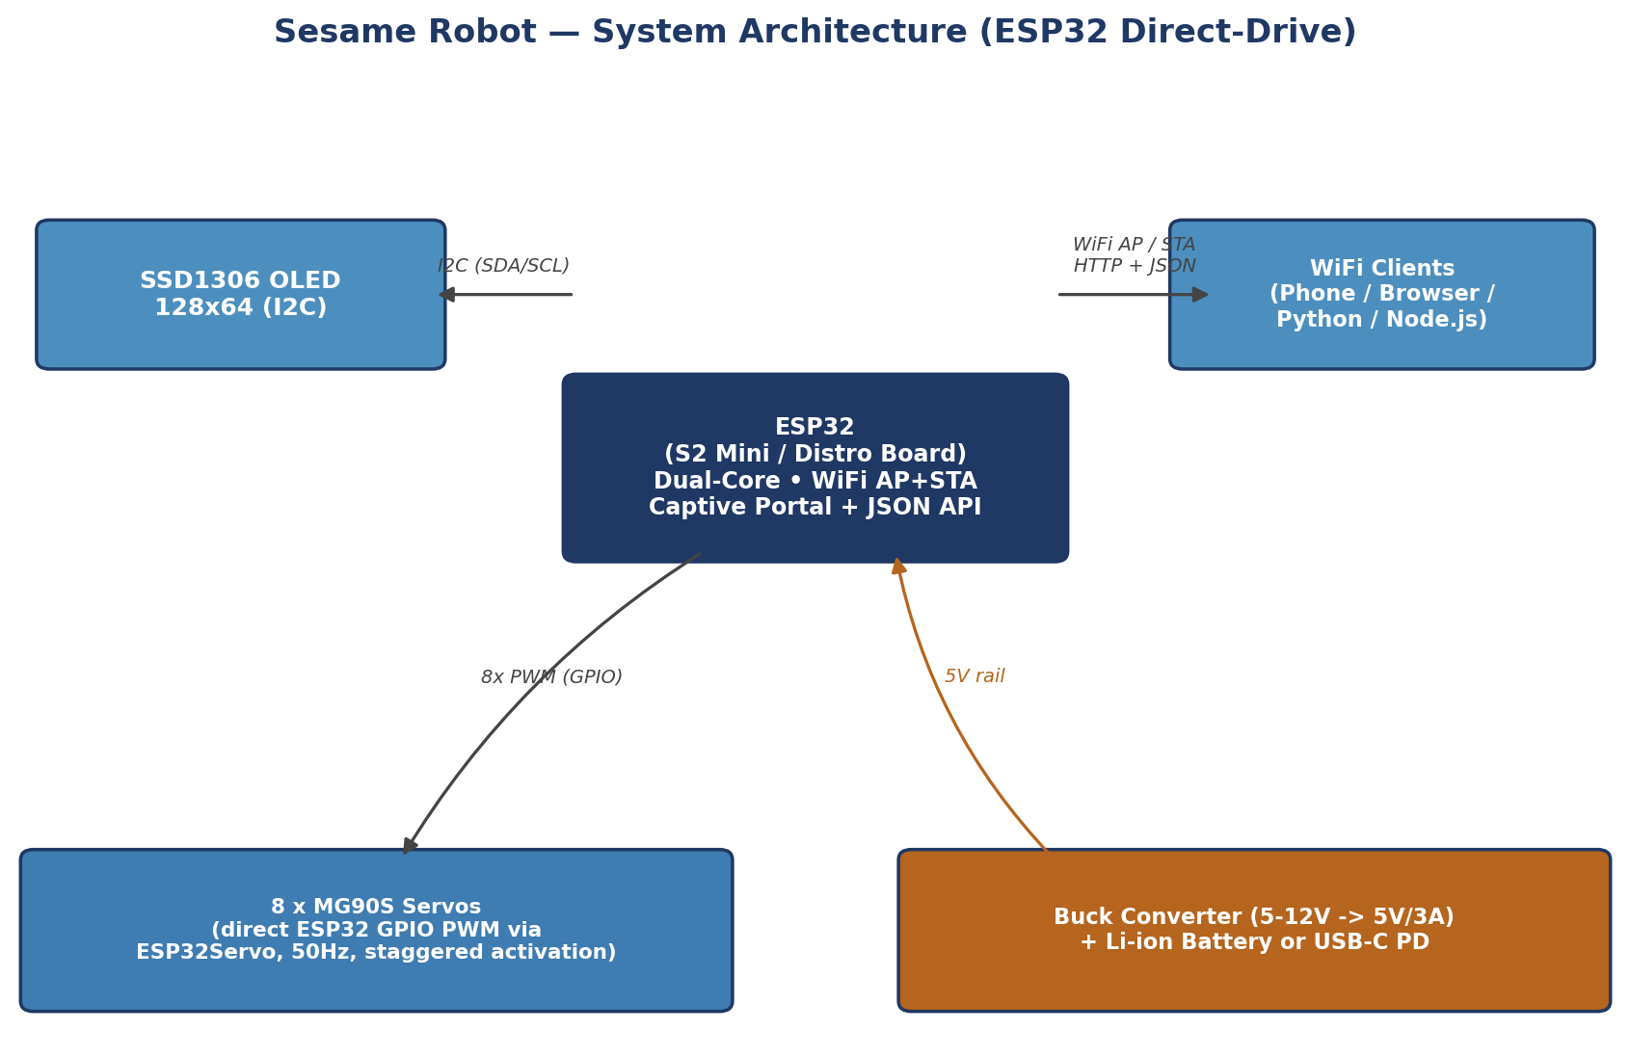
Figure 2: System architecture — ESP32 direct-drives all 8 servos via GPIO PWM (no external servo driver IC), with I2C OLED and dual-mode WiFi.
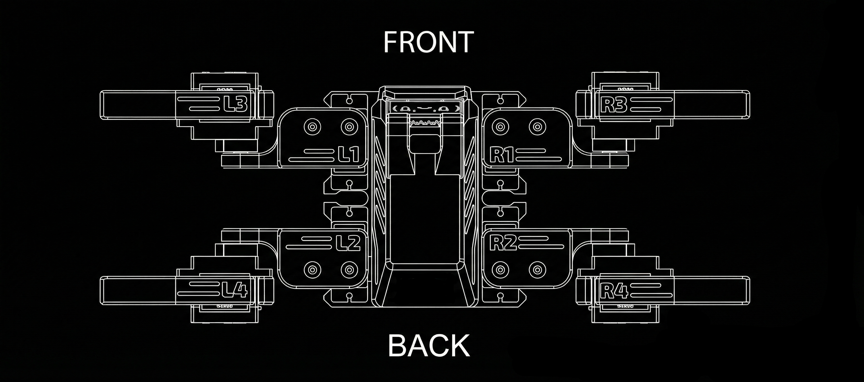
Figure 3: Top-down servo/leg layout and naming convention (L1-L4 left side, R1-R4 right side; FRONT/BACK orientation). (Source: docs/images/sesame-topdown.png)

System/Functional Decomposition
The platform decomposes into five functional layers: (1) Controller — the ESP32 running a single-core event loop with non-blocking HTTP/DNS polling; (2) Locomotion — eight direct-driven MG90S servos executing procedural gait and pose sequences defined in movement-sequences.h; (3) Expression — the OLED display, driven by PROGMEM-stored 1024-byte bitmap frames selected through a FACE_LIST macro, with an idle system that triggers randomized blinking and boomerang animations; (4) Connectivity — the dual-mode WiFi stack, captive portal, mDNS responder, and REST/JSON API surface; (5) Authoring & Simulation tooling — Sesame Studio for visual pose composition, the Sesame Simulator for physics-based gait testing, and the Sesame Companion App for voice-driven control.
Table 1: Bill of Materials (from hardware/bom/README.md)
Component | Qty | Key Specification | Function
ESP32 module | 1 | Lolin S2 Mini (native USB-C) or Sesame Distro Board V1/V2/V3.1 (ESP32-S3) | Main controller, WiFi, PWM timers
MG90S all-metal micro servo | 8 (+2 spares) | 180° travel, metal gear | Leg actuation (2 per leg)
0.96" SSD1306 I2C OLED | 1 | 128x64, monochrome | Reactive face / status display
Sesame Distro Board PCB (optional) | 1 | SMD power & data distribution board, 3A buck converter | Clean servo/OLED wiring, regulated 5V
Buck converter (hand-wired option) | 1 | 5-12V in, stable 5V/3A out | Powers motors + MCU from battery
USB-C PD cable | 1 | 5V/3A capable | Flashing + tethered power
KCD1 rocker power switch | 1 | Panel mount, 2-pin | Main power switch, top-cover mounted
Li-ion battery (Bambu Lab 14500) | 1 | 7.4V, 800mAh | Untethered / wireless operation
22AWG / 30AWG silicone wire | 1 kit each | Power/ground (22AWG), signal (30AWG) | Harnessing
3D-printed PLA part set | 11 parts | PLA/PLA+, 8-10% honeycomb infill | Legs, joints, frame, top/bottom covers

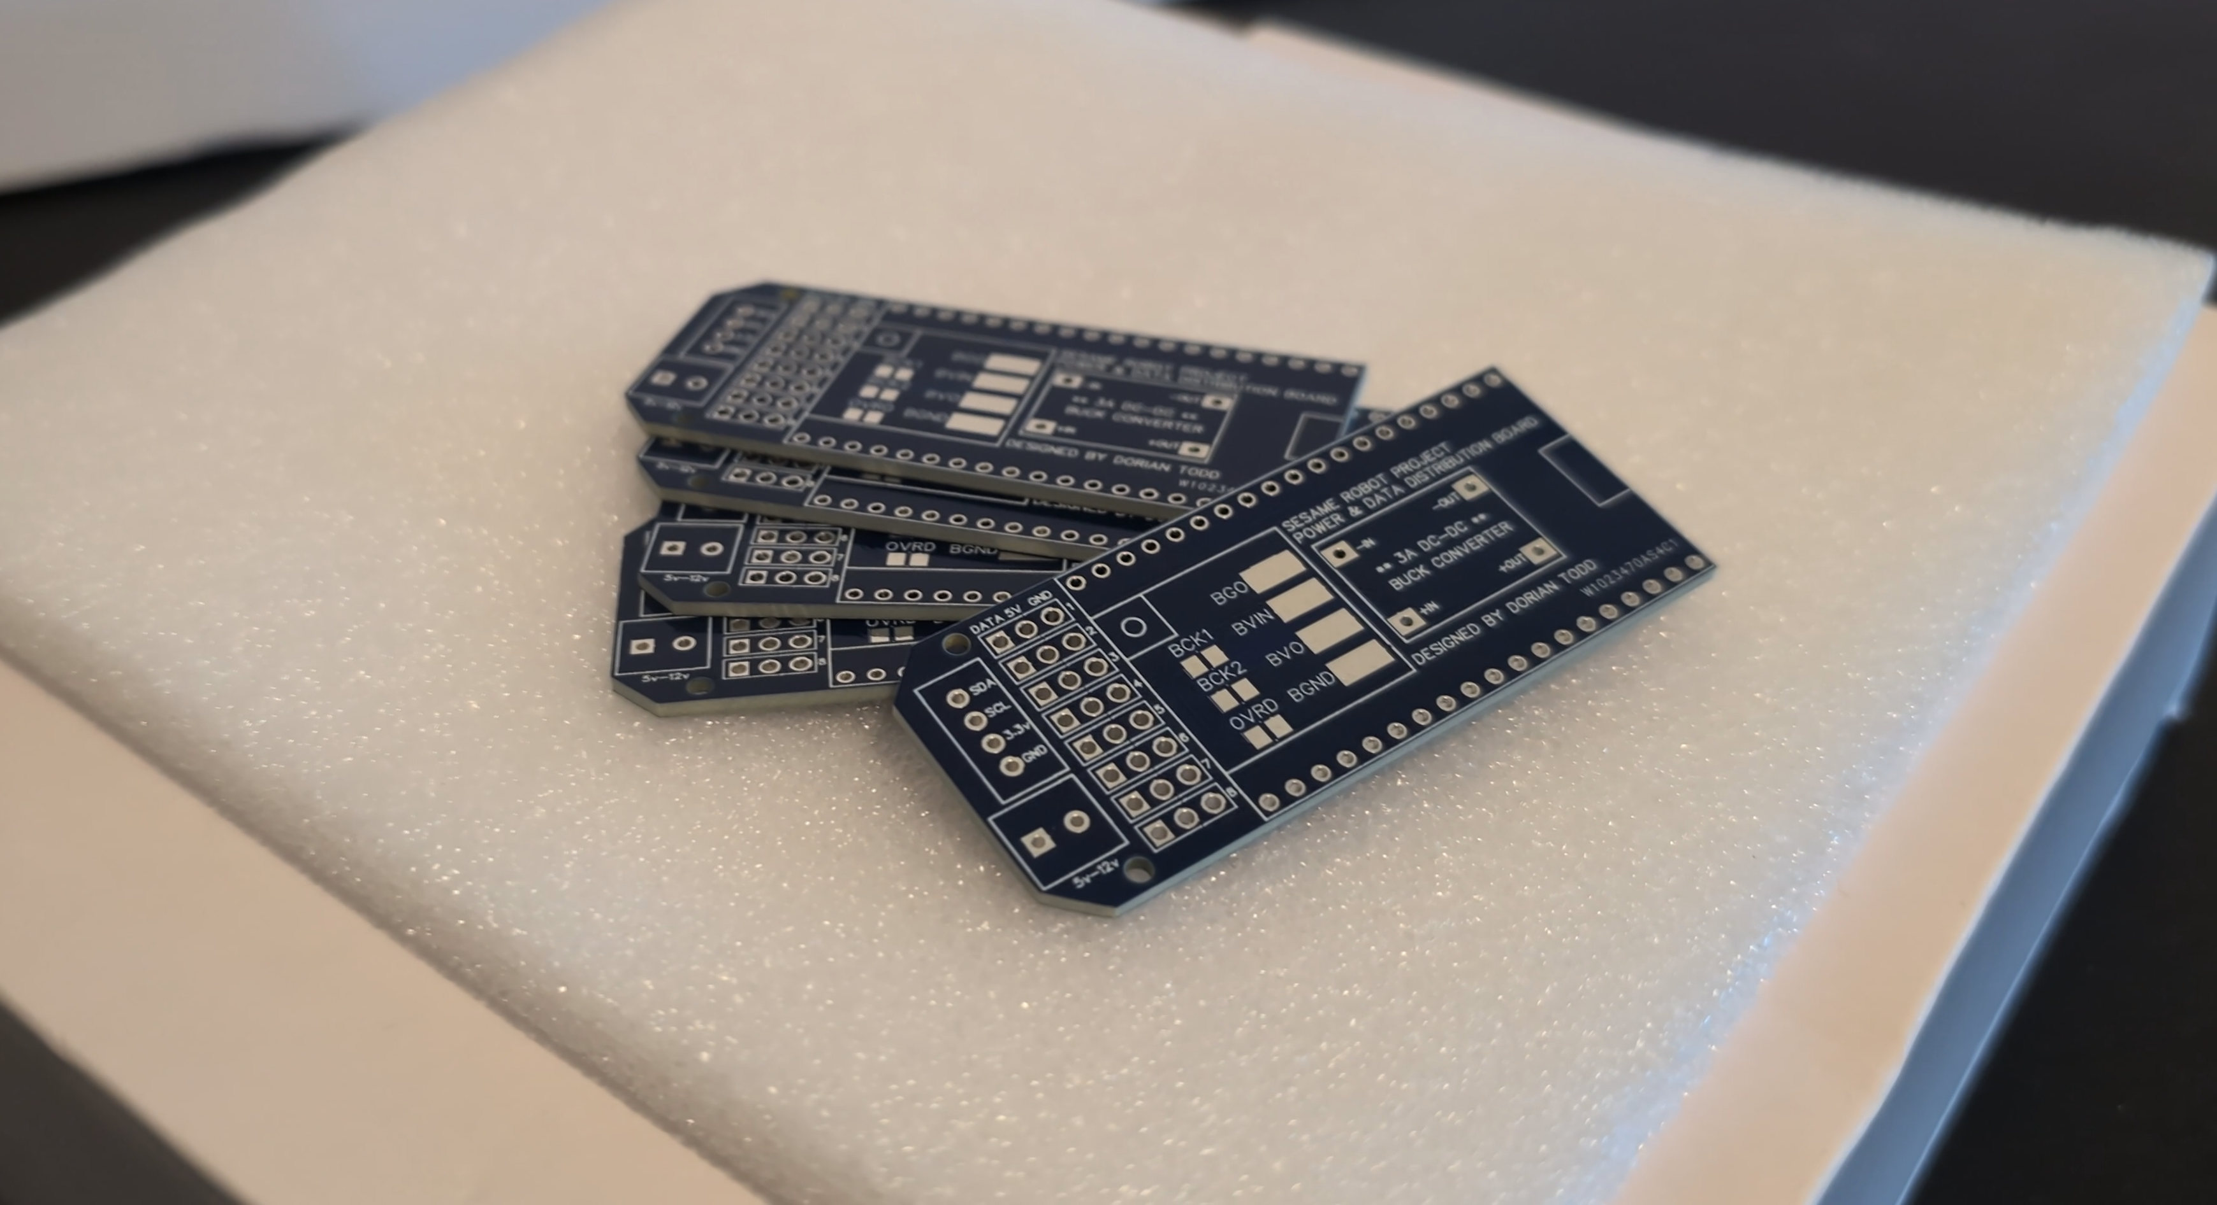
Figure 4: Manufactured Sesame Distro Board PCBs (power & data distribution boards with onboard 3A buck converter). (Source: hardware/pcb/pcbs.png)
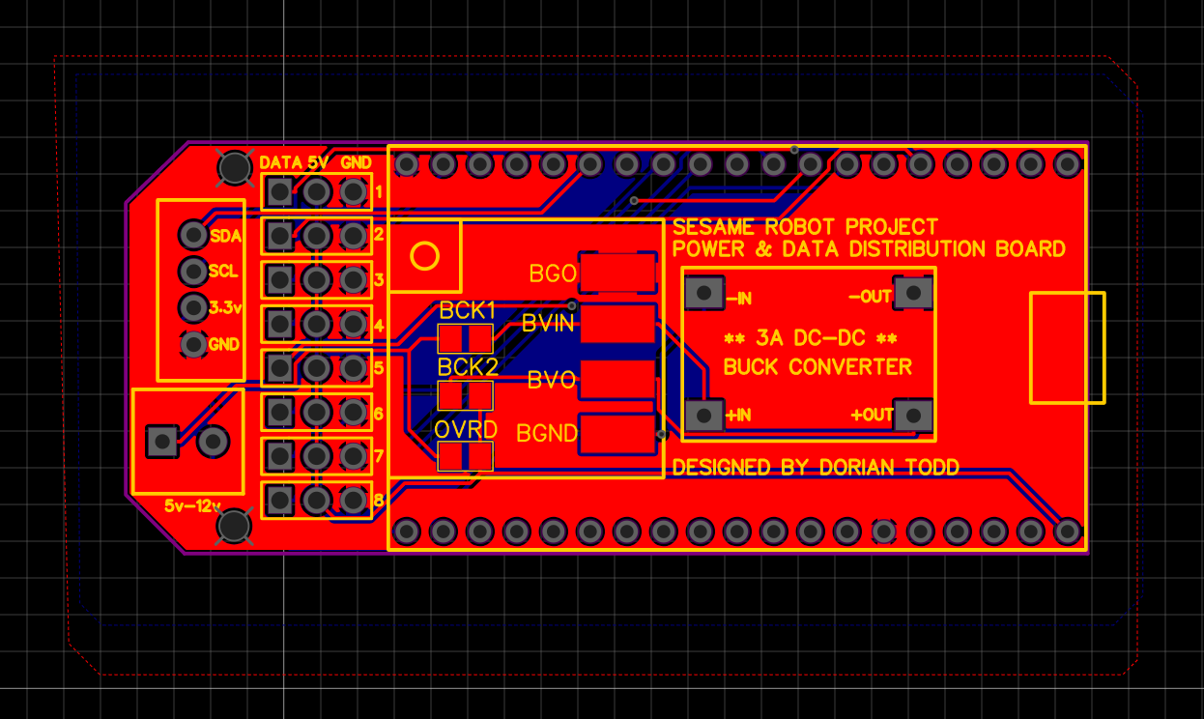
Figure 5: Sesame Distro Board PCB layout — 8-channel servo header row, I2C breakout (SDA/SCL/3.3V/GND), and buck-converter section (BVIN/BVO/BCK1/BCK2/OVRD).

Implementation
The firmware is split across sesame-firmware-main.ino (setup/loop, networking, and API endpoints), face-bitmaps.h (OLED bitmap data and the FACE_LIST macro), movement-sequences.h (pose and gait routines), and captive-portal.h (the embedded HTML/CSS/JS web UI). Eight servoPins arrays are pre-defined for each supported board revision (Distro Board V1/V2/V3, Lolin S2 Mini); only one is uncommented per build. Leg servo pulse widths are mapped from 0-180 degrees to 732-2929 microseconds, matching standard 180-degree hobby servo travel. Instead of blocking delay() calls, the firmware uses a custom pressingCheck(cmd, ms) routine that polls server.handleClient() and the DNS server during every animation frame, keeping the captive portal and API responsive mid-gait and allowing an in-progress movement to be interrupted immediately.
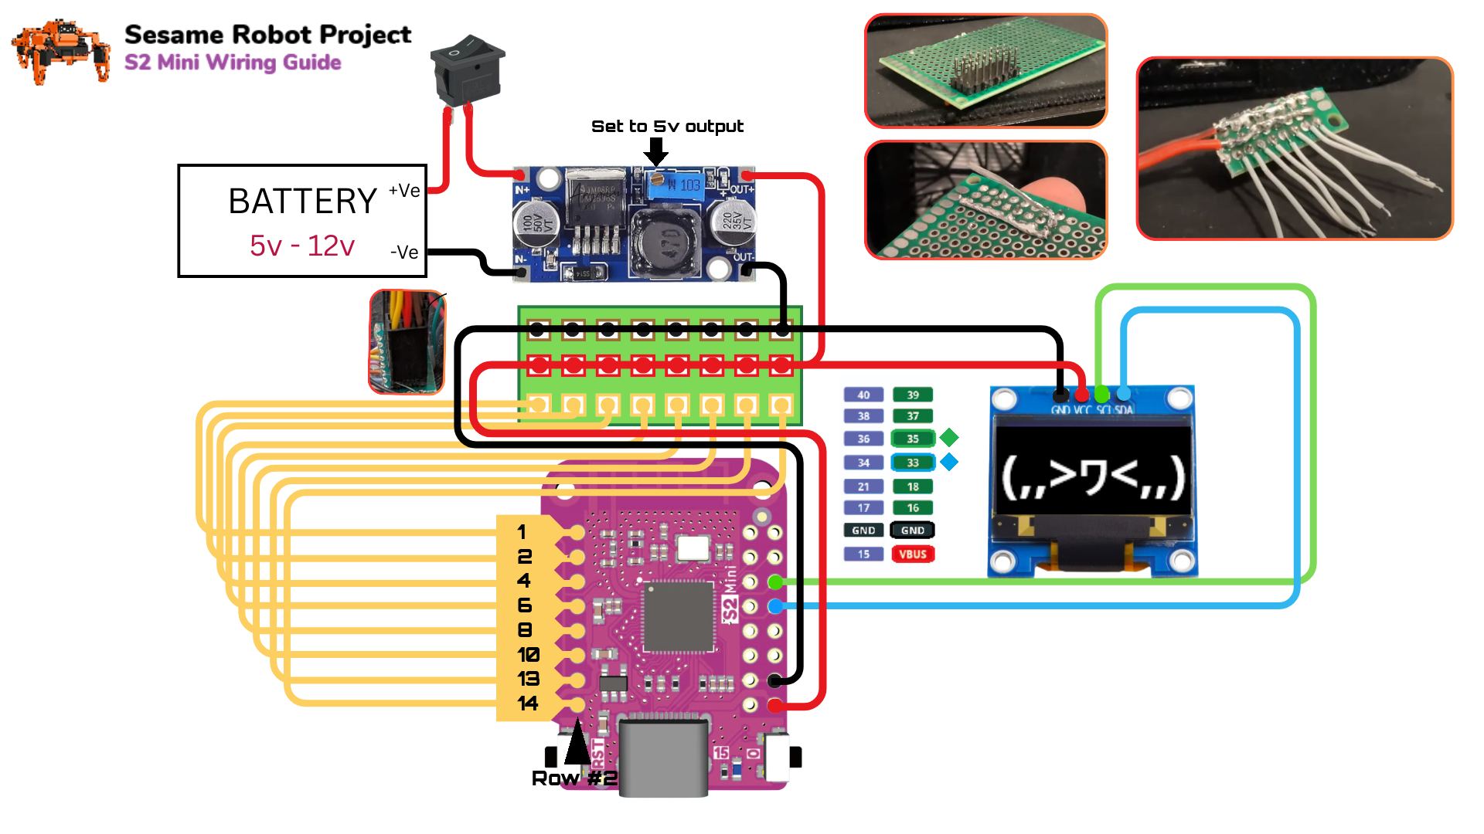
Figure 6: Lolin S2 Mini hand-wiring diagram — battery, buck converter, 8-channel servo breakout, and OLED (SDA=GPIO33, SCL=GPIO35). (Source: docs/wiring-guide, credit @captianeverypowersr)
Table 2: Firmware REST/JSON API Surface (from firmware/README.md)
Endpoint | Method | Purpose
/cmd?go=forward|backward|left|right | GET | Legacy continuous movement control
/cmd?pose=<name> | GET | Legacy pose trigger (e.g. wave, dance, rest)
/cmd?motor=1-8&value=0-180 | GET | Legacy individual motor control
/api/status | GET | JSON status: current command, face, network state, IPs
/api/command | POST (JSON) | Modern command + face control, face-only updates
/getSettings / /setSettings | GET | Read/update frameDelay, walkCycles, motorCurrentDelay, faceFps

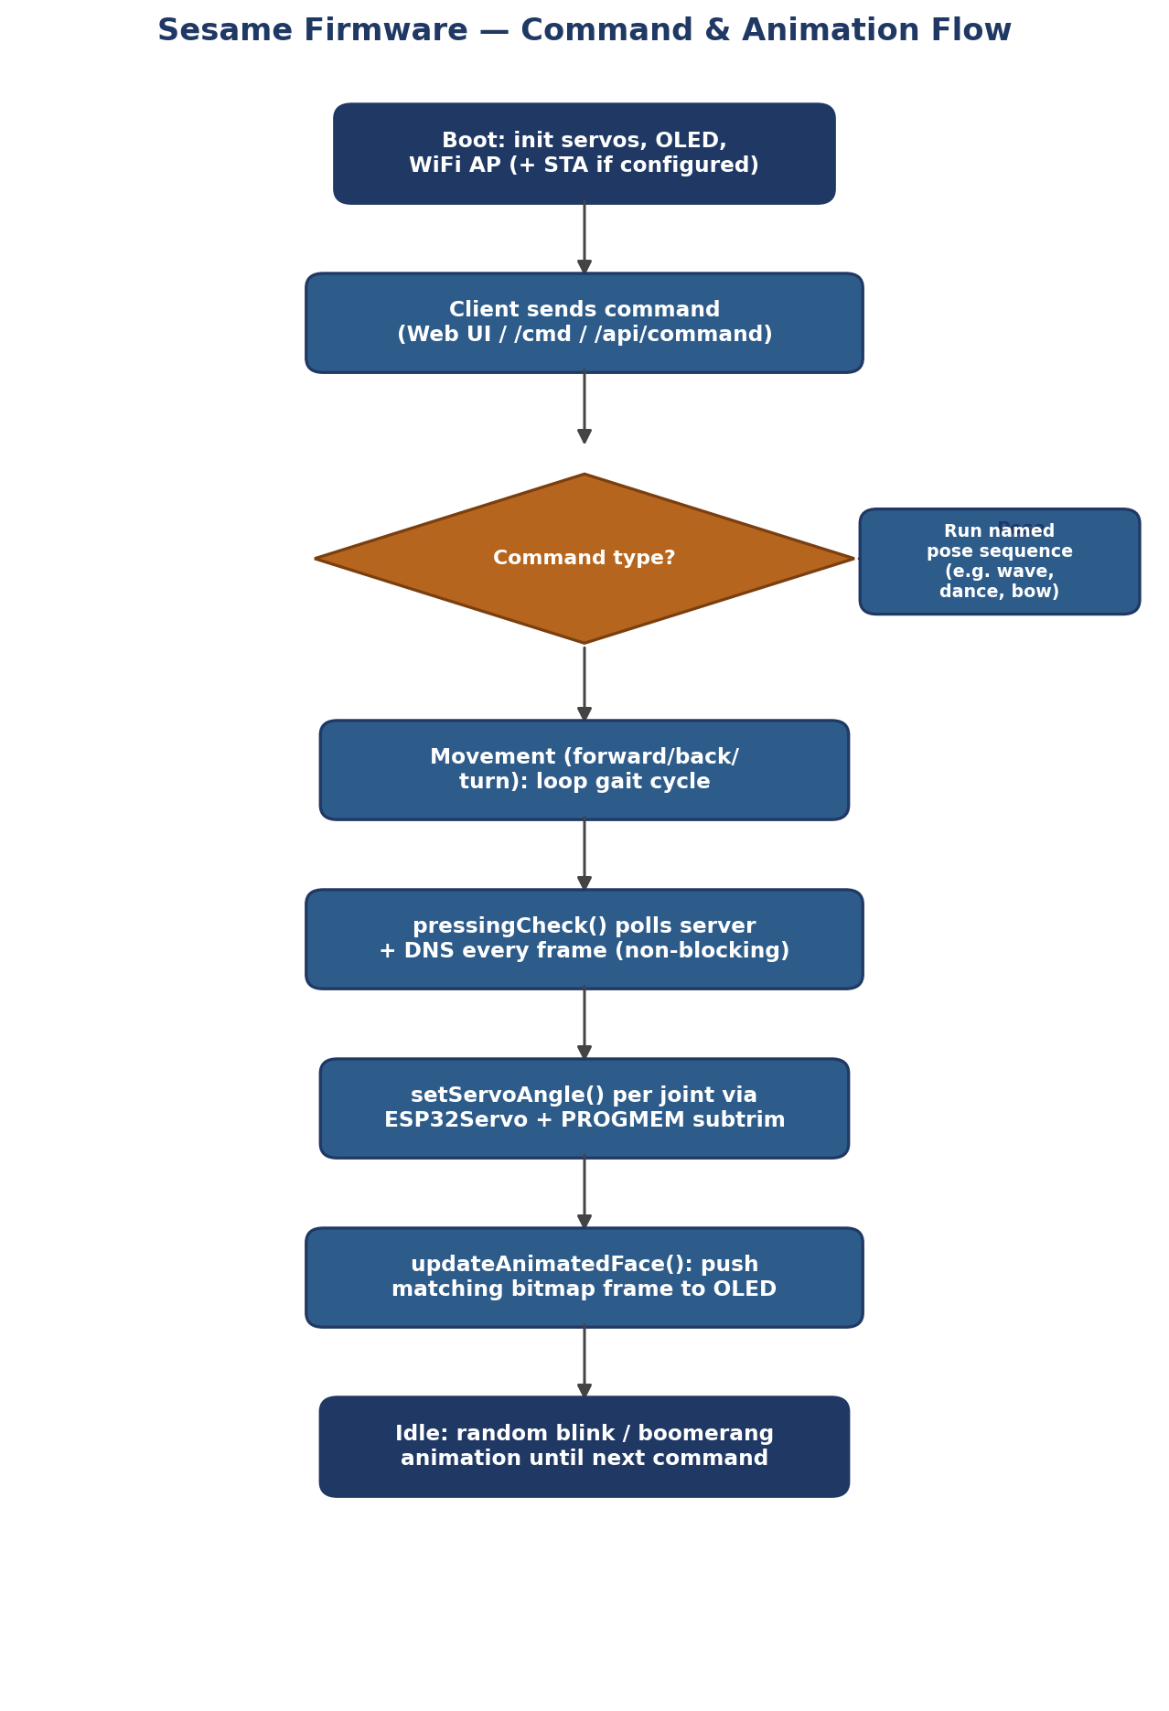
Figure 7: Firmware command and animation execution flow, showing the non-blocking pressingCheck() control loop.

Dataset & Data Processing
Sesame does not train or consume a machine-learning dataset. The closest analogue is its bitmap asset pipeline: monochrome 128x64 face frames are converted to C/C++ byte arrays and stored in flash via PROGMEM, then streamed to the OLED frame buffer by the rendering pipeline. At runtime the JSON API exposes structured status data (current command, current face, network state, AP/station IP addresses) that a client application can log or process as a simple telemetry stream.

AI/ML Model
No onboard AI/ML model is used; all locomotion and expression logic is deterministic, table-driven embedded code, which keeps the implementation within the ESP32's timer and memory budget. The Sesame Companion App adds a voice-assistant layer external to the robot, translating recognized speech into JSON API calls (movement and face commands) rather than running inference on the ESP32 itself — a sensible split given the microcontroller's limited resources.

Experimental Setup
A complete build requires the eleven printed PLA parts, eight MG90S servos, one SSD1306 OLED, an ESP32 board (S2 Mini or a Distro Board revision), a 5 V/3 A power path (USB-C PD or battery plus buck converter), and the fasteners and wiring listed in the project's Bill of Materials. The recommended validation sequence mirrors the repository's own guidance: verify each servo individually via the Serial CLI, confirm all eight channels move to their calibrated neutral position, test each leg's range of motion, validate the standing and walking poses, exercise turning, confirm OLED expression rendering, and finally exercise the JSON API end-to-end (GET /api/status, POST /api/command) from an external client.
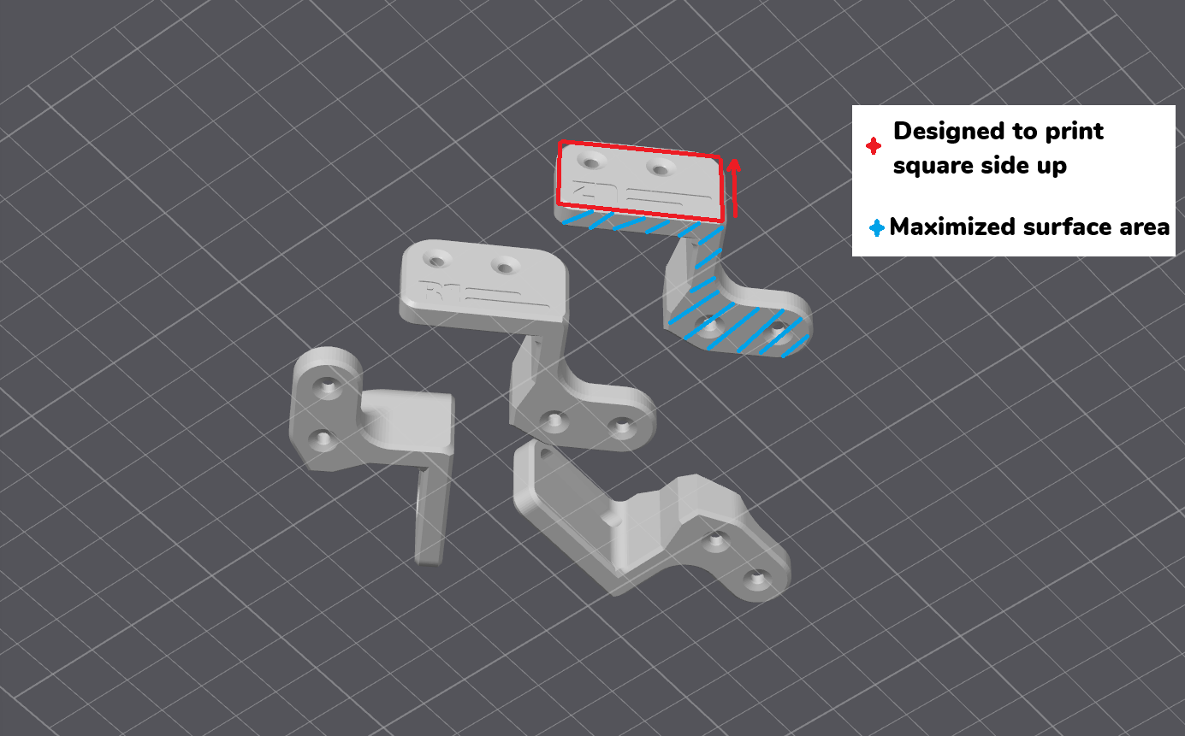
Figure 8: CAD orientation guide for the eight printed leg-joint parts, annotated for optimal print orientation. (Source: hardware/printing/assets)
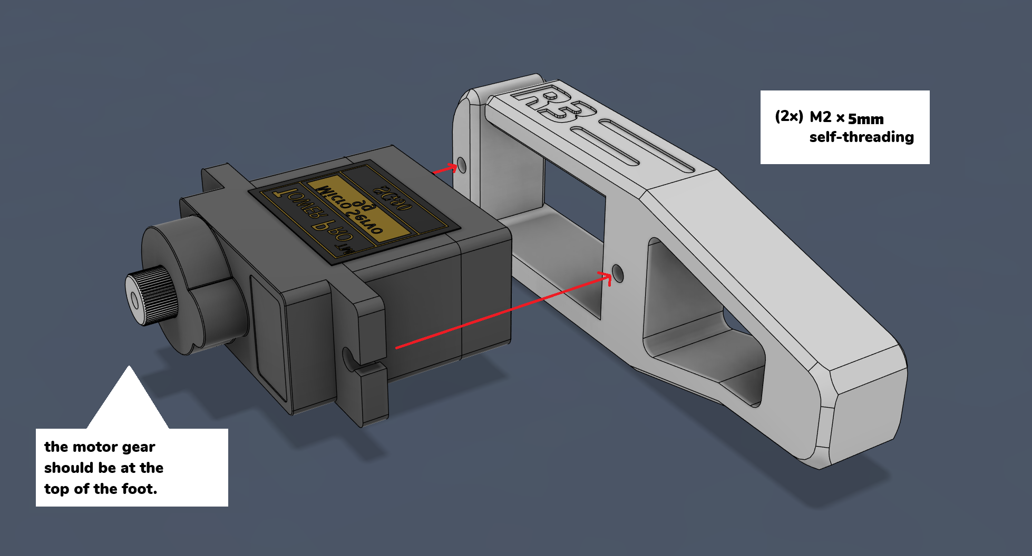
Figure 9: Servo-to-joint assembly detail (R3 leg shown), M2 x 5mm self-threading screw callouts. (Source: docs/build-guide/assets)

Results & Evaluation
The published firmware ships nineteen named procedural poses/gaits — rest, stand, wave, dance, swim, point, pushup, bow, cute, freaky, worm, shake, shrug, dead, crab, walk forward, walk backward, turn left, and turn right — each pairing a servo sequence with a matching OLED expression. Evaluation criteria consistent with the project's own troubleshooting guidance include: successful servo initialization and neutral-position calibration, stable standing posture without brownout resets, repeatable gait execution at the default frameDelay/motorCurrentDelay settings, correct OLED face-to-motion synchronization, successful AP-mode and Station-mode WiFi connection, and correct JSON responses from /api/status and /api/command under both legacy URL-parameter and modern JSON request styles.
Table 3: Pre-Programmed Pose / Gait Library (19 total, from movement-sequences.h)
Category | Named Poses / Gaits
Locomotion | walk (forward), walk backward, turn left, turn right
Static poses | rest, stand, dead, crab
Expressive / social | wave, dance, bow, shrug, shake, cute, point
Novelty | swim, worm, freaky, pushup

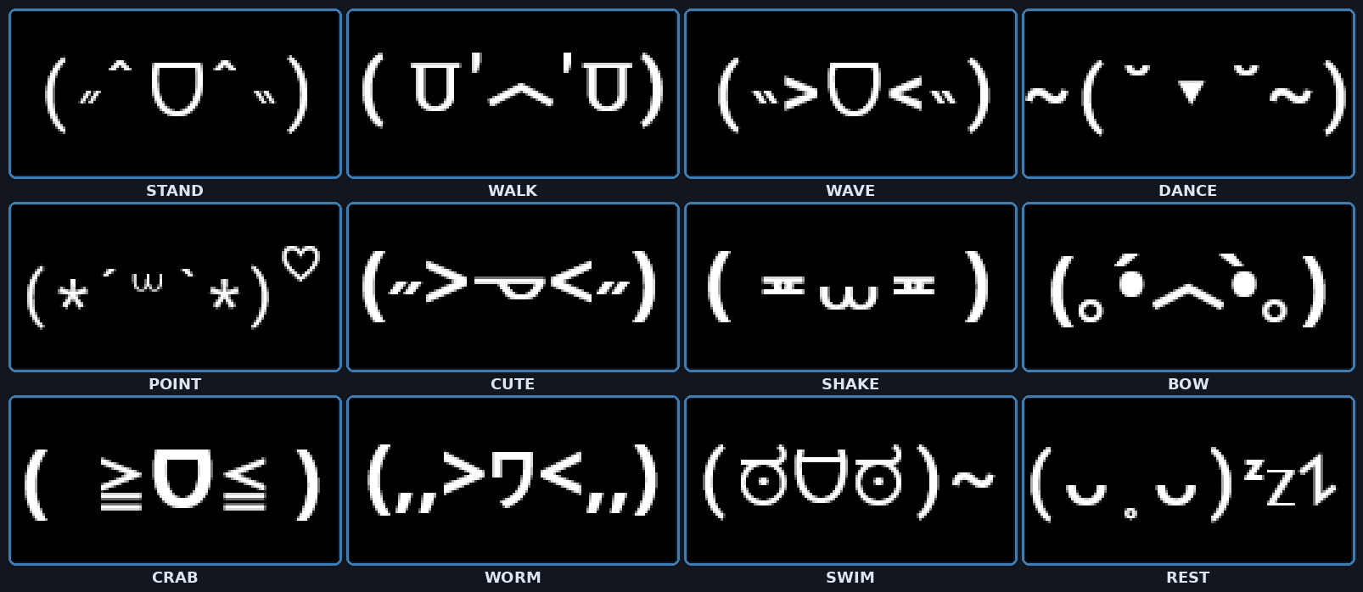
Figure 10: A sample of the OLED expression library — each pose triggers a matching, movement-synchronized face bitmap. (Source: docs/images/sesamefaces)

Discussion
Driving all eight servos directly from ESP32 GPIO pins (rather than through an external PWM driver IC) simplifies the bill of materials and keeps the Distro Board a pure power/data breakout, at the cost of consuming most of the chip's usable timers — a trade-off the firmware's own documentation flags, noting that adding further PWM-driven peripherals (such as extra servos or ESCs) can exhaust the four available hardware timers and destabilize the captive portal. The dual-mode WiFi architecture (simultaneous AP + Station) is a deliberate usability choice: a builder can always fall back to direct AP control even after joining the robot to a home network. The non-blocking pressingCheck() control-flow pattern is notable engineering discipline for a single-core Arduino sketch, since it keeps the HTTP/DNS stack responsive throughout multi-second gait sequences without an RTOS task scheduler.
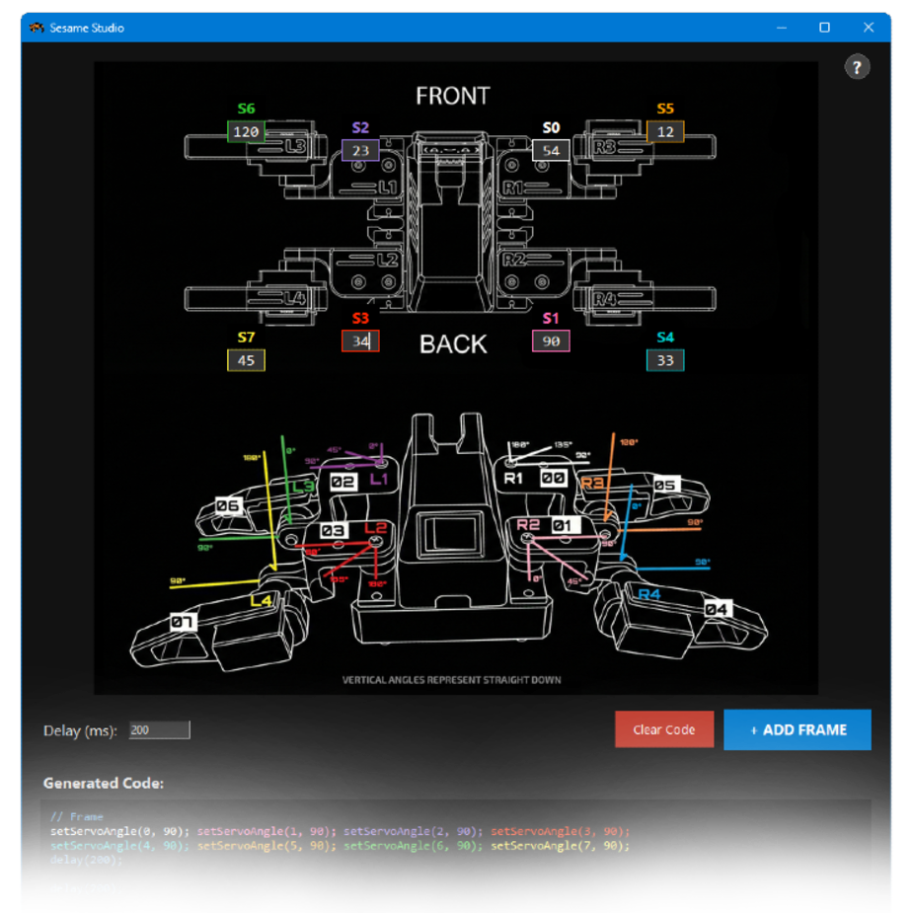
Figure 11: Sesame Studio — the desktop animation composer. Builders pose each of the 8 servos visually and export the frame directly as C++ setServoAngle() code. (Source: software/sesame-studio)

Limitations
The project's own documentation lists several concrete limitations worth preserving here: the ESP32Servo library must be pinned to v3.0.9, since newer releases have a known issue where writing one servo channel can leak into others; the Distro Board V1 cannot run on tethered USB-C power and requires a battery plus buck converter; hardware-timer exhaustion can occur when the firmware is extended with additional PWM peripherals; the WiFi API includes no authentication by default and is intended for trusted local networks only; and runtime-provisioned WiFi credentials (entered through the captive portal) are not persisted to flash by design, so the robot reverts to Access Point mode on every reboot unless credentials are hard-coded at compile time.

Future Scope
The project's own contributing guidelines explicitly invite kinematics improvements, new animations, improved web UI/UX, and sensor integration such as ultrasonic ranging or a gyroscope/IMU for balance and obstacle awareness — none of which are present in the base firmware today. Natural extensions include closed-loop balance correction using IMU feedback, onboard obstacle avoidance (combining an ultrasonic or Time-of-Flight sensor with the existing pose engine), authenticated API access for safer network exposure, and deeper integration between the Sesame Simulator's URDF model and the physical robot for sim-to-real gait tuning.

Conclusion
Sesame demonstrates that a fully open, low-cost quadruped platform can span the entire stack — 3D-printable mechanics, a custom power/data PCB, ESP32 firmware with a real network API, and desktop tooling for animation authoring — while remaining buildable by a single hobbyist for roughly $50-60 in parts. Its direct-drive servo architecture, non-blocking control loop, dual-mode WiFi, and expressive OLED face together produce a platform that is simultaneously a practical embedded-systems teaching tool and a genuinely characterful robot, with a clear and documented path for extension into sensing and autonomy.

References
[1] Todd, D. “The Sesame Robot Project” — official GitHub repository (README.md), Apache 2.0 license.
[2] Sesame Robot — Bill of Materials, hardware/bom/README.md.
[3] Sesame Robot — Hardware / PCB documentation, hardware/pcb/README.md (Distro Board V1, V2, V3.1).
[4] Sesame Robot — 3D Printing Guide, hardware/printing/README.md.
[5] Sesame Robot — Wiring Guide, docs/wiring-guide/README.md.
[6] Sesame Robot — Firmware documentation and API reference, firmware/README.md.
[7] Sesame Robot — movement-sequences.h and face-bitmaps.h (firmware source).
[8] Li, J. “Sesame Simulator” — Rust/WebAssembly physics simulation environment.
[9] Sesame Studio and Sesame Companion App — software/sesame-studio/README.md and companion repository.

