Design and Development of an Enhanced Arduino Uno–Based Expressive Quadruped Robot
Adapting the Open-Source Sesame Robot Chassis with a PCA9685 Driver, Dual-Sensor Obstacle Avoidance, and Bluetooth Control
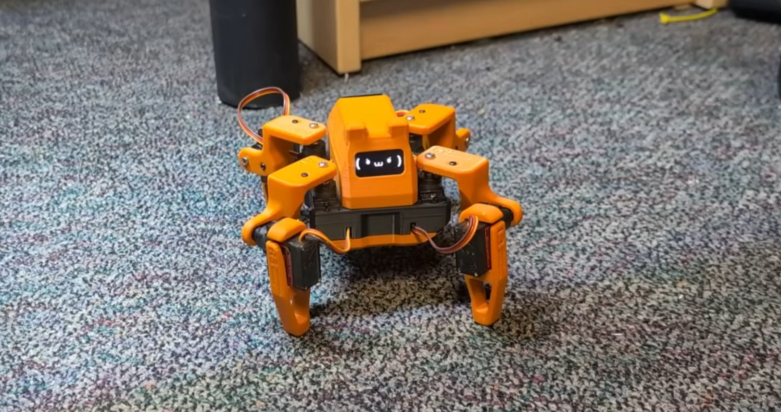
The original Sesame Robot chassis (ESP32 version) whose mechanical design and 8x MG90S servo layout this Arduino Uno adaptation reuses. (Source: Sesame Robot docs/build-guide/assets/sesame-done.png)

Abstract
This report documents the design and development of an Arduino Uno–based expressive quadruped robot, adapted from the open-source Sesame Robot project (originally an ESP32-based platform by Dorian Todd, Apache 2.0 licensed). The mechanical chassis — an eleven-part 3D-printed PLA design driving eight MG90S servos (two per leg) — and the expressive-OLED interaction concept are reused directly from the Sesame reference design. The electronics are redesigned for the Arduino Uno's tighter resource budget: an external PCA9685 16-channel I2C PWM driver generates all eight servo signals in place of the ESP32's direct GPIO drive, an HC-05 Bluetooth serial module replaces WiFi for wireless control, and a VL53L0X Time-of-Flight sensor plus an HC-SR04 ultrasonic sensor add autonomous obstacle avoidance — a capability the base Sesame firmware does not implement. The project ports the Sesame pose/gait library (19 named poses) to PCA9685 PWM output and preserves its movement-synchronized OLED face concept. This report covers the system architecture, functional decomposition, firmware implementation, bill of materials, and evaluation criteria for this enhanced Uno-based adaptation.

Keywords
Arduino Uno; quadruped robot; PCA9685; MG90S servo; SSD1306 OLED; VL53L0X; HC-SR04; HC-05 Bluetooth; obstacle avoidance; open-source robotics; gait control; Sesame Robot adaptation.

Introduction
This project presents an Arduino Uno–based quadruped (four-legged, eight-servo) robot that adapts the mechanical design of the open-source Sesame Robot project — originally an ESP32-based platform created by Dorian Todd — to the ATmega328P-powered Arduino Uno. The Sesame Robot's 3D-printed PLA chassis (eleven parts: eight leg-joint pieces, an internal frame, and top/bottom covers), its eight-MG90S-servo leg architecture, and its expressive 128x64 OLED face concept are reused as the mechanical and interaction-design foundation. The electronics, however, are redesigned around the Arduino Uno, since the Uno lacks the ESP32's native WiFi, multiple hardware PWM timers, and abundant flash/SRAM.
Because a direct one-to-one port is not possible on Uno-class hardware, this build introduces three deliberate enhancements over the original reference design: an external PCA9685 16-channel PWM driver to reliably generate all eight servo signals (solving the Uno's own timer scarcity, a constraint the Sesame firmware documentation itself flags even on the far more capable ESP32), a dual-sensor perception layer (VL53L0X Time-of-Flight and HC-SR04 ultrasonic) for autonomous obstacle avoidance — a capability explicitly requested but not implemented in the base Sesame firmware — and an HC-05 Bluetooth module that replaces the ESP32's WiFi captive portal with a serial wireless command link, so the robot remains remotely controllable despite the Uno having no native networking.

Problem Statement
The challenge is to reproduce the expressive, walking-robot experience of the Sesame Robot on the far more resource-constrained Arduino Uno (16 MHz, 32 KB flash, 2 KB SRAM, and only two usable hardware timers for PWM) without the ESP32's WiFi stack, ESP32Servo library, or spare processing headroom. This requires offloading PWM generation entirely to external hardware, replacing wireless control with a lightweight serial-over-Bluetooth protocol, and adding obstacle sensing that the base project does not include, all while keeping firmware within the Uno's tight flash and SRAM budget.

Literature Review
The Sesame Robot project demonstrates that a servo-driven, eight-degree-of-freedom quadruped with an expressive OLED face and a JSON control API can be built for roughly $50-60 in parts, using direct ESP32 GPIO PWM and a documented mechanical/electrical/firmware pipeline released under Apache 2.0. Its own documentation notes a real constraint even on the ESP32: hardware-timer exhaustion when additional PWM-driven peripherals are added, since only four timers are available. On an Arduino Uno, which has even fewer usable timers and no native WiFi, the same direct-drive approach is impractical for eight independent servo channels plus sensors and wireless control. The PCA9685 I2C PWM driver, HC-05 Bluetooth serial module, VL53L0X Time-of-Flight sensor, and HC-SR04 ultrasonic sensor are all well-documented, widely available components commonly used to work around exactly these AVR-class limitations.

Research Gap
The published Sesame Robot firmware targets ESP32-class hardware exclusively and has no obstacle-sensing capability, despite its own contributing guidelines explicitly inviting “sensor integration (ultrasonic, gyro, etc.)” as a wanted feature. There is therefore a two-part gap: (1) no documented path exists for building the Sesame mechanical design on cheaper, more widely available AVR-class boards such as the Arduino Uno, and (2) the reference firmware ships no obstacle-avoidance logic. This project addresses both by defining a PCA9685-mediated Uno electronics architecture that reuses the Sesame STL files and pose concepts, and by adding a working dual-sensor obstacle-avoidance layer that the original project has not implemented.

Objectives
1. Reuse the Sesame Robot's eleven-part 3D-printed PLA chassis and eight-MG90S leg architecture unmodified.
2. Replace direct ESP32 GPIO servo drive with an Arduino Uno + PCA9685 16-channel PWM architecture.
3. Port the Sesame pose/gait library (19 poses) from ESP32Servo microsecond values to PCA9685 tick units.
4. Render a synchronized, Sesame-inspired expressive face on a 128x64 SSD1306 OLED for every pose.
5. Add VL53L0X + HC-SR04 dual-sensor obstacle avoidance — a capability absent from the base Sesame firmware.
6. Replace ESP32 WiFi/captive-portal control with an HC-05 Bluetooth serial command link.
7. Isolate the servo power rail from Uno logic power to prevent PCA9685-driven brownout resets.
8. Keep the full firmware within the Arduino Uno's 32KB flash / 2KB SRAM budget.

Proposed Methodology
The build reuses the Sesame Robot's own eleven-part PLA STL set and eight-MG90S leg architecture unmodified, so the printing and mechanical-assembly steps follow the original build guide directly. The methodology then diverges at the electronics stage: the Arduino Uno communicates with a PCA9685 over I2C, which in turn generates all eight servo PWM channels; the OLED and VL53L0X share the same I2C bus at their distinct addresses; the HC-SR04 uses two dedicated digital pins (trigger/echo); and the HC-05 Bluetooth module connects via SoftwareSerial for wireless command reception. Firmware is organized in the same modular spirit as the Sesame source (separate pose/gait definitions, face bitmap data, and main control logic) but rewritten for AVR constraints, replacing the ESP32's non-blocking HTTP polling with a non-blocking Bluetooth-serial read inside the main loop.
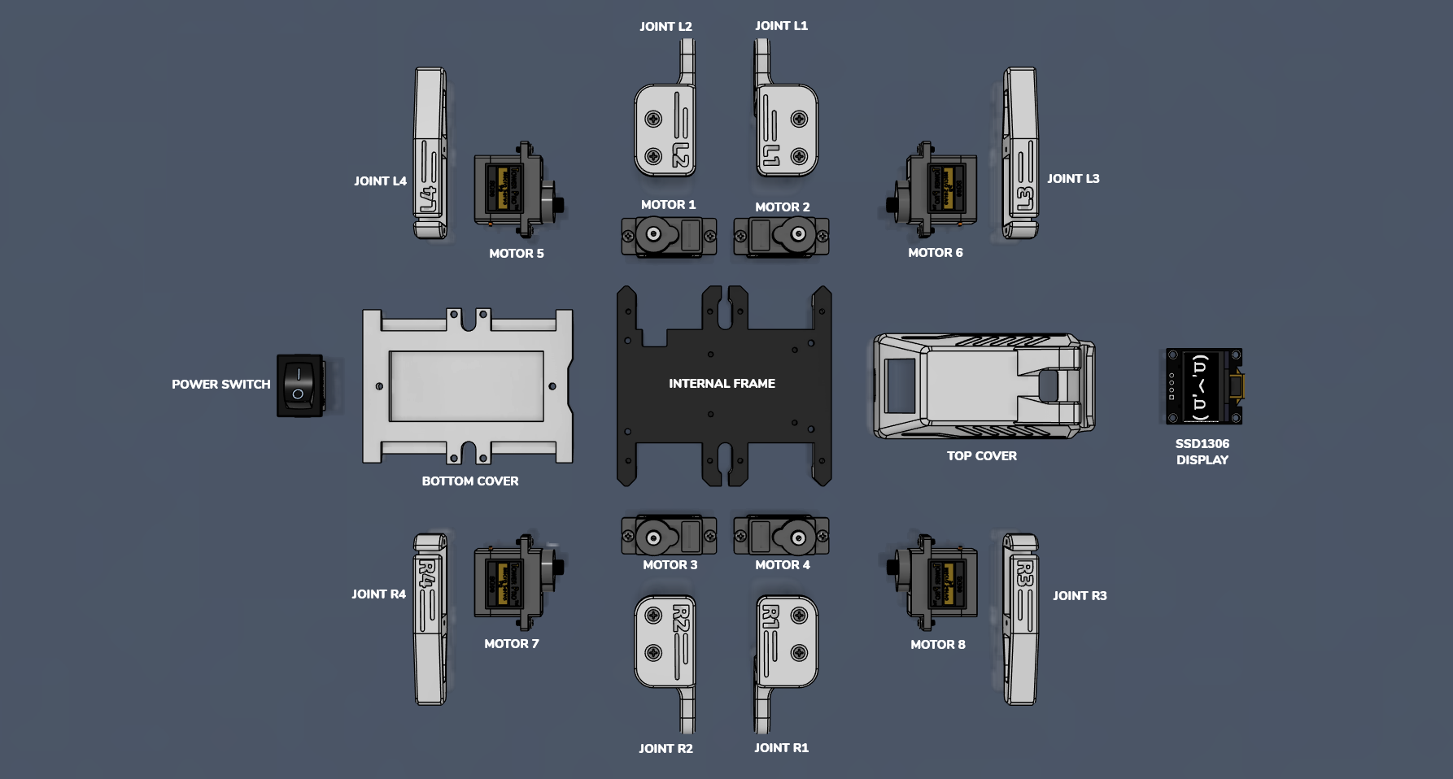
Figure 1: Reused Sesame chassis part inventory — eight MG90S servos, eight printed leg joints (L1-L4, R1-R4), internal frame, top/bottom covers, and OLED mount. (Source: Sesame Robot docs/build-guide)

System Architecture
The Arduino Uno acts as the central controller but no longer drives servos directly. All eight MG90S servo channels are generated by an external PCA9685 16-channel PWM driver over I2C, freeing the Uno's own limited timers for other tasks. The 128x64 SSD1306 OLED and VL53L0X ToF sensor share the same I2C bus as the PCA9685, each at a distinct I2C address, while the HC-SR04 ultrasonic sensor uses two dedicated digital I/O pins for trigger and echo. An HC-05 Bluetooth module attaches via SoftwareSerial, giving a phone or PC wireless command access in place of the ESP32's WiFi captive portal. A dedicated 5V/3A buck converter and battery pack power the PCA9685/servo rail separately from the Uno's own 5V logic supply, preventing servo current spikes from resetting the microcontroller.
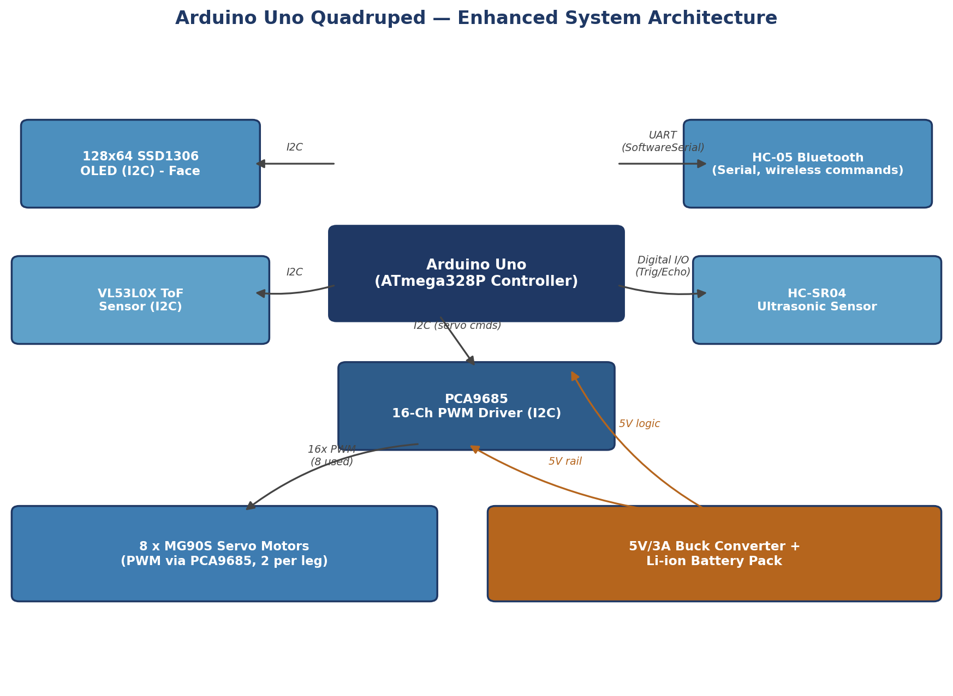
Figure 2: Enhanced system architecture — Arduino Uno + PCA9685 driving all 8 servos, with I2C OLED, dual obstacle sensors, and HC-05 Bluetooth.
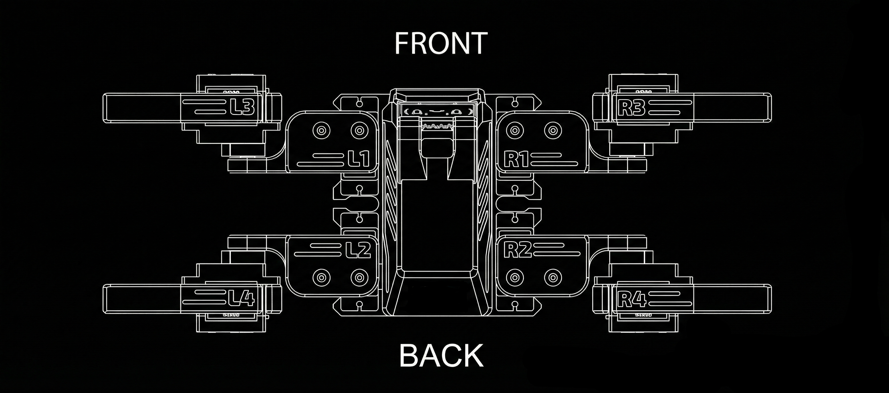
Figure 3: Reused top-down servo/leg layout and naming convention (L1-L4 left side, R1-R4 right side; FRONT/BACK orientation). (Source: Sesame docs/images/sesame-topdown.png)
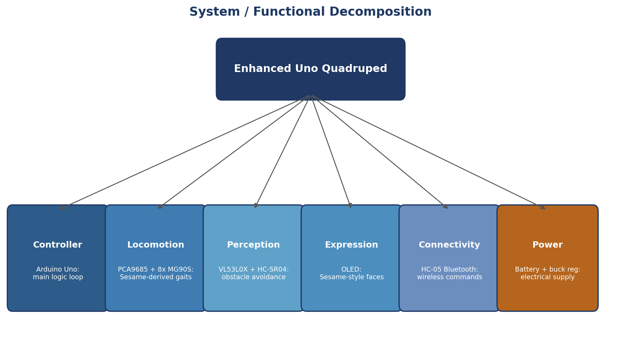
Figure 4: Functional decomposition — Controller, Locomotion, Perception (new), Expression, Connectivity, and Power subsystems.

System/Functional Decomposition
The system decomposes into six functional layers: (1) Controller — the Arduino Uno running the main command/gait loop; (2) Locomotion — the PCA9685 and eight MG90S servos executing Sesame-derived pose and gait sequences; (3) Perception — the VL53L0X and HC-SR04 sensors, an addition not present in the base Sesame firmware, providing autonomous obstacle detection; (4) Expression — the OLED display, rendering Sesame-inspired face bitmaps synchronized to the current pose; (5) Connectivity — the HC-05 Bluetooth module, replacing WiFi with a serial command link; (6) Power — the battery and buck converter supplying a servo-isolated 5V rail.
Table 1: Bill of Materials
Component | Qty | Key Specification | Function
Arduino Uno (ATmega328P) | 1 | 16 MHz, 32KB Flash, 2KB SRAM | Main controller / decision logic
PCA9685 PWM Driver | 1 | 16-channel, 12-bit, I2C | Generates PWM for all 8 servos
MG90S all-metal micro servo | 8 (+2 spares) | 180° travel, metal gear (Sesame-spec) | Leg actuation, 2 per leg
0.96" SSD1306 I2C OLED | 1 | 128x64, monochrome | Sesame-style expressive face
VL53L0X ToF Sensor | 1 | I2C, up to ~2m range | Precision obstacle distance
HC-SR04 Ultrasonic Sensor | 1 | 2cm-400cm range, digital I/O | Secondary obstacle detection
HC-05 Bluetooth Module | 1 | UART, SoftwareSerial, ~10m range | Wireless command link (replaces WiFi)
5V/3A Buck Converter | 1 | 5-12V in, regulated 5V/3A out | Isolated, dedicated servo rail
Li-ion Battery Pack | 1 | 7.4-11.1V nominal | Portable power source
Sesame Robot STL part set (reused) | 11 parts | PLA/PLA+, 8-10% honeycomb infill | Legs, joints, frame, covers

Table 2: Pin and Interface Connections
Module | Arduino Uno Pin | Interface | Notes
PCA9685 | A4 (SDA), A5 (SCL) | I2C | Shared I2C bus, addr 0x40
OLED (SSD1306) | A4 (SDA), A5 (SCL) | I2C | Shared I2C bus, addr 0x3C
VL53L0X | A4 (SDA), A5 (SCL) | I2C | Shared I2C bus, addr 0x29
HC-SR04 Trig | D9 | Digital Out | Trigger pulse
HC-SR04 Echo | D8 | Digital In | Echo pulse width read
HC-05 TX/RX | D2 (RX), D3 (TX) | SoftwareSerial | Wireless command link
PCA9685 / Servo Power | External 5V/3A rail | Power | Isolated from Uno 5V pin
Servos (x8) | PCA9685 CH0-CH7 | PWM | Routed via PCA9685, not Uno pins

Implementation
Firmware is split into logically separate concerns mirroring the Sesame source layout: pose/gait tables (adapted from movement-sequences.h, re-targeted to PCA9685 setPWM() calls instead of direct ESP32Servo writes), face bitmap data (adapted from face-bitmaps.h, stored in PROGMEM given the Uno's 2 KB SRAM budget), and a main loop that replaces ESP32's server.handleClient()/DNS polling with a non-blocking check of the HC-05 serial buffer on every gait frame, preserving the original project's principle of never blocking on delay() during a multi-second animation. Servo pulse widths are calibrated in PCA9685 tick units (12-bit, 4096 steps per 20 ms period) rather than the microsecond values used by ESP32Servo, and a per-channel subtrim table corrects for mechanical assembly tolerance exactly as in the reference firmware.
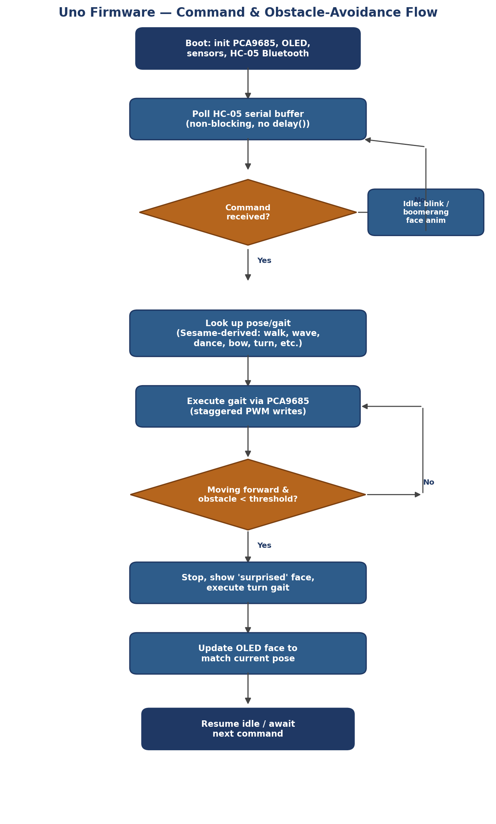
Figure 5: Uno firmware command and obstacle-avoidance flow — non-blocking Bluetooth polling, PCA9685-mediated gait execution, and threshold-based obstacle handling.
Table 3: Bluetooth Serial Command Set (adapted from the Sesame JSON API)
Command (Serial/BT) | Purpose | Adapted From
G,F / G,B | Walk forward / backward | /cmd?go=forward|backward
G,L / G,R | Turn left / right | /cmd?go=left|right
G,S | Stop current gait | /cmd?stop
P,<name> | Trigger named pose (e.g. P,wave) | /cmd?pose=<name>
M,<ch>,<angle> | Individual servo control via PCA9685 channel | /cmd?motor=<n>&value=<deg>
STAT? | Request status string (pose, sensor distances) | /api/status

Dataset & Data Processing
As with the reference project, this is an embedded robotics system with no machine-learning dataset requirement. Sensor data are generated in real time: the VL53L0X and HC-SR04 are each read, validated, and compared against configured obstacle thresholds every control loop iteration, and the resulting state feeds the gait-selection logic. OLED face data are bitmap assets rather than training data, following the Sesame asset-pipeline approach of converting monochrome images to PROGMEM byte arrays.

AI/ML Model
No AI/ML model is used or required; locomotion, expression, and obstacle-avoidance logic are all deterministic, table-driven embedded code, consistent with both the base Sesame project and the Uno's limited computational budget. AI/ML remains a plausible future extension — for example gait optimization or terrain classification — but would very likely need to run off-board given the Uno's 2 KB of SRAM.

Experimental Setup
The experimental setup reuses the Sesame Robot's eleven-part 3D-printed PLA chassis and eight MG90S servos, adding an Arduino Uno, a PCA9685 driver, a VL53L0X sensor, an HC-SR04 sensor, an HC-05 Bluetooth module, a 5V/3A buck converter, and a battery pack. Testing should proceed incrementally, following the same discipline the Sesame project itself recommends: verify each servo individually through the PCA9685, confirm all eight channels reach their calibrated neutral position, validate standing and walking poses ported from the Sesame gait library, test turning, confirm OLED expression rendering, verify Bluetooth command reception from a paired phone or PC, and finally validate obstacle detection and avoidance from both sensors together.
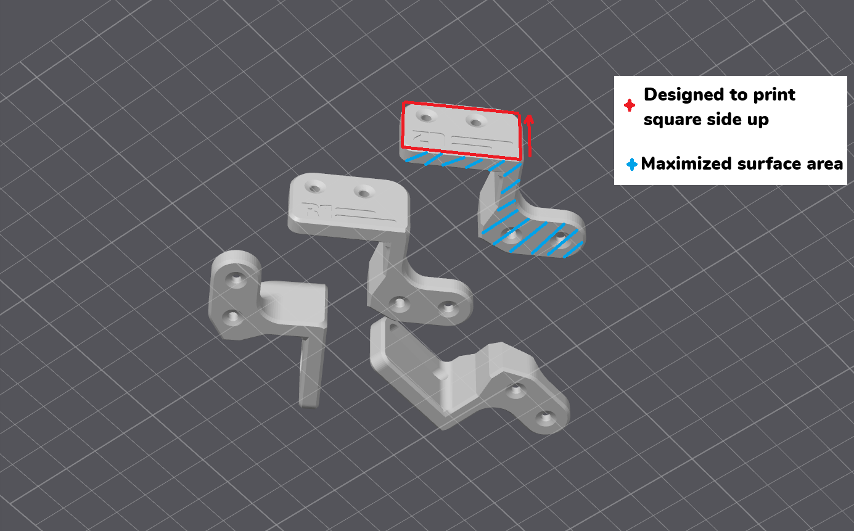
Figure 6: Reused CAD orientation guide for the eight printed leg-joint parts. (Source: Sesame hardware/printing/assets)
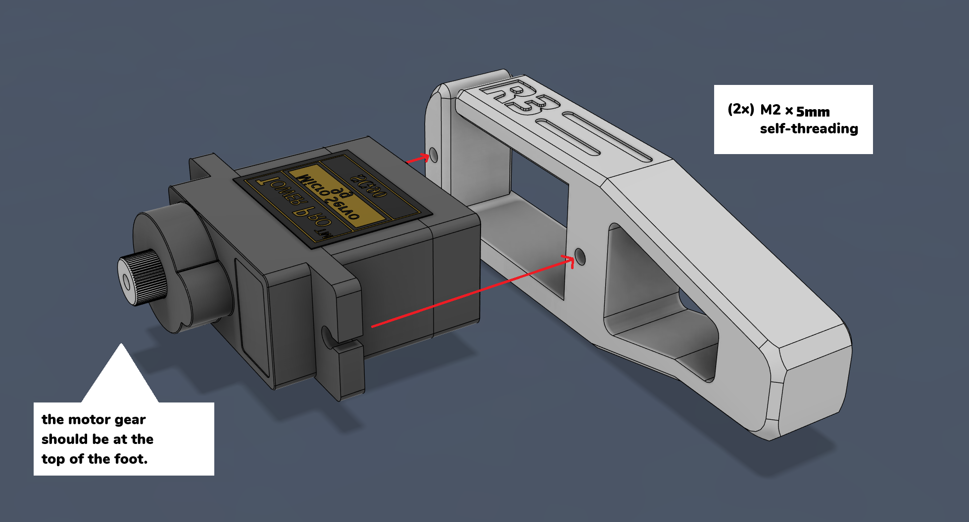
Figure 7: Servo-to-joint assembly detail (leg R3 shown), M2 x 5mm self-threading screw callouts. (Source: Sesame docs/build-guide/assets)

Results & Evaluation
The pose library is ported directly from the Sesame Robot's nineteen named poses/gaits (rest, stand, wave, dance, swim, point, pushup, bow, cute, freaky, worm, shake, shrug, dead, crab, walk forward, walk backward, turn left, turn right), each re-targeted to PCA9685 PWM output and paired with a matching OLED expression. Evaluation criteria include successful PCA9685-mediated servo initialization and calibration, stable standing posture without brownout resets on the isolated servo rail, repeatable gait execution, correct OLED face-to-motion synchronization, reliable Bluetooth command reception, and successful obstacle detection/avoidance using both the VL53L0X and HC-SR04 sensors. Numerical performance figures (walking speed, turning consistency, sensor response distance, battery runtime) should be recorded from the completed physical prototype rather than assumed.
Table 4: Ported Pose / Gait Library (19 total, adapted from Sesame movement-sequences.h)
Category | Named Poses / Gaits (ported from Sesame)
Locomotion | walk (forward), walk backward, turn left, turn right
Static poses | rest, stand, dead, crab
Expressive / social | wave, dance, bow, shrug, shake, cute, point
Novelty | swim, worm, freaky, pushup

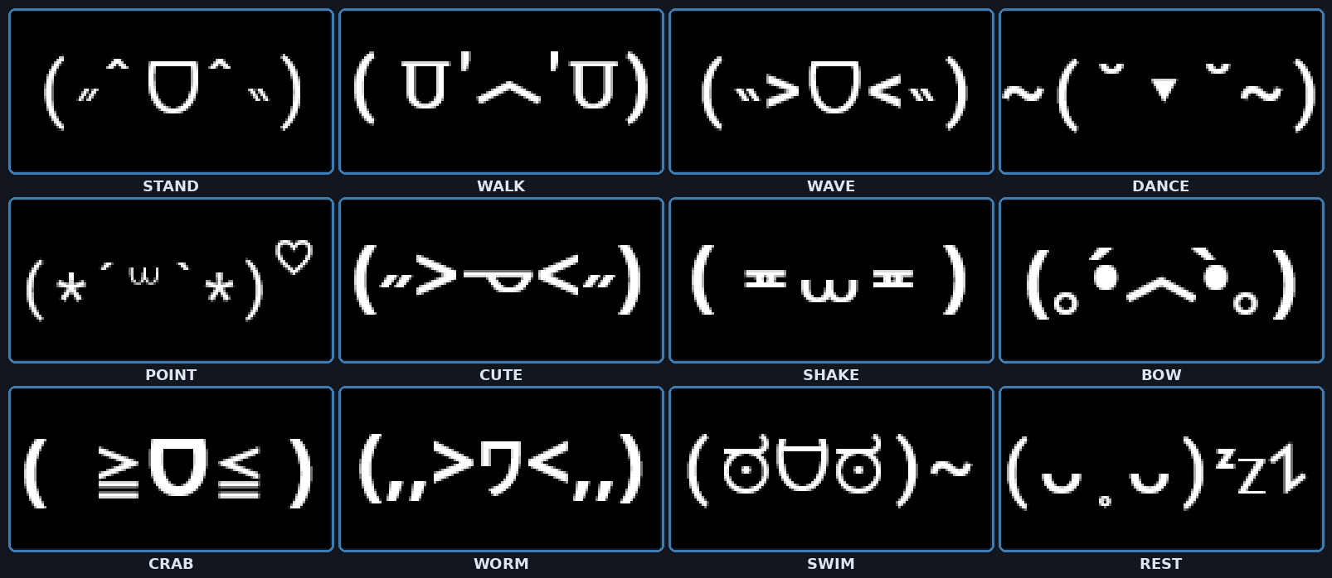
Figure 8: OLED expression library reused from Sesame — each pose triggers a matching face bitmap, rendered here for reference. (Source: Sesame docs/images/sesamefaces)

Discussion
Offloading all eight servo channels to a PCA9685 is the architectural decision that makes this build possible on Uno-class hardware: it sidesteps the Arduino Uno's very limited timer count entirely, in the same spirit as — but more necessary than — the timer-budget caution the Sesame firmware documentation raises for the far more capable ESP32. Replacing WiFi with HC-05 Bluetooth trades the convenience of a full JSON REST API and captive portal for a much simpler serial command protocol that fits comfortably in Uno flash and SRAM. Adding the VL53L0X/HC-SR04 obstacle-avoidance layer directly answers a capability the Sesame project's own contributing guidelines call out as desired but unimplemented, giving this adaptation a concrete, testable improvement over the reference design rather than a like-for-like port.
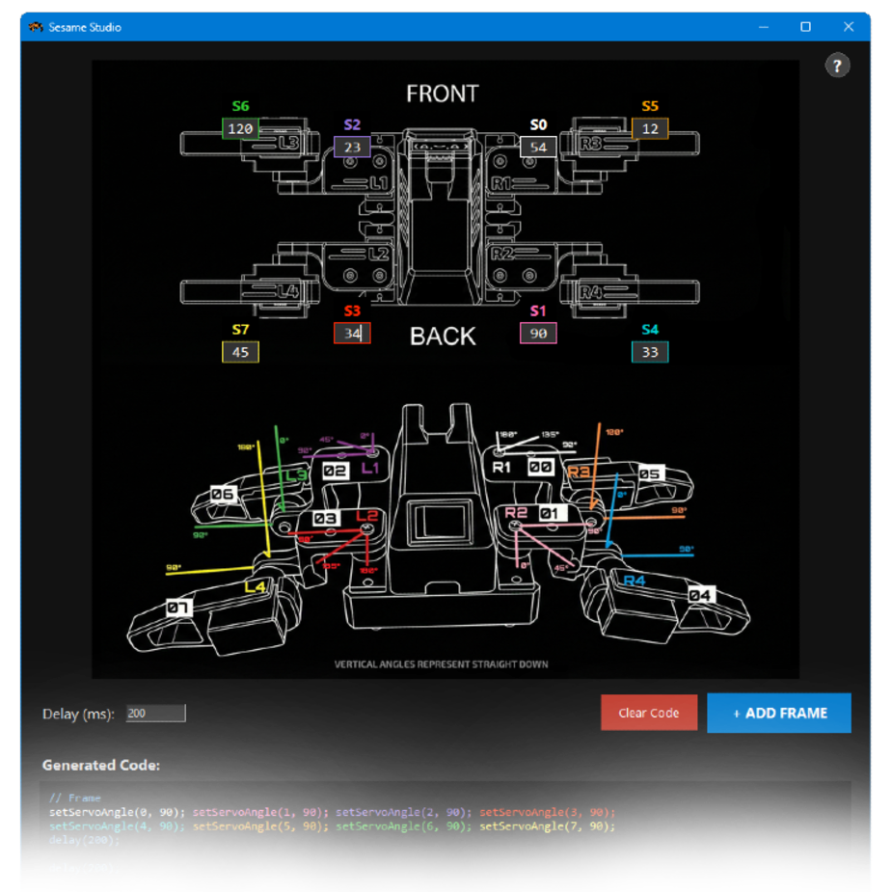
Figure 9: Sesame Studio — the original desktop animation composer from the reference project. A PCA9685-targeted equivalent (exporting tick values instead of microseconds) is a natural companion tool for this Uno adaptation. (Source: Sesame software/sesame-studio)

Limitations
The Arduino Uno has substantially less flash, SRAM, and PWM timer capacity than the ESP32 used by the reference project, so the full nineteen-pose animation set, bitmap face library, and gait tables must be carefully packed into PROGMEM and may need trimming if memory pressure is severe. The HC-05 Bluetooth link offers only point-to-point serial control, not the LAN-wide JSON API, mDNS discovery, or captive portal of the original ESP32 firmware. Obstacle avoidance is rule-based threshold detection rather than semantic scene understanding, and sensor readings remain sensitive to surface material, angle, and ambient conditions. As with the base Sesame project, exact performance figures must be established experimentally rather than assumed from datasheet values.

Future Scope
A natural next step is adding an ESP8266 or similar WiFi co-processor bridged over serial to recover JSON-API-style remote control without requiring an ESP32, effectively re-adding the connectivity layer the base Uno lacks. Further extensions include IMU-based balance correction, terrain-adaptive gait selection, a rewritten desktop pose composer analogous to Sesame Studio but targeting PCA9685 tick values instead of ESP32Servo microseconds, and porting additional Sesame Simulator URDF data for sim-to-real gait tuning on this platform.

Conclusion
This project shows that the Sesame Robot's proven mechanical design and expressive interaction concept can be reproduced on the more widely available and lower-cost Arduino Uno by rethinking the electronics around a PCA9685 PWM driver, an HC-05 Bluetooth link, and a dedicated servo power rail — while going a step further than the reference project by adding real dual-sensor obstacle avoidance. The result is a platform that keeps the character and gait library of the original open-source design while demonstrating a concrete, documented path for adapting ESP32-class open hardware projects to simpler, cheaper AVR-class boards.

