1. 1. Download the AdventureWorks database from the following location and restore it in your server:



2. Restore Backup: Follow the below steps to restore a backup of your database using SQL Server Management Studio:

a. Open SQL Server Management Studio and connect to the target SQL Server instance

b. Right-click on the Databases Node and select Restore Database

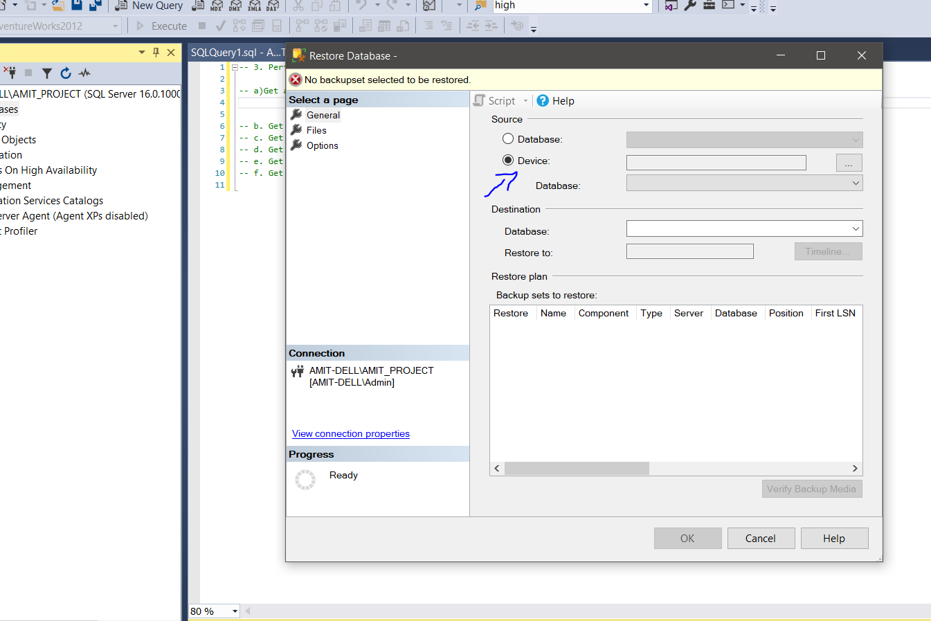

d. In the dialog box, select Backup devices, click on Add, navigate to the database backup in the file system of the server, select the backup, and click on OK

