Docker-Architecture and container
******(OS Level Virtulization)*****
- Docker was first release in March 2013. It was developed by SOLOMAN HYKES and SEBASTIAN PAHL.
- Docker is an open source centralized platform design to create, deploy and run the application.
- Docker uses container on the host OS to run the applications. It allows applications to use the same Linux kernel as a system on the host computer, rather than creating a whole virtual machine.
- We can install docker on any (OS) but Docker engine runs natively on Linux Distribution.
- Dockers written in ‘go Lang’.
- Docker is a tool that performs the OS level Virtualization, also known as Containerization
- Before, Docker many users faces the problem that a particular code is running in one developer system but not in the other user system.
- Docker is a set of Platform as a service that uses the OS level virtualization, whereas VMware uses the Hardware level virtualization.
----IaaS---Paas---Saas

Advantages of the Docker
- No-Pre allocation of RAM.
- CI-efficiency: Docker enables you to build a container image and use that same image across every step of the development process.
- Less Cost
- It is light weighted.
- It can run on any platform H/W or Virtual Machine or Cloud.
- You can re-usage the image.
- It took very less time to create the container.
- It is a CLI (Command Line Interface).
Disadvantages of the Docker
- Docker is not a good solution for application that requires the rich UI.
- Difficult to manage large amount of containers.
- Docker does not provide Cross Platform Compatibility means if an is designed to run in a docker container on windows, then it can’t run on the Linux container or Vice versa.
- No solution for Data Recovery and Backup.

DockerFile
DockerFile is basically a text file. It contains some set of Instructions.
All instruction are given in the capital letter.
FROM: It is used for base image. This command must be on the top of the DockerFile.
RUN: To execute commands, It will create a layer in image.
MAINTAINER: Author/Owner/Description
COPY: copy files from the local system; we need to provide the source and destination.
ADD: This command is similar to the copy command but provides a feature to download the files form the internet, also we extract the files at docker image side.
EXPOSE: to expose ports.
WORKDIR: to set working directory for container.
CMD: Execute commands during container creation.
ENTRYPOINT: is similar to the CMD command (High Priority)
ENV: Environment Variables.

FROM - Base image that you want to start off with.
A Dockerfile needs to start with this. (or can only be preceded by ARG -
in case you want to pass in a version to the FROM tag)

LABEL - This allows you to add labels to your image. (eg. Maintainer name and email)

ADD - This copies files from the host machine to the container filesystem.
This includes handling of tar and URL handling.
However, COPY is preferred for moving files between the host and container file system.
The only reason being that it might do some added steps such as decompress your
tar automatically, etc. It can still definitely be used as long as you know what it will do.

COPY - Same as ADD, but without the tar and remote url handling

WORKDIR - Sets the working directory for the RUN, CMD, ENTRYPOINT, COPY and ADD
instructions that are specified after it is used.
You can run this instruction multiple times within the Dockerfile and the commands
under it will then use the latest directory specified by WORKDIR.

ARG - These are arguments you might want to pass in during build-time only.
Such as version of the base image, or perhaps the path of the war file you might want to
pass in.

ENV - Sets environment variables within the docker container.
The cool thing about this is that they can be set during runtime from the command line.

EXPOSE - Essentially lets the docker container know to enable networking for this port
as it will likely be used by the outside world.

RUN - We use this to run commands during the build phase to add layers onto the image itself.
Something that you want the image to have. (Eg. Your application code or some form of it)

CMD - We use this to run a command at the end that we always want the image to run.
(*Note: All CMD specified before are ignored except the last one* ).
Allows you to override the parameters when you run the docker container via command line.

ENTRYPOINT - Similar to CMD, but doesn't allow you to override the command and parameters
via the command line.

Components of Docker-Ecosystem
- Docker-Daemon(Engine)-Server
- Docker Engine runs on the Host Operating System.
- It is responsible for running containers to manage Docker services.
- Docker Engine can communicate with other Docker Engine.
- Docker Client
- Docker users can interact with Docker Daemon through a client(CLI)
- Docker client uses commands and Rest API to communicate with the Docker Daemon.
- When a client runs any server command on the Docker Client Terminal, The client terminal sends command to the Docker Daemon.
- It is possible for docker client to communicate with more than one Docker Daemon.
- Docker Hub/Registory
- Docker registory manages an stores the docker images
- There are two types of registories in the Docker.
- Private Registory.
It is used to store the images with in the enterprise/company.
- Public Registory.
Public registory is also called as Docker Hub.

- Docker Images
Docker images are the read only binary templates used to create Docker Container.
Single file with all dependencies and configuration require to running a program or container.
- Docker Container
Docker container hold the entire packages that is needed to run an application.
In other words we can say that the image is a template and container is a copy of that template.
Docker container is like as a Virtual Machine.
Docker Image becomes container when they run on the Docker Engine.
- Docker Host
Docker host is used to provide and Environment to execute and run the application. It contains the docker Daemon, Images, Containers.
Networking commands
1) docker network create employee-network
2) docker container run --name employeedb --network employee-network -e MYSQL_ROOT_PASSWORD=root -e MYSQL_DATABASE=mysqlempdb -d mysql:5.7
3) docker build -t employeeapi . -f DockerFile

- docker container run --network employee-network --name employee-nitin-container -p 8091:8085 -d employeeapi

Architecture of the Docker:
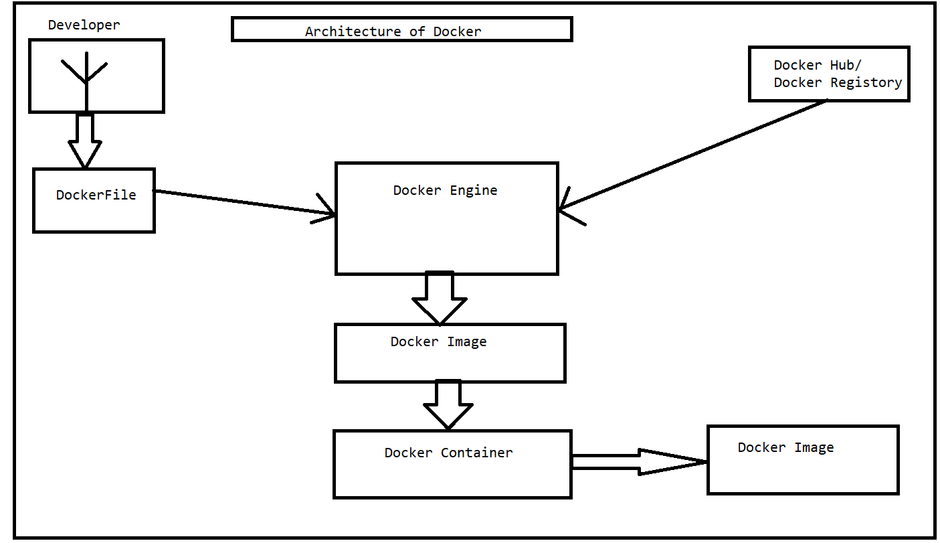

Question Very Important
Ways to create Images
- Take Image form the Docker Hub.
- Create Image form the Docker File.
- Create Image form the existing Container.

Docker Volume
- Docker Volume is simply a directory inside your container.
- Firstly, we have to declare this directory as a volume and then share the volume.
- Even if we stop the container, still we can access the volume.
- Volume will be created in one container.
- You can declare a directory as a volume only while creating container.
- You cannot create Volume from the existing container.
- You can share one Volume across any number of containers.
- Volume will not be included when you update an image.
- You can mapped Volume in two ways.
- Container to Container.
- Host to Container.
Advantage of Docker Volume.
- Decoupling container from storage.
- Share Volume among different containers.
- On deleting container, Volume does not deleted.

Docker Commands
- To see all the images present in your local system(m/c)
docker Images
- To find out images in Docker hub.
docker search opnejdk
- To give name to container.
i->>>Interactive Mode
t ->>>terminal
docker run –it - -name sumancontainer openjdk
RUN->>>CREATE + START
- To Start a container
docker start <Container_Name/Id>
- To see the entire container.
docker ps –a(start/stop both container)
docker ps(only start container)
- To stop a container
docker stop < Container_Name/Id >
- To delete a container
Docker delete < Container_Name/Id >
- Create image from the Docker File.
docker build –t <image_name> . –f <DFile>
- To run an image.
Docker run –p 8080:8080 –name <container_name> <Image_Name>
1) docker network create employee-network
2) docker container run --name employeedb --network employee-network -e MYSQL_ROOT_PASSWORD=root -e MYSQL_DATABASE=mysqlempdb -d mysql:5.7
3) docker build -t employeeapi . -f DockerFile
4) docker container run --network employee-network --name employee-nitin-container -p 8091:8085 -d employeeapi
10) Command to enter in a container.
docker exec –it <container_name/id> bash
Docker Compose(.yaml):
Is used to run more then one container at a time.
--→> docker-compose up
->>> docker-compose down.

