AWS S3 Static Website Hosting


Architecture Diagram
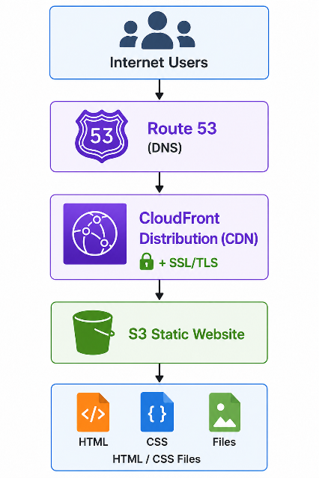
Services Used
Service Purpose
Amazon S3 Store static website files
CloudFront CDN for global content delivery
Route 53 Domain and DNS management
ACM SSL/TLS certificate management
IAM Access control and permissions
Permissions Required
Amazon S3 Full Access
CloudFront Full Access
Route53 Full Access
ACM Full Access

Implementation
Create Bucket
Navigate AWS Console → S3 → Create Bucket
Bucket Name: staticsite.bandarkarami.com
Region: ap-south-1 (Mumbai)
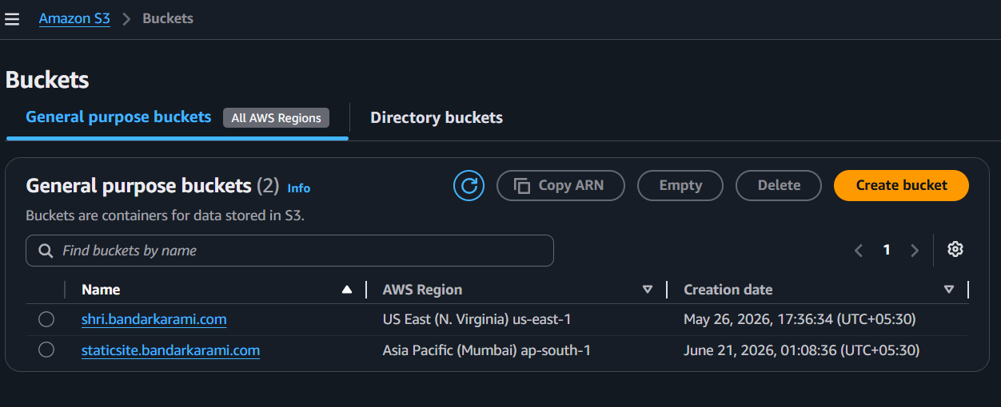
Upload files
index.html
css/
images/
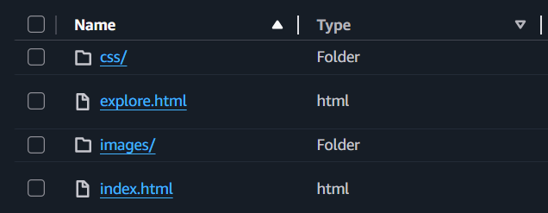
Enable Static Website Hosting
S3 Bucket → Properties
Static Website Hosting : Enable
Index document : index.html
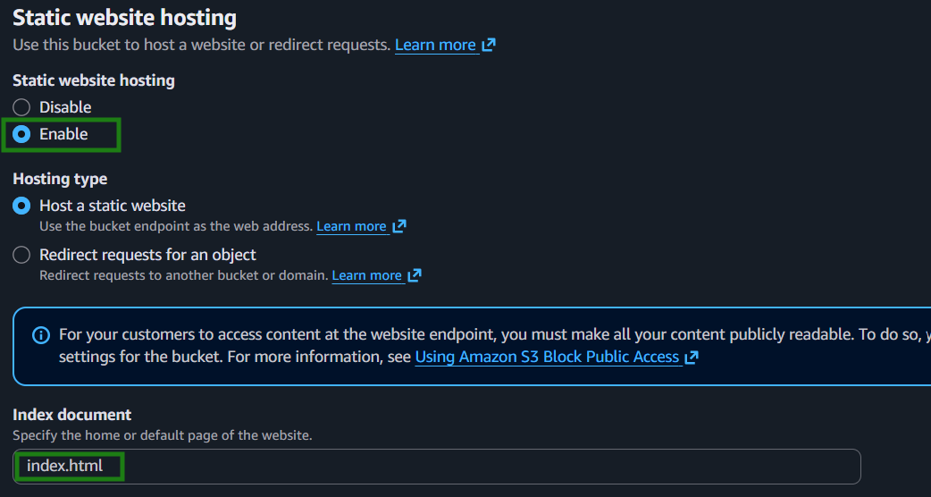
Configure Bucket Policy
Block all public access : Turned Off
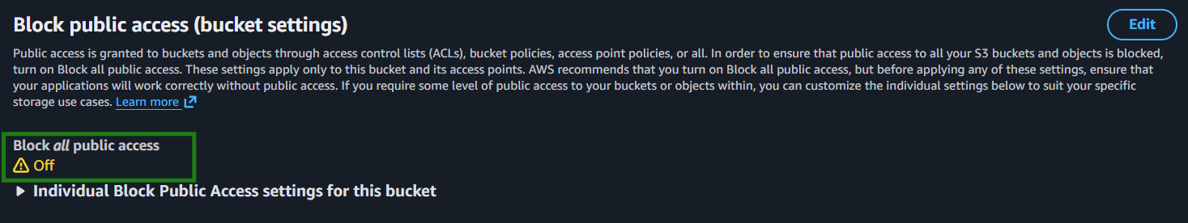
{
"Version": "2012-10-17",
"Statement": [
{
"Sid": "PublicReadAccess",
"Effect": "Allow",
"Principal": "*",
"Action": "s3:GetObject",
"Resource": "arn:aws:s3:::staticsite.bandarkarami.com/*"
}
]
}
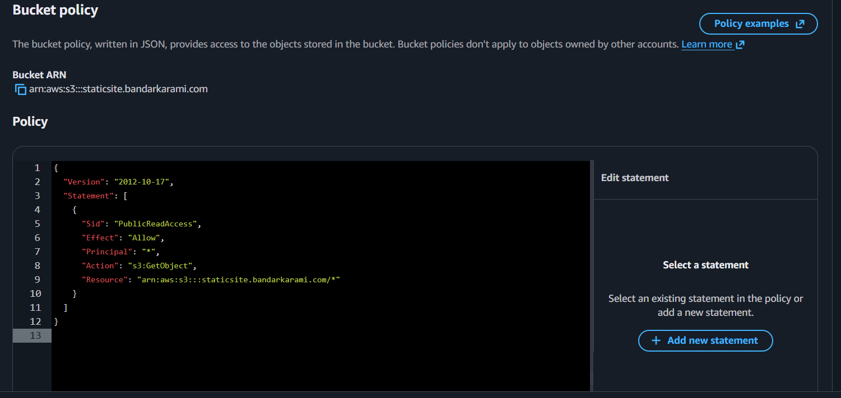
Create SSL Certificate
Open AWS Certificate Manager(ACM)
Click On Request
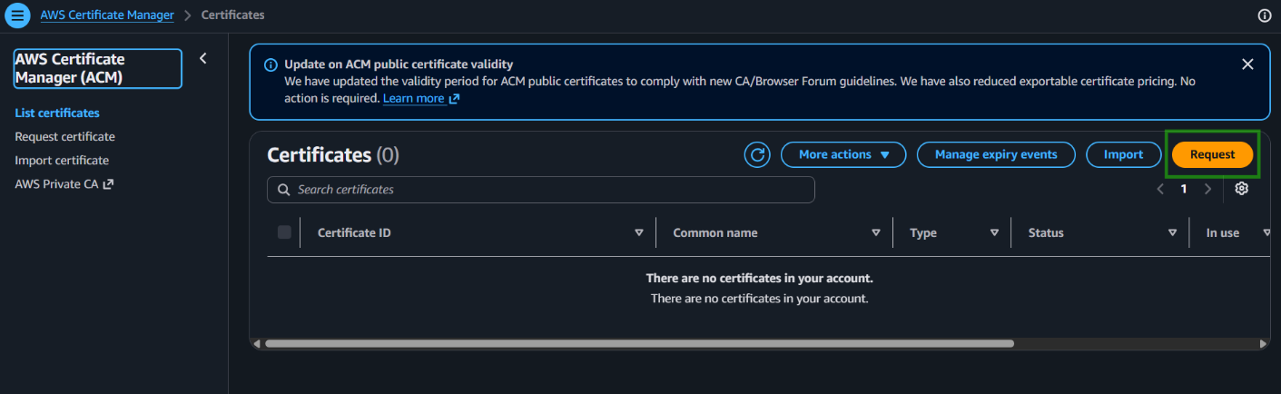
Click On Request a public certificate and Next
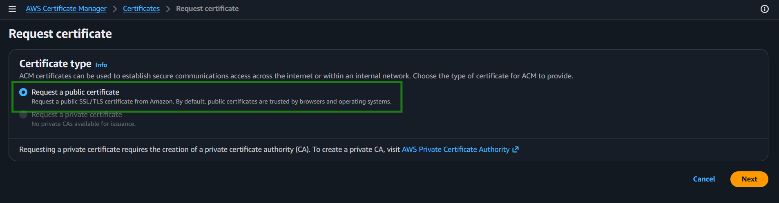
Provide domain name.
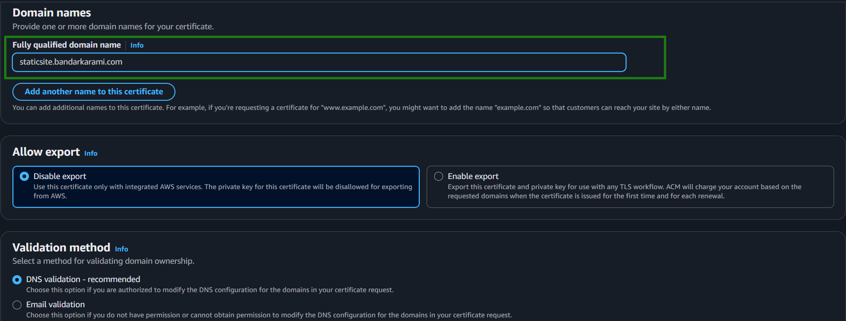
Keep the rest setting as default and click Request
Certificate is created.
Create CloudFront Distribution
Navigate CloudFront and Click on Create Distribution
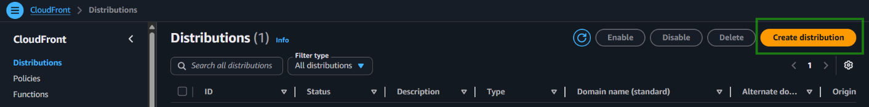
1. Select Plan : Free
2. Get Started
Enter Distribution name : staticsite.bandarkarami.com
Distribution Type : Single Website or APP
Domain : staticsite.bandarkarami.com
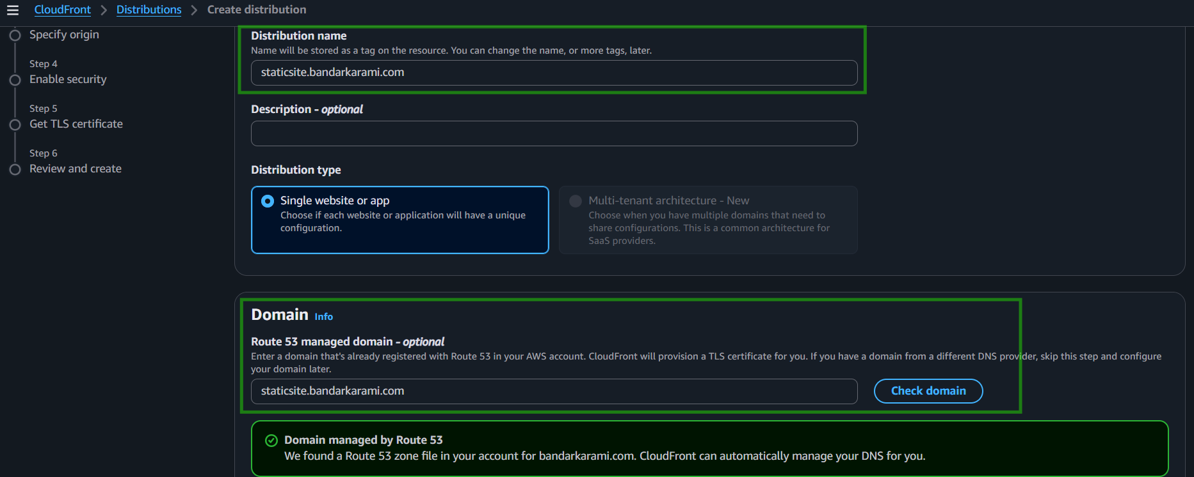

3. Specify Origin
Origin Type : Amazone S3
S3 Origin : staticsite.bandarkarami.com.s3.*****
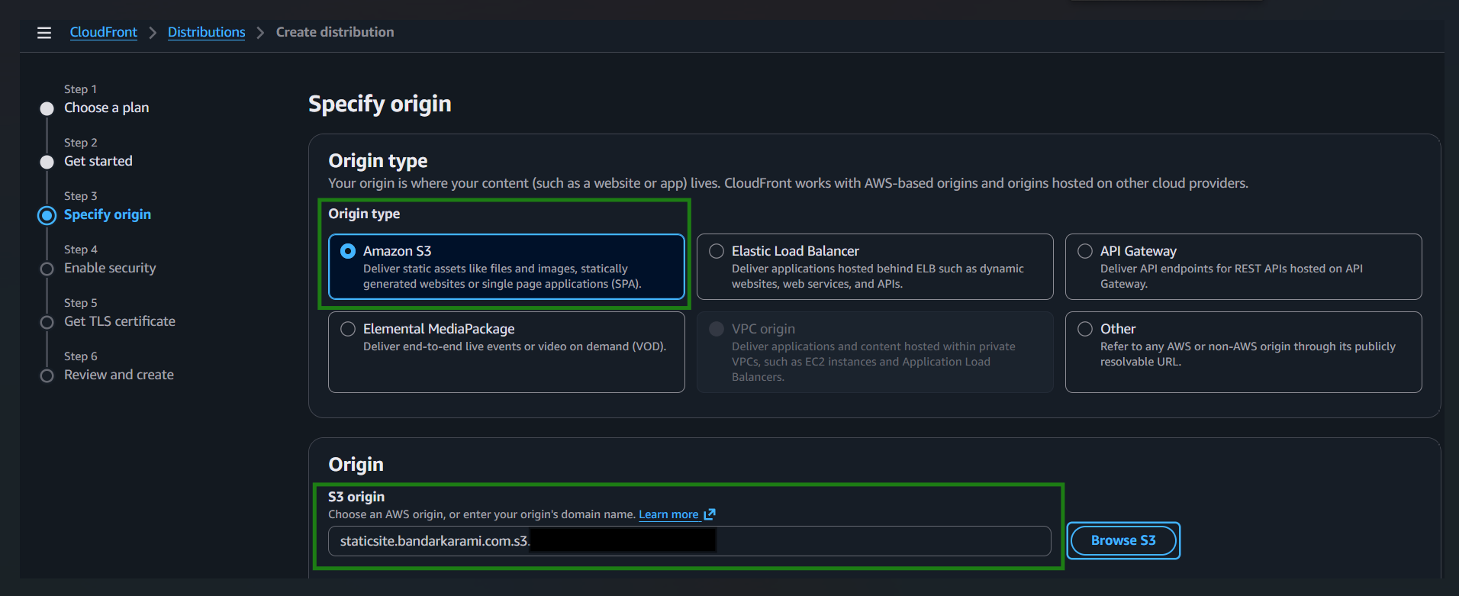
4. Enable Security :
Keep all default setting and click Next
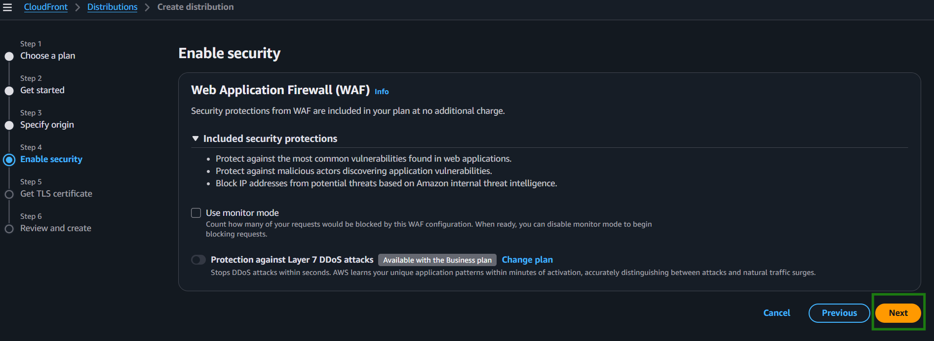
5. Get TLS Certificate
Select certificate from ACM created
6. Review and create
Review all setting and click on Create Distribution
Configure Route 53
Navigate Route 53 → Hosted Zones
bandarkarami.com
Create Record
A Name
AAAA Name
CNAME
Test Website
https://staticsite.bandarkarami.com

