Analog & Digital Communication Laboratory(ET3172)
Name : Amit Barman
Enrollment no : 2021ETB019

Matlab based assignments (Assignment -1):

1> a>

clear all
clc
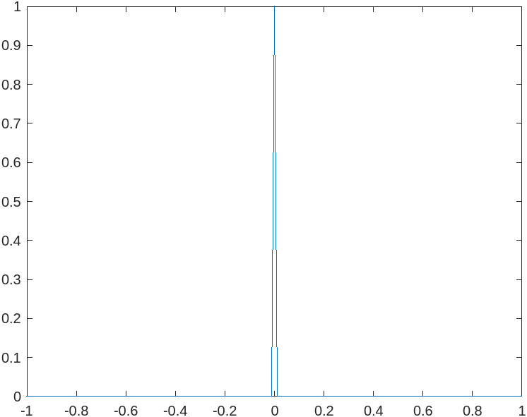
t=-1:0.01:1;
imp = t==0;
plot(t,imp);

Ans:

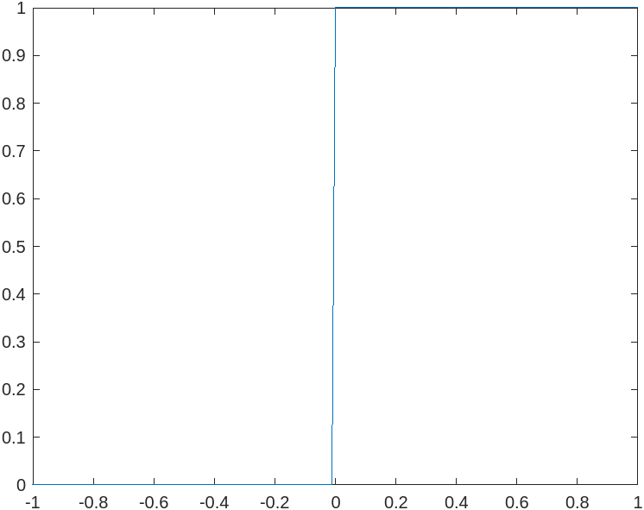

1> b>

clear all
clc
t=-1:0.01:1;
step =t>=0;
plot(t,step);

Ans:

1> c>

clear all
clc
i=0:0.01:10;
k=input("Enter the value of k : ");
x_n=k*(i>=0);
y_n=i.*x_n;
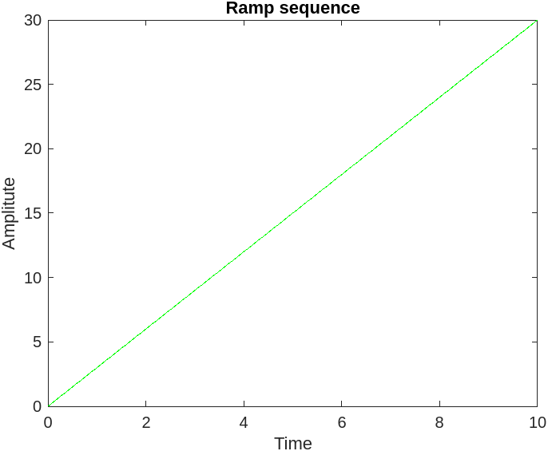
figure
plot(i,y_n,'g');
xlabel('Time')
ylabel('Amplitute')
title('Ramp sequence')

Ans:

1> d>

clear all
clc
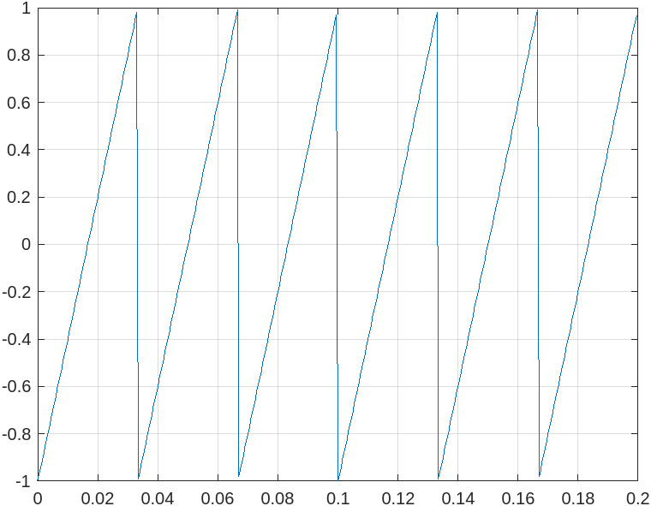
T = 1/5;
f=2000;
t= 0:1/f:T-1/f;
y=sawtooth(2*pi*30*t);
plot(t,y);
grid on

Ans:

1> e>

clear all
clc
t=0:0.1:20;
duty_cycle1 = 25; % in %
duty_cycle2 = 50; % in %
duty_cycle3 = 75; % in %
x1= square(t, duty_cycle1);
x2= square(t, duty_cycle2);
x3= square(t, duty_cycle3);

figure
subplot(3,1,1);
plot(t/pi,x1);
grid on
title("Square wave with 25% duty cycle");

subplot(3,1,2);
plot(t/pi,x2);
grid on
title("Square wave with 50% duty cycle");

subplot(3,1,3);
plot(t/pi,x3);
grid on
title("Square wave with 75% duty cycle");

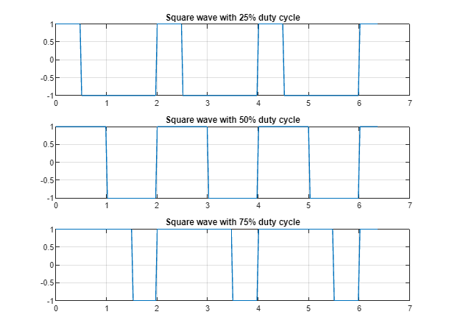
Ans :

2>

clear all
clc
%rate=input("Set sampling rate : ");
t=0:0.01:1;
y= sin(2*pi*2*t);
figure(1)
plot(t,y);
hold on

t1 = 0:0.002:1;
y1 = sin(2*pi*2*t1);
t2 = t1(1:5:end);
figure(1)
stem(t2,y,'*');
grid on

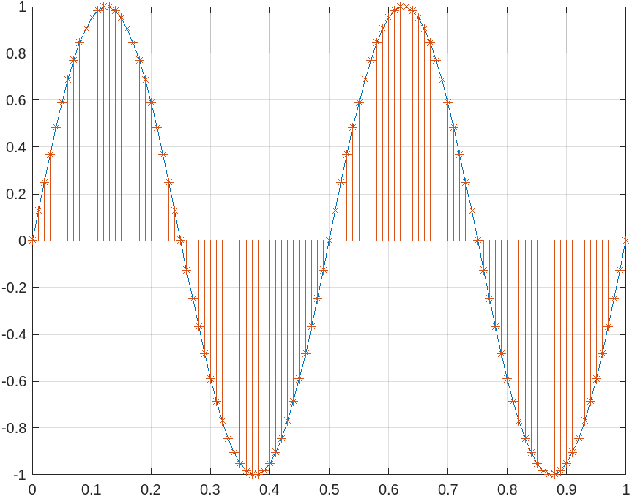
Ans:

3>

clear
clc
x=[1 4 8 4 5];
h=[2 4 3 6];
y=conv(x,h);
m=[x,zeros(1,length(x))];
n=[h,zeros(1,length(h))];

for i=1:length(x)+length(h)-1
Y(i)=0;
for j=1:length(x)
if(i-j+1>0)
Y(i)=Y(i)+m(j)*n(i-j+1);
end
end
end

figure
subplot(4,1,1);
stem(x,"b");
title("x(t)"); %input
subplot(4,1,2);
stem(h,"o");
title("h(t)"); %impulse
subplot(4,1,3);
stem(Y,"g");
title("Convolution without conv()");
subplot(4,1,4);
stem(y,"v");
title("Convolution with conv()");
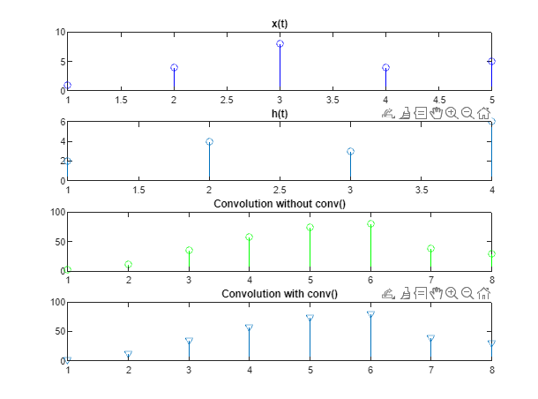
Ans:

4> a>

clear
clc
x=[1 3 -2 1 2 -1 4 4 2];
y=[2 -1 4 1 -2 3];
m=length(x)-1;
n=length(y)-1;
fl=fliplr(y);
con = conv(x,fl);
p=-m:n;

figure
subplot(3,1,1);
stem(x,"g");
title("x(n)");
subplot(3,1,2);
stem(y,"r");
title("y(n)");
subplot(3,1,3);
stem(p,con);
title("Cross correlation");
xlabel("Lag index");
ylabel("Amplitude");

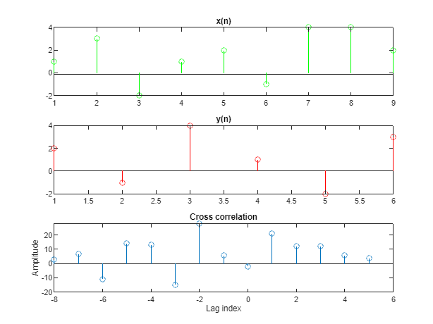
Ans:

4> b>

clear all
clc
%%%%%% Auto correlation %%%%%%%
x = input('Enter the sequence : ');
n = length(x)-1;
f=fliplr(x);
con = conv(x,f);
k = -n:n;
stem(k,con);
title("Auto correlation");
grid on

%%%%% Given sequence is
%%% 4 7 8 3 2 1 4

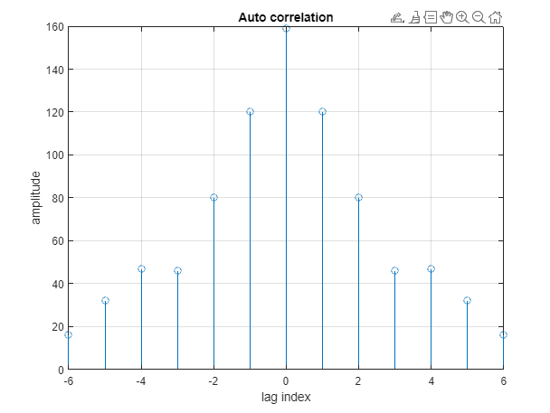
Ans:

4> c>

clear all
clc
x=linspace(-2*pi,2*pi);
d_n =1*rand(size(x));
disp(d_n);
A=input("Enter the amplitude ");
y=(A*sin(x))+d_n;

figure
subplot(2,1,1);
plot(y);
subplot(2,1,2);
plot(autocorr(y));

grid on

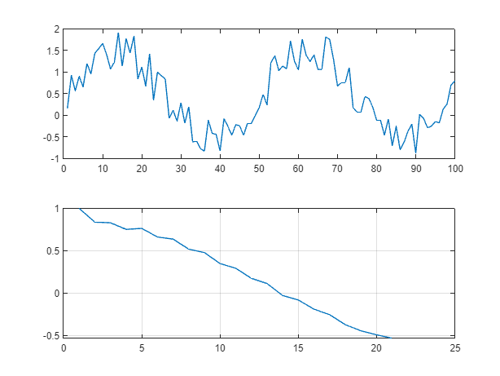
Ans:

4> d>

clear all
clc
pn_seq = [0 0 1 1 1 0 1];
n = length(pn_seq)-1;
k = -n:n;
stem(k,conv(pn_seq,fliplr(pn_seq)));
title("Auto correlation of given pn_sequence");
grid on

Ans:

