ANALOG & DIGITAL COMMUNICATION (ET3172)
Assignment – 04 (MATLAB)

NAME : AMIT BARMAN
ENROLLMENT NO : 2021ETB019

Qs – 01>

clear all
clc
i = imshow('lena.jpg');
j = imread('lena.jpg');
figure
imhist(j);
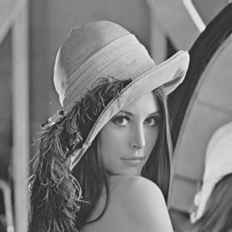

Results:

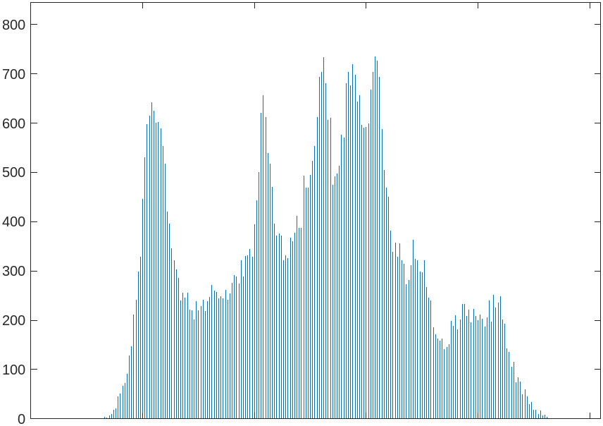

Qs – 02 >

clear all
clc
i = imread('butterfly.png');
g = rgb2gray(i);
imshow(g);

figure
n = imcomplement(g);
imshow(n);

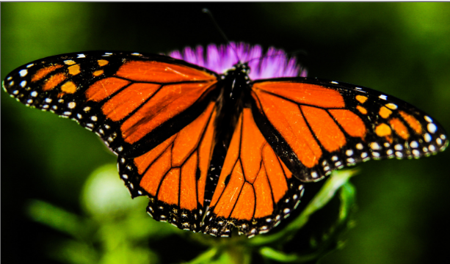
Results :

Original Colour image
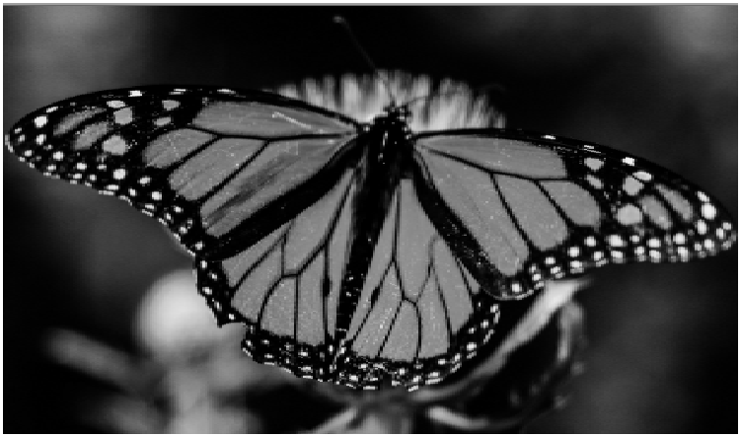

grayscale image

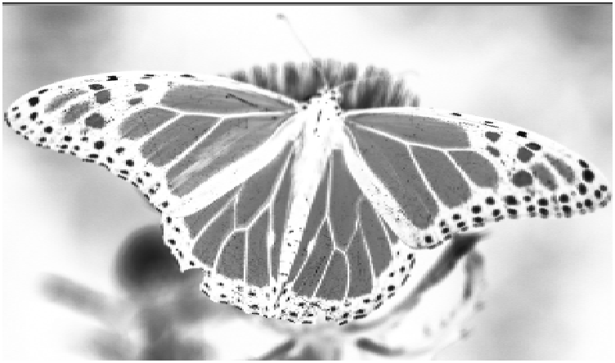

Negative of grayscale image

Qs – 03 >

clear all
clc
i = imread('lena.jpg');
imshow(i);
% addition of salt & pepper noise
n = imnoise(i,"salt & pepper");
figure
imshow(n);
h = ones(10,10)/90;
f1 = imfilter(n,h);
figure
imshow(f1);
f2 = medfilt2(n);
figure
imshow(f2);

Results :

Original image ->

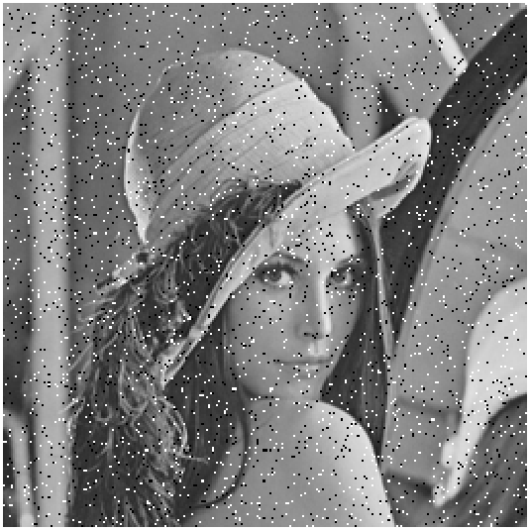
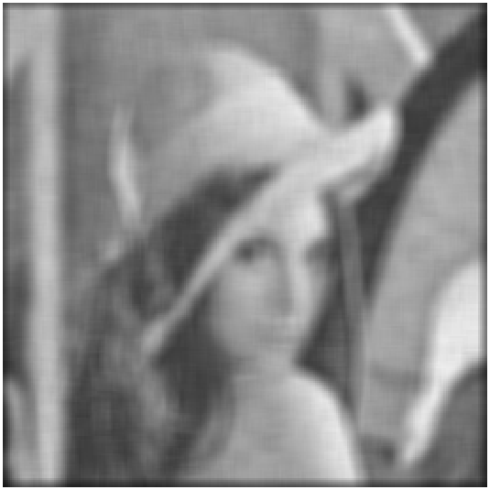

Noisy image Mean filtered image

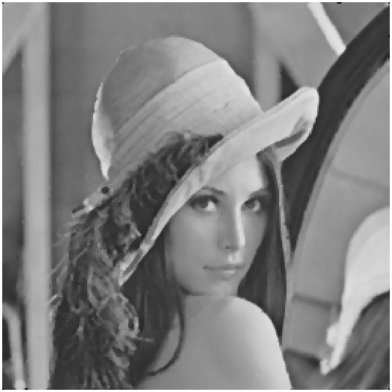

Median filtered image

Qs – 04 >

clear all
clc
i = imread('butterfly.png');
imshow(i);
% for m = 9,by changing this value we can get other square avg filtered image
hs = [9 9];
h = fspecial('average',hs);
f = imfilter(i,h);
figure
imshow(f);

Results :

Original image
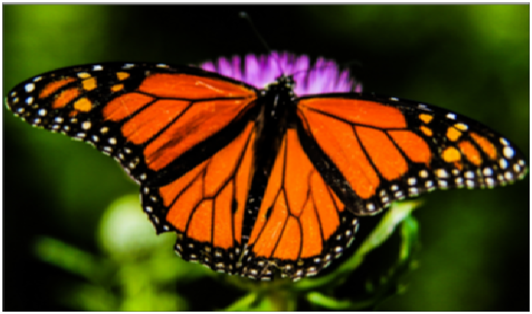

Square avg filtered image when m=3
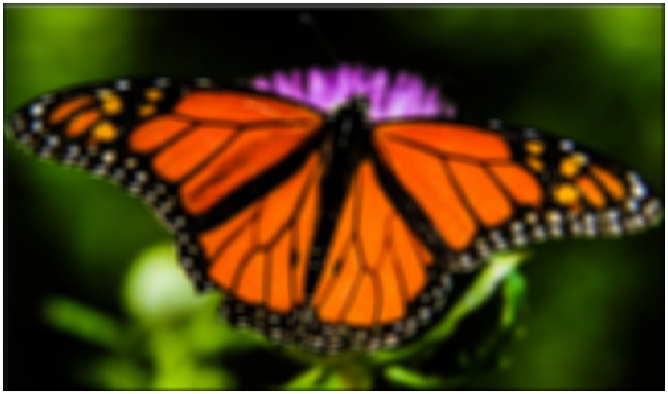

Square avg filtered image when m=9
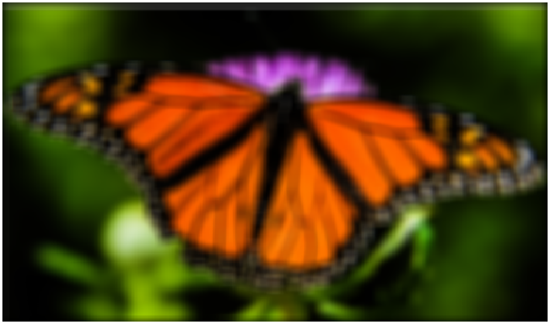

Square avg filtered image when m =15

