Analog & Digital Communication (ET3172)
Assignment – 03 (MATLAB)

NAME : AMIT BARMAN
ENROLLMENT NO : 2021ETB019

Qs – 01>

clear all
clc
% uniform distributed random-exp histogram
y = randi([-5,5],10000,1);
histogram(y,50,'Normalization','pdf');

By changing “ pdf ” to “ cdf ” [last line] we can get both the histogram plot.

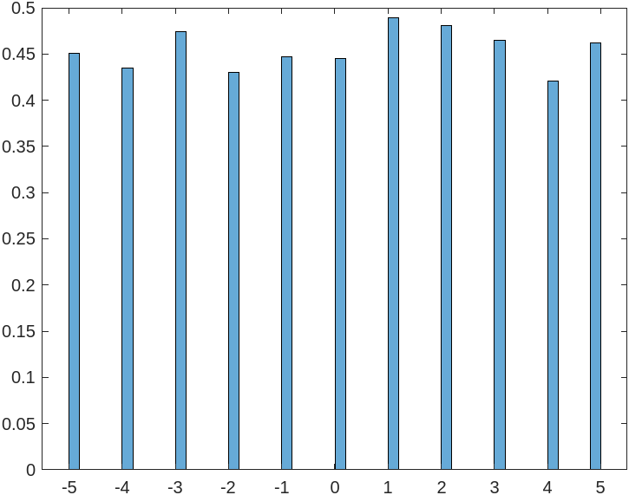
Fig: 1 - Histogram plot for Probability density function (pdf) from uniform distributed samples

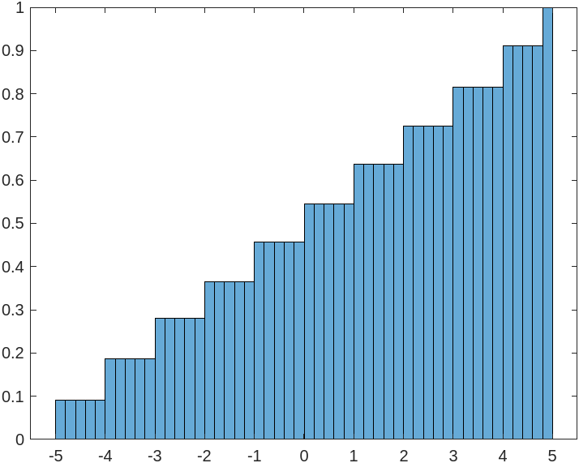
Fig : 2 - Histogram plot for Cumulative Distribution Function (cdf) from uniform distributed samples

Qs – 02>

clear all
clc
for x = 1:10000
d(x) = round(rand(1));
end
histogram(d,'Normalization','pdf');

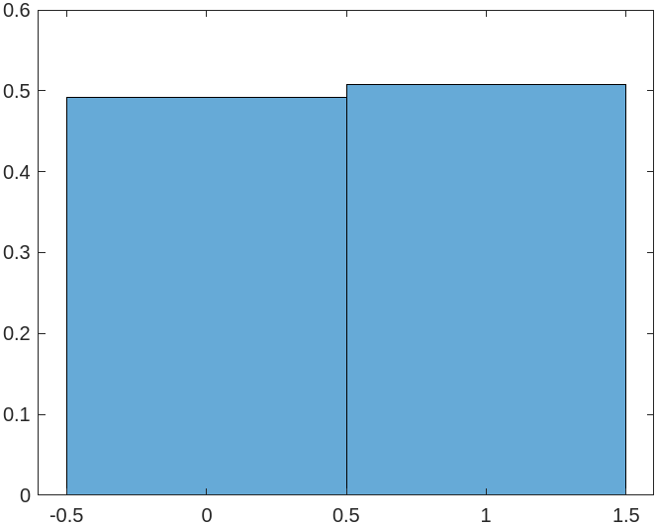

Fig : 3 - Histogram plot of binary samples from uniform distributed samples

Qs – 03>

clear all
clc
x_max = 4;
x_min = 1;
x = normrnd(0,1,10000,1);
% scaling
y=x_min+(x_max - x_min)*((x - min(x))/(max(x)-min(x)));
histogram(y,100,'Normalization','cdf');

By changing “ pdf ” to “ cdf ” [last line] we can get both the histogram plot.

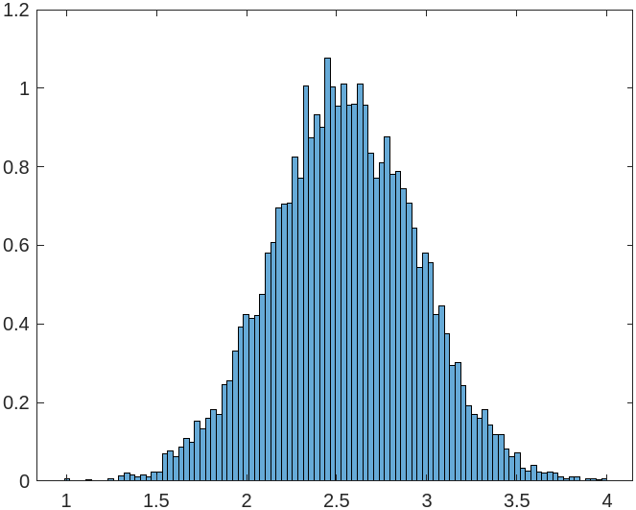
Fig : 4 - Histogram plot for pdf from gaussian distributed samples

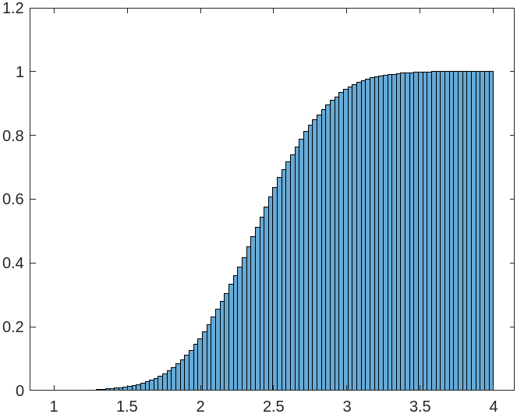

Fig : 5 - Histogram plot for cdf from gaussian distributed samples

Qs – 04 >

clear all
clc
x = exprnd(700,100,1);
histogram(x,20,'Normalization','cdf');

By changing “ pdf ” to “ cdf ” [last line] we can get both the histogram plot.
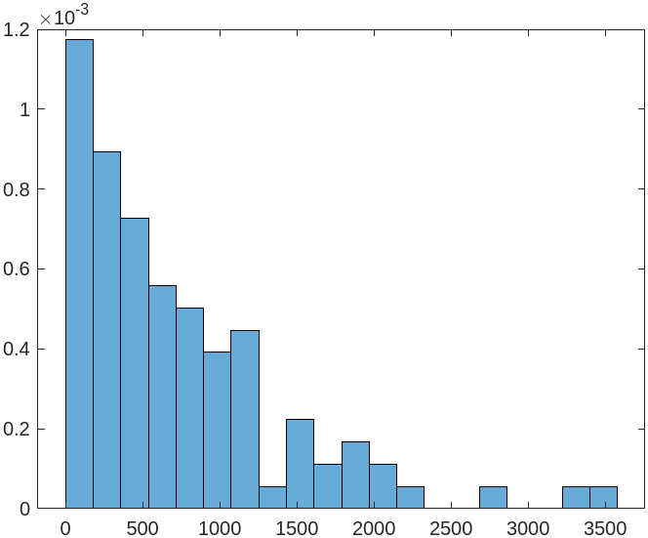
Fig : 6 - Histogram plot for pdf from exponentially distributed samples

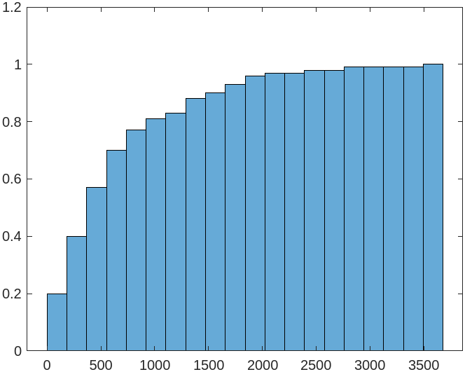

Fig : 7 - Histogram plot for cdf from exponentially distributed samples

Qs – 05>

clear all
clc
% randsrc
x = randsrc(10000,1);
histogram(x,2,'Normalization','cdf');

By changing “ pdf ” to “ cdf ” [last line] we can get both the histogram plot.

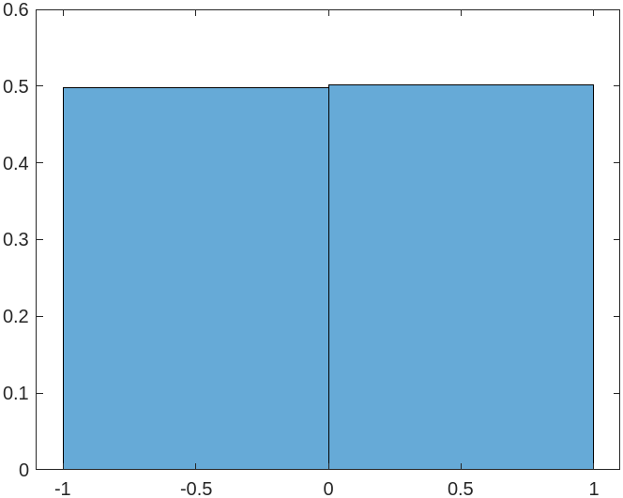

Fig : 8 - Histogram plot for pdf from uniform distributed binary samples(without for loop)

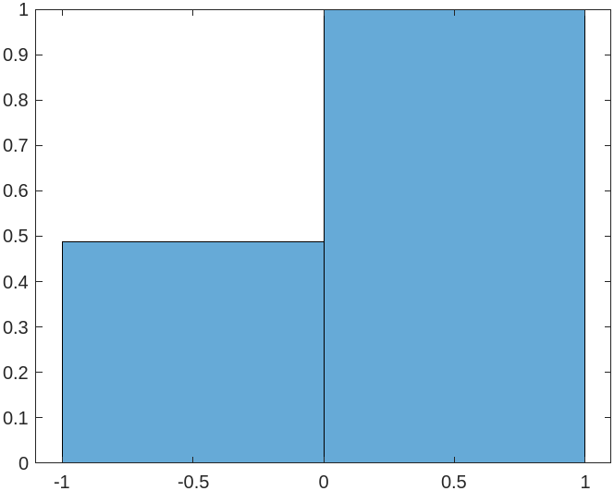
Fig : 9 - Histogram plot for cdf from uniform distributed binary samples(without using loop)

