Matlab Assignment -04

Q1>

clc
n=-2:3;
x_n=[1 2 3 4 5 6];
%a)
y1_n=fliplr(x_n);
%b)
n1=(1/3).*n;
%c)
y3_n=(n>=3);
%d)
y4_n=(fliplr(n)>2);
%e)
n5=3.*n;
figure
subplot(6,1,1);
stem(n,x_n);
title('x(n) vs n');
subplot(6,1,2);
stem(n,y1_n);
title('y1(n) vs n');
subplot(6,1,3);
stem(n1,x_n);
title('y2(n) vs n');
axis([-3,3,0,8])
subplot(6,1,4);
stem(n,y3_n);
title('y3(n) vs n');
axis([-4,4,0,2])
subplot(6,1,5);
stem(n,y4_n);
title('y4(n) vs n');
axis([-5,5,0,2])
subplot(6,1,6);
stem(n5,x_n);
title('y5(n) vs n');
axis([-4,4,0,7])
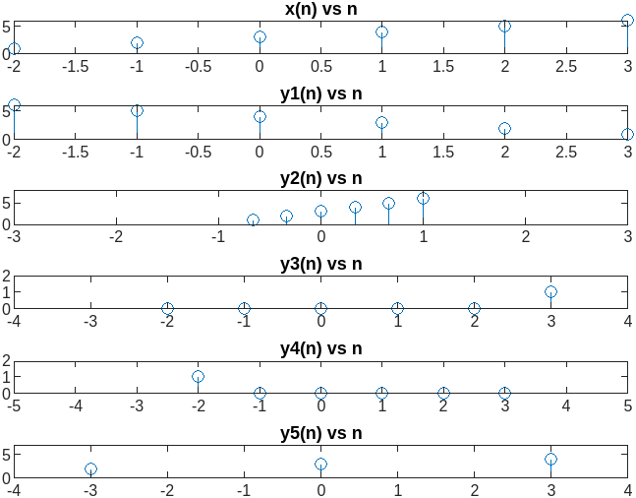

Q2>
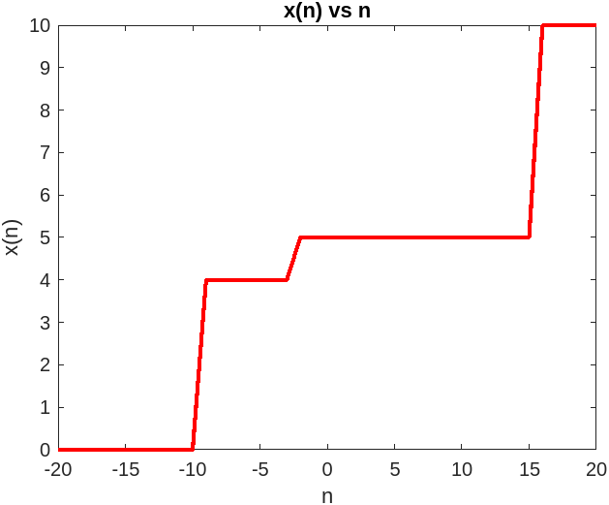
clc
n=-20:20;
u1_n=(n>-3);
u2_n=(n>15);
u3_n=(n>-10);
x_n=u1_n+5.*u2_n+4.*u3_n;
figure
plot(n,x_n,'r','Linewidth',2);
xlabel('n');
ylabel('x(n)');
title('x(n) vs n');

Q3>

clc
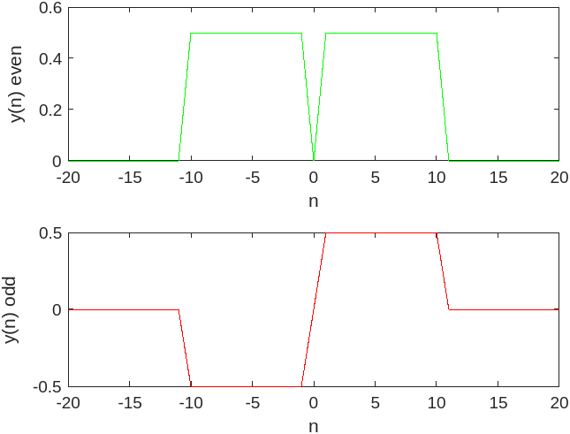
n=-20:20;
u1_n=(n>0);
u2_n=(n>10);
y_n=u1_n-u2_n;
y_n_even=(1/2).*(y_n+fliplr(y_n));
y_n_odd=(1/2).*(y_n-fliplr(y_n));
figure
title('y(n) vs n')
subplot(2,1,1);
plot(n,y_n_even,'g');
xlabel('n');
ylabel('y(n)_ even');
subplot(2,1,2);
plot(n,y_n_odd,'r');
xlabel('n');
ylabel('y(n)_ odd');

Q4>
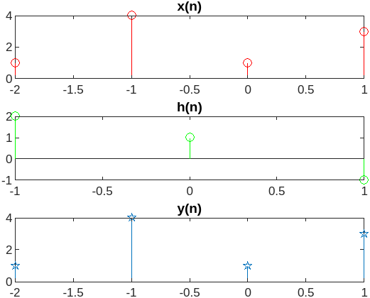
clc
n1=-2:1;
n2=-1:1;
x=[1 4 1 3];
h=[2 1 -1];
y=conv(x,h);
figure
subplot(3,1,1);
stem(n1,x,'r');
title('x(n)');
subplot(3,1,2);
stem(n2,h,'g');
title('h(n)');
subplot(3,1,3);
stem(n1,x,'p');
title('y(n)');

Q5>

clc
n1=-2:1;
n2=-1:1;
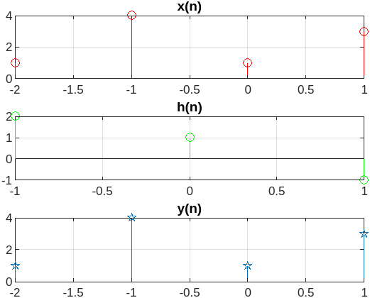
x=[1 4 1 3];
h=[2 1 -1];
m=length(x);
n=length(h);
X=[x,zeros(1,n)];
H=[h,zeros(1,m)];
for i=1:n+m-1
y(i)=0;
for j=1:m
if(i-j+1>0)
y(i)=y(i)+X(j).*H(i-j+1);
else
end
end
end
figure
subplot(3,1,1);
stem(n1,x,'r');
title('x(n)');
grid on;
subplot(3,1,2);
stem(n2,h,'g');
title('h(n)');
grid on;
subplot(3,1,3);
stem(n1,x,'p');
title('y(n)');
grid on;

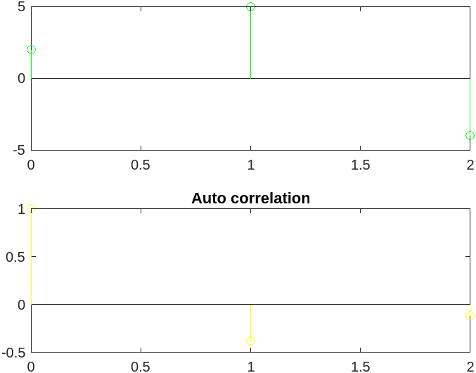

Q6>

clc
n=0:2;
x_n=[2,5,-4];
figure
subplot(2,1,1);
stem(n,x_n,'g');
subplot(2,1,2);
stem(n,autocorr(x_n),'y');
title('Auto correlation');

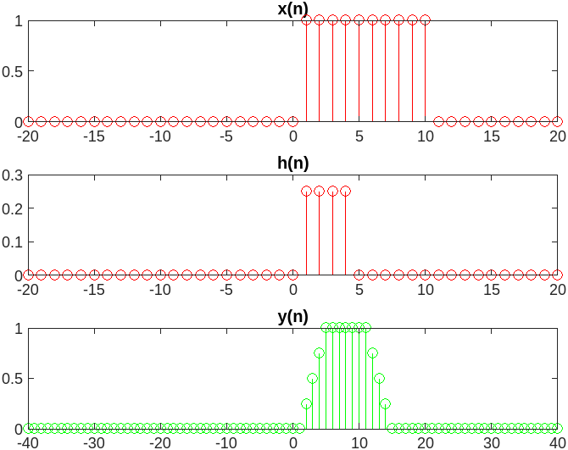
Q7>

clc
n=-20:20;
u1=(n>0);
u2=(n>4);
u3=(n>10);
x=u1-u3;
h=(1/4).*(u1-u2);
y=conv(x,h);
n_change=2*n(1):2*n(end);
figure
subplot(3,1,1);
stem(n,x,'r');
title('x(n)');
subplot(3,1,2);
stem(n,h,'r');
title('h(n)');
subplot(3,1,3);
stem(n_change,y,'g');
title('y(n)');

Q8>

clc
n=-50:50;
s1=0;
s2=0;
for i=1:length(n)
h1(i)=(3^n(i)).*(n(i)<=0);
s1=s1+abs(h1(i));
h2(i)=(4^n(i)).*(n(i)<=-2);
s2=s2+abs(h2(i));
end
figure
stem(n,h1);
title('I) Impulse Response');
if(s1>(10^5))
fprintf('Unstable');
else
fprintf('Stable');
end
figure
stem(n,h2);
title('II) Impulse Response');
if(s2>(10^5))
fprintf('Unstable');
else
fprintf('Stable');
end

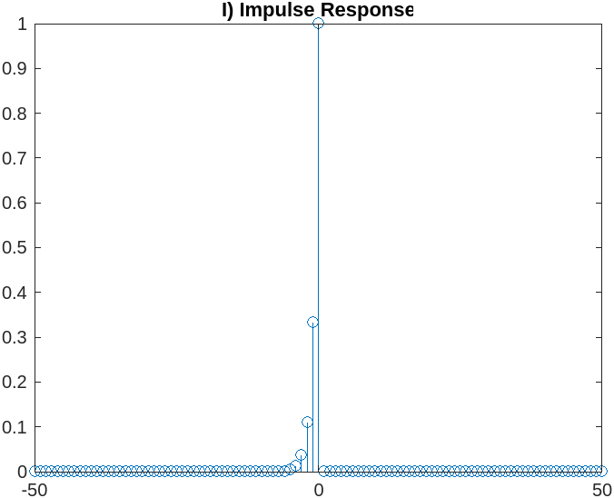
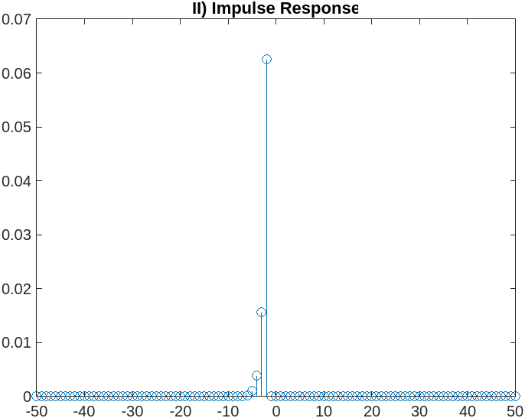
Stable

Stable

Amit Barman (2021ETB019)

