Assignment-03

1) %%% Unit Ramp Function
clear all
clc
i=0:0.01:10;
x_n=(i>=0);
y_n=i.*x_n;

figure
plot(i,y_n,'g');
xlabel('Time')
ylabel('Amplitute')
title('Unit ramp sequence')
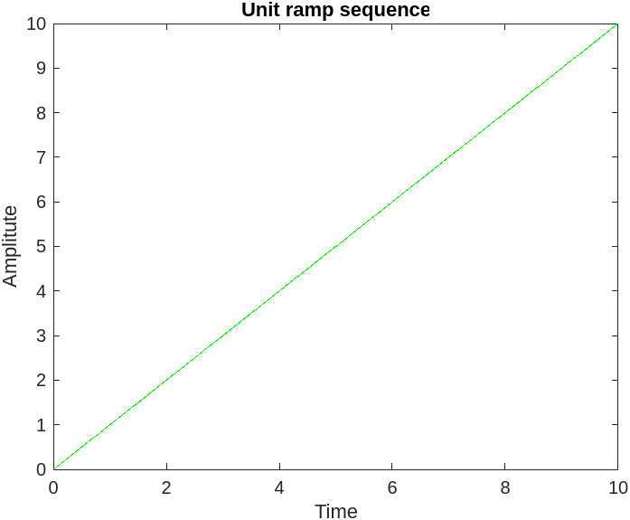

2) %%% Exponential sequence
clear all
clc
n=-10:0.1:10;
a1=input('Enter the value of a (0<a<1): ');
a2=input('Enter the value of a (-1<a<0): ');
a3=input('Enter the value of a (a>1): ');
a4=input('Enter the value of a (a<-1): ');
x1=a1.^n;
x2=a2.^n;
x3=a3.^n;
x4=a4.^n;

figure
subplot(4,1,1);
plot(n,x1,'y');

xlabel('Time');
ylabel('Amplitde');
title('Exponential sequence for 0<a<1');

subplot(4,1,2);
plot(n,x2,'g');

xlabel('Time');
ylabel('Amplitde');
title('Exponential sequence for -1<a<0');

subplot(4,1,3);
plot(n,x3,'b');

xlabel('Time');
ylabel('Amplitde');
title('Exponential sequence for a>1');

subplot(4,1,4);
plot(n,x4,'r');

xlabel('Time');
ylabel('Amplitde');
title('Exponential sequence for a<-1');

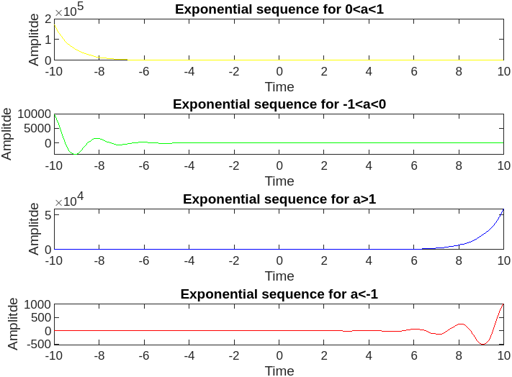

3) %%% Rectangular Pulse
clear all
clc
n=-3:0.01:3;
x_n=rectangularPulse(n);
figure
plot(n,x_n,'g');
xlabel('Time');
ylabel('Amplitude');
title('Rectangular pulse');

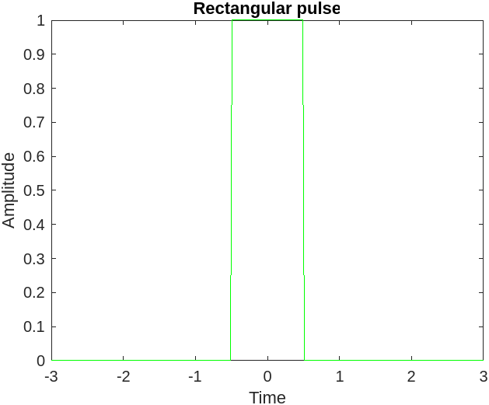

4) %%% Signum function
clear all
clc
n=-10:0.1:10;
x_n=sign(n);
figure
plot(n,x_n,'g');
xlabel('Time');
ylabel('Amplitude');
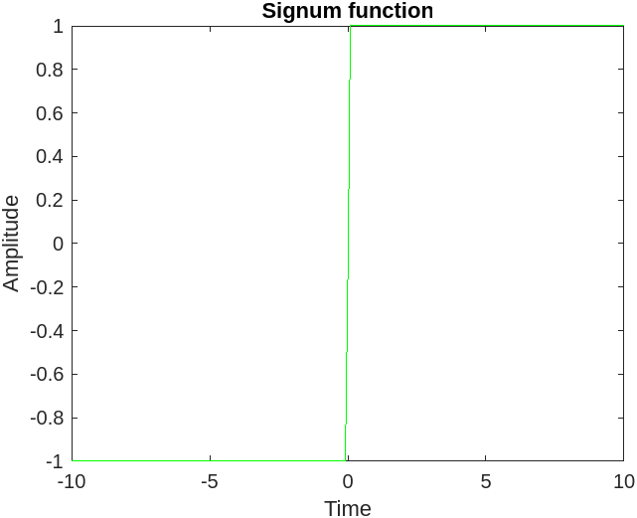
title('Signum function');

5) %%% Sinc Function
clear all
clc
t=-10:0.1:10;
if(t==0)
x_n=1;
else
x_n=sin(t)./t;
end

figure
plot(t,x_n,'r');
xlabel('Time');
ylabel('Amplitude');
title('Sinc function');
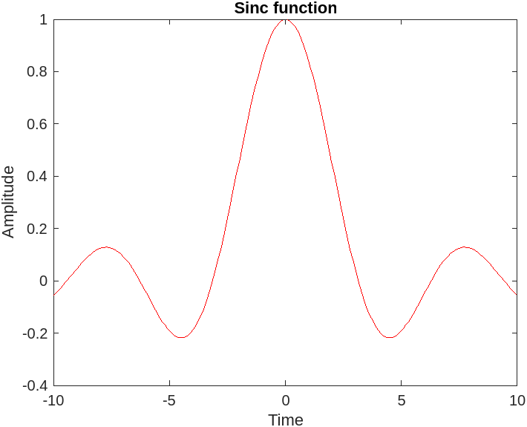

6) %%% Gaussian Function
clear all
clc
t=-10:0.1:10;
a1=input('Enter the value of a : ');
a2=input('Enter the different value of a : ');
a3=input('Enter the different value of a : ');
g_t1=exp(-a1.*t.^2);
g_t2=exp(-a2.*t.^2);
g_t3=exp(-a3.*t.^2);

figure
plot(t,g_t1,'g');
hold on
plot(t,g_t2,'r');
hold on
plot(t,g_t3,'y');

xlabel('Time');
ylabel('Amplitude');
title('Gaussion Function');

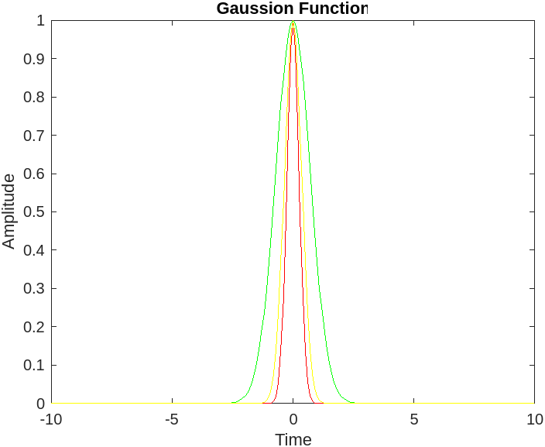

7) %%% Complex Exponential function
clear all
clc
t=-10:0.1:10;
% a)
sigma1=0;
w1=0;
s1=complex(sigma1,w1);
% b)
sigma2=input('Enter finite value of sigma : ');
w2=0;
s2=complex(sigma2,w2);
% c)
sigma3=input('Enter value of sigma (sigma <0) : ');
w3=input('Enter finite value of w : ');
s3=complex(sigma3,w3);
% d)
sigma4=input('Enter sigma (sigma >0) : ');
w4=input('Enter finite value of w : ');
s4=complex(sigma4,w4);

figure
subplot(4,1,1);
plot(t,exp(s1.*t),'r');
subplot(4,1,2);
plot(t,exp(s2.*t),'g');
subplot(4,1,3);
plot(t,exp(s3.*t),'y');
subplot(4,1,4);
plot(t,exp(s4.*t),'b');

xlabel('Time');
ylabel('Amplitude');
title('Complex exponential function');

