Analog & Digital Communication (ET3172)
Assignment – 02 (MATLAB)

NAME : AMIT BARMAN
ENROLLMENT NO : 2021ETB019

Qs- 01>

clear all
clc
close all
% Number of samples
N = input("Enter the value of N : ");

% uncorrupted signal s(n)
n = 0:N-1;
s = 2 * (0.9 .^ n) .* n;

% random noise d(n)
d = randn(1, N);

% Noise corrupted signal
corrupted_sig = s + d;

% X Avarage
x_avg = zeros(1, N);
k = input("Enter the value of K : ");
for i = 1:k
noise = randn(1, N);
x_avg = x_avg + (s + noise);
end
x_avg = x_avg / k;

% Plotting
figure;
subplot(4,1,1);
plot(n, s);
title('s(n)');
xlabel('n');
ylabel('s(n)');

subplot(4,1,2);
plot(n, d);
title('d(n)');
xlabel('n');
ylabel('d(n)');

subplot(4,1,3);
plot(n, corrupted_sig);
title('Corrupted Signal');
xlabel('n');
ylabel('X(n)');

subplot(4,1,4);
plot(n, x_avg);
title('X_avg');
xlabel('n');
ylabel('X_avg');

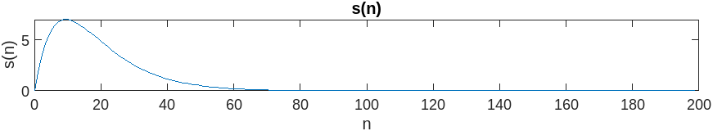

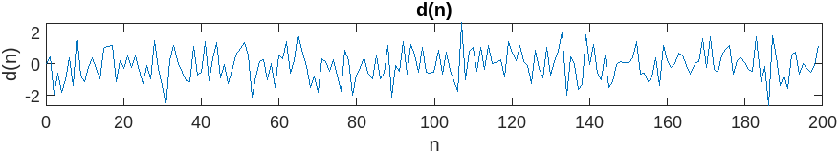

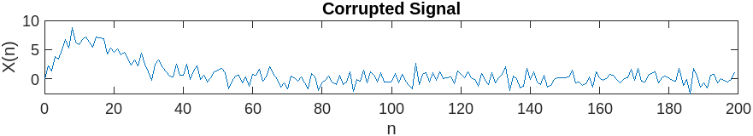

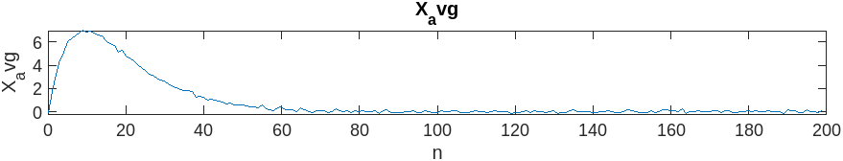

Qs -02>

clear all
clc
close all
% Number of samples
N = input("Enter the value of N : ");

% Original uncorrupted signal s(n)
n = 0:N-1;
s = 2 * (0.9 .^ n) .* n;

% random noise d(n)
d = 0.5*randn(1, N);

% Noise corrupted signal
corrupted_sig = s + d;

% filtering
x_avg = zeros(1, N);
k = input("Enter the numbers of moving average measurements : ");
b = ones(1,k).*(1/k);
y = filter(b,1,corrupted_sig);

figure;
subplot(4,1,1);
plot(n, s);
title('s(n)');
xlabel('n');
ylabel('s(n)');

subplot(4,1,2);
plot(n, d);
title('d(n)');
xlabel('n');
ylabel('d(n)');

subplot(4,1,3);
plot(n,corrupted_sig);
title('Corrupted signal');
xlabel('n');
ylabel('X(n)');

subplot(4,1,4);
plot(n, y);
title('Filter signal');
xlabel('n');
ylabel('y(n)');

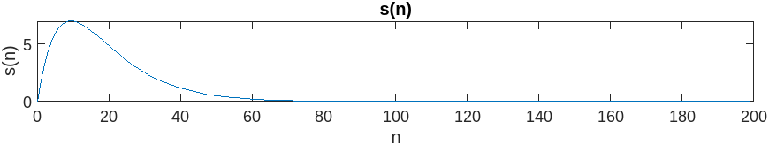
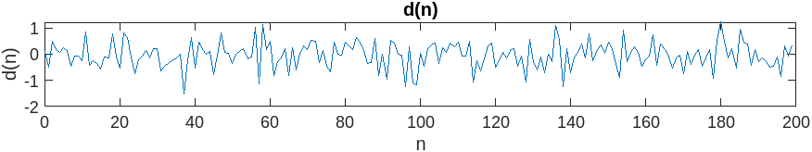

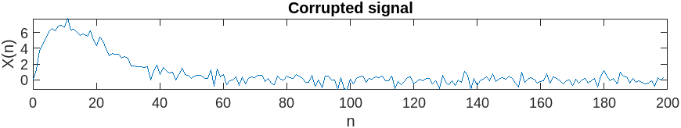
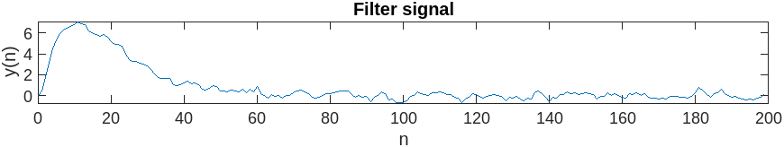

Qs – 03>

clear all
clc
close all
% Number of samples
N = input("Enter the value of N : ");

% Original uncorrupted signal s(n)
n = 0:N-1;
s = 2 * (0.9 .^ n) .* n;

% random noise d(n)
rand = randi([0,N],1,1);
imp_noise = 10.*(n==rand);
% Noise corrupted signal
corrupted_sig = s + imp_noise;

% filtering
M = input("Enter the median filter length : ");
y = medfilt1(corrupted_sig, M);

figure
subplot(3,1,1);
plot(n,s,"r");
title("uncorrupted signal");
xlabel("n");
ylabel("s(n)");

subplot(3,1,2);
plot(n,corrupted_sig,"g");
title("Noise corrupted signal");
xlabel("n");
ylabel("X(n)");

subplot(3,1,3);
plot(n,y,"b");
title("Median filtered signal");
xlabel("n");
ylabel("y(n)");

figure
plot(n,imp_noise,"r");

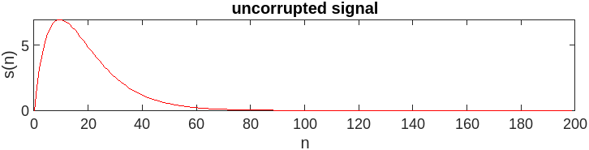

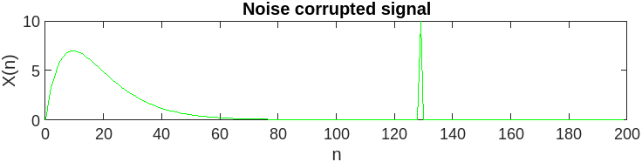
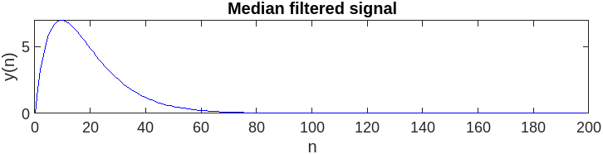

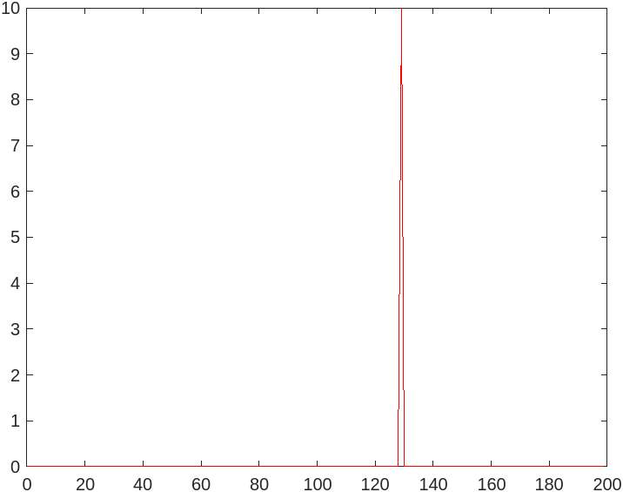


random impulse signal

